Determination of operating parameters of accumulative electric heating systems
Anatolii Kolienko¹, Rasul Ahmednabiev1, Olena Gupalo² Oksana Demchenko¹, Olha Hukasian¹
¹National University Yuri Kondratyuk Poltava Polytechnic, Pershotravneva St., 24, Poltava, 36011, Ukraine
²Ukrainian State University of Science and Technologies, Lazaryan St., 2, Dnipro, 49010, Ukraine
The article presents the results of research, the purpose of which is to determine the parameters and characteristics of accumulative electric heating systems, to substantiate the possibility of using heat accumulators to reduce the connected power of the heating system and the effective use of renewable sources of electrical energy, most of which are characterized by virtuality, periodicity of electrical energy generation and significant dependence on natural conditions and climate. The methodology of the work is based on a critical analysis of available data on the issue of heat accumulation in electric heating systems, as well as our own theoretical and experimental research. Dependencies have been obtained that make it possible to determine the use of heat accumulators and their characteristics depending on a wide range of factors. Recommendations for the design of heat accumulators in heating systems of residential and public buildings have been developed, various factors have been assessed for the effectiveness and possibility of using such systems and the limitations that occur when using them. Scientific and practical results of the work make it possible to carry out a low-cost reconstruction of electric heating systems for the introduction of storage systems using electrical energy, the source of which is wind and solar energy.

Introduction
Thermal accumulators are one of the important elements when addressing the issue of increasing the energy efficiency of heating and ventilation systems. Heat storage in some cases turns out to be an important way to achieve the goals of increasing the efficiency of heating and ventilation systems and makes it possible to solve important tasks set in the updated energy efficiency directive [1].
First, we are talking about the use of batteries in thermal power systems with renewable sources, which generate energy that is variable both in time and in quantity. For example, the use of solar or wind energy for heating purposes is practically impossible without the use of heat storage. In addition, heat accumulation can be considered as a means of leveling the energy consumption schedule. When using two and three-rate tariffs, heat accumulators in the heating system make it possible to obtain a significant economic effect associated with the ability to use energy during periods of lowest cost and tariffs.
An additional challenge is charging for installed capacity. The use of heat accumulators makes it possible to reduce the installed capacity of consumer heat and power systems by leveling the load and covering peak loads using accumulated heat.
There are two types of such batteries. The first type includes those whose temperature increases when heat is supplied, the second - those in which the supplied heat is spent on some kind of phase transition - most often melting. In the first case, the specific energy of the battery is determined by the heat capacity of the storage substance and the permissible change in its temperature, and in the second - by the latent heat of phase transition.
The article discusses the issues of determining the operating parameters of water batteries without a phase transition.

Methodology
The study of determining the operating parameters of heat accumulators was carried out in the following sequence:
- work with literary sources on the topic of using electrical energy in heating systems [2,3,4];
- analysis of the issue of using heat accumulators in electric heating systems [5,6,7];
- full-scale studies of operating modes of heating systems in residential and public buildings;
- creation of a mathematical model to determine the operating parameters of heat accumulators;
- determination of the main parameters of the heat accumulation system;
- experimental verification of the obtained dependencies to determine the operating parameters of the accumulation system.
The design and installation of electric heating systems is facilitated by the continuous increase in the price of natural gas, which is used as fuel in boiler houses, and, accordingly, an increase in tariffs for thermal energy obtained from centralized and other heat supply systems.
Thus, electrical energy can be considered as an alternative to heat obtained by burning fuel (for example, natural gas).
On the other hand, the use of electrical energy for heating needs helps solve the problems of power engineers themselves. Namely, the problem of a shortage of shunting capacity to regulate the daily load schedule of the country’s energy system against the backdrop of a surplus in electrical energy generation. The use of electrical energy for heating buildings at night can be a good way to level out the unevenness of electrical energy consumption in the power supply system. Especially when using electrical energy generators using renewable and alternative energy sources.
The introduction of electric heating systems makes it urgent to evaluate the effectiveness of such systems, both from the point of view of economic assessment of the efficiency of using secondary (derivative) energy carriers in relation to the chemical energy of hydrocarbon fuels, which is electrical energy, and from the point of view of thermotechnical assessment of the efficiency of heating systems. using electrical energy, including electric storage systems.
From a thermodynamic point of view, from one m³ of natural gas of group L or E according to classification [8,9] with a calorific value of up to 40 MJ / m³) it is theoretically possible to obtain (provided that the process is 100% efficient) up to 11 kW ∙ hour / m³ of electrical energy.
However, the low efficiency of condensing thermal power plants leads to the fact that the amount of generated electrical energy does not exceed 3....4 kW ∙hour / m³, which immediately affects electricity tariffs.
The advantage of electric heating boilers, without a doubt, is their high thermal efficiency of converting electrical energy into heat, which is close to 99%.
When using the best hydrocarbon fuel - natural gas - in non-condensing boilers, the thermal efficiency does not exceed 91...92% and cannot be greater due to the fear of water condensation in the composition of the fuel combustion products. In condensing heat generators, the efficiency of fuel use can be increased to 95...96%.
For most industrial units, there is an overconsumption of equivalent fuel when using electrical energy compared to gas by 10...42% [10].
The use of electrical energy as an energy carrier makes it possible to achieve high accuracy in maintaining the temperature regime of heat treatment of products; however, the economic indicators of electric furnaces are significantly inferior to those of fuel furnaces using natural gas. Thus, the cost of heating turned out to be 1.3-2.4 times with induction heating compared to gas heating [10].
However, the difference in the efficiency of heating gas and electric boilers for municipal energy from 8...9% to 4...5% of the operating efficiency of the heat generating units themselves is easily compensated by the extremely low efficiency of the steam power cycle for generating electrical energy at condensing power plants and the fact that electrical energy is a derivative of compared with the chemical energy of mineral organic fuel. Therefore, the overall energy efficiency of using the potential of primary hydrocarbon fuel with the direct use of fuel to produce thermal energy in fuel-burning units in urban municipal services will always be higher compared to heat generation systems in electric boilers. As a result, the cost of generating thermal energy in electric boilers is 1.5-2.0 times higher compared to natural gas boilers.
The situation may change if renewable sources are used to obtain electrical energy. However, the potential of such energy sources in the cold season, as a rule, decreases, and the virtuality of obtaining energy from renewable sources, on the one hand, and high requirements for the reliability of heating systems, on the other, transform this problem into a multivariate one.
This conclusion may also be valid when comparing the cost of energy, unless the cost of electrical energy is subject to any preferences, such as a “night tariff”.
A significant reduction in the cost of electrical energy occurs when switching to a two (or three-rate) tariff for electrical energy. This method of payment for electrical energy makes it possible to implement such a method of electric heating as electric storage heating.
During the night period of the day, during the period of preferential tariff for electrical energy), the electric storage system takes electrical energy from the network for the purpose of heating water and accumulates hot water in the accumulation tank in an amount sufficient for the full operation of the heating system during the daytime period, when electrical energy is withdrawn from the network at an increased rate is not available. During this period of the day, coolant will be withdrawn from the storage tank.
A schematic diagram of the arrangement of such a system is shown in Fig. 1.
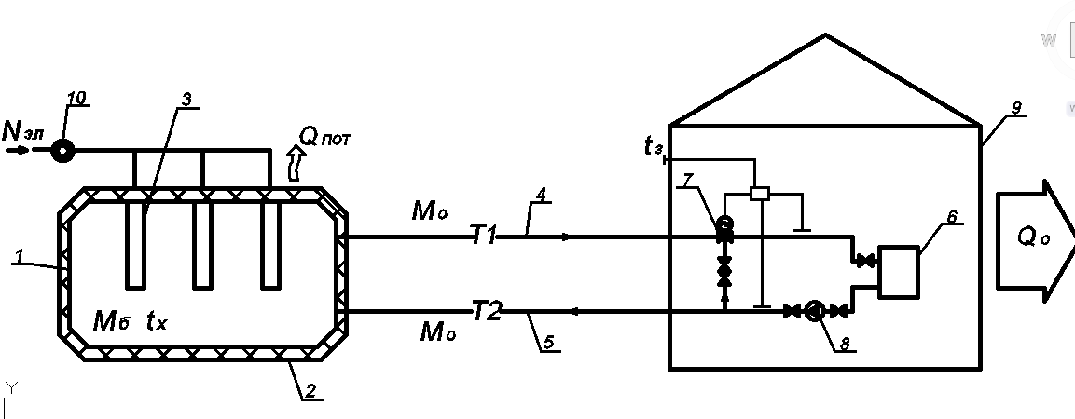
Fig. 1. Schematic diagram of the arrangement of an electric storage system with a water storage tank. 1- water storage tank; 2- thermal insulation of the tank; 3- electric heater; 4- hot water supply pipeline with coolant temperature t₁; 5-return pipeline with temperature t₂; 6- heating devices for building heating systems; 7- three-way control valve; 8 – circulation pump; 9 – heated building; 10 - multi-tariff electric meter. Q_{пот} – heat loss from the electric storage tank.

Let us determine the main design parameters of such a system and performance indicators of its operation.
Initial data for calculation:
M_{o} - the flow rate of water that circulates in the heating system of the building is determined according to the relationship:
, kg/h $M_{o}=\frac{Q_{hc}}{\left(t_{1}-t_{2}\right)c_{a}}, kg/h$
where Q_{hc} is the calculated heat consumption for heating the building, depends on the heat-protective characteristics of the building envelope, kcal/h, kW;
с_{a} – heat capacity of water, kcal/kg.°С;
M_{b} – the mass of water in the accumulation tank can be written as:
$M_{b}=V_{b}*ρ_{w}$

where V_{b} is the volume of the accumulation tank, m³; ρ_{w} – density of water in the container, t/m³.
Let us introduce other factors that influence the solution of the problem.
N_{el} is the power of the electric heater, which should ensure heating of water with a flow rate of M_{o} to a temperature t₁ sufficient to ensure comfortable conditions for people to stay in the building during the periods of both supply and accumulation, and consumption of thermal energy;
τ_{sup} – duration of night supply of electrical energy and accumulation of heat throughout the day, at a reduced tariff, per hour, for example τ_{sup} = 7 hours (from 23.00 to 6.00) – time of supply and accumulation of energy;
τ_{use} = (24 – τ_{sup}) – daily duration of energy use without external replenishment. During this period of the day, the use of electrical energy to heat the coolant is not economically justified, since the daytime electricity tariff is significantly higher than the night tariff;
η_{los} is a coefficient that takes into account heat loss from the battery tank to the environment. Provided effective thermal insulation of the tank η_{los} = 0.93÷0.95 (heat loss to the environment is 5÷7%);
– a coefficient that takes into account the presence in the system of such buildings and structures for which it is possible to partially or completely reduce the amount of heat released for heating during the period of supply and accumulation of energy (for example, for a set of heat accumulation in building envelopes or a temporary decrease in the temperature in the room);
$n^{''}=\frac{Q_{o}^{''}}{Q_{o}}$ – a coefficient that takes into account the share of buildings in which it is impossible to temporarily reduce the supply of heat for heating during the period of energy accumulation;
$Q_{o}^{'}$ – calculated heat consumption for heating that part of buildings in which it is possible to reduce the amount of heat supplied for heating during the period of energy supply and accumulation, kcal/h, kW;
$Q_{o}^{''}$–– the calculated heat consumption for heating that part of the buildings in which it is not possible to reduce the amount of heat released for heating during the accumulation period, kcal/h, kW.

Thus, the total amount of heat supplied for heating needs for a group of buildings and structures can be written as an equation:
, kcal/h, kW , (1).
If the coefficient $n^{'}$ =0, then this means that there are no buildings in which a temporary reduction in the supply of heat during the night period of electricity consumption at the lot rate is allowed. If during the night period, there is a possibility of turning off all buildings from a heat source, then $n^{'}$=1, and the coefficient $n^{''}$=0. If it is possible to reduce the heat consumption for heating at night by half, the values of the above coefficients will have the values $n^{'}$=0.5 and $n^{''}$=0.5.

Results and discussion.

The main design parameters of electric storage heating systems include the following:
- required electrical power of the heater. N_{el};
- capacity of the storage tank for hot water. Such a tank, under conditions of periodic supply of energy to water, must provide the required temperature of the coolant in the supply line of the heating system throughout the entire period of energy use throughout the day. This temperature, in addition, depends on the temperature of the external air and is determined in accordance with the temperature schedule for the release of the coolant.
Table 1 shows the required coolant temperatures in the supply and return pipelines of the heating system when the outside air temperature changes (temperature schedule for coolant release 95-70°C) for climatic conditions with a calculated outside air temperature of 23°C.

Table 1. The temperature of the coolant supplied to the heating system according to the temperature schedule is 95-70°C (calculated outside air temperature -23°C).
Outside air temperature, °C | -23 | -17,5 | -12,5 | -7,5 | -2,5 | +2,5 | +6,5
Coolant temperature in the supply pipeline, °C | 95 | 85 | 76 | 68 | 59 | 50 | 43
Coolant temperature in the return pipeline, °C | 70 | 64 | 60 | 58 | 47 | 42 | 37

We determine the required power of the electric heater from the system heat balance equation:

$$η_{los}*860*N_{el}*τ_{sup}=n^{'}*Q_{o}*\left(24-τ_{sup}\right)+n^{''}*Q_{o}*24 kcal/hour (kW hour),$$

After some mathematical transformations, we get:

,

860*$η_{los}$*$N_{el}$*$τ_{sup}$=$Q_{o}$(24$n^{'}$-$τ_{sup}n^{'}$+24$n^{''}$)

Or the required electrical power of the heater should be:

, kW
$N_{el}=\frac{Q_{o*}[n^{'}*\left(24-τ_{sup}\right)+24*n^{''}]}{860*η_{los}*τ_{sup}}, KW$

The results of calculations of the required thermal power of the electric heater of the system depending on the outside air temperature up to which the accumulation mode of operation will be ensured are shown in Figures 2, 3 and 4 for various values of the coefficients $n^{'}$ and $n^{''}$, as well as for various durations of operation of the system in the mode supply and accumulation of energy τ_{sup}. In order to make the calculation results universal and possible for use in the conditions of any building with an arbitrary value of calculated losses Q_{o}, the ordinate axis of the graph shows not the absolute, but the relative value of the required power of the electric heater k, which is defined as the ratio of the absolute power N_{el} to the calculated flow rate heat for heating the building is related to the calculated amount of heat flow required to heat the building - Q_{о}:

k=$\frac{N_{el}}{Q_{o}}$
This coefficient shows how many times the power of the electric heater must exceed the calculated value of the heat flow for heating in order for the heat accumulation system to operate with comfortable indoor microclimate parameters corresponding to the outside air temperature.

For example, in accordance with Fig. 2, to ensure the functionality of the electric storage heating system for buildings with complete heat extraction ($n^{'}$=0) during the period of energy storage, the required power of the electric heater must exceed the calculated heat requirement for heating by 4 times (subject to operation in the entire range of outside air temperatures, including the design temperature $t_{od}$= -23°С).
Provided the accumulation system operates to a temperature not lower than -10°C (87% of the time of the total operating time heating system) the electric heater power at the level N_{el} = (2.5÷2.6).Q_{о} is sufficient.
Provided that the duration of the energy supply and storage cycle increases from seven hours at the most favorable tariff to ten hours, of which three hours are the time of the increased tariff, the power of the electric heater can be reduced to N_{el} = (1.8÷1.9).Q_{о}.
However, in this case, the economic attractiveness of the system is significantly reduced. In addition, the question of how to provide consumers with heat for heating during the period when the external air temperature reaches values from -10°C to a calculated value of -23°C becomes relevant. And this is about 600 hours of work for the climatic conditions of the city with a calculated outside air temperature of about t_{od} = -23°С).
In the absence of a heat source using fossil fuels, the only alternative to supplying heat during this period is the extraction of electrical power during the daytime period at an increased tariff, which is economically unprofitable.
Thus, reducing the consumption of primary fuel (for example, natural gas), which is usually the main goal of using electric storage heating systems, will actually lead to an increase in funds for heating buildings.
In this case, the overall economic efficiency of electric storage systems will be inferior to systems that operate on fossil fuels.
A significant problem with the use of electric storage heating systems is the need to modernize external electrical networks, which is explained by the inability of electrical networks to withstand additional significant loads that arise during electric heating. Thus, when introducing an accumulative electric heating system in an 80-apartment residential building with an estimated heat requirement for heating of 250 kW, the power of the electric heater, in accordance with the graph in Fig. 2, should be about 900 kW. Connecting such a heater to a home's existing electrical networks poses a significant challenge.

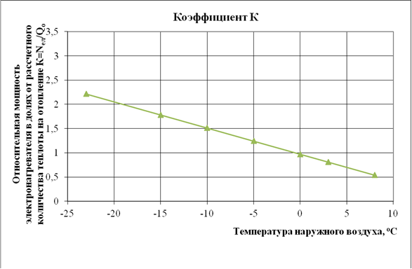
Fig. 2. Dependence of the required power of electric heaters of an electric storage heating system on the outside air temperature, up to which the system can operate in storage mode without additional heat supply at different values of the duration of the period of energy supply and accumulation.

1 – τ_{sub} = 7 hour (electric energy consumption at a reduced night tariff; 2 – τ_{sub} = 8 hour; 3 – τ_{sub} = 10 hour (electric energy consumption at an increased tariff); $n^{'}$= 1, $n^{''}$= 0.0 ( During the night charging period, all buildings do not consume thermal energy for heating).

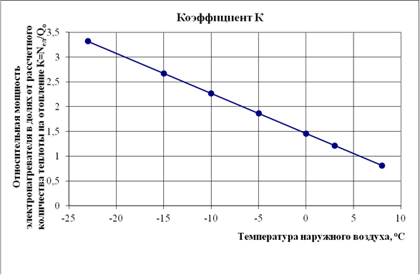

Fig. 3. Dependence of the required power of electric heaters of an electric storage heating system on the outside air temperature, up to which the system can operate in storage mode without additional heat supply at different values of the duration of the period of energy supply and accumulation.
1 – τ_{sub} = 7 hour (electric energy consumption at a reduced night tariff; 2 – τ_{sub} = 8 hour; 3 – τ_{sub} = 10 hour (electric energy consumption at an increased tariff); $n^{'}$ = 0, $n^{''}$= 1.0 ( During the night charging period, all buildings consume thermal energy for heating in full, depending on the outside temperature).

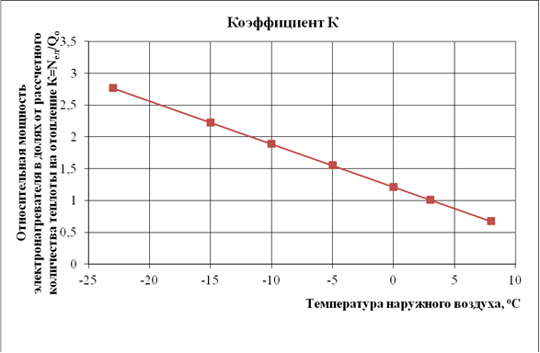
Fig. 4. Dependence of the required power of electric heaters of an electric storage heating system on the outside air temperature, up to which the system can operate in storage mode without additional heat supply at different values of the duration of the period of energy supply and accumulation.

1 – τ_{sub} = 7 hour (electricity consumption at a reduced night tariff; 2 – τ_{sub} = 8 hour; 3 – τ_{sub} = 10 hour (electricity consumption at an increased tariff); $n^{'}$= 0.5, $n^{''}$= 0, 5 (at night, 50% of buildings do not consume thermal energy for heating, and the remaining 50% consume energy in full, depending on the outside temperature

Another important parameter of the system is the volume of the water storage tank.
The capacity of such a tank must ensure the required temperature of the coolant throughout the entire period of its circulation in the system without replenishing energy during the period of increased tariff.
Let us denote by t_{x} the current values of the coolant temperature in the tank. And through n - the relative capacity of the tank, which we will express through the calculated value of the hourly water consumption in the heating system, $M_{o}^{'}$:
$n=\frac{M_{t}}{M_{o}^{'}},$ (4)
where $M_{o}^{'}$- the estimated flow rate of network water in the heating system, is determined in accordance with the relationship:
, t $M_{o}^{'}=\frac{Q_{o}}{∆t*c_{t}}*3,6 t$
where Q_{o} is the estimated heat consumption for heating buildings, kW;
Δt – calculated temperature difference in the heating system Δt = t₁ - t₂ (for example Δt = 90 – 70 = 20°C);
c_{t} – heat capacity of water S_{t} = 4.2 kJ/kg.°C.
Let us write the heat balance equation for the period of water withdrawal from the tank in the form:
(5)
$$c_{t}*M_{t}*t_{1}-c_{t}*M_{o}^{'}*t_{2}=c_{t}*M_{t}*t_{x}$$
From (5) we obtain the value of the current temperature of hot water during its consumption from the tank - t_{x}:
(6)

$$t_{x}=\frac{M_{t}*t_{1}-M_{o}^{'}*(t_{1}-t_{2})}{M_{t}}=\frac{k*M_{0}^{'}t_{1}-M_{0}^{'}(t_{1}-t_{2}) }{k*M_{0}^{'}}=\frac{t_{1}\left(n-1\right)+t_{2}}{n}$$
In accordance with calculations using dependence (6), after completion of the first cycle (circle) of coolant circulation, under the condition M_{t} = 10$M_{0}^{'}$, the water temperature in the tank will decrease from the initial 95°C to 93°C. If the volume of the tank is reduced to M_{t} = 5$M_{0}^{'}$, then the water temperature after the first round of circulation will be established at 91°C with a further continuous decrease in the temperature in the tank during subsequent circulation.
Thus, it is possible to construct a graph of the dependence of the required capacity of the accumulator tank on the outside air temperature, provided that the established heat supply schedule is ensured and optimal microclimate parameters are maintained in the premises when operating in the mode of continuous water withdrawal from the tank without replenishing energy from outside during the daytime period of the day at elevated temperatures. electricity tariff.
Figure 5 shows such a graph. It is built for a calculated temperature difference in the supply and return lines of the heating system Δt = 20°C and a calculated outside air temperature t_{od} = - 23°C.
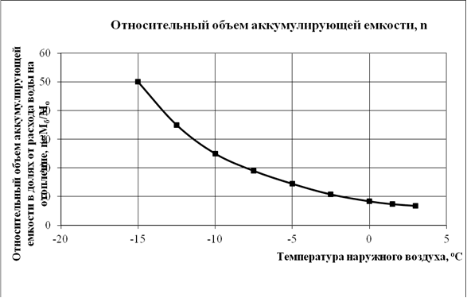
Fig. 5. Dependence of the relative capacity of the accumulator tank “n” of the electric storage system on the outside air temperature, to which it is possible to operate the heating system to ensure comfortable microclimate parameters without additional consumption of electrical energy in the heating system during the daytime hours at an increased tariff.
In accordance with this graph, for the operation of an accumulative heating system of a residential building with a calculated heat consumption for heating of 250 kW without replenishing energy up to an outside air temperature of -10°C, the required tank capacity must be at least V_{t} = 25*$V_{0}^{'}$ or 134 m³.
Placing a tank of this size within a building will require some structural work and significant costs. In addition, the question remains open about how to provide thermal energy to the heating system during the period when the outside air temperature decreases from -10°C to -23°C.
Experimental studies on the arrangement of a heating system with water storage tanks confirmed the obtained research results. However, it is noted that placing accumulation tanks of significant size in the premises of a building will require certain structural work and significant costs.

Conclusions
The paper presents a methodology for determining the main design parameters of an electric storage heating system with water storage tanks.
Dependencies were obtained to determine the required volume of storage tanks and the required power of electric heaters of the electric storage heating system depending on the outside air temperature.
The results of calculations based on the given methodology indicate the possibilities of using electric storage heating systems and give an idea of the limitations that occur when implementing such systems.
As a result of the studies performed, it was shown that the tank capacity and the power of the system’s electric heaters depend on the magnitude of the building’s heating needs. In this regard, one of the conditions for the successful implementation of electric storage heating systems is the thermal modernization of buildings to a level that meets modern requirements for thermal protection of buildings. Carrying out work on thermal modernization of heat supply facilities and reducing the need for heat for heating significantly increases the efficiency of electric storage systems.

References

1.Directive (EU) 2023/1791 of the European Parliament and of the Council of 13 September 2023 on energy efficiency and amending Regulation (EU) 2023/955 Official Journal of the European Union, 20.09. 2023.Д 231/1 https://eur-lex.europa.eu/legalcontent/EN/TXT/?uri=OJ%3AJOL_2023_231_R_0001&qid=1695186598766

2. Veeraboina P., Yesuratnam G. Significance of design for energy conservation in buildings: building envelope components. International Journal of Energy Technology and Policy, 2013, vol.9, no.1, pp. 34-52. doi: 10.1504/IJETP.2013.055814.
3. Arteconi A., Patteeuw D., Bruninx K., Delarue E., D’haeseleer W., Helsen L. Active demand response with electric heating systems: Impact of market penetration. Applied Energy, 2016, vol.177, pp. 636-648. doi: 10.1016/j.apenergy.2016.05.146.
4. Li J., Fang J., Zeng Q., Z Chen. Optimal operation of the integrated electrical and heating systems to accommodate the intermittent renewable sources. Applied Energy, 2016, vol.167, pp. 244-254. doi: 10.1016/j.apenergy.2015.10.054.7
5. Ziemele J., Gravelsins A., Blumberga A., Blumberga D. Sustainability of heat energy tariff in district heating system: Statistic and dynamic methodologies. Energy, 2017, vol.137, pp. 834-845. doi: 10.1016/j.energy.2017.04.130.
6. Patteeuw D., K Bruninx., Arteconi A., Delarue E., D’haeseleer W., Helsen L. Integrated modeling of active demand response with electric heating systems coupled to thermal energy storage systems. Applied Energy, 2015, vol.151, pp. 306- 319. doi: 10.1016/j.apenergy.2015.04.014.
7. Paraska G.B., Mykoljuk O.A. Efficiency of electrical heating systems usage. Power Engineering: economics, technique, ecology, 2015, no.4, pp. 73-79. (Ukr).
8. International Organization for Standardization (2013). Natural gas – Quality designation. ISO 13686:2013. Geneva: ISO. 48 p.
9. European Commission (2020). Сommunication from the Commission to the European Parlament, the Сouncil the European Economic and Social Committee, and the Committee of the Regions. A hydrogen strategy for a climate-neutral Europe. Brussels, 08.07.2020. СOM(2020) 301 final.
10. Лисиенко В.Г. Анализ тепловой работs электрических печей для обработки титановых и алюмиевых сплавов Известие вузов. Цветная металлургия.2009. №4 с. 63-68.

