UDK 658.264

V. P. Chichulin, Ph.D., Assoc. Prof.
Poltava National Technical Yuri Kondratyuk University
ORCID 0000-0003-1838-7269 e-mail: chichulinvp@gmail.com
K.V. Chichulina, Ph.D.
ORCID 0000-0001-7448-0180 e-mail: chichulinak@rambler.ru
Poltava National Technical Yuri Kondratyuk University

ENERGY SECURITY OF THE STATE: COMPARATIVE ANALYSIS AND IMPROVING THE REGULATORY FRAMEWORKS FOR ENERGY, RESOURCE EFFICIENCY OF BUILDINGS IN UKRAINE AND IN THE EU

The article was the analysis and compare existing regulatory frameworks for energy and resource efficiency of various buildings in Ukraine and in the EU. The main assignment of the present research is studying the current situation and trends towards improvement of the Ukrainian regulatory framework concerning energy saving in the construction engineering sector. With the aim of ensuring energy security of the state determined approaches to effectively addressing the problem of high energy consumption. Efficient solution of the high energy resources consumption problem in the field of industrial and civil engineering is only possible with an integrated approach. It is necessary both to control heat losses by means of walling and to reduce energy consumption for conditioning buildings, ventilation air transporting, etc. To successfully solve the problem of high energy resources consumption, it is necessary to improve the total costs of producing electricity, heat/cold, to minimize losses on their way from the energy manufacturer to the consumer. The article presents: energy classification houses by European standards, proved the need to develop the existing regulations energy efficiency in Ukraine; the experience of European countries for energy certification in order to introduce in Ukraine; the structure of the legislative framework of Ukraine in the sphere of energy efficiency of buildings; implementing European practices energy conservation in Ukraine; development of recommendations on adaptation of Ukraine standards to EU; the formation of proposals for deepening energy cooperation between Ukraine and the EU.
Keywords: energy security, regulatory framework, energy and resource efficiency, buildings, energy performance certificates.

В.П. Чичулін, к.т.н., доц.
К.В. Чичуліна, к.т.н.
Полтавський національний технічний університет імені Юрія Кондратюка

ЕНЕРГЕТИЧНА БЕЗПЕКА КРАЇНИ: ПОРІВНЯЛЬНИЙ АНАЛІЗ ТА УДОСКОНАЛЕННЯ НОРМАТИВНОЇ БАЗИ ЕНЕРГО-, РЕСУРСОЗБЕРЕЖЕННЯ БУДІВЕЛЬ В УКРАЇНІ ТА ЄС

У статті проведено аналіз і порівняння існуючої нормативної бази з енерго- та ресурсозбереження будівель різного призначення в Україні та в ЄС. Завданням цього дослідження є вивчення поточної ситуації та тенденції до удосконалення української нормативної бази, що стосується енергозбереження у будівельній галузі. З метою забезпечення енергетичної безпеки держави визначено підходи для ефективного вирішення проблеми високого споживання енергії. Ефективне вирішення проблеми високого споживання енергетичних ресурсів в сфері промислового і цивільного будівництва можливе лише при комплексному підході. Це необхідно для контролю втрат тепла за допомогою зведення стін і зменшення витрат енергії на кондиціювання будівлі, вентиляція транспортування повітря та інше. Щоб успішно вирішити проблему високого споживання енергетичних ресурсів, необхідно вдосконалювати загальну вартість отримання електроенергії, тепла/холоду, щоб мінімізувати втрати на шляху від виробника електроенергії до споживача. У статті представлені: енергетична класифікація будинків за європейськими стандартами, доведено необхідність розвитку існуючих правил енергоефективності в Україні; досвід європейських країн з енергетичної сертифікації для подальшого впровадження в Україні; структура законодавчої бази України у сфері енергетичної ефективності будівель; впровадження Європейського досвіду енергозбереження в Україні; розробка рекомендацій з адаптації стандартів України до ЄС; формування пропозицій щодо поглиблення співробітництва у сфері енергетики між Україною та ЄС.
Ключові слова: енергетична безпека, нормативна база, енерго- та ресурсозбереження, будівель, енергетичний паспорт.

Problem setting. Year by, the energy security of the state and the energy saving problem in the construction engineering sector acquires more and more topicality. Construction objects possess their own specific weight in the total national structure of energy consumption. About 40% of the total energy consumption in Ukraine is accounted for heating residential and public buildings.
As of today, considerable part of Ukraine’s housing stock does not satisfy the requirements to life-supporting qualities of buildings. It concerns, primarily, residential areas developed in 60-70-s of XX century, which are subject to the total redevelopment. Nowadays, most residential houses belonging to the first mass-scale series are in the state of disrepair and the amount of heat lost through their windows, walls and roof space is thrice the amount lost in modern buildings. The following defects and construction draw-backs are peculiar with the old housing stock (Figure 1): waterproofing failure, insufficient durability of building materials, used to seal joints between the wall panels. Many years service of the buildings caused the engineering networks’ wear, balconies weakening, huge losses of heat, but for all that, they haven’t depleted their resources yet. To solve this problem, the total redevelopment of the obsolete housing quarters (areas) and primarily their heating should be performed. The task of the construction engineering and the public utilities sectors is significant reduction of heat supply expenditures. Therefore, the development of the new regulatory framework based on existing European standards and regulations on energy and resource efficiency is a very pressing issue today
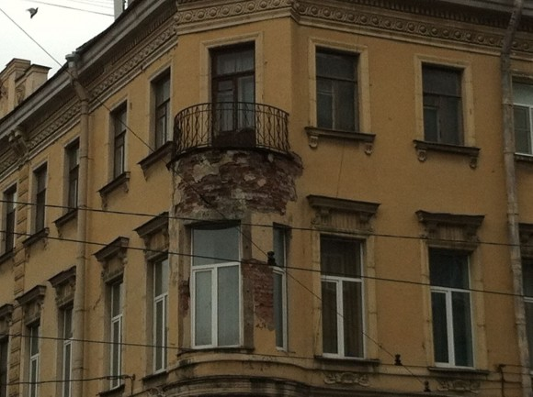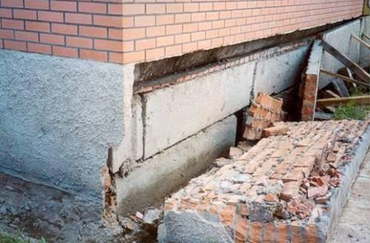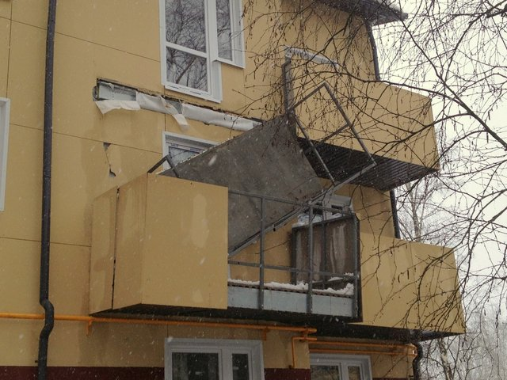
Figure 1. Inherent defects of old housing
Latest sources of studies and publications review. Issue analysis of the regulatory framework in Ukraine and the EU articles, as well as scientific works the following Ukrainian and foreign authors: A.V. Voronin [1], Berbel Shwaiger [2], G.G. Farenyuk [3], T.V. Serdyuk [4], Kitskay L.І. [5] and other.
Allocation of unsolved aspects of the problem. In the sources [1-2] presented questions about the Experience of EU countries in the field of technical regulation for thermal protection of buildings and structures, considered European Directive on energy efficiency in buildings and energy certificate.
The paper [3] presents the results of analytical studies on the relevance of energy saving in the construction industry of the country. The following main reasons that led to excessive energy losses in the housing stock of the country, are the statistics relating to trends in the decrease in imports of natural gas and the structure of energy consumption to housing complex of Ukraine. Present energy classification of buildings according to European standards [3, 4] and comparative growth dynamics of thermal resistance of the walls of houses in Ukraine and of Denmark. Confirmed the efficiency of regulations self-construction companies. But existing European experience of energy conservation requires further generalization and comparison with the Ukrainian realities with the aim of further implementation.
The article purposes. To analyze and compare existing regulatory frameworks for energy and resource efficiency of various buildings in Ukraine and in the EU. The main assignment of the present research is studying the current situation and trends towards improvement of the Ukrainian regulatory framework concerning energy saving in the construction engineering sector. To identify approaches for effectively addressing the problem of high energy consumption. One of the main purposes of article is the dissemination of European experience in Ukraine
Basic material and results. Since January, 1, 2008, the outer walls’ heat transfer resistance for the first and the “coldest” zone has been raised up to 2.8 м²·RU/W, thus, heat insulation indices increase has made nearly 2.5 times if compared to that in 1993. In 2003, amendments were introduced into Construction Norma and Regulations DBN B.2.6-31:2006 “Heat Insulation of Buildings”, stipulating significant increase of regulatory requirements to the walling structures’ thermal (air-to-air) resistance in Ukraine. They were approximated to the mean European indices (class D). Instead of 4 climatic zones only 2 zones were suggested; for the first climatic zone, walling thermal resistance increase was set up to 3.3 м²·RU/W, and for the second one – up to 2.8 м²·RU/W. The second climatic zone includes Odessa, Mykolayiv, Kherson, Zaporizhzhya regions, all the rest of regions are included into the first climatic zone. Table 1 presents the generalized European classification of buildings in terms of energy consumption for buildings maintenance.

Table 1
Generalized European classification of buildings in terms of energy consumption for buildings maintenance [1]
Energy consumption class | Energy consumption assessment | Е indice (kWh/m² per year)
А+ | Passive | Up to 15
А | Low-energy | from 15 to 45
В | Energy saving | from 45 to 80
С | Medium energy saving | from 80 to 100
D | Medium energy intensive | from 100 to 150
Е | Energy intensive | from 150 to 250
F | Highly energy intensive | over 250

E-indice presented in Table 1 indicates energy consumption in kWh consumed per 1 m² of the premises’ floor space per year.
Even taking into account the latest regular growth of thermal resistance indices in Ukraine, the comparison testifies to the relatively low regulatory requirements to the above indice in this country and its significant and permanent growth delay (several decades).
Energy saving policy in Europe is being implemented into practice in accordance with Directive 2002/91/EU “Energy Performance of Building Directive” (EPBD) adopted by the European Parliament and the EU Council in 2002, where energy saving requirements for premises are significantly tightened.
Energy performance is characterized by the amount of energy consumed during the heating season and the cooling period. EPBD Directive establishes the general frame of the buildings energy performance calculation methodology, applicability of the minimal requirements to the energy performance for new buildings and those subject to reconstruction, energy certification of buildings (energy passportization), regular НVАС-systems inspection. Directive is also raising the problem of substantial increase of sustainable energy sources’ (SES) share in the total energy consumption. Meanwhile, EPBD Directive together with the subsequent regulatory documents upon it mandatorily and definitely suggest achievement of all the above goals without the premises microclimate indices deterioration and, in a number of cases, put forward the hightened requirements to microclimate.
The most important item at the building energy performance calculation is taking into account each and every factor, able to affect the final results, namely building’s thermotechnical characteristics, heating appliances, indoor microclimate characteristics, as well as the regional climate pattern and the building orientation with respect to the cardinal directions.
EPBD Standards take into account the correlation of the three main Directive provisions and consider them in block: requirements to the building energy performances and their calculations, energy performance certificates (energy passportization) and regular inspections (Table 2).
Thus, based on the analysis performed, we can make the conclusion that Directive (EPBD) stipulates general solutions taken by the EU-membering countries and including: the unified methodology for building energy performance calculation in terms of energy consumption; minimal energy utilization patterns for all new and reconstructed old big buildings; the buildings certification system regulating the amount of energy consumed and the building’s energy performance, respectively [1].
From now on, in the US countries, there should be an Energy Performance Certificate (energy performance passport) for each new building or for a previously erected building in case of an owner (or a tenant) change.
According to EN 15217 and EN 15603 Standards each certificate must now contain detailed information on the building’s energy performance: indices of primary energy resurces consumption, СO2 emission level, indices set by the national standards and recommendations on raising energy performance of the building (Figure 2, a).
Considering the certificate, drawn up on the basis of the energy consumption data in accordance with the German Energy Saving Standard EnEV 2009 (Energieeinsparverordnung in Deutschland), it was detected that it had been drawn based on the energy consumption measured (for the latest 3 years); data on the energy consumed are usually presented by the building’s owner as a report on the premises heating expenditures, energy suppliers’ bills or the energy consumption measurement data; energy consumption depends upon each inhabitant’s behaviour; it is a very simple and a cheap method; energy consumption data are defined by means of accounting the calculated energy consumption for a few years’ period based on the mean indices without reference to weather temperature oscillations (Figure 2, b).
Table 2
Key EPBD standards
The standard’s name
EN 15217. Energy performance of buildings. Methods for expressing energy performance and for energy certification of buildings (CEN/TC 89)
EN 15603. Energy performance of buildings. Overall energy use and definition of energy ratings (CEN/TC 371)
EN ISO 13790. Energy performance of buildings. Calculation of energy use for space heating and cooling (CEN/TC 89)
EN 13779. Ventilation for non residential buildings. Performance requirements for ventilation and room-conditioning systems
EN 15316. Heating systems in buildings. Method for calculation of system energy requirements and system efficiencies (CEN/TC 228)
EN 15243. Ventilation for buildings. Calculation of room temperatures and of load and energy for buildings with room conditioning systems (CEN/TC 156)
EN 15378. Heating systems in buildings. Inspection of boilers and heating systems (CEN/TC 228)
EN 15240. Ventilation for buildings. Energy performance of buildings. Guidelines for inspection of air-conditioning systems (CEN/TC 156)
EN 15241 Ventilation for buildings. Calculation methods for energy losses due to ventilation and infiltration in commercial buildings CEN/TC 156)
EN 15239. Ventilation for buildings. Energy performance of buildings. Guidelines for inspection of ventilation systems (CEN/TC 156)
EN 15251. Indoor environmental input parameters for design and assessment of energy performance of buildings addressing indoor air quality, thermal environment, lighting and acoustics (CEN/TC 156)
a) b)
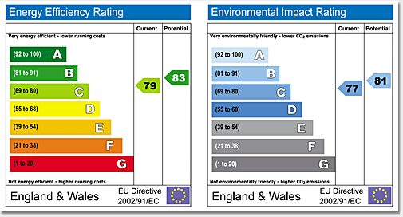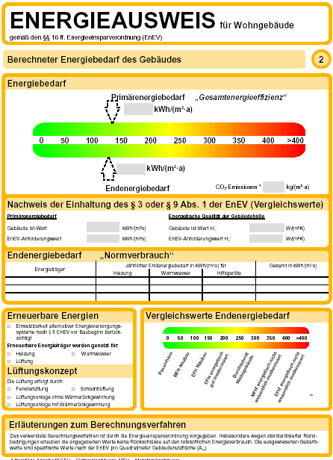
Figure 2. Energy performance certificates examples [2]
Due to the significant influence of climate systems on buildings’ energy consumption (Figure 3.), CEN has developed Methodology for checking heating systems (EN 15378), ventilation (EN 15239) and air conditioning (EN 15240). These documents are having similar structures and are starting with definitions and terms and the list of equipment to be checked. Considerable part in the documents is further occupied with detailed methodologies of checking the equipment aimed at monitoring it a energy performance and the air quality in the premises (IAQ – Indoor Air Quality), as well as reference annexes, quoted in the methodologies.
EPBD Directive has been regularly reconsidered. Thus, in November, 2008, amendments to EPBD Directive, considerably tightening the energy performance regulations, were adopted. Whereas the primary version of the Directive stated that “energy performance of buildings should be evidently expressed”, the 2008-11-13 version specifies: ”energy performance of buildings should be strongly pronounced and should contain numeric indices of СО2 emission and primary energy resources consumption”. Methodology of buildings’ energy performance accounting should take into consideration European standards.
The participating countries have set up ambitious goals in terms of obtaining low energy consumption. Thus, Denmark is planning to reduce it by 70% compared to the old buildings; Norway, Netherlands and Germany are going to build passive houses (heated at the expense of the internal resources) (Figure 4), Great Britain and Hungary are designing buildings without CO2 emission into the atmosphere while in operation, and France is planning to build houses not consuming but producing energy. The present-day structure of the total energy consumption in Europe is presented in Figure 5.
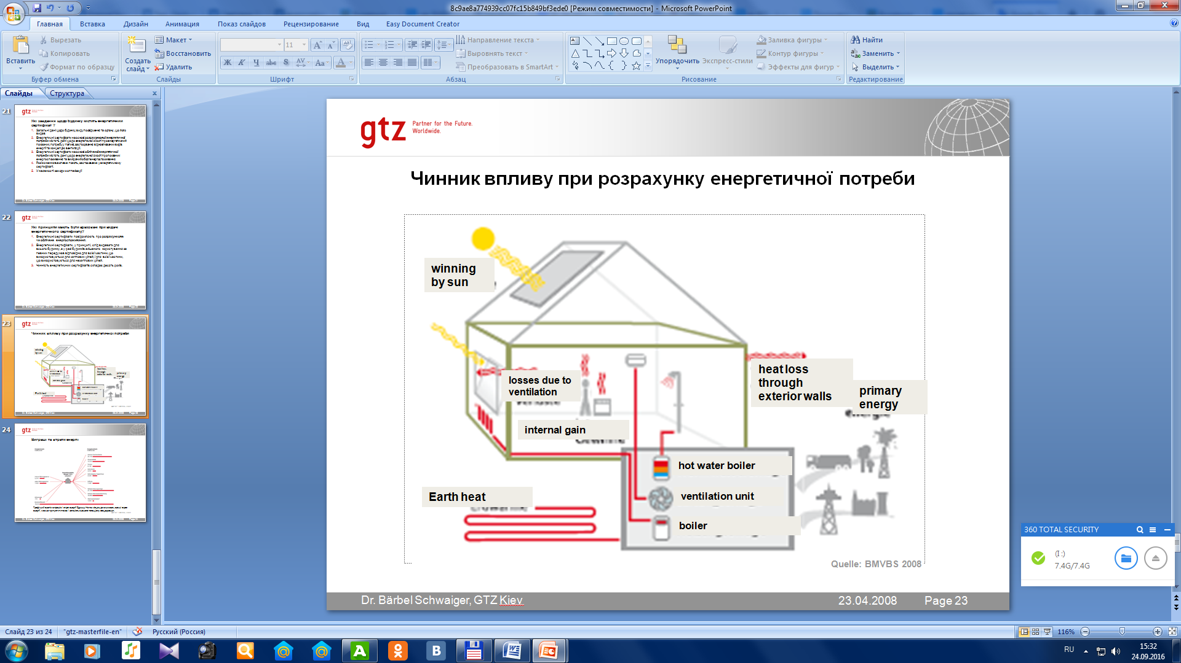
Figure 3. Factors influencing the energy demand accounting
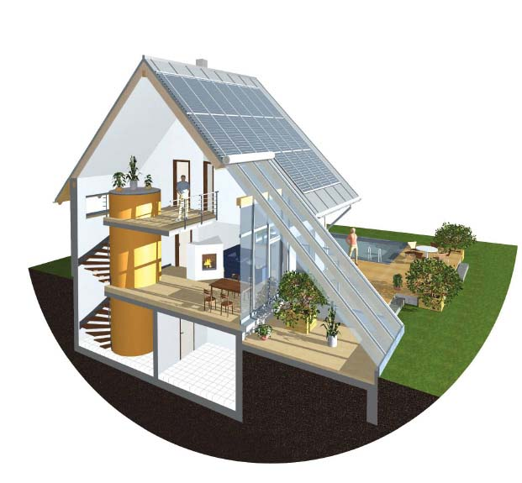
Figure 4. Examples of passive houses in Europe
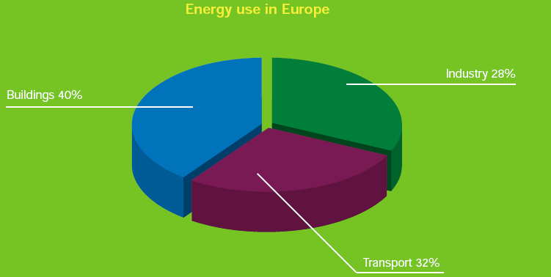
Figure 5. The total energy consumption structure in Europe [2]

In April, 2009, the European Parliament approved the new EPBD Directive’s version where one of the most significant amendments was the zero energy consumption policy (zero energy) conserning all buildings erected after 31, December, 2018. It means that their annual energy consumption must not overdraw the energy amount produced by sustainable energy sources “in-house” (solar batteries, wind power generators, heat pumps). Every membering EU country should set up its goals independently within the Program of raising energy performance and implement the relevant legal regulations to achieve these goals.
As of today, in practically every EU country, standard regulations are adopted, considering all aspects of raising the buildings’ energy performance. However, additionally, the EU members must reconsider and renew building construction regulations every few years.
The country with the strictest regulations is Germany. There, to perform the task of raising the buildings’ energy performance, an extensional documentation packet of new laws and directives has been developed, containing strict requirements to both walling structures (building and physical performance) and to the equipment installed (heating, sanitary, ventilation, cooling, climate-control, lighting) and its unit efficiency (energy performance). The basic German document is the Energy Saving Directive (Energieeinsparverordnung – EnEV), as well as the Law on using sustainable energy sources for heat supply purposes (Erneuerbare-Energien-Warmegesetz – EEWarme). In 2009, EnEV was reconsidered towards more strictness.
In the context of raising the HVAC-systems’ energy performance, it’s worth mentioning the equipment certifying implementation according to the three main parameters: airflow rate in the equipment at a certain mode of operation (heating, cooling, moisturizing, dehumidification); the ventilator’s SFP (specific fan power) and the heat recuperation system’s efficiency. Based on the certification results, the energy performance class marking is assigned, the additional class A+ being introduced besides classes A and B (classes C and D are not even mentioned in Germany). Germany was one of the first countries to implement the energy performance passport where the owner’s energy expenditures are clearly seen. At present, the above document is very significant for taking the decision of buying or renting a house.
The most important building characteristics fixed in the energy performance passport include HVAC-systems indications. Based on the results of the routine inspection, the owner (or the tenant) is given a report obligatorily containing the suggestions on raising the building’s energy performance, including HVAC-equipment.
The equipment’s cleanliness is important for air processing as it is fixed in the national standards and standard regulations of many countries (here are just some of them):
- ASHRAE Indoor Air Quality Standard 62R;
- EN 1886 Ventilation for buildings. Air handling units. Mechanical performance;
- EN 13053 Ventilation for buildings. Air handling units. Ratings and performance for units, components and sections;
- VDI 3803 Air-conditioning systems Structural and technical principles;
- VDI 6022 Hygienic standards for ventilation and air-conditioning systems;
- DIN 1946 Ventilation and air conditioning.
Separately considering the approaches fixed in EnEV (Energieeinsparverordnung in Deutschland), let us shape the diagram of the basic norms relevant for EnEV (Fig. 6).
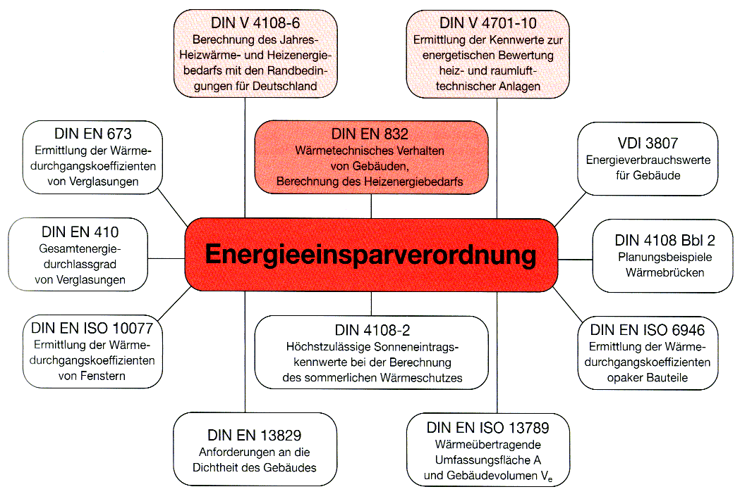
Figure 6. Norms relevant for EnEV [2]

In the framework of the energy security of Ukraine, to comply with the decisions of the Government, Ministry of Regional Development and Construction (Minregionbud) of Ukraine has started developing the new version of the sectoral program on energy saving in building construction aimed to solve the problem of raising the energy consumption efficiency and reducing the energy resources consumed by the housing stock, namely natural gas; expanding the amount of electric energy consumption for heating residential and public buildings and structures, expanding the amount and the application sphere of non-traditional and sustainable energy sources, using innovative engineering, technological and organizational solutions. Let’s consider the legislative framework of Ukraine in the field of buildings’ energy performance (Figure 7). The Ministry has adopted a number of orders and decisions on organizational and engineering issues of implementing measures to raise the newly constructed buildings’ energy performance and that of the old housing stock. In 2008, the Ministry developed a packet of regulatory-methodological documentation to implement since 2009 the regulatory energy certification and energy auditing, which legal framework is determined by the draft Law of Ukraine “On the Energy Performance of Buildings”.
Further, let’s consider the draft Law of Ukraine on the energy performance of residential and public buildings (register No. 9683, 12.01.2012) aimed at determining legal, economic and organizational framework for providing energy performance of residential and public buildings and at setting the stage for reducing the energy resources consumption in them. Article 9 defines the principal concept of the buildings’ energy performance: it is ability of the building, its structural elements and its engineering equipment to provide, during the expected life cycle of this building, household requirements of people and the best climatic environment for their staying (living) in this building’s premises with permissible (optimal) energy resources consumption for heating, lighting, ventilation, air conditioning and water heating with account of the local climate conditions. Energy performance of buildings is calculated in accordance with the methodology approved by the joint resolution of the authorized public management bodies.

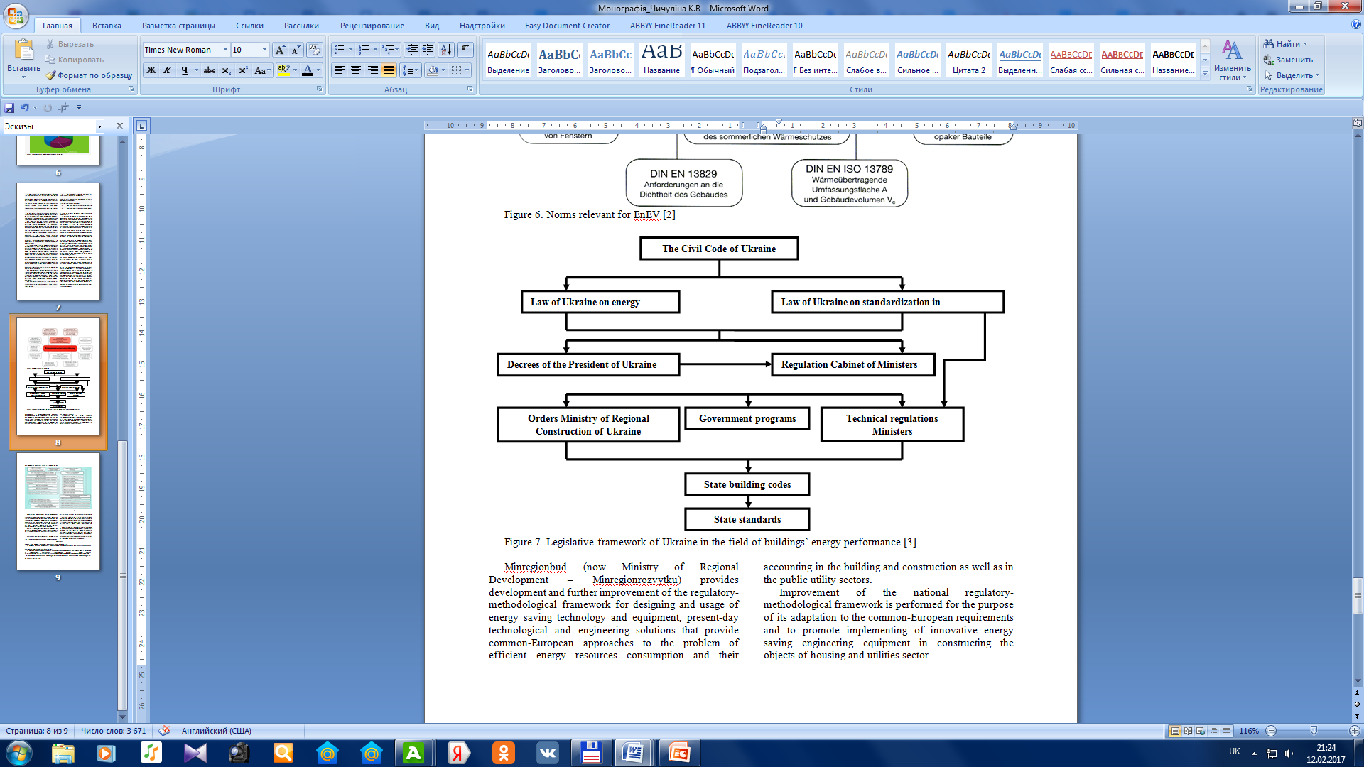
Figure 7. Legislative framework of Ukraine in the field of buildings’ energy performance [3]

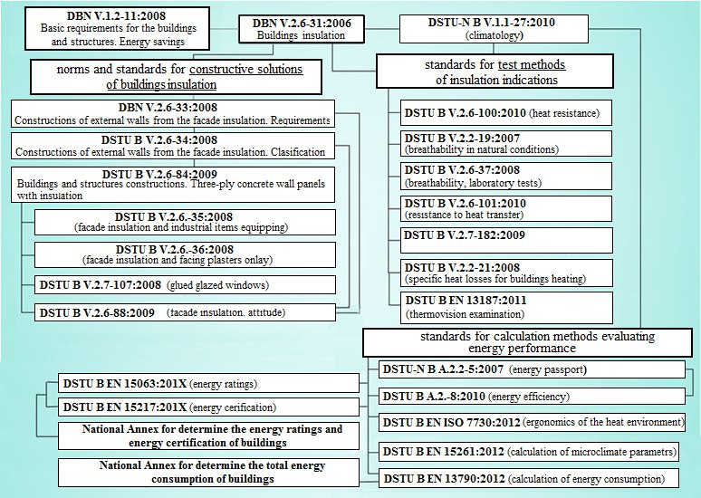
Figure 8. Present regulations and standards system in the field of buildings’ energy performance
Minregionbud (now Ministry of Regional Development – Minregionrozvytku) provides development and further improvement of the regulatory-methodological framework for designing and usage of energy saving technology and equipment, present-day technological and engineering solutions that provide common-European approaches to the problem of efficient energy resources consumption and their accounting in the building and construction as well as in the public utility sectors.
Improvement of the national regulatory-methodological framework is performed for the purpose of its adaptation to the common-European requirements and to promote implementing of innovative energy saving engineering equipment in constructing the objects of housing and utilities sector. Figure 8 shows data on the main regulatory and methodological documents aimed at introduction of energy saving solutions in the field of construction.
Conclusions and prospects for the development direction. It is quite evident that the next stage of the regulatory framework improvement in terms of energy saving in building construction should be a new wave of regulatory-methodological documentation development concerning the mainstream usage of alternative sustainable energy sources (sunlight, wind, geothermal hot water reservoirs, biomass, etc.) and efficient consumption of the traditional energy resources.
Taking into consideration the current problems of Ukrainian economy’s power supply, those are namely building construction and public utilities sectors that must provide significant reduction of energy consumption. Present-day regulatory framework is performing the function of top importance and it should be expanded in the field of developing regulatory documentation on designing and usage of sustainable energy sources for heating buildings and structures.
Efficient solution of the high energy resources consumption problem in the field of industrial and civil engineering is only possible with an integrated approach. It is necessary both to control heat losses by means of walling and to reduce energy consumption for conditioning buildings, ventilation air transporting, etc.
To ensure energy security of the state and successfully solve the problem of high energy resources consumption, it is necessary to improve the total costs of producing electricity, heat/cold, to minimize losses on their way from the energy manufacturer to the consumer. Developments and improvement of the regulatory framework are insufficient. Strict regulation of energy auditing in terms of these norms performance is also topical.

References

1. Воронін А.В. Досвід країн Євросоюзу в галузі технічного нормування теплового захисту будівель і споруд / А.В. Воронін // Технології будівництва. – 2007. – № 4. – С. 75.
Voronin A.V. (2007), "The experience of EU countries in the field of technical regulation thermal protection of buildings and strtructures", Tehnologii budivnistva, No. 4, P. 75.
2. Бербель Швайгер (2015), Європейські директиви щодо енергоефективності у будівлях та енергетичний сертифікат. [Електронний ресурс]. - Режим доступу до даних: http://svitppt.com.ua/nauka/evropeyski-direktivi-schodo-energoefektivnosti-u-budivlyah-ta-energeti.html
Berbel Shwaiger (2015), "European Directive on energy efficiency in buildings and energy certificate", available at: http://svitppt.com.ua/nauka/evropeyski-direktivi-schodo-energoefektivnosti-u-budivlyah-ta-energeti.html
3. Фаренюк Г.Г. (2013), Вплив нормативної бази на енерго- та ресурсозбереження будівельних об'єктів житлового та громадського призначення. [Електронний ресурс]. - Режим доступа http://teplydim.com.ua/static/storage/filesfiles/Farenuk_Impact_of_laws_on_EE_resource_conserv_2013_Ukr.pdf
Farenyuk G.G (2013), "Impact of regulatory framework on energy - saving construction of residential and public buildings", available at: http://teplydim.com.ua/static/storage/filesfiles/Farenuk_Impact_of_laws_on_EE_resource_conserv_2013_Ukr.pdf
4. Сердюк Т.В. Вдосконалення нормативної бази енергозбереження у будівельному комплексі України / Т.В. Сердюк // Сучасні технології, матеріали і конструкції в будівництві. - 2014. – Том 16, № 1 . – С.162 – 168.
Serdyuk T.V. (2014), "Improving the regulatory framework of energy saving in the construction industry Ukraine", Suchasnі tehnologії, materіali i konstruktsії u budіvnitstvі", Vol. 16, No. 1, pp. 162 – 168.
5. Кицкай Л.І. Енергоефективність в Україні: аналіз, проблеми та шляхи підвищення / Л.І. Кицкай // Інноваційна економіка. – 2013. – Том 41, № 3 . – С.32 – 37.
Kitskay L.І. ( 2013), "Energy Efficiency in Ukraine: analysis, issues and ways to improve", Vol. 41, No. 3, pp. 32 – 37.

