Збірник наукових праць. Галузеве машинобудування, будівництво
Academic journal. Industrial Machine Building, Civil Engineering
http://journals.nupp.edu.ua/znp
https://doi.org/10.26906/znp.2022.59.ХХХХ

UDC 624.016:624.042.65

Experimental studies of prestressed steel-concrete wall girders

Semko Oleksandr ¹, Hasenko Anton²*, Drobotia Oleksandr ³, Marchenko Dmytro⁴

¹ National University «Yuri Kondratyuk Poltava Polytechnic» https://orcid.org/0000-0002-2455-752X
² National University «Yuri Kondratyuk Poltava Polytechnic» https://orcid.org/0000-0003-1045-8077
³ National University «Yuri Kondratyuk Poltava Polytechnic» https://orcid.org/0000-0002-0288-081X
⁴ National University «Yuri Kondratyuk Poltava Polytechnic» https://orcid.org/0000-0001-5773-4484
*Corresponding author E-mail: gasentk@gmail.com

To reduce the cost of steel for the installation of load-bearing elements of the wall enclosure made of sandwich panels, it is suggested to use prestressed steel-concrete girders with reduced stiffness of the steel part of the cross-section in one plane instead of girders from the pipe. Thus, the span cross-section will be a U-shaped steel profile filled with concrete. Experimental tests were carried out on eight samples of 3000 mm long girders made of bent channel № 10, size 100x50 mm, with a wall thickness of 3 mm, filled with C20/25 class concrete. The prestressing of the cross-section steel part was carried out by pre-bending the cross-section steel part with jacks and fixing it in this position by filling the inner cavity with concrete. As a result of the implementation of these measures during experimental studies, an increase in bearing capacity up to 31% and stiffness up to 57% was confirmed in the case of preliminary bending of the channel and filling with concrete 1.6 times higher than the height of its shelves. The use of such beams makes it possible to reduce steel consumption by 39%.

Keywords: prestressing, steel-concrete, wall girder, experimental studies.

Експериментальні дослідження попередньо напружених сталебетонних стінових прогонів

Семко О.В.¹, Гасенко А.В.²*, Дроботя О.В.³, Марченко Д.П.⁴

^{1, 2, 3, 4} Національний університет «Полтавська політехніка імені Юрія Кондратюка»
*Адреса для листування E-mail: gasentk@gmail.com

Стінові прогони являються горизонтальними конструктивними балковими елементами стінового огородження будівлі. Під час використання легких сендвіч-панелей у якості стінового огородження, несучі стінові прогони виконують сталевими. З метою зменшення витрат сталі для влаштування таких прогонів, авторами пропонується використовувати сталебетонні прогони, попередньо напружені у площині зменшеної жорсткості сталевої частини перерізу. Сталебетонні прогони пропонується виготовляти із гнутих швелерів із заповненням коритоподібного сталевого профілю бетоном. Сумісну роботу двох матеріалів слід забезпечувати встановленням системи анкерних стержнів. Суть попереднього напруження полягає в наступному. Спочатку сталевий коритоподібний профіль вигинається домкратом проти експлуатаційного прогину і в такому положенні заповнюється бетоном. Після набору бетоном проектної міцності, домкрат витягується. Утворений таким чином сталебетонний прогін за рахунок сумісної роботи сталі та бетону залишається вигнутим проти експлуатаційного прогину. Під час експлуатаційного навантаження на прогони, спочатку необхідно вибрати їх попередній вигин, повернувши прогони в початковий прямолінійний стан, а лише потім буде виникати прогин від прямолінійної початкової осі балки. Саме цим пояснюється підвищення міцності та жорсткості досліджуваних попередньо напружених сталебетонних прогонів. Для підтвердження наведених викладок було проведено експериментальні випробування восьми зразків прогонів довжиною 3000 мм, виконаних із гнутого швелеру №10 розміром 100×50 мм з товщиною стінки 3 мм, заповнених бетоном класу С20/25. Між собою зразки відрізнялися наявністю попереднього напруження сталевої частини перерізу, розміром перерізу бетонного осердя та схемою навантаження. У результаті проведених експериментальних досліджень підтверджено підвищення несучої здатності та жорсткості сталебетонних балок, що складає: 1) у випадку заповнення бетоном внутрішньої порожнини швелера 19% і 27% відповідно; 2) у випадку попереднього вигину сталевої частини перерізу 24% і 29% відповідно; 3) у випадку збільшення в 1,6 рази висоти перерізу бетонного осердя попередньо напруженого зразка 31% і 57% відповідно.

Ключові слова: попереднє напруження, сталебетон, стіновий прогін, експериментальні дослідження.

Introduction
Wall girders are horizontal structural beam elements of the building wall enclosure. The external load on the wall girders is the vertical load from the wall enclosure weight and the horizontal wind load. Thus, wall girders work for bending in two planes. The load from the weight of the wall enclosure, made of light sandwich panels, is approximately equal to the wind impact load on Ukrainian territory. Therefore, in this case, the wall girders are designed with equal strength in two planes.
A light, modern wall enclosure is made of hinged sandwich panels, consisting of two sheets of profiled wall flooring and effective rigid mineral wool insulation between them. Steel girders with a cross-section in the form of a pipe usually serve as the load-bearing elements of such a wall enclosure [1].

Review of the research sources and publications
Different methods of rational forces adjustment in steel structures are known, which are implemented both at the design stage and at the stage of manufacture and installation. The essence of these methods is described in detail in the work of M.V. Gogol [2].
One of the active methods of increasing the steel structures bearing capacity is the method of their preliminary deformation. For the most part, this method regulates the stress in individual rod elements. Preliminary elements deformation is arranged opposite to operational bending. This method consists in the fact that a prestressed deformed rod is formed using several elements connected into one in a pre-bent state (see fig. 1). Welding of curved elements requires significant additional costs of labor and energy, which is a disadvantage of this method [3].

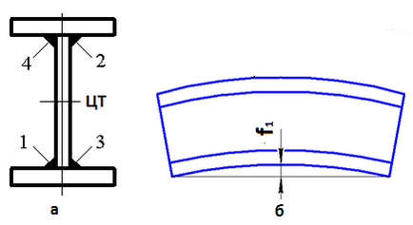
Figure 1 – Scheme of preliminary stresses
creation by the rod layers deformation
followed by their welding [3]:
1, 2, 3, 4 – the order of welding seams

Another method of prestressing is the arrangement of local bonded tendons on the beam structures' steel parts in the zone of the maximum bending moment action. Izbash M.Yu. [4] proved the effectiveness of bonded tendons installing both on the lower girdle of the beams with a single-span scheme of their operation, and on the upper girdle above the supports with a non-split scheme (see fig. 2). A positive feature of such a constructive solution of prestressing is that, due to the small value of the angle α, the pulling force F_{sp} is almost an order of magnitude less than the reinforcement tension force Н_{sp} created by it [5].

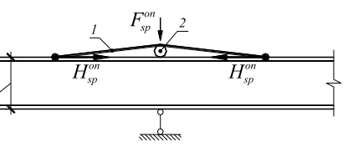
Figure 2 – Installation of tension rod
for prestressing locally on intermediate
supports of continuous steel beam [5]:
1 – tension rod; 2 – fixing cylinder

Preliminary stresses in the elements of bent continuous and spatial steel-reinforced concrete structures can be created both due to a well-chosen design, including nodes, and the development of manufacturing technology or preliminary reinforcing assembly during installation [6; 7], as well as by placing additional prestressed reinforcing bars (bonded tendons) in the stretched cross-sectional area [8; 9].
Scientific studies of reinforced concrete beams
prestressing by placing additional prestressed reinforcing bars were conducted under the leadership of L. Storozhenko. In [10] V. Pents with Yu. Kushnir conducted a study of I-beams with side cavities filled with concrete with installed external or internal prestressed bonded tendons (see fig. 3).

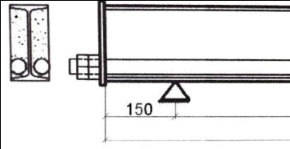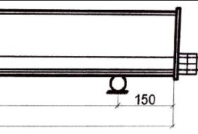
Figure 3 – Scheme of additional prestressed internal reinforcement of steel-concrete beams [10]

Similar types of beams were also studied by foreign researchers. In particular, C. Wang, Y. Shen, R. Yang, and Z. Wen (China) [11] conducted a study of prestressed steel-reinforced concrete beams shown in Figure 4. Prestressed steel-reinforced concrete beams have an inverted arch deflection before loading, which is advantageous for service loading. Compared to a conventional steel-reinforced concrete beam, the prestressed one has greater rigidity, which increases the resistance to cracking in tension concrete, but at the same time reduces the overall plasticity of the beam.
A positive result of prestressing by installing additional stressed reinforcing rods is an increase in the bearing capacity and rigidity of steel-reinforced concrete structures. At the same time, the general disadvantage of this method is the additional cost of materials and the installation of additional stressed rods.

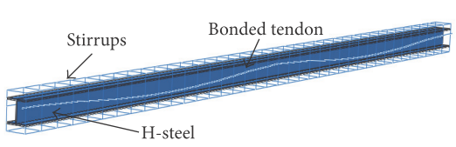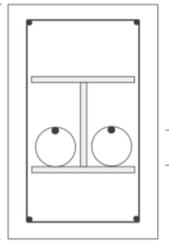
Figure 4 – Prestressed steel-reinforced
concrete beams [11]

A separate type of steel-reinforced concrete structure self-tension is a special technology for their manufacture, the result of which is a change in the calculation scheme of their operation [12]. In particular, Figure 5 shows prefabricated monolithic steel-reinforced concrete crossbars stressed due to the staged production (concreting). This idea is patented by D. Bibik, V. Semko. and O. Voskbiynyk [13]. The production of prefabricated monolithic crossbars is carried out in several stages - the prefabricated part of the structure is manufactured at the factory, and the monolithic part is in the process of installation. Thus, the calculation scheme of the crossbar operation changes at the stages of its installation. In the first stage, the crossbar is a single-span beam freely supported on two supports. At this stage, the crossbar cross-section is a trough-shaped steel profile filled with concrete. At the second stage of production, prefabricated ribbed reinforced concrete floor slabs are mounted on the lower steel shelf of a trough-like profile, and the crossbar is welded to the embedded parts of the columns. At the same time, the crossbar calculation scheme is changed to a rigidly clamped one-span one. Then, a concrete monolithic upper shelf is arranged, which combines the crossbar with the floor slabs installed on it for joint work on the operational load.

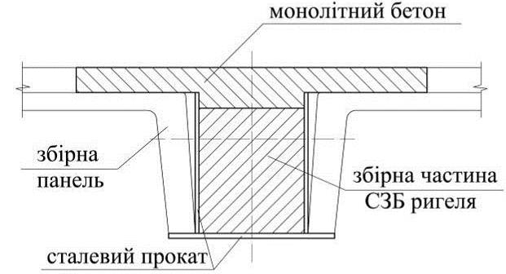
monolithic concrete
prefabricated part of a crossbar
rolled steel
prefabricated panel
Figure 5 – Cross-sectional with showing
concreting stages [13]

Experimental studies of steel-reinforced concrete prefabricated monolithic crossbars confirmed the theoretical prerequisites regarding the effect of changing the cross-section during manufacture on the development of deflections and internal forces [14].

Definition of unsolved aspects of the problem
Thus, an effective method of prestressing the steel part of steel-reinforced concrete structures is their preliminary deformation by bends that are opposite to operational ones. Such bends are arranged either with jacks [3] or by arranging additional pre-stressed rods [4-5; 9-11]. At the same time, the steel part pre-bent state is fixed either by welding its component parts during manufacture [3], or by changing the conditions for fixing this steel beam part with columns [12-14], or by actually arranging stressed additional rods [4-5; 9-11]. Concreting of the steel part of steel-reinforced concrete structures cross-section in order to fix its pre-bent state was not considered.

Problem statement
The purpose of the work is to study experimentally the possibility of fixing the pre-bent state by filling with concrete the inner cavity of the steel U-shaped section of the steel-concrete rod, which can be used as a wall girder. The subject of the study is the stress-strain state and bearing capacity of a reinforced concrete rod prestressed in this way.

Basic material and results
General principles of creating rational preliminary stresses in the layers of reinforced concrete girders. The essence of the proposed measures set for the rational efforts redistribution is as follows. At the first stage of prestressed reinforced concrete girders production, mechanical jacks are used to create the initial bending of the beams' steel part, which is opposite to the operational one (see fig. 6). That is, at this stage, the deformations of the steel beam normal section are created opposite to the operational ones: the beam lower fibers will be compressed, and the upper fibers will be stretched (see fig. 7, a). At the second stage of production, the inner cavity of the rod U-shaped steel part is filled with concrete. During concreting and during the period when the concrete reaches the design strength, the jacks remain under the steel beams. That is, the stress-strain state of the steel beams does not change compared to the first stage, and the deformations of the normal section in the concrete are zero (see fig. 7, b). To ensure further compatible operation of the cross-section steel and concrete parts, anchoring means are welded to the inner side of the cross-section steel part in advance. For the useful load (third stage), the combined steel-concrete section will work together. In the concrete part, the deformations will develop from the undeformed (zero) state, while in the steel part, the deformations of the normal section will be superimposed on the already existing operational deformations obtained at the first stage of the combined structure (see Fig. 7, c). That is, during the operating load increase, the beam steel part first returns to its original undeformed state and only then it will deform according to the generally accepted scheme: the beam's lower fibers will stretch, and the upper fibers will compress. This explains the increase in the load-bearing capacity of reinforced concrete structures prestressed in this way. It should be noted that by selecting the beams’ steel part pre-bending optimal parameters and the rational ratio of the steel and concrete parts’ stiffness, it is possible to achieve a significant increase not only in the steel-concrete rod stiffness but also in its bearing capacity.

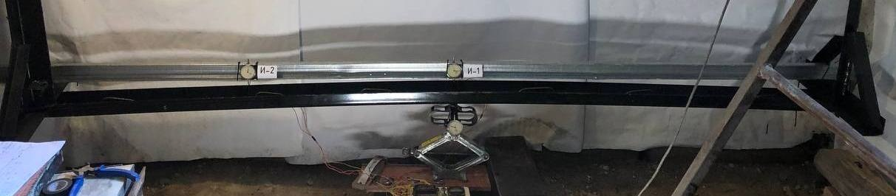
support

support
mechanical strain gauge to control the bending value
steel beam
mechanical jack
Figure 6 – General view of the arrangement of the previous opposite to operational bending
of the cross-section steel part

a) | 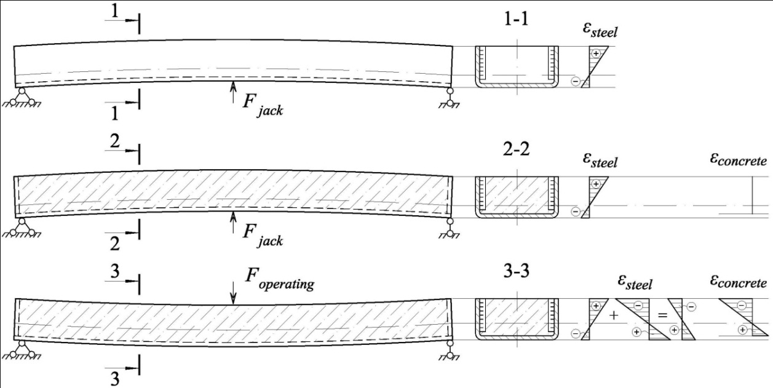
b)
c)
Figure 7 – Stages of a prestressed reinforced concrete rod work:
а) the previous opposite to operational bending of the section steel part; b) filling with concrete the inner cavity of the U-shaped steel part of the rod when the jack is installed; c) the operational stage

Construction of experimentally studied prestressed reinforced concrete girders. Samples of prestressed steel-concrete girders were made from steel bent channel № 10, 3000 mm long, with an external cross-sectional dimension of 50×100 mm and a wall thickness of 3 mm, with an internal U-shaped cavity filled with concrete. Experimental prestressed samples differed in the size of the concrete core cross-section and the operational load scheme (see fig. 8). Samples PSC1.1 and PSC1.2 were filled with concrete to the level with the channel shelves edge; the total height of their cross-section was equal to 50 mm, the reinforcement ratio was 11.4% (see section 1-1 in fig. 9). Samples PSC2.1 and PSC2.2 were filled with concrete 30 mm above the level of the channel shelves edge; the total height of their cross-section was equal to 80 mm, the reinforcement ratio was 7.3% (see section 1-1* in fig. 9). To determine the cross-section steel part prestressing effectiveness, samples SC1.1 and SC1.2 were made with concrete filling to the level of the channel shelves. The beam steel part prestressing was created by jacking it by bending it opposite to its previous operational bending by the amount of 1/300 of the span, which was 10 mm (see fig. 6). To determine the effectiveness of filling the channel inner cavity with concrete, empty steel samples S1.1 and S1.2 were manufactured and tested. Samples S1.1, SC1.1, PSC1.1, and PSC2.1 were loaded by one force in the middle of the span, and samples S1.2, SC1.2, PSC1.2, and PSC2.2 were loaded by two equal forces equidistant from the supports.
The concrete to fill the internal cavity and the U-shaped steel part of the reinforced concrete beams were combined into a joint operation by means of vertical reinforcing bars of class A240С, 6 mm in diameter and 40 mm long, which were welded to the inside of the channel side shelves at a variable step, shown in figure 9. Since these anchoring means were welded along their entire height to the channel shelves, their own bending during loading is impossible. In addition, in order to prevent the two layers from shifting relative to each other, plates with a thickness of 4 mm were welded on the ends of the beams. Therefore, the investigated beams can be considered as two-layer composite structures with a rigid combination of two layers (steel and concrete).
To ensure the joint operation of the two materials in the plastic stage of their operation, S-shaped anchor rods of class A240С with a diameter of 6 mm are additionally welded from the inner side to the horizontally located wall of the channel, the shape and welding step of which is shown in figure 10. These additional anchoring means were to be included in the work after the loss of the channel shelves local stability and their detachment from the concrete core.

Figure 8 – Scheme of experimental research planning

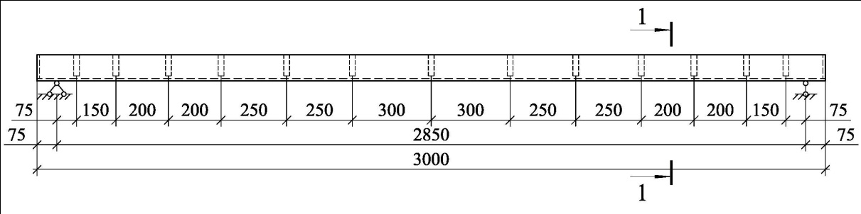

1-1 for beams SC1.1, SC1.2, PSC1.1, PSC1.2 1-1* for beams PSC 2.1, PSC 2.2
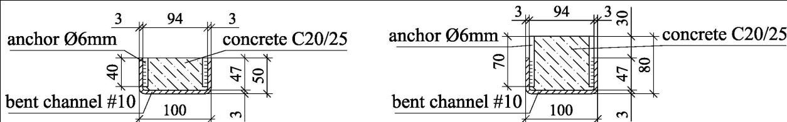

Figure 9 – Geometrical parameters of experimental single-span reinforced concrete girders

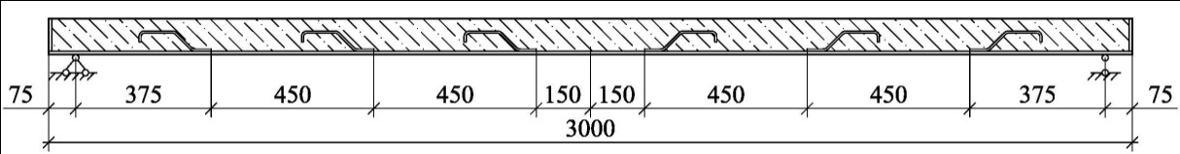

Figure 10 – Scheme of additional anchors placement along the length of the tested samples

The physical and mechanical characteristics of the materials used for the manufacture of samples of prestressed steel-concrete girders (sheet and round steel and concrete) are shown in tables 1 and 2, respectively.

Table 1 – Physical and mechanical characteristics of rolled steel
Rolled steel type | Середня міцність, МПа |  | Normative resistance, MPa: |  |  |  | Coef. var., % |  | Absolute elongation | Steel strength class | Normative resistance, MPa |  | Modulus of elasticity E_{s}, .10⁵ МПа
Rolled steel type |  |  | of sample |  | average |  |  |  |  | Steel strength class |  |  | Modulus of elasticity E_{s}, .10⁵ МПа
Rolled steel type | σ_{у} | σ_{u} | R_{уn} | R_{un} | R_{уn} | R_{un} | V_{уn} | V_{un} | ε_{s,u}, % | Steel strength class | R_{у} | R_{u} | Modulus of elasticity E_{s}, .10⁵ МПа
Channel #10 (sheet steel | 279 | 393 | 266 | 374 | 253,5 | 367,5 | 4,2 | 2,8 | 28,4 | С245 | 240 | 360 | 2,1
Channel #10 (sheet steel | 252 | 374 | 240 | 356
Channel #10 (sheet steel | 267 | 380 | 254 | 362
Channel #10 (sheet steel | 267 | 397 | 254 | 378
Anchor ∅6 mm (rod steel) | 278 | 383 | 265 | 365 | 262,2 | 371,7 | 3,2 | 1,6 | 24,2 | А240С | 240 | 370 | 2,1
Anchor ∅6 mm (rod steel) | 266 | 395 | 253 | 376
Anchor ∅6 mm (rod steel) | 282 | 393 | 269 | 374

Table 2 – Physical and mechanical characteristics of concrete cubes and prisms
Code of samples | Mean value of concrete compressive strength, MPa |  | Coefficient of variation of concrete strength in a batch V_{с}, % | Normative compressive strength of concrete, MPa: |  |  |  | Coef. var.,% | Concrete class | Design value of concrete:
Code of samples |  |  |  | of sample |  | average |  |  | Concrete class | compressive strength | modulus of elasticity
Code of samples | f_{cm,cube} | f_{cm,prism} |  | f_{ck,cube} | f_{ck,prism} | f_{ck,cube} | f_{ck,prism} | V_{с}, % | Concrete class | f_{cd}, МПа | Е_{cd}, ГПа
SC1 | 30,4 | 22,5 | 12,0 | 24,4 | 18,1 | 26,6 | 19,7 | 12,2 | С20/25 | 14,5 | 23,0
PSC1 | 29,4 | 21,8 | 9,1 | 25,0 | 18,5
PSC2 | 35,5 | 26,3 | 8,9 | 30,3 | 22,4

Methodology of conducting experimental studies of prestressed reinforced concrete girders. After the concrete had reached the design strength, the jack was removed, with the help of which the preliminary bending of the beam steel part was created. The setting for reinforced concrete samples testing looked the same as for the preliminary bending of their steel part. Therefore, steel concrete samples were tested with a cavity filled with concrete to the bottom with a ∩-like arrangement of steel channel. Figure 11 shows the general appearance of reinforced concrete samples during tests with the indication of the load application node with one or two forces.

support

support

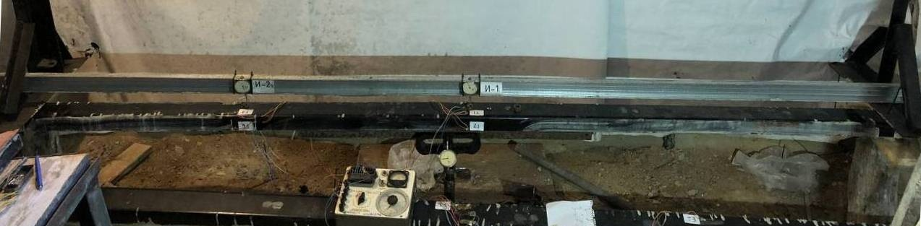
instrument for measuring deformations
steel-concrete beam
dynamometer DOSM-2
mechanical strain gauges for deflection measurement
механічні тензометри для вимірювання прогинів
mechanical jack
when loaded by one force at midspan | during loading by two equal forces equidistant  from the supports
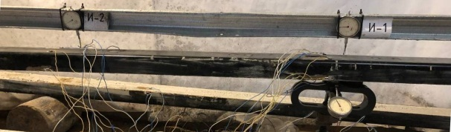  F | 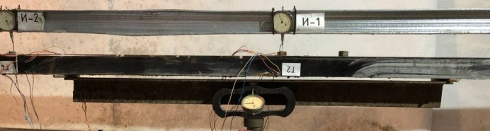  F/2  F/2

Figure 11 – General view of reinforced concrete samples during testing

The strains of steel and concrete were measured in the area of maximum bending moment (in the middle of the span) and at a distance of 0.25 of the span length from the supports using strain gauges with a base of 20 mm (see fig. 12). To control the deformations in the most compressed and stretched fibers of the sample, a 20 mm base Hugenberger mechanical strain gauge with a division value of 0.005 mm was installed, which ensured the accuracy of relative deformation measurements 25×10⁻⁵. Clock-type indicators were used to measure deflections in the middle of the span and at a distance of 0.25 of the span length from the supports.
Results of experimental studies of prestressed reinforced concrete girders. Figure 13 shows the changes in the distribution of strains of the normal cross-section, located in the middle of the span, of the steel part of
the tested samples loaded by one force in the middle of the span. The relative deformations of the stretched part of the cross-section were determined as the arithmetic average between the readings of the electro-tensile resistors T1 and T6, and of the compressed part of
the cross-section – as the arithmetic average between the readings of the electro-tensile resistors T2 and T7
(see fig. 12).

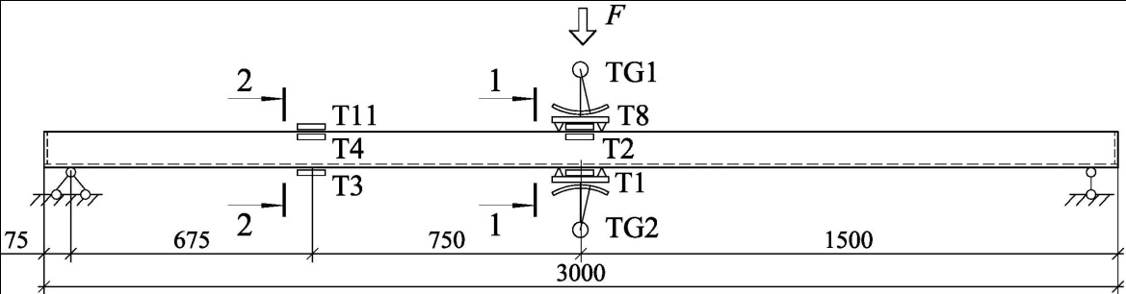
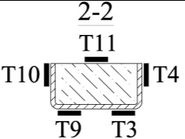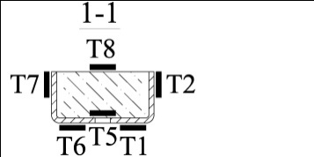
Figure 12 – Scheme of measuring devices location on the studied samples

a) steel sample S1.1 | b) steel concrete sample SC1.1
c) prestressed steel concrete sample PSC1.1 | d) prestressed steel concrete sample PSC2.1
Figure 13 – Changes in the distributions of strains of the steel part normal cross-section located
in the middle of the span of samples loaded by one force in the middle of the span

On the distributions of strains of normal cross-sections of the studied samples, the movement of the zero line along the height of the cross-section can be clearly traced. For the empty steel sample S1.1 (see fig. 13, a), the zero line is at the height of the central axis of the used bent channel. For the steel-concrete sample without prestressing SC1.1 (see fig. 13, b), the zero line is located slightly higher. This is explained by the presence of concrete in the cavity, which raises the cross-section central axis. For prestressed steel concrete samples PSC1.1 and PSC2.1 (see fig. 13, c-d), the zero line is higher, the higher the cross-section height of the concrete core. This increase in the position of the zero line is explained, firstly, by the inclusion of concrete in the work and, secondly, by the presence of previous deformations of steel normal section, which are "subtracted" from the deformations during operational loads.
To determine the efficiency of the proposed prestressing of the cross-section steel before its concreting, a comparison of the development of the normal cross-section relative deformations and the deflections of all samples was made. For samples loaded with a single force at mid-span, these comparisons are shown in figure 14. For specimens loaded with two equal forces equidistant from the supports, these comparisons are shown in figure 15.

a) b)
Figure 14 – Comparison of the development of the steel part normal section strains (a) and the deflections (b) of the samples loaded by one force in the middle of the span

a) b)
Figure 15 – Comparison of the development of the steel part normal section strains (a) and the deflections (b) of the samples loaded by two equal forces equidistant from the supports

Conclusions
As a result of experimental studies of prestressed steel-concrete wall girders' stress-strain state and bearing capacity, the following was established:
– by filling the steel U-shaped section inner cavity with concrete, it is possible to fix its pre-bent state. After the concrete gains strength and the jack is released, the preliminary bending decreases by 81% and 31% for samples filled with concrete at the level and 30 mm above of the channel edges suitably;
– preliminary bending of the section steel part increases the load-bearing capacity by 24% and the steel-concrete beam rigidity by 29%;

– filling the channel inner cavity with concrete increases the load-bearing capacity by 19% and the reinforced concrete beam rigidity by 27%;
– a 1.6-fold increase in the cross-sectional height of the concrete core of the prestressed sample increases the load-bearing capacity by 31% and the stiffness of the reinforced concrete beam by 57%.
Thus, the experimentally investigated prestressed reinforced concrete girders consisting of bent channel #10 with a wall thickness of 3 mm filled with concrete have the same load-bearing capacity with a higher stiffness of up to 27%, as a steel beam made of pipe 80×3mm, which reducing steel consumption by 39%.

References
1. George K.G. (2017). Preliminary Structural Design of Wall-Frame Systems for Optimum Torsional Response. International Journal of Concrete Structures and Materials, 11, 45-58 |  | 1. George K.G. (2017). Preliminary Structural Design of Wall-Frame Systems for Optimum Torsional Response. International Journal of Concrete Structures and Materials, 11, 45-58
2. Гоголь М.В. (2018). Регулювання напружень у сталевих комбінованих конструкціях. Київ: Сталь. |  | 2. Gogol M.V. (2018). Adjustment of stresses in steel combined structures. Kyiv: Stal
3. Гоголь М.В. (2017). Вплив деформованого стану балки жорсткості на розподіл зусиль в системі. International Scientific Journal, 11(33), 45-47  https://doi.org/10.25313/2520-2057-1-11-2771 |  | 3. Gogol M.V. (2017). The influence of the deformed state of the stiffening beam on the distribution of forces in the system. International Scientific Journal, 11(33), 45-47  https://doi.org/10.25313/2520-2057-1-11-2771
4. Ізбаш М.Ю. (2011). Пряме проектування підсилення експлуатованих нерозрізних багатопролітних сталезалізобетонних балок. Комунальне господарство міст.  Серія: Технічні науки та архітектура, 100, 425-434 |  | 4. Izbash M.Yu. (2011). Direct design of operated uncut multi-span steel-reinforced concrete beams reinforcement. Communal management of cities. Series: Technical sciences and architecture, 100, 425-434.
5. Ізбаш М.Ю. (2008). Зниження витрат напружуваної арматури в локально обтиснутих сталезалізобетонних згинаних конструкціях. Комунальне господарство міст. Серія: Технічні науки та архітектура, 81, 15-23 |  | 5. Izbash M.Yu. (2008). Reducing costs of prestressed reinforcement in locally pressed steel-reinforced concrete bent structures. Communal management of cities. Series: Technical sciences and architecture, 81, 15-23
6. Гасенко А.В. (2022). Огляд методів створення попередніх самонапружень у згинаних просторових сталезалізобетонних конструкціях. Ресурсоекономні матеріали, конструкції, будівлі та споруди, 41, 110-118  https://doi.org/10.31713/budres.v0i41.12 |  | 6. Hasenko A.V. (2022). Methods review of previous self-stresses creation in bended spatial steel reinforced concrete structures. Resource-saving materials, constructions, buildings and structures, 41, 110-118  https://doi.org/10.31713/budres.v0i41.12
7. Vatulia G., Berestianskaya S., Opanasenko E., Berestianskaya A. (2017). Substantiation of concrete core rational parameters for bending composite structures. MATEC Web of Conf.: DYN-WIND’2017, 107, 00044  https://doi.org/10.1051/matecconf/201710700044 |  | 7. Vatulia G., Berestianskaya S., Opanasenko E., Berestianskaya A. (2017). Substantiation of concrete core rational parameters for bending composite structures. MATEC Web of Conf.: DYN-WIND’2017, 107, 00044  https://doi.org/10.1051/matecconf/201710700044
8. Hasenko A.V. (2021). Previous self-stresses creation methods review in bent steel reinforced concrete structures with solid cross section. Academic journal. Industrial Machine Building, Civil Engineering, 2(57), 82-89  https://doi.org/10.26906/znp.2021.57.XXXX |  | 8. Hasenko A.V. (2021). Previous self-stresses creation methods review in bent steel reinforced concrete structures with solid cross section. Academic journal. Industrial Machine Building, Civil Engineering, 2(57), 82-89  https://doi.org/10.26906/znp.2021.57.XXXX
9. Al-Kaimakchi A., Rambo-Roddenberry M. (2021) Structural behavior of concrete girders prestressed and reinforced with stainless steel materials. Structures, 35(11)  https://doi.org/10.1016/j.istruc.2021.08.134 |  | 9. Al-Kaimakchi A., Rambo-Roddenberry M. (2021) Structural behavior of concrete girders prestressed and reinforced with stainless steel materials. Structures, 35(11)  https://doi.org/10.1016/j.istruc.2021.08.134
10. Кушнір Ю.О., Пенц В.Ф. (2013). Підбір оптимального армування нормального прямокутного перерізу попередньо-напружених сталезалізобетонних балок на основі деформаційної моделі. Будівельні конструкції. Науково-технічні проблеми сучасного залізобетону,  78-2, 78-84 |  | 10. Kushnir, Yu.O. & Pents, V.F. (2013). Selection of optimal reinforcement of pre-stressed steel-reinforced concrete beams normal rectangular section based on a deformation model. Building constructions. Scientific and technical problems of modern reinforced concrete, 78-2, 78-84
11. Wang C., Shen Y., Yang R., Wen Z. (2017). Ductility and Ultimate Capacity of Prestressed Steel Reinforced Concrete Beams. Hindawi Mathematical Problems in Engineering, 6, 1467940  https://doi.org/10.1155/2017/1467940 |  | 11. Wang C., Shen Y., Yang R., Wen Z. (2017). Ductility and Ultimate Capacity of Prestressed Steel Reinforced Concrete Beams. Hindawi Mathematical Problems in Engineering, 6, 1467940  https://doi.org/10.1155/2017/1467940
12. Hasenko A.V. (2021). Deformability of bends continuous three-span preliminary self-stressed steel concrete slabs. Academic journal. Industrial Machine Building, Civil Engineering, 1(56), 135-141  https://doi.org/10.26906/znp.2021.56.2518 |  | 12. Hasenko A.V. (2021). Deformability of bends continuous three-span preliminary self-stressed steel concrete slabs. Academic journal. Industrial Machine Building, Civil Engineering, 1(56), 135-141  https://doi.org/10.26906/znp.2021.56.2518
13. Бібік Д.В., Семко В.О., Воскобійник О.П. (2011). Патент України 61921. Сталезалізобетонний ригель покриття таврового перерізу. Київ: Український інститут промислової власності |  | 13. Bibyk D.V., Semko V.O., Voskobinik O.P. (2011).  Patent Ukraine 61921. Steel-reinforced-concrete cross-section cover beam. Kyiv: Ukrainian Institute of Intellectual Property
14. Семко О.В., Бібік Д.В., Воскобійник О.П., Семко В.О. (2011). Експериментальні дослідження сталезалізобетонного ригеля прольотом 13,5 м. Ресурсоекономні матеріали, конструкції, будівлі та споруди, 21, 323-330 |  | 14. Semko O.V., Bibyk D.V., Voskobiynyk O.P., Semko V.O. (2011). Experimental studies of a steel-reinforced concrete beam with a span of 13.5 m. Resource-economic materials, constructions, buildings and structures, 21, 323-330

