Збірник наукових праць. Галузеве машинобудування, будівництво
Academic journal. Industrial Machine Building, Civil Engineering
http://journals.nupp.edu.ua/znp
https://doi.org/10.26906/znp.2022.58.ХХХХ

UDC 629.331

Spatial interaction analytical links study
of category M1 road trains

Orysenko Oleksandr^{1*}, Skoryk Maksym², Kryvorot Anatolii³, Virchenko Viktor⁴

¹ National University «Yuri Kondratyuk Poltava Polytechnic» https://orcid.org/0000-0003-3103-0096
² National University «Yuri Kondratyuk Poltava Polytechnic» https://orcid.org/0000-0001-9001-4913
³ National University «Yuri Kondratyuk Poltava Polytechnic» https://orcid.org/0000-0001-5919-7352
⁴ National University «Yuri Kondratyuk Poltava Polytechnic» https://orcid.org/0000-0001-7681-5124
*Corresponding author E-mail: oleksandr.orysenko@gmail.com

During the movement of a road train, the towing device takes on the load from one link of the road train and transmits it to another. In the study of the processes of links interaction in real traffic conditions, a spatial system of forces acts on each road train link and there is a need to bring them to the calculated plane. It is proposed to consider each link in a separate spatial coordinate system, which is fixed with this link, and then, using the developed transition tables, to bring these forces to the coordinate system, which is fixed with another link

Keywords: road train, traction and coupling device, trailer, rotation matrices, fixed and moving coordinate systems.

Аналітичне дослідження просторової взаємодії
ланок автопоїзда категорії М1

Орисенко О.В.^{1*}, Скорик М.О.², Криворот А.І.³, Вірченко В.В.⁷

^{1, 2, 3, 4} Національний університет «Полтавська політехніка імені Юрія Кондратюка»
* Адреса для листування E-mail: oleksandr.orysenko@gmail.com

Під час руху автомобільного поїзда взаємодія між його окремими ланками відбувається через тягово-зчіпний пристрій. Саме цей вузол сприймає на себе навантаження від однієї ланки автопоїзда та передає його до іншої. Тому вірне визначення величини та напрямку сил, які виникають в тягово-зчіпному пристрої є актуальною задачею, яка дозволяє вирішити ряд питань пов’язаних з дослідженням експлуатаційних властивостей автопоїзда, таких як: динаміка руху, гальмівні властивості, паливна економічність, стійкість, безпека руху, зручність керування та ряд інших. Також це є важливим і при проектуванні його окремих деталей і вузлів, таких, наприклад, як тягово-зчіпний пристрій. Зазвичай, при дослідженні динамічної взаємодії ланок автопоїзда та кінематики його руху обмежуються плоскими розрахунковими схемами, які дозволяють розглядати протікання цих процесів лише в одній площині. Проте, в реальних умовах руху на кожну ланку автопоїзда діє просторова система сил і виникає потреба у їх приведенні до розрахункової площини. У протилежному випадку облік складових, що впливають на взаємодію ланок буде неповним, а отже і неточним. Для більш повного врахування силової взаємодії між ланками автопоїзда пропонується розглядати кожну ланку у окремій просторовій системі координат, яка нерухомо пов’язана з цією ланкою, а потім за допомогою розроблених таблиць переходу приводити ці сили до системи координат, яка нерухомо пов’язана з іншою ланкою. Застосовуючи такий підхід, на прикладі розрахунку динамічних навантажень у тягово-зчіпному пристрої автопоїзда категорії М1 у випадку відхилення напрямку його руху від горизонтального прямолінійного показано, що динамічний вплив причепа на автомобіль-тягач виявлятиметься не лише у повздовжньому напрямку, а й у складових по іншим осям просторової системи координат, що дозволяє прогнозувати вплив причепа на характер руху автопоїзда в цілому.

Ключові слова: автопоїзд, тягово-зчіпний пристрій, причіп, матриці поворотів, нерухома та рухома системи координат.

Introduction
The study of the road train links interaction today remains an urgent task. This is due to the fact that this interaction determines the nature of the movement of the train as a whole and affects such indicators as: motion dynamics, braking properties, fuel efficiency, resistance, traffic safety, ease of operation and a number of others [1]. It is also necessary to take into account the load on the power plant, the transmission of the tractor car and the towing device, which determines their wear, reliable and trouble-free operation during the established service life.
Given that this interaction occurs through a towing device, it can be argued that knowledge of the magnitude and direction of the forces applied by one of the links of the road train to the towing device makes it possible to predict how the other link and the road train as a whole will react to this influence.
Therefore, the correct determination of the magnitude and direction of the forces brought to the towing device is an urgent issue, since it allows solving a number of problems related to the design and operation of road trains.

Review of the research sources and publications
The interaction of the links of the road train during movement is devoted to a number of works by domestic and foreign scientists. The issues of determining the stability indicators of road trains of category M1 are devoted to the work [2-4], the development of the trains mathematical model movement is devoted to the work [5, 7], and simulation of his work is considered in [6, 8, 9]. The study of braking processes is devoted to the work [10].
The study of the loads influence of the towing device on the category M1 road train movement stability during transient driving modes is given in the work [11].
In work [12] systems of differential equations are given, which take into account the law of change in the force arising in the towing device in the case of using the usual and dynamic drawbar of the road train trailed link. It is also shown that the cause of longitudinal dynamic loads in the towing device is the oscillations of the trailer in the longitudinal vertical plane.
This interaction of the links of the road train is explained by the fact that any spatial system of forces that affect a separate link of a road train can be led to one equilibrium, which is then decomposed into projections along the axes of the spatial coordinate system [13]. Since the power interaction between the links of the road train is carried out through a towing device, it becomes necessary to bring the equilibrium projections of the forces spatial system to this particular device and decomposition on the projections along the axes of the spatial coordinate system associated with this device.
In the preparation of differential equations given in [12], the following assumptions are made:
– the traction car and trailer are absolutely solid bodies that do not change their size in the process of movement;
– the link that has elastic and dissipative properties in this system is only a towing device;
– gaps in the towing device are neglected, given their small size;
– the traction car and trailer move in a straight line;
– the traction car moves on a flat horizontal surface, and oscillations in the longitudinal vertical plane are performed only by the trailer.

Definition of unsolved aspects of the problem
The analysis of scientific papers devoted to the study of the interaction of links of a road train shows that to compile differential equations of motion or establish kinematic dependencies, the authors use design schemes that lie in the same plane – horizontal or vertical. However, under real conditions, each of the links is affected by a spatial system of forces in which a number of components do not belong to the calculated plane, but affect the train movement nature.
Consideration of such components is possible provided that there is a mathematical model that allows you to bring spatial forces to the axes of coordinate systems that are associated with each individual link of the train.

Problem statement
The purpose of this publication is to highlight the results of a trailer influence analytical study on a traction car, taking into account the spatial interactions of these links on the M1 category road train example.

Basic material and results
In work [14] a table of transition between coordinate systems is given, one of which is fixed with a traction car and the other with a trailer.
The compilation of such a table is carried out on the basis of the assumption that the traction car and the trailer interact with each other through a traction coupling device, which has the shape of a sphere and in which there are no gaps. Under such conditions, the translational movements of the traction car and trailer relative to each other can be neglected and assume that the mutual change in the position of these links is carried out only in the form of deviations of one link relative to another at certain angles in the planes of the spatial coordinate system. It is also assumed that while driving, the tractor car is always on a flat horizontal surface, and when overcoming road irregularities, only the trailer changes its position.
The use of this approach allows you to carry out operations with forces that affect one of the links of the road train in its own coordinate system, and then, if necessary, bring these forces to the coordinate system of the other link.
When choosing the location of fixed and moving coordinate systems, the requirements of SAE were taken into account when describing the dynamic processes of the car (Figure 1). In this case, a right-handed orthogonal coordinate system is used, with a beginning in the center of mass of the vehicle. It is assumed that this coordinate system is motionlessly connected to the vehicle and moves with it. According to the SAE convention, the axes of the coordinate system have the following directions:
– О_{Х} – located in the plane of the longitudinal axis of symmetry of the car and directed in the direction of its movement forward;
– О_{Y} – lies in the horizontal plane and is directed sideways to the right side of the vehicle;
– О_{Z} – directed downward in relation to the vehicle.
Rotations around these axes have the following names:
– р – rotate around an axis Х (roll);
– q – rotate around an axis Y (pitch);
– r – rotate around an axis Z (yawning).

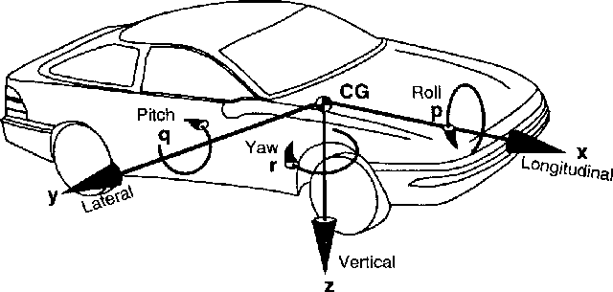
Figure 1 – Vehicle axle system according to SAE

In our case, the location of the coordinate systems is as follows. We associate the beginning of the O_{XYZ} coordinate system with the center of the hinge of the towing device, which is rigidly connected to the traction car and does not change its position relative to it while driving (Figure 2). The position of the coordinate axes of this system is as follows: the O_{X} axis is horizontal and is located along the longitudinal axis of symmetry of the car and is directed in the direction opposite to the movement; the O_{Y} axis is also in the horizontal plane and directed to the left side of the car; O_{Z} axis pointing vertically upwards.

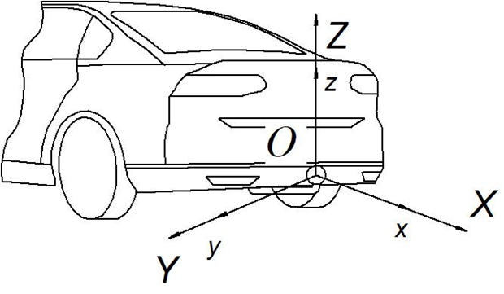
Figure 2 – Coordinate systems of the car and trailer in the initial period of time

The rotation from the O_{X} axis to the O_{Z} axis is clockwise (left-handed coordinate system).
Another Oxyz coordinate system also originates in the center of the hinge of the towing device, the direction of its axes in the initial period of time coincides with the direction of the axes of the Oxyz coordinate system, but it is rigidly connected to the trailer and does not change its position relative to it while driving. Thus, we have two coordinate systems, fixed Oxyz and movable Oxyz (in relation to the tractor car), which originate in the center of the hinge of the towing device and coincide in the initial period of time (Figure 2).
When driving, overcoming the irregularities of the supporting surface, the trailer will change its position relative to the car. The axes of the Oxyz coordinate system will deviate from their original position, and therefore from the axes of the Oxyz coordinate system.
In this case, the change in the position of the links relative to each other is conveniently represented as a spherical motion.
As is known [13], with spherical motion, the position of the body in space can be set using three coordinates, which represent the angles of rotation of the moving coordinate system relative to the fixed axes. Usually, a moving coordinate system is associated with the body under study, and a fixed one with the surface of the earth, or a body that is mistaken for stationary. The axes of both coordinate systems originate at the same point and coincide at the initial point in time.
In work [14] it is shown that each of the rotations around the axes of a fixed coordinate system corresponds to a matrix that determines the position of the axes of the moving coordinate system relative to the stationary one. By introducing the following notation of rotation angles around the axes of a fixed coordinate system, α – rotation angle around axis О_{Х}, β – rotation angle around axis O_{Y}, γ – rotation angle around axis O_{Z}, we obtain the rotation matrices given in the table 1.
In cases where the position of a moving body relative to a fixed one is described using several turns, the resulting matrix is used, which is obtained by multiplying the matrices of individual turns.
In [14], the resulting matrix for the sequence of rotations around the axes is given O_{X}, O_{Y}, O_{Z} (Figure 3) respectively at angles α, β, γ.
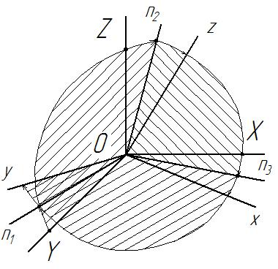

Figure 3 – The position of the moving coordinate system relative to stationary with sequential execution of three turns around the axes OX, OY, OZ

This matrix will have the form
Table 1 − Matrices of rotation
around axes O_{X}, O_{Y}, O_{Z}
Rotate around an axis OX
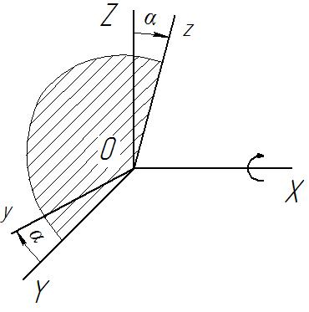
Rotate around an axis OY
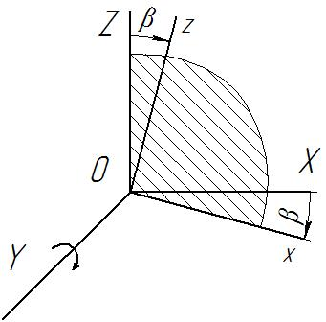
Rotate around an axis OZ
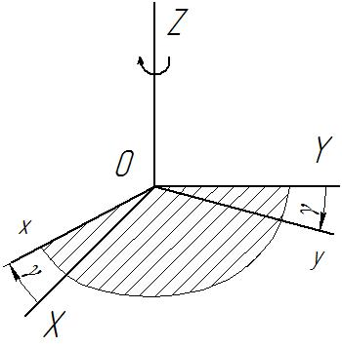

Transposing the matrix, we obtain a table of transition between moving and fixed coordinate systems (Table 2).

Table 2 – Transition table between moving and fixed coordinate systems
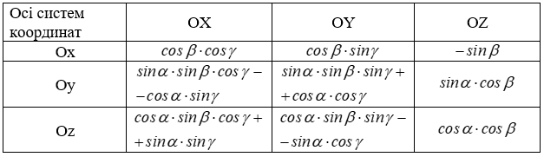

The use of such a transition table allows you to bring the spatial system of forces that affect the link of the trailer to the associated coordinate system. In the future, using the above table, you can bring the indicated forces to the coordinate system of another link.
Since the product of the matrices is not commutative, it is obvious that the transition tables between coordinate systems will differ depending on the sequence of rotations adopted. If we take into account that the rotation around each of the axes of a fixed coordinate system is carried out only once, then as shown in [14] there are six possible variants of transition tables. The question arises what will be the difference in the values of the projections of forces on the axis of a fixed coordinate system with different possible variants of the sequence of rotations and, accordingly, when using different transition tables?
For this purpose, a computational study was conducted. The force, the value of which was conventionally taken as 100 units and the direction of action of which in the moving coordinate system Oxyz coincides with the axis Oh, is reduced to a fixed system Oxyz using the transition tables given in the work [14]. The angles of rotation were also conventionally assumed to be the same and with a magnitude of 0.2 radians. The calculations carried out show that the choice of the matrix does not affect the final result. The discrepancy in the results lies within the accuracy of the calculations.
For an analytical study of the interaction of road train links, we consider the case of the dynamic influence of a trailer on a tractor car during transient modes of movement of a transport train, taking into account the possible deviation of the road from the rectilinear direction and the presence of bows in the transverse and longitudinal directions.
We use the equation of dynamic interaction of the links of the train, which is given in [12]. We neglect the forces of dissipative resistance, since the task is to determine the maximum possible loads.
, (1)
where Т – traction force of the traction car;
F – trailer resistance force when towing;
m₁, m₂ – weight of traction car and trailer, respectively;
k – trailer natural frequency;
t – time.
We use the transition table between moving and fixed coordinate systems in the sequence of turns OX, OY, OZ (Table 2).
Then the component of the dynamic impact falling on the OX axis of the coordinate system associated with the tractor car is defined as

, (2)
where γ, β – angles of rotation of the axes of the moving coordinate system relative to the fixed axes, respectively; OZ, OY.
Component of dynamic influence per axis OY
. (3)
Component of dynamic influence per axis OZ
. (4)
After analyzing equations 2 – 4, we come to the conclusion that the component of the dynamic load, which in the coordinate system of the trailer had a direction only along the OX axis, will affect the tractor car also along the OY and OZ axes, which makes it possible to take into account the vertical and transverse horizontal dynamic components acting on the towing device.
So, for example, for a road train of category M1, which includes a passenger car and a passenger trailer with the technical characteristics given in Table 3, we have the results shown in the graph (Figure 4). The calculation of load values for possible sequences of turns was obtained in the application Mathcad 15.

Table 3 – Brief technical characteristics of the traction car and trailer
№ | Name | Value
Car
1 | Gross weight, m₁ kg | 1595
2 | Design traction force on the drive wheels T, N | 7050
Trailer
1 | Gross weight m², kg | 700
2 | Design resistance to movement F, N | 686,7
Towing device
1 | Natural frequency of the system, k | 543,38

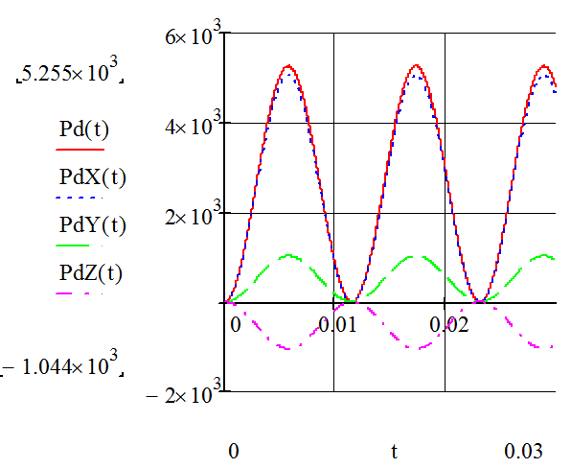

Figure 4 – Graph of the spatial load of the towing device during the sequence of turns OX, OY, OZ

In order to determine the maximum and minimum values of loads on the towing device for a given sequence of turns, we will check the function for extremes.
To do this, we find the first-time derivative of the function, equate it to zero, solve the equation and substitute the found roots into the function equation.
We find the first-time derivative of function (1) at constant values of quantities Т = 7050; F = 686,7; m₁ = 1595; m₂ = 700; k = 543,38; α = 0,2; β =0,2; γ = 0,2.
. (5)
We equate (5) to zero
. (6)
Obviously, this function will be zero provided , what is possible with
, (7)
where – Z the set of natural numbers, i.e. Z = 1, 2, 3, ....
With n = 1, time t, s
. (8)
. (9)
Then , N,
. (10)
With n = 2 time will be t = 0,012.
Then the value of , N,
. (11)
Subsequently, with increasing values of n, the value of Р_{д} will be repeated based on the frequency of the function cos.
Find the maximum values of dynamic load projections Р_{д} on the axis of the fixed coordinate system OXYZ, taking into account the spatial impact.
The projection onto the OX axis will have expression (2). Then the first time derivative
. (12)
Equating to zero (12) and solving the equation, we obtain the value t = 5,782·10⁻³ with n = 1 and t = 0,012 with n = 2.
With these t values, the value of the projection on the OX axis will be Р_{дХ} = 5,084·10³ N and Р_{дХ} = 0.
We carry out similar calculations to determine the values of the projections of the dynamic load Р_{д} on the axis of a fixed coordinate system OY and OZ. For the same values of angles of rotation, we have maximum projection values Р_{дY} = 1,023·10³ N, Р_{дZ} = -1,044·10³ N with n = 1 and Р_{дY} = Р_{дZ} = 0 with n = 2.
We find the percentage ratio of individual projections and dynamic load, which is obtained without taking into account the rotation of the coordinate system according to the formula
. (13)
For projection onto an axis ОХ, %
. (14)
For projection onto an axis ОY, %
. (15)
For projection onto an axis ОZ, %
. (16)

Conclusions
Based on the calculations of the maximum values of projections of dynamic loads in the towing device on the axis of the fixed coordinate system with the sequence of turns OX, OY, OZ and graphical dependencies are constructed (Figure 1) we come to the following conclusions:
– in case of deviation of the direction of movement of the road train from the horizontal rectilinear dynamic effect of the trailer on the tractor car will be manifested not only in the longitudinal component along the OX axis, but also along other axes of the spatial coordinate system;
– as a percentage, the magnitude of the projections of dynamic impact at the angles of deviation of the moving coordinate system relative to a fixed one by an angle of 0.2 rad is: along the OX axis – 96.7%, which is the largest value among the projections; OY axis – 19.5%; on the OZ axis – 19.9% in the negative direction;
– The dynamic component that occurs during transient modes of movement of a road train under these conditions, in addition to loading in the longitudinal direction, causes a force effect on the tractor car also in the lateral direction, which under certain conditions can lead to skidding of the car;
– The vertical component of the dynamic impact has a negative direction, that is, it is directed downwards and will contribute to pressing the wheels of the rear axle of the car to the supporting surface, which, in addition to the positive effect for movement due to an increase in the coefficient of adhesion of the wheels to the road, has negative consequences, expressed in raising the front of the car and, as a result, deterioration in handling and adhesion of the drive wheels to the supporting surface for front-wheel drive cars.

References
1. Подригало М.А., Шелудченко В.В. (2015). Нове в теорії експлуатаційних властивостей автомобілів та тракторів, Суми: Сумський національний аграрний університет |  | 1. Podrigalo M.A., Sheludchenko V.V. (2015). New in the theory of operational properties of cars and tractors. Sumy: Sumy National Agrarian University
2. Сахно В.П., Кузнєцов Р.М., Стельмащук В.В., Козачук Л.С. (2014). До визначення показників стійкості автопоїзда категорії М1 у перехідних режимах руху. Сучаснi технологii в машинобудуваннi та транспортi, 2, 123-128  http://nbuv.gov.ua/UJRN/ctmbt_2014_2_20 |  | 2. Sakhno V.P., Kuznetsov R.M., Stelmashchuk V.V., Kozachuk L.S. (2014). To determine the stability indices of a M1 category train in transitional modes of movement. Modern technologies in machine building and transport, 2, 123-128  http://nbuv.gov.ua/UJRN/ctmbt_2014_2_20
3. Козачук Л.С. (2014). До визначення стійкості руху автопоїзда категорії М1. Вісник ЖДТУ. Серія «Технічні науки», 2(69), 121-128  http://nbuv.gov.ua/UJRN/Vzhdtu_2014_2_23 |  | 3. Kozachuk L.S. (2014). To determine the stability of the road train category M1. Bulletin of ZhSTU. «Technical Sciences», 2(69), 121-128  http://nbuv.gov.ua/UJRN/Vzhdtu_2014_2_23
4. Стельмащук В.В., Пазін Р.В. (2016). До питання комплектації автопоїзда з причепом категорії О2. Вісник машинобудування та транспорту, 2, 97-105 |  | 4. Stelmashchuk V.V., Pazin R.V. (2016). On the question of completing a road train with a trailer of category O2. Bulletin of Mechanical Engineering and Transport, 2, 97-105
5. Сахно В.П., Шарай С.М., Мурований І.С., Човча І.В. (2021). До розробки математичної моделі автопоїзда з причепом категорії О1 у поперечній площині. Сучаснi технологii в машинобудуваннi та транспортi, 2(17), 151-160 |  | 5. Sakhno V.P., Sharay S.M., Murovany I.S., Chovcha I.V. (2021). To the development of a mathematical model of a road train with a trailer of category O1 in the transverse plane. Modern technologies in machine building and transport, 2(17), 151-160
6. Fratila D., Darling J. (1996). Simulation of Coupled Car and Caravan Handling Behavior. Vehicle System Dynamics, 26:6, 397-429  http://worldcat.org/issn/00423114 |  | 6. Fratila D., Darling J. (1996). Simulation of Coupled Car and Caravan Handling Behavior. Vehicle System Dynamics, 26:6, 397-429  http://worldcat.org/issn/00423114
7. Zhang N., Yin G., Mi T., Li X., Chen N. (2017). Analysis of Dynamic Stability of Car-trailer Combinations with Nonlinear Damper Properties. Procedia IUTAM, 22, 251-258  https://doi.org/10.1016/j.piutam.2017.08.033 |  | 7. Zhang N., Yin G., Mi T., Li X., Chen N. (2017). Analysis of Dynamic Stability of Car-trailer Combinations with Nonlinear Damper Properties. Procedia IUTAM, 22, 251-258  https://doi.org/10.1016/j.piutam.2017.08.033
8. Mohajer N., Abdi H., Nelson K., Nahavandi S. (2015). Vehicle motion simulators, a key step towards road vehicle dynamics improvement. Vehicle System Dynamics, 53:8, 1204-1226  https://doi.org/10.1080/00423114.2015.1039551 |  | 8. Mohajer N., Abdi H., Nelson K., Nahavandi S. (2015). Vehicle motion simulators, a key step towards road vehicle dynamics improvement. Vehicle System Dynamics, 53:8, 1204-1226  https://doi.org/10.1080/00423114.2015.1039551
9. Gomez-Bravo F., Cuesta F., Ollero A. (2005). Autonomous tractor-trailer back-up manoeuvering based on changing trailer orientation. IFAC Proceedings Volumes, 38(1), 301-306  https://www.researchgate.net/publication/289879510_Autonomous_tractor-trailer_back-up_manoeuvering_based_on_changing_trailer_orientation |  | 9. Gomez-Bravo F., Cuesta F., Ollero A. (2005). Autonomous tractor-trailer back-up manoeuvering based on changing trailer orientation. IFAC Proceedings Volumes, 38(1), 301-306  https://www.researchgate.net/publication/289879510_Autonomous_tractor-trailer_back-up_manoeuvering_based_on_changing_trailer_orientation
10. Zhang N., Wu J., Li T., Zhao Z. Yin G. (2021). Influence of braking on dynamic stability of car-trailer combinations. Proceedings of the Institution of Mechanical Engineers, Part D: Journal of Automobile Engineering, 235(2-3), 455-464  https://doi.org/10.1177/0954407020959895 |  | 10. Zhang N., Wu J., Li T., Zhao Z. Yin G. (2021). Influence of braking on dynamic stability of car-trailer combinations. Proceedings of the Institution of Mechanical Engineers, Part D: Journal of Automobile Engineering, 235(2-3), 455-464  https://doi.org/10.1177/0954407020959895
11. Сахно В.П., Кузнецов Р.М., Стельмащук В.В., Козачук Л.С. (2015). Вплив навантаження на тягово-зчіпний пристрій на стійкість руху автопоїзда категорії М1 у перехідних режимах руху. Сучасні технології в машинобудуванні та транспорті, 1(3), 148-157  https://doi.org/10.36910/automash.v1i3 |  | 11. Sakhno V.P., Kuznetsov R.M., Stelmashchuk V.V., Kozachuk L.S. (2015). Influence of loading on the traction coupling device on stability of movement of a road train of category M1 in transient modes of movement. Modern technologies in mechanical engineering and transport, 1(3), 148-157  https://doi.org/10.36910/automash.v1i3
12. Orysenko O.V., Skoryk M.O., Kryvorot A.I., Shapoval M.V. (2018). The Dynamic Processes Mathematical Modeling in the Traction Coupling Device From Cars to the Trailers. International Journal of Engineering & Technology, 7(4.8), 473-477  https://doi.org/10.14419/ijet.v7i4.8.27291 |  | 12. Orysenko O.V., Skoryk M.O., Kryvorot A.I., Shapoval M.V. (2018). The Dynamic Processes Mathematical Modeling in the Traction Coupling Device From Cars to the Trailers. International Journal of Engineering & Technology, 7(4.8), 473-477  https://doi.org/10.14419/ijet.v7i4.8.27291
13. Павловський М.А. (2002). Теоретична механіка. Київ: Техніка |  | 13. Pavlovsky M.A. (2002). Theoretical mechanics. Kyiv: Tekhnika
14. Orysenko O., Skoryk M., Kryvorot A., Rassoha I. (2021). Determination of spatial interaction of the individual road train links. Academic Journal. Industrial Machine Building, Civil Engineering, 2(57), 98-104  https://doi.org/10.26906/znp.2021.57.2591 |  | 14. Orysenko O., Skoryk M., Kryvorot A., Rassoha I. (2021). Determination of spatial interaction of the individual road train links. Academic Journal. Industrial Machine Building, Civil Engineering, 2(57), 98-104  https://doi.org/10.26906/znp.2021.57.2591

