Збірник наукових праць. Галузеве машинобудування, будівництво
Academic journal. Industrial Machine Building, Civil Engineering
http://journals.nupp.edu.ua/znp
https://doi.org/10.26906/znp.2022.58.ХХХХ

UDC 666.97.033.16

Reasoning of the expediency of using vibration supports
with variable parameters

Sheka Oleksandr¹*, Yakovenko Andrii², Vedmid Vasyl³

¹National University «Yuri Kondratyuk Poltava Polytechnic» https://orcid.org/0009-0005-1328-1416
²National University «Yuri Kondratyuk Poltava Polytechnic» https://orcid.org/0000-0003-0818-6332
³National University «Yuri Kondratyuk Poltava Polytechnic» https://orcid.org/0000-0003-1514-1212
*Corresponding author E-mail: asheka51@ukr.net

The problem of reducing the negative impact of vibration on staff and equipment and their compliance with sanitary standards is always relevant for construction vibrating machines with vibration exciters of various types and modes. So, in practice, vibration isolation of vibroactive elements of vibrating machines and technological equipment is applied using systems with quasi-zero stiffness. This article highlights the results of experimental studies of changes in the elastic qualities of vibration support parameters at different pressure levels and changes in the length of the free part of the elastic element. Therefore, the construction of a vibration support with a limiter of the free part of the elastic element was developed. The stiffness of the support changes as a result of changing the free part of the support with metal limiters. The results of the search experiment showed that the deformation of the rubber element is carried out according to a law close to the linear one. Therefore, a mathematical model in the form of regression was built to conduct the main experiment and process the obtained data. The obtained regression equation makes it possible to establish the dependence of the shrinkage of the support when the pressure on it changes and the height of the free part of the elastic element.

Keywords: vibration amplitude, vibration support, vibration isolation, vibration platform, vibration exciter

Обґрунтування доцільності застосування вібраційних опор
зі змінними параметрами

Шека О.П.¹*, Яковенко А.М.², Ведмідь В.В.³

^{1, 2, 3} Національний університет «Полтавська політехніка імені Юрія Кондратюка»
*Адреса для листування E-mail: asheka51@ukr.net

При створенні вібраційних машин з віброзбудниками різних типів і способів дії завжди актуальною є проблема зменшення негативного впливу вібрації на персонал та обладнання та їх відповідність санітарним нормам. Для її розв’язання на практиці застосовують віброізоляцію віброактивних елементів вібраційних машин і технологічного обладнання з використанням систем із квазінульовою жорсткістю. Зокрема, у віброплощадках із класичною двомасовою системою віброізоляція машини від фундаменту або робочого органу та рами здійснюється шляхом зміни жорсткості параметрів їх вібраційних опор. В статті висвітлюється результати експериментальних досліджень зміни пружних властивостей параметрів вібраційної опори при різних значеннях навантаження та зміни довжини вільної частини пружного елемента. Відповідно була розроблена конструкція віброопори з обмежувачем вільної частини пружного елемента. При нерівномірному розподілу навантаження на вібраційну машину запропонована конструкція опори дозволяє підібрати параметри жорсткості для її рівномірної роботи шляхом обмеження висоти робочої частини опори. Жорсткість опори змінюється внаслідок зміни вільної частини опори металевими обмежувачами. З метою отримання достовірної математичної моделі експериментальні дослідження ґрунтуються на методах математичного планування експерименту та математичної статистики. Результати пошукового експерименту показали, що деформація гумового елементу здійснюється за законом, близьким до лінійного. Тому для проведення основного експерименту та обробки одержаних даних побудовано математичну модель у вигляді регресії. Розраховані значення коефіцієнтів регресії перевірено за критерієм Стьюдента. Отримане рівняння регресії дозволяє встановити залежність усадки опори при зміні навантаження на неї та висоти вільної частини пружного елемента. За отриманими даними можна припустити, що змінюючи жорсткість пружної вібраційної опори, можна змінювати в потрібних межах амплітуду вимушених коливань рухомої частини віброплощадки відповідно, забезпечувати потрібну якість ущільнення бетонної суміші.

Ключові слова: амплітуда віброколивань, вібраційна опора, віброізоляція, вібраційна площадка, віброзбуджувач

Introduction
The development of the construction industry in our country and abroad is impossible without the creation of high-performance energy-saving machines and equipment. The technical operation of machines for the production and compaction of building materials (sieves, vibrating plates, conveyors, vibrating stands, etc.) causes vibrations, which inevitably increases the intensity and widens the spectrum of their vibration field’s negative effects. Vibration in machines contributes to the growth of dynamic pessure in structural elements, joints and connections, causes the formation and increasing the number of cracks, decreases the load-bearing capacity of structural parts, and has a negative impact on the health of staff [1]. Problems of vibration isolation of dynamic objects arise in almost all branches of modern technology. The use of vibration isolation for vibroactive elements of machines allows to reduce the negative impact of vibration on technological equipment and technical staff.
In construction engineering, vibration isolation systems installed between the source of vibration and the protective object are widely used to protect against the dynamic effects of vibrating objects [1,2]. It is better to use passive vibration isolation systems to protect from the harmful effects of vibration in practice. as simple and economic version.
The main characteristics of passive vibration isolation systems are the frequency of their own oscillations and load-bearing capacity (reaction to static preasure) [3]. The lower the frequency of natural oscillations of the vibration isolator, the wider the range of frequencies of the disturbing force in which the action of the vibration isolator is effective can be. However, in linear vibration systems, ensuring the load-bearing capacity of the vibration isolator is usually accompanied by an increase in its overall dimensions.
Non-linear systems with quasi-zero stiffness are also used for the construction of anti-vibration systems with a low natural frequency of oscillation [4]. These systems are distinguished by the fact that in the working range they have a gentle section of the force characteristic and, therefore, have a comparatively low stiffness, while maintaining a high load-bearing capacity in the equilibrium position. This allows such systems to be used as a vibration isolation for objects of large mass, effective at low vibration frequencies [5], although their construction may cause certain technological difficulties.
An urgent task that requires a solution is the usage of systems with quasi-zero stiffness is to ensure vibration isolation of structural elements of technological equipment with vibration processes and unbalanced moving joints [4,6].

Review of Research Resources and Publications
A significant number of scientific developments are devoted to the study of the influence of the parameters of elastic vibration supports on the characteristics of vibrations of moving parts of vibrating machines [7]. In particular, one study emphasizes that one of the important characteristics that determine the amplitude of vibrations of the concrete mixture is the stiffness of the elastic support. Also, in the scientific thesis it is stated that the stiffness of the elastic vibration supports is one of the key parameters for determining the amplitude of vibration movements of the points of the movable frame of the vibrating platform [8].
Oscillations in different configurations can be achieved by adjusting the stiffness of the support in the horizontal and vertical directions and accordingly choosing the trajectory that best meets the process conditions [9].

Definition of unsolved aspects of the problem
The characteristics of vibration supports are selected in accordance with the mass, size and frequency parameters of the equipment being isolated, as well as in accordance with the conditions of its fixation [10]. In most cases a classic two-mass system is implemented for building vibrating construction machines, since it makes it possible to isolate the machine from the foundation or from the working body and frame. Depending on the mass of the sealing medium or the mode of operation of the vibrating machine, there is a need to change the parameters of the vibration supports by changing their stiffness. This can be achieved by replacing elastic elements with others with other stiffness parameters. However, this effect can also be achieved by changing the length of the free part of the elastic support element. Therefore, there is a need to study the change in the elastic properties of the support depending on the length of its free part.
This article examines the question of changing the stiffness of the support by installing auxiliary variable bushings of different heights without replacing the support itself. At a constant value of the mass of the sealing medium, reducing the length of the free part of the elastic element of the support, as is known, leads to an increase in its stiffness, and vice versa. As a result, their rigidity changes for the same design of the supports.

Problem statement
The purpose of this article is to highlight the results of the study of changes in the elastic properties of the parameters of the vibration support at different preasure values and changes in the length of the free part of its elastic element.

Basic material and results
The elastic supports of vibrating platforms simultaneously perform several functions. The most important of them are the perception of the force of gravity from those parts of the vibrating platform that are in oscillating motion and their isolation from the foundation.
It is known that the quality of concrete mixture compaction depends on the vibration parameters of the moving part of the vibrating platform [11,12]. The main parameters that affect this are the amplitude and frequency of oscillations of the moving part of the vibrating platform. Also, the moving part of the vibrating platform is in a state of forced oscillations, the frequency of which is set by the vibration exciter, and the amplitude depends on the mass of the moving part with the mixture and the stiffness of the elastic parts of the vibration supports [13]
In addition, a change in the stiffness of vibration supports affects the amplitude of oscillations of the moving part of the vibrating machine [14], which follows from equation (1):
, (1)
where A – displacement amplitude of the working body;
f₀ = F₀ / m ;
ω – natural cyclic frequency of forced oscillations of the working body;
β = b / 2m ;
– coefficient of dissipative viscous resistance;
, (2)
where k – stiffness coefficient of the elastic support;
m – mass of vibrating parts of the vibrating platform.
From equations (1) and (2) it follows that with an increase in the cyclic frequency ω₀ of the free oscillations of the system under the action of an elastic force, which is caused by an increase in the stiffness k of the elastic support at a constant mass m of its vibrating parts, the amplitude A of the forced vibrations of the moving part of the vibrating machine will be decreasing.
In addition, according to these equations, the amplitude of forced oscillations of the working body depends indirectly on the mass of the vibrating part of the vibrating platform, if its other parameters do not change.
In production conditions, there are often cases when products of different nomenclature are formed on the same vibrating platform [10, 11]. This means that the masses of molding products fluctuate within certain limits, which also negatively affects the quality of sealing.
Taking into account this circumstance, we come to the conclusion that elastic supports, which have design possibilities for operational changes of their parameters, in particular for changing stiffness, allow to select the necessary amplitudes of vibrations of the moving part of the vibrating machine during the formation of concrete products of various nomenclature, which ensures the proper quality of compaction for the according concrete mixtures.
We proposed the construction of an elastic support (Fig. 1), consisting of a rubber cylindrical hollow central part, lower and upper sleeves and variable metal limiters of the working height of the support. As elastic elements of vibration dampers, we suggest using rubber cord sleeves [15].
Limitations of the working height of the support are proportional to the amplitudes of oscillations of the working body or the moving frame of the vibrating platform.
With uneven distribution of the load, the proposed design of the elastic support allows, by limiting the working height of the support, to select such parameters of its stiffness that ensure uniform operation of the vibrating platform.
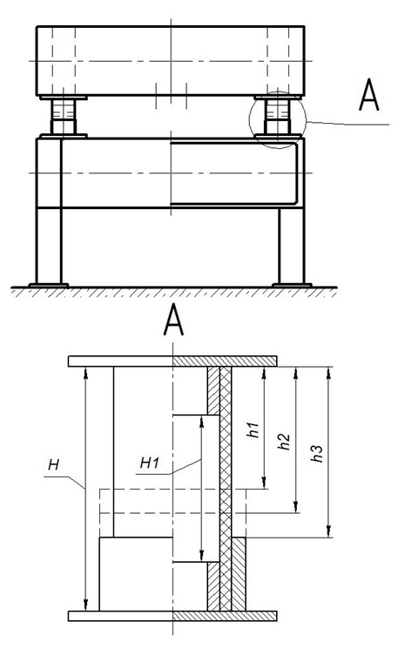
Figure 1 – Diagram of a vibration support
with limiters of the free part of
the elastic support element
Н – support height; Н₁ – working height of the support;
h₁ – limiter height 1, high 50 mm;
h₂ – limiter height 2, high 40 mm;
h₃ – limiter height 3, high 30 mm.

In order to study the elastic qualities of the support of the proposed structure, experimental measurements of support shrinkage were carried out within the ranges of changes in the initial factors - the load on the vibration support and the height limitation of the free part of its elastic element (Fig. 2), and the statistical processing and analysis of the obtained experimental data was carried out.
The methods of mathematical planning and mathematical statistics were applied during the experimental studies in order to obtain a reliable mathematical model of the elastic support [16].
Measurements of support shrinkage were carried out in the ranges of change of the initial factors described above, the numerical values of which are shown in table 1.
The results of the search experiment showed that the deformations of the elastic element of the support satisfy the conditions of dependence close to linear. Therefore, a two-factor linear experimental design was adopted for the main experiment.

Table 1 – Ranges of change of initial factors
Code | Code value | Factor values
Code | Code value | Х₁ (load) | Х₂ (free part of elastic support)
The main level | 0 | 85 | 75
Variation interval | ΔХ_{i} | 45 | 25
Upper  level | + | 130 | 100
Lower  level | - | 40 | 50
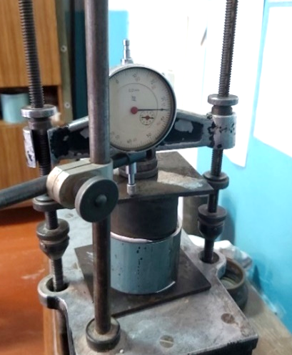

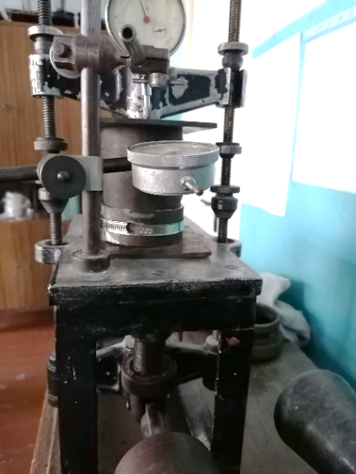

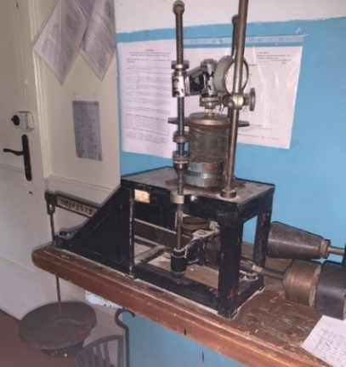

Figure 2 – Measurement of the load
on the vibration damper with a limiter

The experimental planning matrix and obtained measurement results are shown in table 2.

Table 2 - Implementation
of the experimental plan
№ | Experiment plan |  | Interaction | Y₁ | Y₂ | Y₃ | Y_{ср}
№ | Х₁ | Х₂ | Х₁Х₂
1 | + | + | + | 7,9 | 8 | 7,85 | 7,92
2 | - | + | - | 2,6 | 2,7 | 2,5 | 2,6
3 | + | - | - | 5,9 | 5,4 | 5,6 | 5,63
4 | - | - | + | 1,9 | 1,7 | 1,9 | 1,83

The implementation of this experiment and the processing of the obtained data allow obtaining a mathematical model of elastic support in the form of a regression equation (3):
y = b₀ + b₁ X₁ + b₂ X₂ + b₃ X₁ X₂, (3)
where y – support shrinkage;
b₀, b₁, b₂, b₃ – regression equation coefficients.
As a result of the calculations, the numerical values of the regression coefficients were obtained:
b₀ = 4,5;
b₁ = 2,28;
b₂ = 0,76;
b₃ = 0,38.
The calculated values of the regression coefficients were tested for significance according to the Student's test and found that all of them are significant.
So, the required regression equation has such form (3):
y = 4.5 + 2.28 X₁ + 0.76 X₂ + 0.38 X₁ X₂, (4)
The resulting equation establishes the dependence of support shrinkage on changes in the external preasure on it and the height of the free part of the elastic support element.
This equation was tested for adequacy by the Fisher test. It was established that the difference between the corresponding values of the experimental data and those calculated according to the regression equation does not exceed the permissible limits and the regression equation reflects the real process of the vibration support with sufficient accuracy.
The value of the elastic support shrinkage during the experiment is given in table 3.
Corresponding graphs were constructed according to the obtained dependence. Thus, the graph of the dependence of the shrinkage of the elastic support on the preasure during the absence of a limiter is shown in (Fig. 3).
In order to determine the statistical relationship between the shrinkage of the elastic support and the preasure applied to it, the correlation coefficient (5) was calculated for each of the options for limiting the free part of the support, which are presented in table 4.
, | (5)
The calculation was carried out using the Microsoft Office Excel spreadsheet.
Thus, for the free part with a height of 100 mm, 75 mm, and 50 mm, accordingly, the correlation coefficients exceed r = 0.99, which indicates the existence of a statistically significant relationship between the variables under investigation.

Table 3 - Results of measurements
№ | Preasure F, H | Shrinkage S,mm
№ | Preasure F, H | Free part, L=100 mm  (Without restrictions) |  |  | Free part, L=75 mm |  |  | Free part, L=50 mm
1 | 40 | 2,1 | 2,7 | 2,8 | 1,9 | 2,1 | 2,1 | 1,5 | 1,6 | 1,7
2 | 80 | 4,7 | 5,5 | 5,5 | 3,9 | 4,1 | 3,9 | 3,5 | 3,6 | 3,5
3 | 120 | 7,1 | 7,6 | 7,8 | 6,6 | 6,6 | 6,3 | 5,2 | 5,2 | 5,2
4 | 130 | 8,31 | 8,7 | 8,4 | 7,0 | 7,0 | 6,7 | 5,8 | 5,7 | 5,7

Table 4 – Correlation coefficients
Free part | Correlation coefficient
L=100 mm (without limiter) | 0,997
L=75 mm | 0,999
L=50 mm | 0,999

The coefficient of variation (6) for is also calculated, which allows you to compare the level of variation between different limit variants that have different values.
, | (6)
, | (7)
where – value of the optimization parameter in the j-th parallel experiment;
– the arithmetic average value of the optimization parameter from m repeated experiments in each i-th experiment;
m – number of parallel experiments.
The calculated values of the coefficient of variation are presented in table 5, which do not exceed 10%. So, we can talk about sufficiently high reproducibility of measurement results during experiments.

Table 5 – Coefficients of variation

Free part | Coefficient of variation
L=100 mm (without limiter) | 3,74%
L=75 mm | 0,47%
L=50 mm | 0,48%

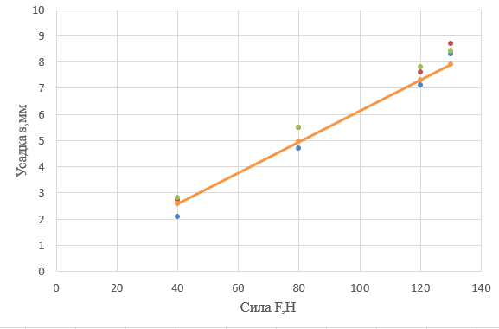
Figure 3 – Graph of the dependence of the shrinkage of the elastic support under the preasure with the absence of a limiter.

A mathematical model of support with two factors in natural values was also obtained.
If in the above obtained regression equation (4) to accept:

(8)

then we obtain the functional dependence of the shrinkage h_{i} of the elastic support under the external preasure F_{i} on the elastic support and on the height S_{i} of the limiter of the free part of the elastic element of the support:

(9)
Graphs of the dependence of the shrinkage of the vibration support under the external preasure on the support at different values of the limiter are shown in (Fig. 4, 5).
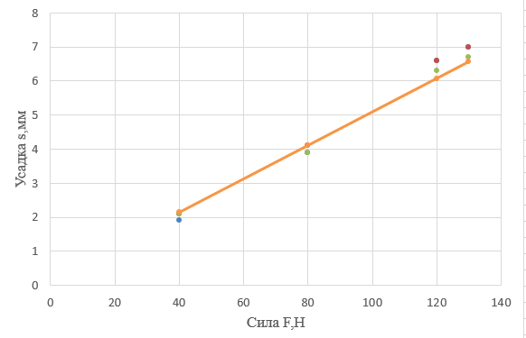
Figure 4 – Graph of the dependence of the shrinkage of the elastic support under the preasure with a free part of 75 mm.

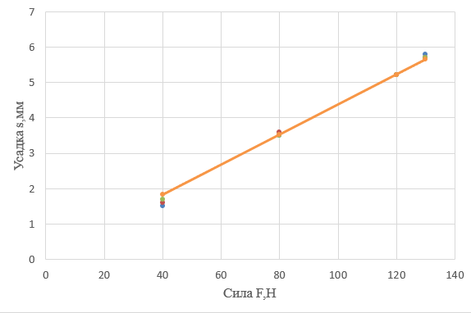
Figure 5 – Graph of the dependence of the shrinkage of the elastic support under the preasure with a free part of 50 mm
Using the regression equation, it is possible to determine the shrinkage of the support at arbitrary values of the external preasure and the height of the free part of the elastic element within the above-mentioned ranges of changes in the numerical values of these initial factors: force values - from 40 N to 130 N; the height of the free part is from 50 mm to 100 mm.

Conclusions
1 It is described the method of changing the stiffness of an elastic support by changing the linear size of the free part of its elastic element with limiters of different heights.
2 Experimental dependences were obtained to determine the shrinkage of the support while the external preasure on it changes and the height of the free part of its elastic element changes.
3 Practical value of the research is presented in desined vibration resistance with variable stiffness parameters. By changing the stiffness of the elastic vibration support, it is possible to change within the required limits the amplitude of the forced vibrations of the moving part of the vibrating platform or its moving frame and, accordingly, ensure the required quality of compaction of the concrete mixture.

References

1. Подобєд, І. М., Биковський, А. І., & Кобасов, В. М. (2014). Перспективні засоби захисту працівників від шкідливої дії вібрації та шуму на рейковому транспорті. Проблеми охорони праці в Україні, (28), 39- 46.  2. Wang, S., Xin, W., Ning, Y., Li, B., & Hu, Y. (2020). Design, Experiment, and Improvement of a Quasi-Zero-Stiffness Vibration Isolation System. Applied Sciences, 10(7), 2273. https://doi.org/10.3390/app10072273  3. Клітной, В. В. (2015). Аналіз використання активних віброзахисних систем з керованою квазінульовою жорсткістю. Энергосбережение. Энергетика. Энергоаудит, (2), 66-71. http://nbuv.gov.ua/UJRN/ecee_2015_2_10  4. Ma, Z., Zhou, R., & Yang, Q. (2022). Recent advances in quasi-zero stiffness vibration isolation systems: An overview and future possibilities. Machines, 10(9), 813. https://doi.org/10.3390/machines10090813  5. Kowal, J., Pluta, J., Konieczny, J., & Kot, A. (2008). Energy recovering in active vibration isolation system − results of experimental research. Journal of Vibration and Control, 14(7), 1075–1088. https://doi.org/10.1177/1077546308088980  6. Massarsch, K. R., & Fellenius, B. H. (2019). Evaluation of vibratory compaction by in situ tests. Journal of Geotechnical and Geoenvironmental Engineering, 145(12). https://doi.org/10.1061/(asce)gt.1943-5606.0002166  7. Федоляк, Н.В. , Лях, М.М. & Михайлів, В.В. 2020. Аналіз чинників, що впливають на траєкторію руху ситополотна вібросита. Prospecting and Development of Oil and Gas Fields. 3(76), 61–70 https://doi.org/10.31471/1993-9973-2020-3(76)-61-70  8. Нестеренко, М. П., Скляренко, Т. О., & Малинський, С. М. (2009). Дослідження руху віброплощадки із циліндричними та конічними опорами. Збірник наукових праць галузеве машинобудування, будівництво, 23(2), 56–62. http://reposit.pntu.edu.ua/handle/PoltNTU/8328  9. Лях, М. М., Федоляк, Н. В., & Вакалюк, В. М. (2015). Дослідження впливу коливальних рухів сітки на ефективність роботи вібросита. Prospecting and Development of Oil and Gas Fields, (4(57), 36–42. http://nbuv.gov.ua/UJRN/rrngr_2015_4_6  10. Назаренко, І. І. (2007). Вібраційні машини і процеси будівельної індустрії. Київ: КНУБА.  11. Назаренко, І. І. ,& Туманська, О. В. (2004).  Машини і устаткування підприємств будівельних матеріалів: Конструкції та основи експлуатації. Київ: Вища школа.  12. Juradin, S., Baloević, G., & Harapin, A. (2014). Impact of vibrations on the final characteristics of normal and self-compacting concrete. Materials Research, 17(1), 178-185.  https://doi.org/10.1590/S1516-14392013005000201  13. Сівко В.Й., Кузьмінець М.П. (2012). Оцінка впливу робочого середовища на режими коливань вібраційних машин. Теорія і практика будівництва, 10, 3-5  14. Нестеренко, М. П., Воскобійник, О. П., Павленко, А. М. (2017). Розроблення пружних опор вібраційних площадок для формування залізобетонних виробів. ACADEMIC JOURNAL Industrial Machine Building, Civil Engineering, 1(43), 238-243.  http://journals.nupp.edu.ua/znp/article/view/129  15. Гурин, В. А., Востріков, В. П., & Кузьмич, Л. В. (2019). Основи промислових технологій і матеріалознавства. Рівне: НУВГП.  16. Нечаєв, В. П., Берідзе, Т. М., & Кононенко, В. В. (2005). Теорія планування експерименту. Київ: Кондор. |  | 1. Podobed, I. M., Bykovsky, A. I., & Kobasov, V. M. (2014). Promising means of protecting workers from the harmful effects of vibration and noise on rail transport. Problems of labor protection in Ukraine, (28), 39-46.  2. Wang, S., Xin, W., Ning, Y., Li, B., & Hu, Y. (2020). Design, Experiment, and Improvement of a Quasi-Zero-Stiffness Vibration Isolation System. Applied Sciences, 10(7), 2273. https://doi.org/10.3390/app10072273  3. Klitnoi, V. V. (2015). Analysis of the use of active anti-vibration systems with controlled quasi-zero stiffness. Energy saving. Power engineering. Energy audit, (2), 66-71. http://nbuv.gov.ua/UJRN/ecee_2015_2_10  4. Ma, Z., Zhou, R., & Yang, Q. (2022). Recent advances in quasi-zero stiffness vibration isolation systems: An overview and future possibilities. Machines, 10(9), 813. https://doi.org/10.3390/machines10090813  5. Kowal, J., Pluta, J., Konieczny, J., & Kot, A. (2008). Energy recovering in active vibration isolation system − results of experimental research. Journal of Vibration and Control, 14(7), 1075–1088.  https://doi.org/10.1177/1077546308088980  6. Massarsch, K. R., & Fellenius, B. H. (2019). Evaluation of vibratory compaction by in situ tests. Journal of Geotechnical and Geoenvironmental Engineering, 145(12).  https://doi.org/10.1061/(asce)gt.1943-5606.0002166  7. Fedoliak, N. V., Liakh, М. М., & Mykhayliv, V. V. (2020). The analysis of factors influencing the trajectory of the vibrating screen. Prospecting and Development of Oil and Gas Fields, 3(76), 61–70.  https://doi.org/10.31471/1993-9973-2020-3(76)-61-70  8. Nesterenko, M. P., Sklyarenko, T. O., & Malinsky, S. M. (2009). Study of the movement of a vibrating platform with cylindrical and conical supports. Collection of scientific works branch engineering, construction, 23(2), 56–62.  http://reposit.pntu.edu.ua/handle/PoltNTU/8328  9. Lyakh, M. M., Fedolyak, N. V., & Vakalyuk, V. M. (2015). Study of the effect of vibrating net movements on the efficiency of the vibrating screen. Prospecting and Development of Oil and Gas Fields, (4(57), 36–42.  http://nbuv.gov.ua/UJRN/rrngr_2015_4_6  10. Nazarenko I.I. (2007). Vibration machines and the processes of the construction industry. Kyiv: KNUCA  11. Nazarenko, I. I., & Tumanska, O. V. (2004). Machines and equipment of building materials enterprises: Designs and basics of operation. Kyiv: Higher School.  12. Juradin, S., Baloević, G., & Harapin, A. (2014). Impact of vibrations on the final characteristics of normal and self-compacting concrete. Materials Research, 17(1), 178-185.  https://doi.org/10.1590/S1516-14392013005000201  13 Sivko V.Y., Kuzminets M.P. (2012). Estimation of influence of the working environment on vibration modes of vibrating machines. The Theory and practice of construction, 10, 3-5.  14. Nesterenko, M. P., Voskobiynyk, O. P., Pavlenko, A. M. (2017). Development of elastic supports of vibrating platforms for the formation of reinforced concrete products. ACADEMIC JOURNAL Industrial Machine Building, Civil Engineering, 1(43), 238-243.  http://journals.nupp.edu.ua/znp/article/view/129  15. Guryn, V. A., Vostrikov, V. P., & Kuzmych, L. V. (2019). Basics of industrial technologies and materials science. Rivne: NUWEE.  16. Nechaev, V. P., Beridze, T. M., & Kononenko, V. V. (2005). Theory of experiment planning. Kyiv: Condor.

