Збірник наукових праць. Галузеве машинобудування, будівництво
Academic journal. Industrial Machine Building, Civil Engineering
http://journals.nupp.edu.ua/znp
https://doi.org/10.26906/znp.2023.60.ХХХХ

UDC 624.154: 624.138.2

The influence of the arrangement scheme of vertical
soil-cement elements of the soil base reinforcement
on their joint work with the strip stamp

Vynnykov Yuriy¹, Razdui Roman^{2*}

¹ National University «Yuri Kondratyuk Poltava Polytechnic» https://orcid.org/0000-0003-2164-9936
² National University «Yuri Kondratyuk Poltava Polytechnic» https://orcid.org/0000-0002-5819-6056
*Corresponding author E-mail: romanrazduy@gmail.com

The characteristics and parameters for modeling the soil base under the strip stamp with variable parameters of the vertical soil base reinforcement are given. Variants of soil-cement element placement with varying reinforcement ratio are presented.
Differences in graphical results are shown on the example of longitudinal and transversal cross. Graphs of dependences of pressures on the soil base according to numerical modeling using HSM model and volumetric soil elements on the reinforcement ratio for different variants for of the arrangement scheme of SCE are shown. The effective zones of soil work of strip foundations (stamps) under the considered soil conditions for each of the options for placement of SCE have been identified

Key words: vertical soil base reinforcement, vertical soil-cement element, reinforcement ratio, soil-cement soil base, tray experiment, finite element method, settlements, weak soil base, strip stamp, numerical simulation

Вплив розміщення в плані вертикальних
ґрунтоцементних елементів армування основи
на їх спільну роботу зі стрічковим штампом

Винников Ю.Л.¹, Раздуй Р.В.^{2*}

^{1, 2} Національний університет «Полтавська політехніка імені Юрія Кондратюка»
*Адреса для листування E-mail: romanrazduy@gmail.com

Наведено характеристики та параметри для моделювання напружено-деформованого стану (НДС) основи, армованої вертикальними ґрунтоцементними елементами (ҐЦЕ), під стрічковим штампом при варіативних параметрах вертикального армування основи. Для моделювання методом скінченних елементів (МСЕ) у просторовій постановці (2D) використано вже добре апробовану модель ґрунту ізотропного ущільнення (Hardening soil model) і спосіб задання ҐЦЕ об’ємними елементами з відповідними характеристиками за моделлю поведінки linear elastic. Створено сітку скінчених елементів, для якої прийнятий рівень щільності fine. Представлено варіанти розміщення ҐЦЕ в плані при варіюванні відсотку армування від 0% до 39,7%. Показано відмінності у графічних результатах на прикладі повздовжніх та поперечних перерізів при відсотку армування 7,1%; 10,8%; 16,4%. Показано графіки залежності тисків на основу при чисельному моделюванні із використанням моделі ізотропного ущільнення ґрунту та об’ємних елементів від відсотку армування при різних варіантах розміщення ҐЦЕ в плані при різних значеннях осідання центру штампу. Виокремлено ефективні зони роботи стрічкових фундаментів (штампів) при розглянутих ґрунтових умовах для кожного із варіантів розміщення ҐЦЕ як у лінійній, так і в нелінійній (пружно-пластичній) стадіях роботи основи. Визначено, що до 7% армування ефективно армування, при якому відстань від центру ҐЦЕ до грані штампу складає 1,5 їх діаметри, в діапазоні 7…40% – варіант армування із співпадінням зовнішніх граней елементу армування та фундаменту (штампу), а при більшому відсотку армування – можливий вихід зони армування за межі розміщення фундаменту (штампу).
Винесення елементів армування в плані за бічну грань штампу (третій їх варіант розміщення) не дає суттєвого ефекту, оскільки більшу частину навантаження сприймає саме центральний ряд ГЦЕ

Ключові слова: вертикальне армування основи, вертикальний ґрунтоцементний елемент, відсоток армування основи, ґрунтоцементна основа, лоткове дослідження, метод скінченних елементів, осідання, слабка основа, стрічковий штамп, чисельне моделювання

Introduction
The need to improve the natural soil base under conditions of weak soils is quite obvious because with low characteristics the probability of the development of supernormal deformations of the soil base of buildings increases, which may cause the need to calculate the settlements of the soil base with methods of nonlinear soil mechanics, including, with usage of software complexes [1, 3, 4]. One of the methods of ground improvement is the reinforcement of the soil massif with vertical soil-cement elements (SCE) which are used for a whole range of needs, in particular, the reinforcement of foundations under strip foundations.

Review of the research sources and publications
The following materials are a continuation of a series of studies [7, 8, 9] on determining the effectiveness of using SCE for reinforcing the bases of strip foundations. In previous works the results of tray [7] and field studies [8] were presented and the optimal method of determining SCE and soil base for calculation by the finite element method (FEM) [9] was determined for the soil conditions specified in the study.

Definition of unsolved aspects of the problem
The effectiveness of reinforcing the soil bases of strip foundations with a low modulus of soil deformation using SCE has already been repeatedly proven [9]. However, the issues of effectiveness of SCE reinforcement and the dependences of foundation settlements on foundation pressure [2], including depending on the reinforcement ratio, as well as the influence of the arrangement scheme of SCE under the strip foundation on their work as a system have not yet been sufficiently studied.

Problem statement
A reliable method of solving such problem is to compare the settlements of a natural experiment with its numerical simulation. Therefore, based on the results of past works [7, 9], the goal is the FEM simulation of the soil-cement base under variable reinforcement parameters while preserving the dimensions of the tray, stamp, diameter and depth of the SCE for evaluating the effect of placing elements in the plan under the stamp, analyzing the results and determining the best option for their placement.

Basic material and results
The hardening soil model was used to FEM modelling in a spatial setting. To perform numerical simulations of stamp studies in the tray, the same characteristics of the tray, soil base, soil-cement, and reinforcement ratio as in the tray study [7, 8] were chosen (Table 1). The dimensions of the calculation area in the plan were 580×530 mm, the depth – 560 mm. The depth of the reinforcement from the base surface was 100 mm, the diameter of the elements was 6 mm. A rectangular steel stamp with a plan size of 420×35 mm is modeled by a plate element. The selected hardening soil model behavior and the determination of SCE by volume elements was chosen as the most correct according to the results of previous studies [5, 6, 8]. At the same time, the reinforcement ratio varied from 0 to 39.7% (that is, from the unreinforced base to the filling of the massif area by SCE under stamp in a staggered order with a step of two SCE diameters between the centers of the elements in each of the directions). SCEs were modeled by volumetric elements. Excavation of soil for the installation of a buffer crushed stone cushion, SCE installation, filling of wells with soil-cement, installation of a cushion, stamp and gradual loading were gradually taken into account. SCE were modeled as a volumetric soil bodies with appropriate characteristics with a linear elastic behavior model.
The following assumptions and parameters are used in the calculations. The iterative procedure provided for: a relative error equal to 0.05; the maximum number of iterations does not exceed 60; the maximum number of steps in each phase is 250. The density level fine was set for created mesh.

Table 1 –Characteristics set for the soil model with modeling the stress-strain state system "soil-cement soil base - rigid strip stamp"

Element | ρ, g/cm³ | Е_{oed}, MPa | Е_{ur}, MPa | φ,  ̊ | с, kPa | υ
Soil paste | 1,85 | 0,7 | 3,5 | 0 | 15,8 | 0,35
Crushed stone | 2,00 | 40 | - | 40 | 1,0 | 0,25
Soil-cement | 2,00 | 300 | - | - | - | -

Three variants of modelling based on the arrangement scheme of SCE under strip stamp are presented.
The first variant was performed similarly to the tray experiments, when a gap of one diameter of the SCE remained between the side faces of the SCE and the stamp. The maximum reinforcement ratio was 16.4%, which corresponds to two diameters between the centers of the elements in the plan (Fig. 1).
The second option is to place the outer edge of the SCE on the outer edge of the stamp. At the same time, the reinforcement ratio ranged from 0 to 39.7% (Fig. 2).
The third variant is to place the inner face of the SCE behind the outer face of the stamp (that is, when the SCE protrude beyond the dimensions of the stamp in plan on each side). The reinforcement ratio ranged from 7.1 to 39.7%, since at a lower percentage of reinforcement, each row of SCE placement along the stamp had less than three elements, that is, the condition was accepted that at least one SCE in the row was under the stamp (Fig. 3).
According to the results of FEM modeling in fig. 4–6, a–b shows the longitudinal and transversal cross-sections of the settlements of the base at the value of the settlements of the center of the stamp of 4 mm at the reinforcement ratio of 7.1%, respectively in fig. 4–6, c–d at 10.8%, in fig. 4–6, d–e at 16.4%.

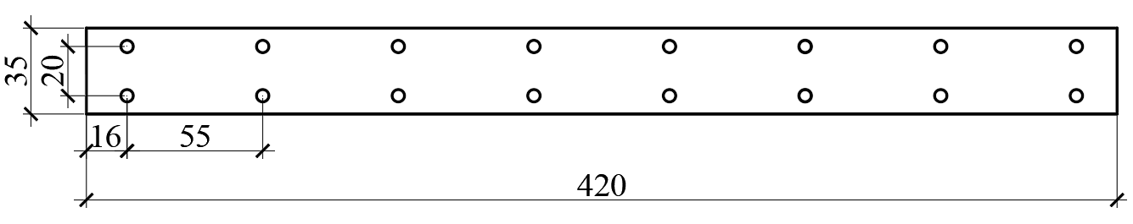 | 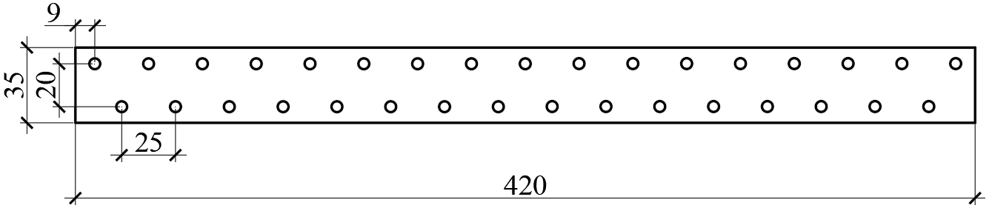 | 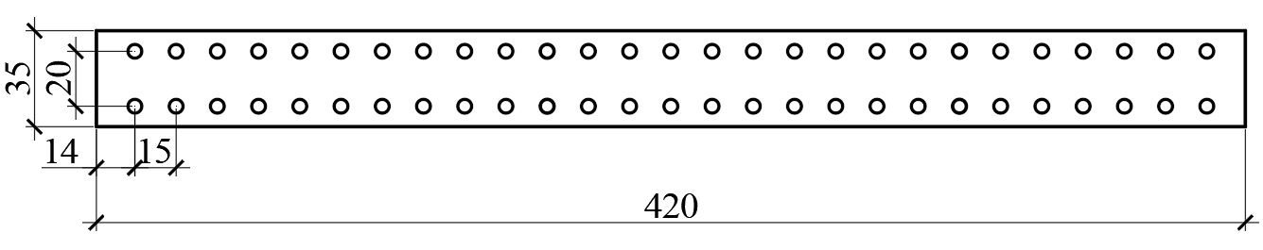 | 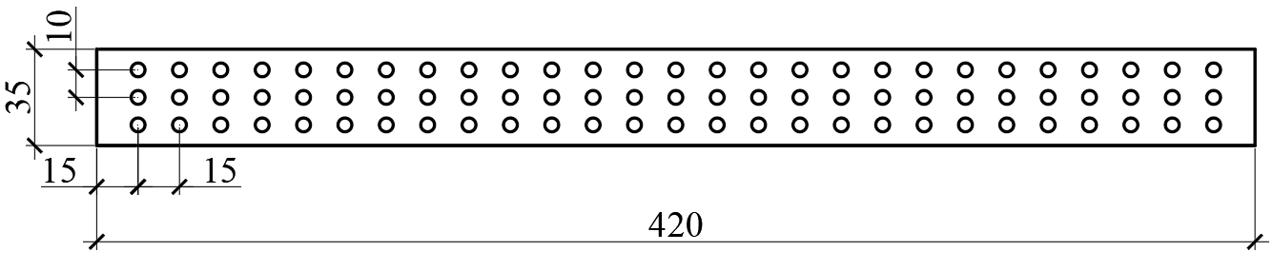 | 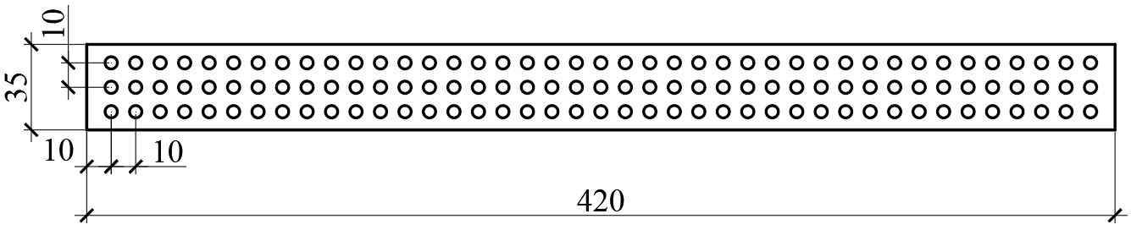
a | b | c | d | e
Figure 1 – The first variant of the arrangement scheme of SCE under strip stamp:
a – 2,1%; b – 4,4%; c – 7,1%; d – 10,8%; e – 16,4%

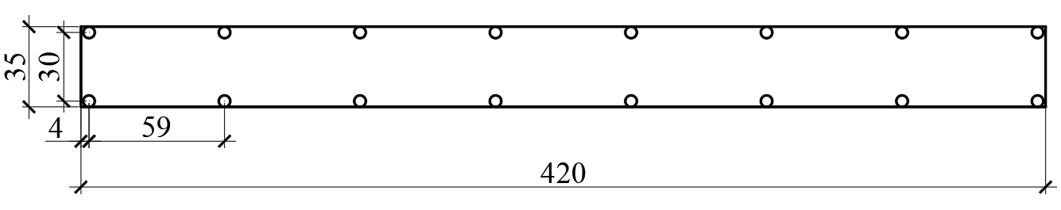 | 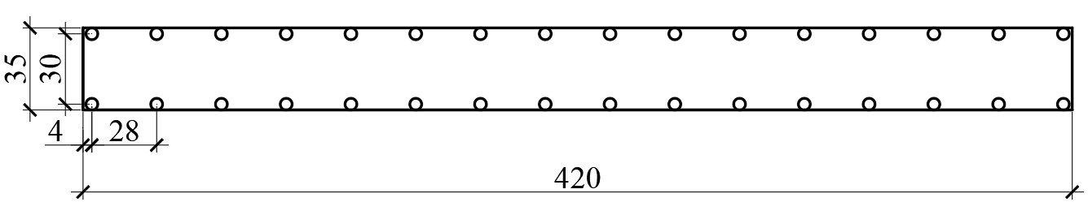 | 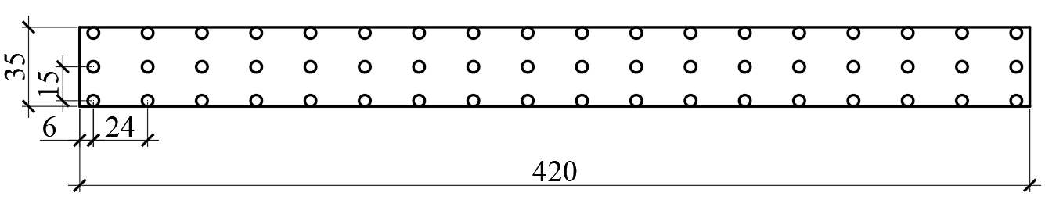 | 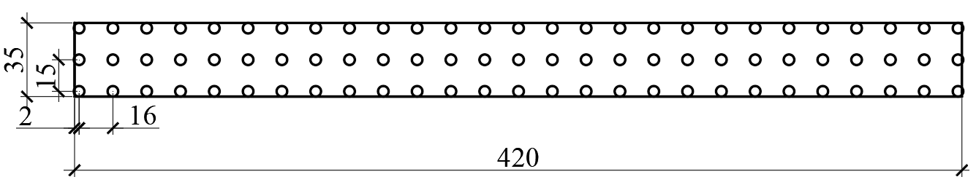 | 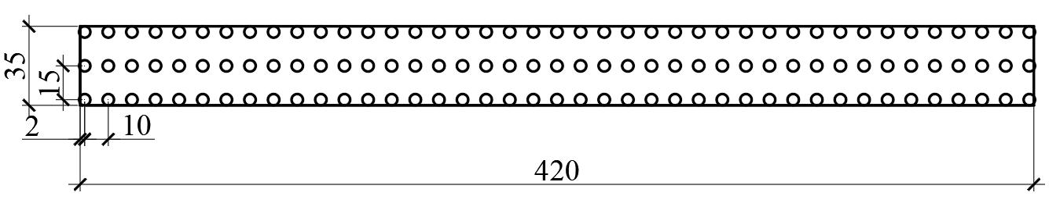 | 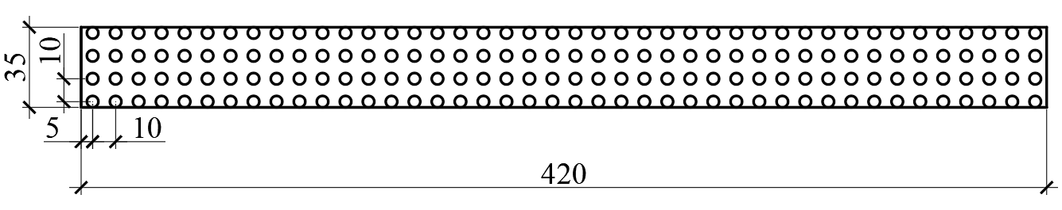 | 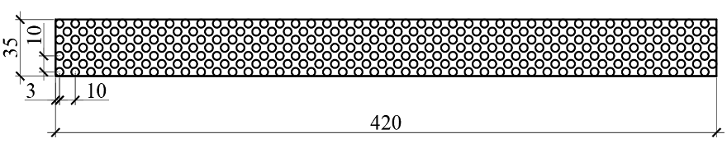
a | b | c | d | e | f | g
Figure 2 – The second variant of the arrangement scheme of SCE under strip stamp:
a – 2,1%; b – 4,4%; c – 7,1%; d – 10,8%; e – 16,4%; f – 22,4%; g – 36,7%
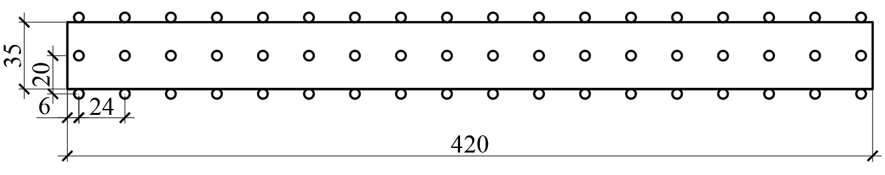 | 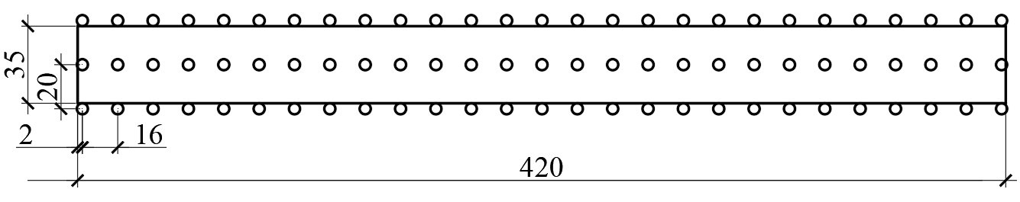 | 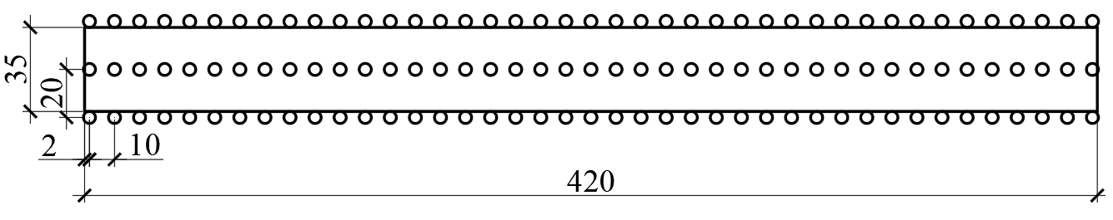 | 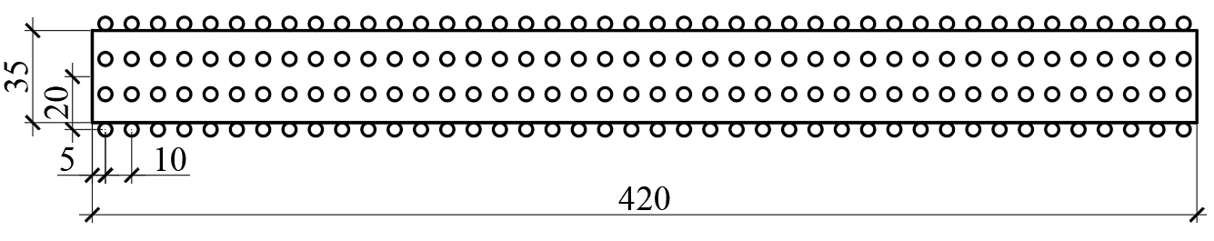 | 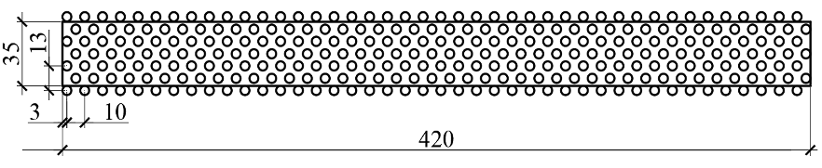
а | б | в | г | д
Figure 3 – The third variant of the arrangement scheme of SCE under strip stamp:
a – 7,1%; b – 10,8%; c – 16,4%; d – 22,4%; e – 36,7%

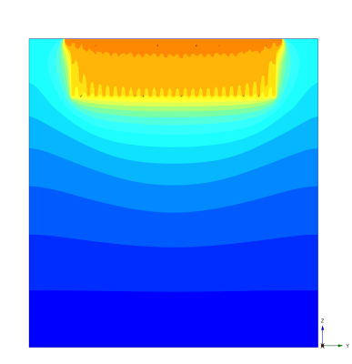 | 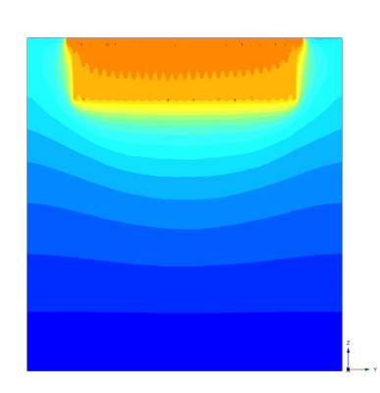 | 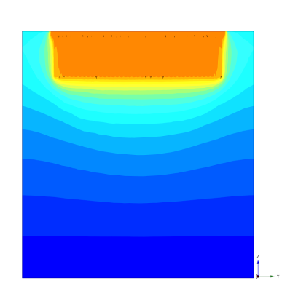 | 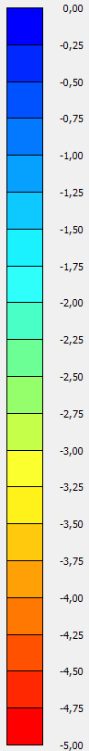
a | c | e
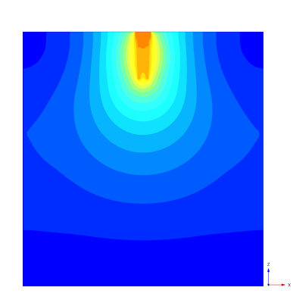 | 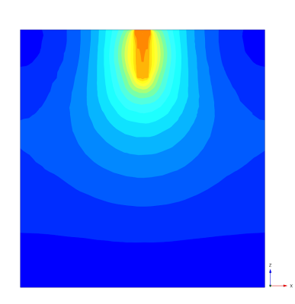 | 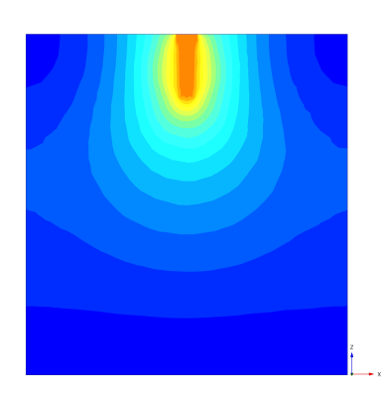
b | d | f
Figure 4 – Vertical longitudinal and transversal cross-sections of soil base settlements according
to the results of FEM simulation (with a 4 mm settlement in the center of the stamp)
for the first variant of the arrangement scheme of SCE at: a, b – 7,1%; c, d – 10,8%; e, f – 16,4%
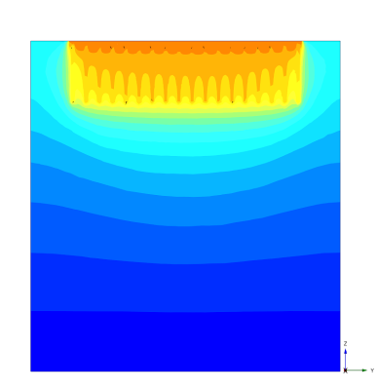 | 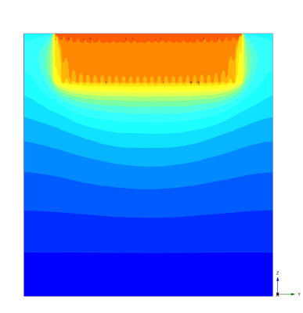 | 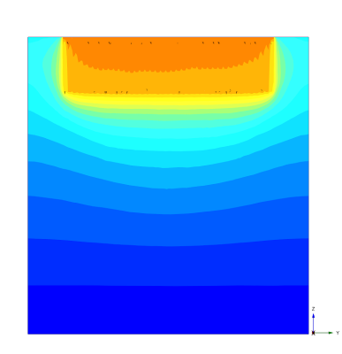
a | c | e
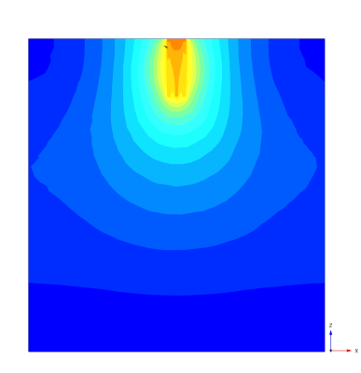 | 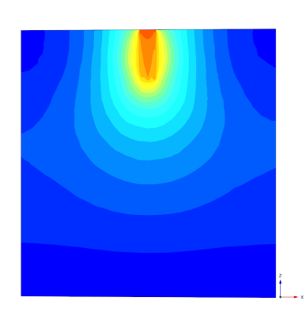 | 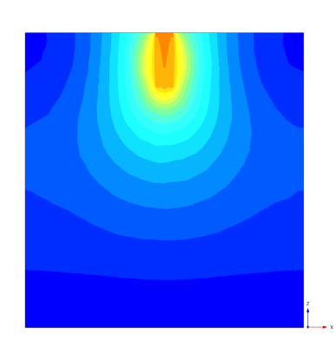
b | d | f
Figure 5 – Vertical longitudinal and transversal cross-sections of soil base settlements according
to the results of FEM simulation (with a 4 mm settlement in the center of the stamp)
for the second variant of the arrangement scheme of SCE at: a, b – 7,1%; c, d – 10,8%; e, f – 16,4%

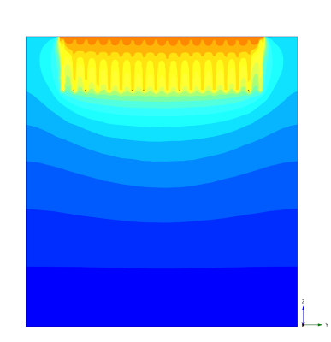 | 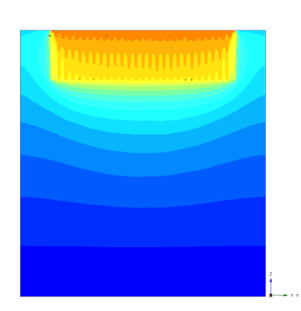 | 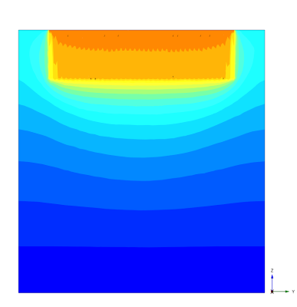
a | c | e
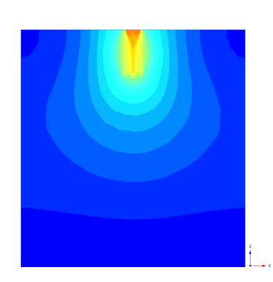 | 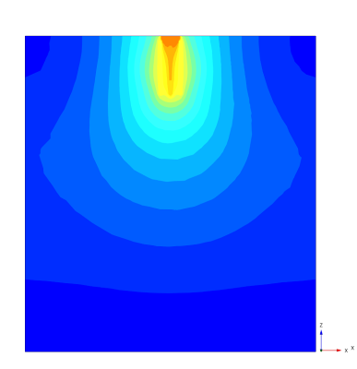 | 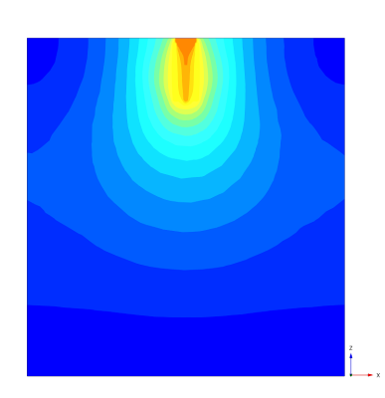
b | d | f
Figure 6 – Vertical longitudinal and transversal cross-sections of soil base settlements according
to the results of FEM simulation (with a 4 mm settlement in the center of the stamp)
for the third variant of the arrangement scheme of SCE at: a, b – 7,1%; c, d – 10,8%; e, f – 16,4%

These cross-sections demonstrate that under these conditions with reinforcement up to 16.4% the soil base can be considered as reinforced by individual SCEs, while at 16.4% and more it can be considered as a continuous reinforced array. Carrying out the reinforcement elements in the plan beyond the side face of the stamp (the third variant of their placement) is not effective, since most of the load is perceived by the central row of the SCE.

In order to compare the effectiveness of the placement of elements in the plan under the stamp, graphs
are given that demonstrate what pressure was transmitted to the soil base for all options for placement of SCE depending on the reinforcement ratio with the same settlements of the stamp (Fig. 7).
The graphs are given for different values of soil base settlements: 4 mm; 6 mm; 8 mm; 10 mm. The listed values of settlements were chosen in such a way that for all percentages of reinforcement of the experimental foundation, settlements were analyzed for both linear and non-linear stages of soil work.

a | b
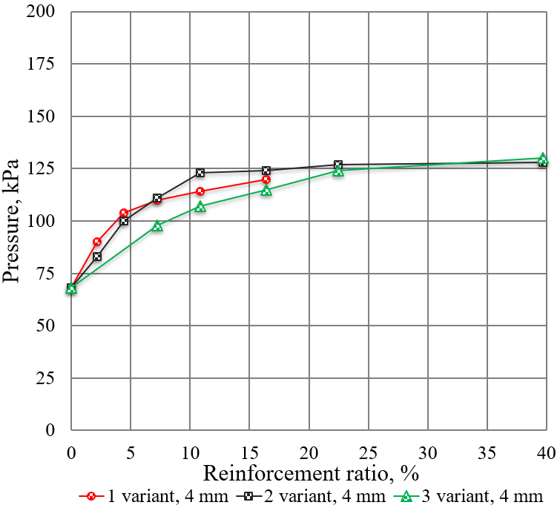 | 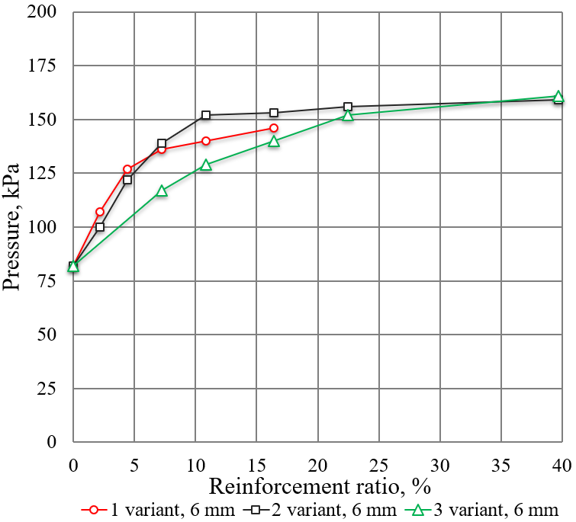
c | d
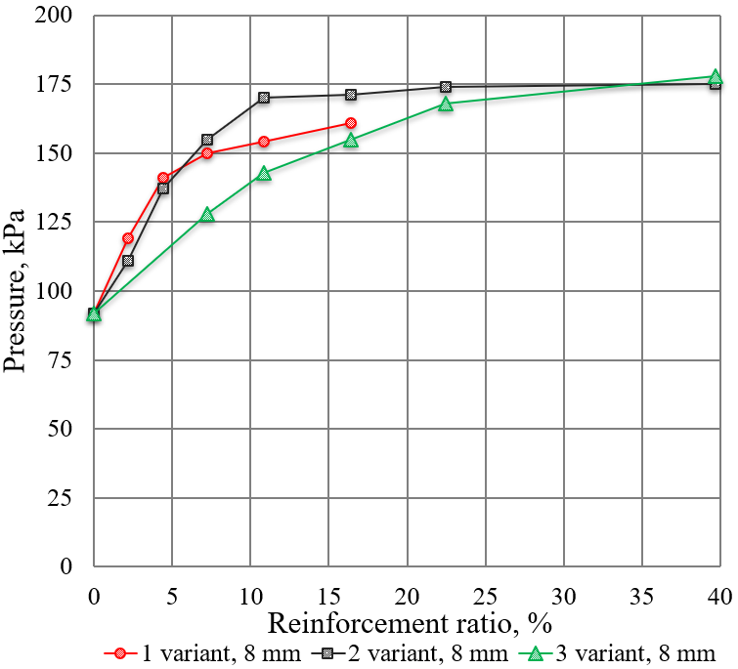 | 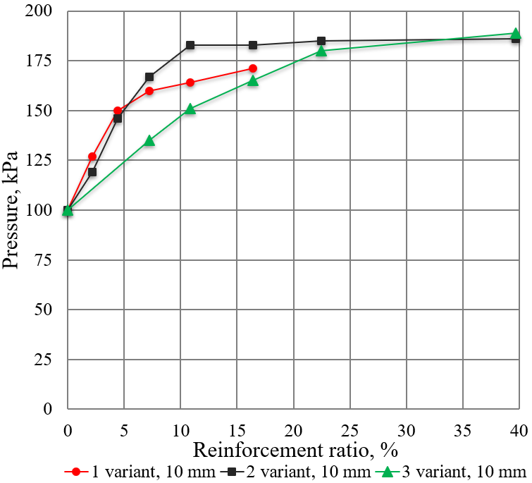

Figure 7 – The graph of dependences of pressures on the soil base according to FEM modeling using hardening soil model and volumetric soil elements on the reinforcement ratio for different variants
of the arrangement scheme of SCE in the plan at values of settlement of the center of the stamp:
a – 4 mm; b – 6 mm; c – 8 mm; d – 10 mm

Therefore, analyzing the obtained cross-sections and curves on the graphs of the dependences of the pressures on the base from the reinforcement ratio of SCE with the parameters of the soil base, strip stamp and constant depth of base reinforcement specified in the study, the following generalizations are possible.
1. When placing 2 elements in each row of reinforcement (up to the reinforcement ratio of 7.1%), the first arrangement scheme is the most effective, when all elements are placed under the stamp, and the distance from the center of the SCE to the edge of the stamp is 1.5 their diameters.
2. When placing more than two elements in each row of reinforcement (7.1% reinforcement ratio and more), the second arrangement scheme is the most effective, when all elements are located under the stamp, and the distance from the center of the SCE to the edge of the stamp is 0.5 of their diameters.
3. With high reinforcement ratio of the soil base (39.7%), when the elements are located closer than 1.5 of their diameters from each other, the placement of elements becomes effective, in which the base is also reinforced behind the side faces of the stamp (in the conducted studies, the distance from the center of the SCE to the outer face of the stamp is 0.5 diameters).
4. We also note that the generalizations formulated above generally correspond to different pressures on the soil base, both in linear and non-linear (elastic-plastic) stages of the base's work.

Conclusions
Thus, we can summarize the following from the results obtained in this work.
1. The effective zones of work of strip stamps are identified under the considered soil conditions both in linear and non-linear (elastic-plastic) stages of operation of the base
2. It was determined that up to 7% of reinforcement is effective when the distance from the center of the SCE to the edge of the stamp is 1.5 their diameters, in the range of 7...40% - the reinforcement option with the coincidence of the outer faces of the reinforcing element and the foundation (stamp) and with a greater reinforcement ratio – possible placement of the reinforcement zone outside the foundation placement (stamp).
3. The obtained statements based on the graphs of the dependences of the pressures under the strip stamps on the soil base from the reinforcement ratio have a satisfactory convergence with the graphic cross-sections of the soil base settlements.

References
1. ДБН В.2.1-10: 2018. (2018). Основи і фундаменти будівель та споруд. Основні положення. Київ: Міністерство регіонального розвитку, будівництва та житлово-комунального господарства України |  | 1. DBN V.2.1-10: 2018. (2018). Bases and foundations of buildings and structures. Main principles. Kyiv: Ministry of Regional Development, Construction, and Housing of Ukraine
2. Alipour R., Khazaei J., Pakbaz M., Ghalandarzadeh A. (2016). Settlement control by deep and mass soil mixing in clayey soil. ICE Proc. Geotechnical Eng., 169, 319-330  http://dx.doi.org/10.1680/jgeen.16.00008 |  | 2. Alipour R., Khazaei J., Pakbaz M., Ghalandarzadeh A. (2016). Settlement control by deep and mass soil mixing in clayey soil. ICE Proc. Geotechnical Eng., 169, 319-330  http://dx.doi.org/10.1680/jgeen.16.00008
3. Bull J.W. Linear and Non-linear Numerical Analysis of Foundations (2014). London: CRC Press  https://doi.org/10.1201/9781482265958 |  | 3. Bull J.W. Linear and Non-linear Numerical Analysis of Foundations (2014). London: CRC Press  https://doi.org/10.1201/9781482265958
4. Chau K. (2013). Numerical Methods. Proc. of the 18th Intern. Conf. on Soil Mechanics and Geotechnical Engineering. Paris, 2013 |  | 4. Chau K. (2013). Numerical Methods. Proc. of the 18th Intern. Conf. on Soil Mechanics and Geotechnical Engineering. Paris
5. Cocco L., Ruiz M.E. (2018). Numerical implementation of hardening soil model. Numerical Methods in Geotechnical Engineering IX: Proc. of the 9th European Conf. on Numerical Methods in Geotechnical Engineering (Porto, June, 2018)  https://doi.org/10.1201/9780429446931 |  | 5. Cocco L., Ruiz M.E. (2018). Numerical implementation of hardening soil model. Numerical Methods in Geotechnical Engineering IX: Proc. of the 9th European Conf. on Numerical Methods in Geotechnical Engineering (Porto, June, 2018)  https://doi.org/10.1201/9780429446931
6. Faizi K., A. Rashid A.S., Jahed Armaghani D., Nazir R. (2015). Deformation model of deep soil mixing using finite element method. Jurnal Teknologi (Sciences and Engineering), 74, 179-184  http://dx.doi.org/10.11113/jt.v74.3316 |  | 6. Faizi K., A. Rashid A.S., Jahed Armaghani D., Nazir R. (2015). Deformation model of deep soil mixing using finite element method. Jurnal Teknologi (Sciences and Engineering), 74, 179-184  http://dx.doi.org/10.11113/jt.v74.3316
7. Vynnykov Yu., Aniskin A. & Razdui R. (2019). Tray research of the strain state of soil bases reinforced by soil-cement elements under the strip stamp. Academic J. Industrial Machine Building, Civil Engineering, 2(53), 90-97  https://doi.org/10.26906/znp.2019.53.1898 |  | 7. Vynnykov Yu., Aniskin A. & Razdui R. (2019). Tray research of the strain state of soil bases reinforced by soil-cement elements under the strip stamp. Academic J. Industrial Machine Building, Civil Engineering, 2(53), 90-97  https://doi.org/10.26906/znp.2019.53.1898
8. Vynnykov Yu. & Razdui R. (2021). The results of modeling the strain state of soil base reinforced by soil-cement elements under strip foundations of the building.  Academic J. Industrial Machine Building, Civil Engineering, 2(57), 74-81  https://doi.org/10.26906/znp.2021.57.2588 |  | 8. Vynnykov Yu. & Razdui R. (2021). The results of modeling the strain state of soil base reinforced by soil-cement elements under strip foundations of the building.  Academic J. Industrial Machine Building, Civil Engineering, 2(57), 74-81  https://doi.org/10.26906/znp.2021.57.2588
9. Vynnykov Yu. & Razdui R. (2022). Comparative analysis of calculation models of soil behavior on the example of the tray experiment`s modeling. Academic J. Industrial Machine Building, Civil Engineering, 1(58), 66-73 |  | 9. Vynnykov Yu. & Razdui R. (2022). Comparative analysis of calculation models of soil behavior on the example of the tray experiment`s modeling. Academic J. Industrial Machine Building, Civil Engineering, 1(58), 66-73
10. Zotsenko N, Vynnykov Yu. & Zotsenko V. (2015). Soil-cement piles by boring-mixing technology. Energy, energy saving and rational nature use, 192-253 |  | 10. Zotsenko N, Vynnykov Yu. & Zotsenko V. (2015). Soil-cement piles by boring-mixing technology. Energy, energy saving and rational nature use, 192-253

