Збірник наукових праць. Галузеве машинобудування, будівництво
Academic journal. Industrial Machine Building, Civil Engineering
http://journals.nupp.edu.ua/znp
https://doi.org/10.26906/znp.2022.59.ХХХХ

UDC 624.012.4:691.328.4:620.17

Strength of fiber concrete (concrete) under local compression
according to the theory of plasticity and experimental studies

Kuznietsova Iryna¹*, Dovzhenko Oksana², Pohribnyi Volodymyr³, Pents Volodymyr⁴

¹ National University «Yuri Kondratyuk Poltava Polytechnic» https://orcid.org/0000-0002-5859-4636
² National University «Yuri Kondratyuk Poltava Polytechnic» https://orcid.org/0000-0002-2266-2588
³ National University «Yuri Kondratyuk Poltava Polytechnic» https://orcid.org/0000-0001-7531-2912
⁴ National University «Yuri Kondratyuk Poltava Polytechnic» https://orcid.org/0000-0001-9580-1457
*Corresponding author E-mail: oldfieldeik@gmail.com

Local compression of concrete is often implemented in supporting joints of reinforced concrete structures. As a strength calculation method for this case, a variational method in the theory of plasticity is proposed, which is based on the consideration of the failure stage and takes into account the full set of determining factors of strength: the dimensions of the sample, the shape and dimensions of the loading platform, its location, the ratio of the dimensions of the loading device and the element, type and class of concrete (by taking into account both strength characteristics). In experimental studies, the kinematic schemes of failure adopted in the calculation and the influence of determining factors were confirmed. A comparative analysis of the strength calculated by the proposed method with the experimental one for 78 samples showed that they are sufficiently close.

Keywords: local compression; strength; variational method; theory of plasticity; fiber concrete

Міцність фібробетону (бетону) при місцевому стисненні
за даними теорії пластичності й експериментальних досліджень

Кузнєцова І.Г.¹*, Довженко О.О.², Погрібний В.В.³, Пенц В.Ф.⁴

^{1, 2, 3, 4} Національний університет «Полтавська політехніка імені Юрія Кондратюка»
*Адреса для листування E-mail: oldfieldeik@gmail.com

Прикладом місцевого стиснення бетону слугує вузол обпирання залізобетонних колон багатоповерхових будинків на бетонні елементи, які входять до складу цокольної або підвальної їх частин. Для підвищення точності розрахунку при зминанні запропонований варіаційний метод у теорії пластичності бетону, розроблений у Національному університеті «Полтавська політехніка імені Юрія Кондратюка». Випробувані стандартні куби із бетону (фібробетону на базальтовій фібрі) при односторонньому місцевому стисненні, в котрих ділянка навантаження змінювалася від квадрату до смуги. Характер руйнування дослідних зразків підтвердив кінематично можливі схеми руйнування, прийняті в теоретичних розрахунках залежно від форми площадки завантаження (квадрат, прямокутник, смуга). Визначено вплив на міцність співвідношення ширини ділянки завантаження до ширини і висоти дослідного зразка. Введення базальтової фібри в склад бетону не змінює характер руйнування, але збільшує міцносні характеристики бетону при стискові і розтягу, та як результат міцність при місцевому стисненні. Для забезпечення достовірності запропонованої методики розрахунку виконано порівняння теоретичної міцності, підрахованої за варіаційним методом у теорії пластичності, з експериментальною для 78 дослідних зразків, у тому числі й авторських. За широкого інтервалу варіювання параметрів експериментальних зразків теоретична міцність добре сходиться із дослідною: середнє значення відношення її теоретичного значення до дослідного складає m=1,02 з коефіцієнтом варіації ν=13,16%. Отримані результати дозволяють рекомендувати варіаційний метод у теорії пластичності бетону у якості теоретичної основи для розрахунку бетонних елементів при місцевому стисненні, як такий що базується на розгляді стадії руйнування та враховує вплив повної сукупності визначальних факторів міцності.

Ключові слова: місцеве стиснення; варіаційний метод; міцність; теорія пластичності; фібробетон

Introduction
In the practice of construction, there are quite often cases of transfer of large concentrated loads to concrete wall or foundation elements. As an example (Fig. 1), it is possible to cite the supporting of reinforced concrete columns of multi-story buildings or supports of hanging walls on concrete members of different heights, thicknesses and dimensions in plan, which are part of the basement, basement or other structural parts of buildings (structures). At the same time, there is a local compression of concrete in structural members.
One of the reserves for increasing the operational reliability of such concrete (fiber concrete) members is the improvement of their calculation methods. At the moment, it is necessary to shift from empirical dependences in the calculation of crushing, characteristic of current standards, to other methods that are close to the results of experimental studies, taking into account the stress-strain state of the elements and characteristic kinematics.

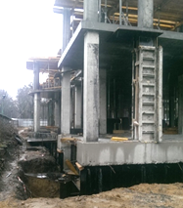

Figure 1 ‒ A case of local compression

Review of the research sources and publications
At the National University “Yury Kondratyuk Poltava Polytechnic” a variational method in the theory of plasticity of concrete is proposed as a theoretical basis for calculating the strength of concrete (fiber concrete) members under local compression [1]. The general sequence of tasks is as follows: the failure character is modeled for the case under consideration (a cinematically possible failure scheme is created: with the help of unknown geometric parameters, the outline of the failure surface is outlined and the directions of movement (velocities) of individual discs separated by the failure surface are set); as a rule, geometric parameters are the angles of inclination of the failure areas to the vertical; at the same time, they operate with relative values of velocities; there are velocity jumps on the sections of the failure surface and their area; the functional of the method is recorded, the corresponding mathematical transformations are performed; the functional is examined for a stationary state, in the process of which a formula is derived for calculating the ultimate load in the function from unknown parameters; this function is studied for the extremum (unconditional during translational motion of rigid disks on the kinematic scheme or conditional in another case: equilibrium equations are used as additional conditions); the ultimate load value is determined.
The variational method in the theory of plasticity [2] solved the problem of the strength of concrete (fiber concrete) members with one-sided central crushing, while taking into account the ratio of the length of the loading platform to the height (cross-sectional dimensions) of the member, the scheme and method of load transfer, the type of concrete (both characteristics of its strength); impact of basalt fiber.
Analysis of experimental studies of the bearing capacity of fiber concrete members under local compression [3 – 8] indicates their insufficient number. As a rule, the variable parameters were the volumetric percentage of fiber reinforcement (only steel), the ratio of the load area to the cross-sectional dimensions of the sample; both cubes and prisms were used as test samples.

Definition of unsolved aspects of the problem
Basalt fiber was not used in crushing experiments. According to experimental studies [7], the optimal dimensions of basalt fiber are – length 12 mm, diameter 20 μm, percentage content – 0.2%. At the same time, the tensile and compressive strength increases significantly compared to unreinforced concrete [9].

Problem statement
The purpose of the work is to compare the strength of concrete (fiber concrete) memders under local compression, calculated according to the proposed method, with experimental data, including those obtained by the authors.

Basic material and results
The method of manufacturing and testing experimental samples is given in [10]. According to the test results of standard cubes and prisms, which were made together with the test samples, the average value of the cubic strength of heavy concrete without the
use of plasticizer is f_{cm.cube} = 28.7 MPa, with the
use of plasticizer f_{cm.cube} = 33.1 MPa, fiber concrete f_{cm.cube} = 39.8 MPa (20% increase). The average value of the prism strength and the tensile strength, respectively, are f_{cm.prizm} = 22.7 MPa, f_{ctm} = 1.6 MPa; f_{cm.prizm} = 27.2 MPa, f_{ctm} = 1.8 MPa; f_{cm.prizm} = 35.1 MPa (29% increase), f_{ctm} = 2.3 MPa (28% increase). There is a steady tendency to increase the value of the strength characteristics both when adding a plasticizer and when it is combined with basalt fiber, while both the prismatic strength and the tensile strength increased by almost the same amount.
Table 1 presents the results of experimental studies. The addition of basalt fiber increases the resistance of concrete to local compression.

Table 1 – Results of experimental studies
№  of sample | Sample key | №  of batch | Load, t | Strength, f_{loc,} MPa | f_{loc}/ f_{c,prizm}
1 | F1КС50 | 1 | 14.2 | 56.8 | 1.62
2 | F1КС100 | 1 | 36.86 | 73.71 | 2.1
3 | F1КС150 | 1 | 32.9 | 43.86 | 1.25
4 | В2КС50 | 2 | 21.22 | 84.86 | 3.12
5 | В2КС100 | 2 | 25.2 | 50.4 | 1.85
6 | В2КС150 | 2 | 25.9 | 34.5 | 1.27
7 | В3КС50 | 3 | 17.2 | 68.8 | 3.03
9 | В3КС100 | 3 | 29.85 | 59.7 | 2.63
10 | В3КС150 | 3 | 23.84 | 31.79 | 1.40

In Table 1, the following marking of test samples is adopted: B – heavy concrete or F ‒ fiber concrete (the first letter in the marking); 1 (with the addition of the addition of only a plasticizer), 3 (basic composition) – series number; КС – type of experimental sample (standard cubes were tested for local compression (fig. 2); 50, 100, 150 (fig. 3) – the stamp width b_{loc} when the load is applied locally, mm (the stamp length l_{loc} for all samples is the same and is equal to 50 mm).

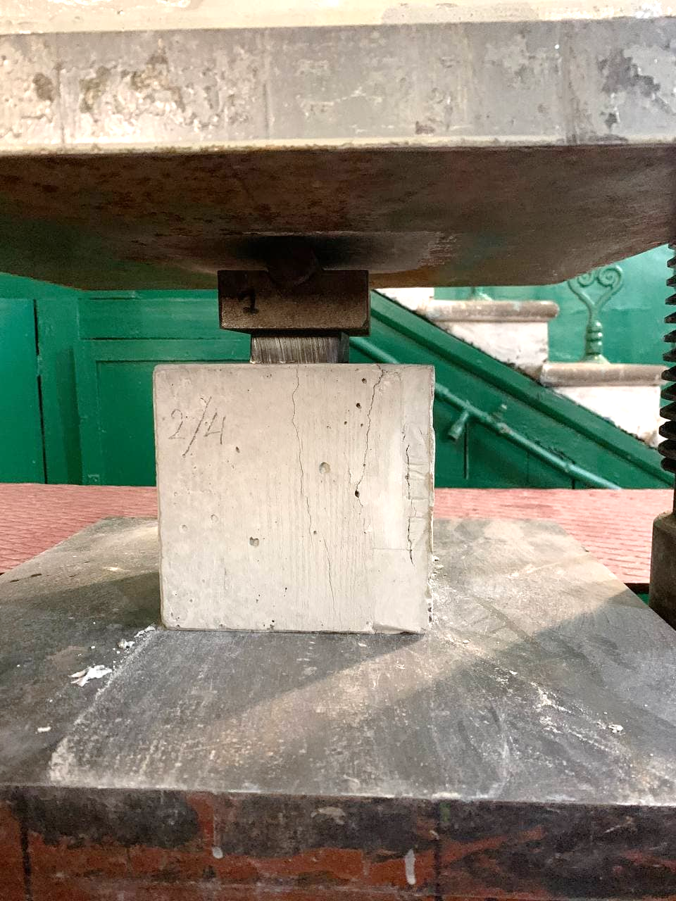

Figure 2 ‒ Sample testing for local compression in the press ПГ-125

In the process of experimental research, failure character of cubes during central one-sided compression was revealed, which was taken as a basis for theoretical calculations under the conditions of a space stress state: the sample is divided into three parts: a pyramid with a square (fig. 4) or rectangular (fig. 5) base, which is equal to the load platform, two halves of a cube, separated by a splitting plane and a shear surface, which move away from each other in the horizontal plane.

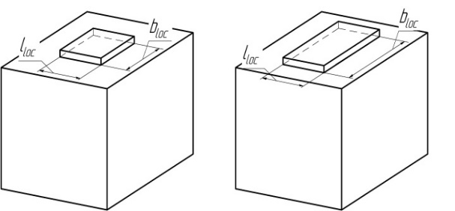

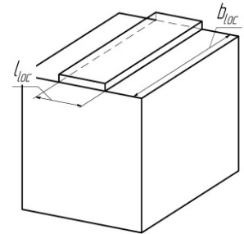

Figure 3 ‒ Loading scheme of cubes with size 150×150×150 mm through stamps with size l_{loc}×b_{loc} = 50×50 mm, 50×100 mm, 50×150 mm

The obtained results confirm the data of the study of strength to local compression of concrete obtained by other authors [11-15].
In order the features of the structures in the ultimate state. to ensure the reliability of the proposed calculation method, it is important to create a cinematically possible scheme for the members failure, which should take into account.
There is also an asymmetric failure character under symmetrical loading (fig. 6), which is explained by the concentration of stresses near the corners of the stamp and the heterogeneous structure of the concrete. The proposed calculation method allows you to take into account such case of failure by making changes to the cinematically possible scheme.

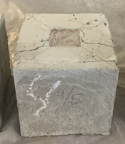
a

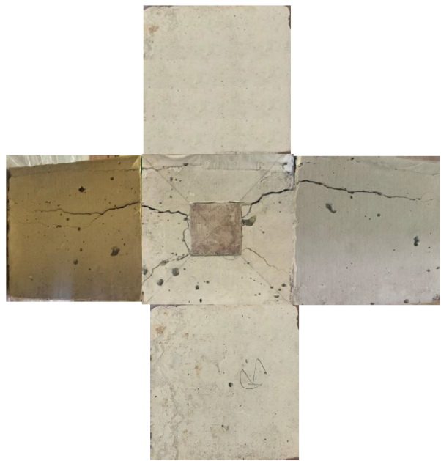
b

Figure 4 ‒ Failure character (a) and surface
view (b) of the destroyed sample В3КС50

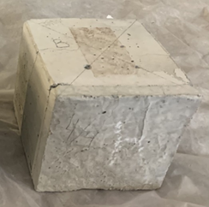
a

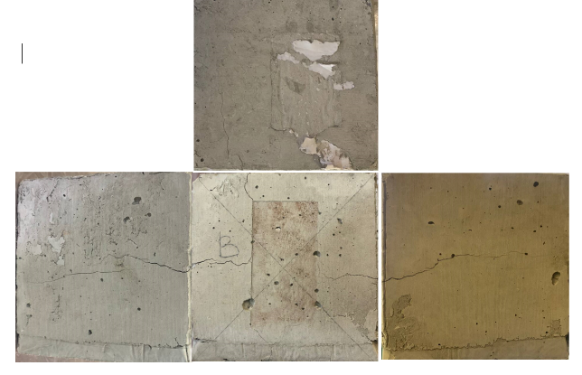
b

Figure 5 ‒ Failure character (a) and surface
view (b) of the destroyed sample В3КС100

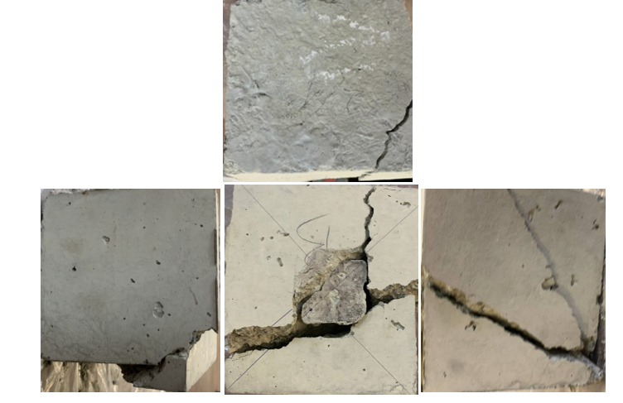

Figure 6 ‒ Surface view
of the destroyed sample F1КС50

The use of fiber does not fundamentally change the failure character of samples, but it becomes more plastic, stretched over time.
Changing the width of the loading platform (from a square to a strip stamp) affects the magnitude of local compressive stresses: within the limits of the experiment, the stress decreases up to 2 times (table 1).
The addition of basalt fiber increases the strength characteristics, reduces the probability of brittle failure and the presence of microcracks in concrete, and ultimately the resistance of concrete to local compression.
To confirm the validity of the proposed calculation method [1], a comparative analysis of the theoretical strength with the experimental strength was performed for 78 test samples tested by Gladyshev B.M.,
Piradov A.B., Dovzhenko O.O. and Mytrofanov V.P., Ince R. and Arici E., Au T. and Baird D.L., Keras V., Augonis M., Adamukaitis N., Vaitekūnaitė E. and authors [10] with parameters that differed significantly: the dimensions of the cube varied from 50 mm to 300 mm; ratio h/l_{loc} (ratio of the height of the cube to the length of the loading platform) was from 1 to 6.67; value of concrete tensile strength f_{ct} was from 0.4 MPa to 4.8 MPa; value of concrete strength under compression f_{c} was from 3.87 MPa to 48 MPa; samples were concrete and fiber concrete: steel fiber content was from 25 kg/m³ to 40 kg/m³, basalt fiber was 18 kg/m³. It should be noted that all test samples were loaded with a square stamp, a rectangular stamp was used only in the author’s experiments.
The results of the comparison are presented in tables 2, 3, 4 and in fig. 7.

Table 2 – Comparison of the theoretical strength calculated according
to the variational method with the experimental one for concrete cubes

№ | l×b×h,  cm | l_{loc},  cm | α = h / l_{loc} | χ = f_{ct} / f_{c}
1 | 2 | 3 | 4 | 5 | 6 | 7 | 8
Samples of Gladyshev B.M. [11]
1 | 20×20×20 | 5 | 4 | 0.103 | 4.85 | 5.07 | 1.04
2 | 20×20×20 | 5 | 4 | 0.109 | 4.24 | 5.12 | 1.21
3 | 20×20×20 | 5 | 4 | 0.099 | 4.81 | 4.99 | 1.04
4 | 20×20×20 | 5 | 4 | 0.099 | 4.96 | 4.99 | 1.01
5 | 20×20×20 | 5 | 4 | 0.103 | 3.47 | 3.85 | 1.11
6 | 15×15×15 | 5 | 3 | 0.079 | 3.06 | 3.60 | 1.17
7 | 25×25×25 | 10 | 2.5 | 0.119 | 2.88 | 3.53 | 1.22
Piradov A.B. [12]
1 | 30×30×30 | 5 | 5 | 0.05 | 5.34 | 5.48 | 1.03
2 | 20×20×20 | 3 | 3 | 0.103 | 8.99 | 8.73 | 0.97
3 | 20×20×20 | 3 | 3 | 0.099 | 8.05 | 8.55 | 1.06
4 | 20×20×20 | 3 | 3 | 0.057 | 6.75 | 6.47 | 0.96
5 | 15×15×15 | 3 | 3 | 0.079 | 5.28 | 5.62 | 1.07
6 | 20×20×20 | 3 | 3 | 0.094 | 8.05 | 8.32 | 1.03
7 | 20×20×20 | 3 | 3 | 0.099 | 8.60 | 8.55 | 0.99
Dovzhenko O.O., Mytrofanov V.P. [13]
1 | 20×20×20 | 5 | 4 | 0.08 | 4.11 | 4.55 | 1.11
2 | 15×15×15 | 5 | 3 | 0.08 | 3.07 | 3.59 | 1.17
3 | 15×15×15 | 5 | 3 | 0.08 | 2.73 | 3.59 | 1.31
Ince R., Arici E. [14]
1 | 5×5×5 | 2 | 2.5 | 0.13 | 4.72 | 3.61 | 0.76
2 | 10×10×10 | 4 | 2.5 | 0.13 | 3.45 | 3.61 | 1.05
3 | 20×20×20 | 8 | 2.5 | 0.13 | 2.9 | 3.61 | 1.24
4 | 5×5×5 | 2 | 2.5 | 0.09 | 4.23 | 3.32 | 0.78
5 | 10×10×10 | 4 | 2.5 | 0.09 | 3.64 | 3.32 | 0.91
6 | 20×20×20 | 8 | 2.5 | 0.09 | 2.7 | 3.32 | 1.23
7 | 5×5×5 | 4 | 2.5 | 0.09 | 3.99 | 3.32 | 0.83
8 | 10×10×10 | 8 | 2.5 | 0.09 | 3.25 | 3.32 | 1.02
9 | 20×20×20 | 4 | 2.5 | 0.09 | 3.57 | 3.29 | 0.92
10 | 5×5×5 | 2 | 2.5 | 0.07 | 4.39 | 3.14 | 0.72
11 | 10×10×10 | 4 | 2.5 | 0.07 | 3.46 | 3.14 | 0.91
12 | 20×20×20 | 8 | 2.5 | 0.07 | 2.45 | 3.14 | 1.28
13 | 10×10×10 | 2.5 | 4 | 0.09 | 6.36 | 4.90 | 0.77
14 | 20×20×20 | 5 | 4 | 0.09 | 4.83 | 4.90 | 1.01
Au T. and Baird D. L. [15]
1 | 10×10×10 | 10 | 1 | 0.09 | 2.06 | 2.46 | 1.19
2 | 10×10×10 | 8 | 1.25 | 0.09 | 2.77 | 2.66 | 0.96

Table 3 – Comparison of the theoretical strength calculated according
to the variation method with the experimental strength according
to the authors’ data for concrete samples

№ | l×b×h,  cm | l_{loc},  cm | α = h / l_{loc} | χ = f_{ct} / f_{c}
1 | 2 | 3 | 4 | 5 | 6 | 7 | 8
1 | 15×15×15 | 5 | 3 | 0.07 | 3.62 | 3.48 | 0.96
2 | 15×15×15 | 10 (5) | 3 | 0.07 | 2.29 | 2.47 | 1.08
3 | 15×15×15 | 15 (5) | 3 | 0.07 | 1.95 | 2.25 | 1.15
4 | 15×15×15 | 5 | 3 | 0.06 | 3.55 | 3.42 | 0.96
5 | 15×15×15 | 10 (5) | 3 | 0.06 | 2.26 | 2.46 | 1.08
6 | 15×15×15 | 15 (5) | 3 | 0.06 | 1.93 | 2.25 | 1.16
7 | 15×15×15 | 5 | 3 | 0.06 | 3.54 | 3.41 | 0.96
8 | 15×15×15 | 15 (5) | 3 | 0.06 | 1.93 | 2.25 | 1.16

Table 4 – Comparison of theoretical strength with experimental strength for fiber concrete samples

№ | l×b×h,  cm | l_{loc},  cm | Content of metal fibers, kg/m³ | α = h / l_{loc} | χ = f_{ct} / f_{c}
1 | 2 | 3 | 4 | 5 | 6 | 7 | 8 | 9
Samples of Keras V., Augonis M., Adamukaitis N., Vaitekūnaitė E. [7]
1 | 15×15×15 | 3 | 25 | 5 | 0.17 | 6.06 | 6.58 | 1.08
2 | 15×15×15 | 3 | 25 | 5 | 0.17 | 6.06 | 5.41 | 0.89
3 | 15×15×15 | 3 | 25 | 5 | 0.17 | 6.06 | 6.72 | 1.10
4 | 15×15×15 | 3 | 25 | 5 | 0.17 | 6.06 | 5.59 | 0.92
5 | 15×15×15 | 3 | 25 | 5 | 0.17 | 6.06 | 6.58 | 1.08
6 | 15×15×15 | 3 | 30 | 5 | 0.15 | 5.75 | 5.03 | 0.87
7 | 15×15×15 | 3 | 30 | 5 | 0.15 | 5.75 | 5.21 | 0.90
8 | 15×15×15 | 3 | 30 | 5 | 0.15 | 5.75 | 5.35 | 0.93
9 | 15×15×15 | 3 | 30 | 5 | 0.15 | 5.75 | 4.34 | 0.75
10 | 15×15×15 | 3 | 30 | 5 | 0.15 | 5.75 | 5.97 | 1.04
11 | 15×15×15 | 3 | 35 | 5 | 0.19 | 6.36 | 7.15 | 1.12
12 | 15×15×15 | 3 | 35 | 5 | 0.19 | 6.36 | 6.62 | 1.04
13 | 15×15×15 | 3 | 35 | 5 | 0.19 | 6.36 | 6.62 | 1.04
14 | 15×15×15 | 3 | 35 | 5 | 0.19 | 6.36 | 7.77 | 1.22
15 | 15×15×15 | 3 | 35 | 5 | 0.19 | 6.36 | 7.06 | 1.11
16 | 15×15×15 | 3 | 40 | 5 | 0.15 | 5.75 | 6.14 | 1.06
17 | 15×15×15 | 3 | 40 | 5 | 0.15 | 5.75 | 5.56 | 0.96
18 | 15×15×15 | 3 | 40 | 5 | 0.15 | 5.75 | 5.02 | 0.87
19 | 15×15×15 | 3 | 40 | 5 | 0.15 | 5.75 | 4.79 | 0.83
20 | 15×15×15 | 3 | 40 | 5 | 0.15 | 5.75 | 5.63 | 0.98
21 | 15×15×15 | 5.3 | 25 | 2.83 | 0.05 | 3.12 | 3.33 | 1.06
22 | 15×15×15 | 5.3 | 25 | 2.83 | 0.05 | 3.12 | 2.37 | 0.76
23 | 15×15×15 | 5.3 | 25 | 2.83 | 0.05 | 3.12 | 2.90 | 0.93
24 | 15×15×15 | 5.3 | 25 | 2.83 | 0.05 | 3.12 | 2.97 | 0.95

Continuation of Table 4
1 | 2 | 3 | 4 | 5 | 6 | 7 | 8 | 9
25 | 15×15×15 | 5.3 | 30 | 2.83 | 0.05 | 3.12 | 3.15 | 1.01
26 | 15×15×15 | 5.3 | 30 | 2.83 | 0.05 | 3.12 | 3.29 | 1.05
27 | 15×15×15 | 5.3 | 30 | 2.83 | 0.05 | 3.12 | 3.11 | 0.99
28 | 15×15×15 | 5.3 | 30 | 2.83 | 0.05 | 3.12 | 3.22 | 1.03
29 | 15×15×15 | 5.3 | 35 | 2.83 | 0.11 | 3.27 | 4.17 | 1.06
30 | 15×15×15 | 5.3 | 35 | 2.83 | 0.11 | 3.27 | 4.31 | 1.1
31 | 15×15×15 | 5.3 | 35 | 2.83 | 0.11 | 3.27 | 4.40 | 1.12
32 | 15×15×15 | 5.3 | 35 | 2.83 | 0.11 | 3.27 | 4.13 | 1.05
33 | 15×15×15 | 5.3 | 40 | 2.83 | 0.05 | 3.12 | 3.27 | 1.05
34 | 15×15×15 | 5.3 | 40 | 2.83 | 0.05 | 3.12 | 3.03 | 0.97
35 | 15×15×15 | 5.3 | 40 | 2.83 | 0.05 | 3.12 | 3.07 | 0.98
36 | 15×15×15 | 5.3 | 40 | 2.83 | 0.05 | 3.12 | 3.14 | 1.00

According to the data of tables 2-4 and fig. 7, it can be claimed that the results obtained by the proposed method are fairly close to the experimental data: the average arithmetic value of the ratio of theoretical strength to experimental strength is m=1.02 with a coefficient of variation ν=13.16%.

Similarly, a comparative analysis of the theoretical strength calculated according to the standards [17 - 22] and some author’s methods showed much worse statistical indicators: the best convergence is given by the standard method of DSTU [18] , , the worst one – by the method of ACI and NZ standards [21, 22], , , among the authors’ methods the best indicators were of the proposed method by V.G. Kvasha [23]: , , the worst indicators – S.K. Niyogi [24] , .

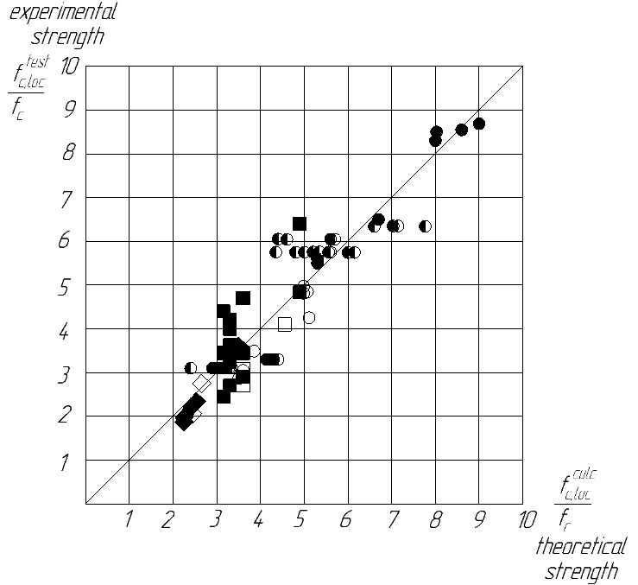 | Experimental data: 

Figure 7 ‒ Comparison of the theoretical strength obtained
by the variational method with the experimental one

Conclusions
The failure character of cubes under one-sided central local compression, which is taken as a basis for theoretical calculations under the conditions of a space stress state, has been confirmed. The use of basalt fiber (length 12 mm, diameter 20 μm, percentage content - 0.2%) does not fundamentally change the failure character of the samples, but it occurs more plastically.
Changing the width of the loading platform (from a square to a strip stamp) affects the magnitude of local compression stresses: within the limits of the experiment, they decrease up to 2 times. The addition of basalt fiber increases the strength characteristics of concrete (by approximately 25% the in compression and tension), reduces the probability of brittle failure and the presence of microcracks in concrete, and ultimately increases the resistance of concrete to local compression.

The statistical indicators of the comparison of the theoretical strength, calculated according to the proposed method, with the experimental one (arithmetic mean value of the theoretical strength to the experimental one with the coefficient of variation ) indicate their sufficient proximity and allow recommending the variational method in the theory of concrete plasticity as a method for calculating the strength of concrete (fiber concrete) under local compression.

References
1. Kuznietsova I., Dovzhenko O., Pohribnyi V., Usenko I. (2020). Influence of the sizes and the loading platform form on the strength of concrete elements at local compression. Proceedings of the 2020 Session of the 13th fib International PhD Symposium in Civil Engineering, 2020, 63-69 |  | 1. Kuznietsova I., Dovzhenko O., Pohribnyi V., Usenko I. (2020). Influence of the sizes and the loading platform form on the strength of concrete elements at local compression. Proceedings of the 2020 Session of the 13th fib International PhD Symposium in Civil Engineering, 2020, 63-69
2. Кузнєцова І., Довженко. О., Погрібний В. (2021). Міцність бетону за місцевого стиснення з урахуванням відношення висоти елемента до розміру ділянки навантаження. Український журнал будівництва та архітектури, 5(005), 61-67  https://doi.org/10.30838/J.Bpsacea.2312.261021.61.802 |  | 2. Kuznietsova I., Dovzhenko O., Pohribnyi V. (2021). Strength of concrete under local compression taking into account the relationship of the element height to the size of the loading area. Ukrainian Journal of Civil Engineering and Architecture, 5(005), 61-67.https://doi.org/10.30838/J.Bpsacea.2312.261021.61.802
3. Chen W.F., Carson J.L. (1974). Bearing capacity of fiber reinforced concrete. ACI Special Publication, SP–44, 209-220 |  | 3. Chen W.F., Carson J.L. (1974). Bearing capacity of fiber reinforced concrete. ACI Special Publication, SP–44, 209-220
4. Kameswara Rao C.V.S. (1974). Bearing strength of steel fibre reinforced concrete. Building Science, 9(4), 263-268 |  | 4. Kameswara Rao C.V.S. (1974). Bearing strength of steel fibre reinforced concrete. Building Science, 9(4), 263-268
5. Al-Taan S.A. (2005). Bearing capacity of steel fibrous concrete. Al-Rafidain Engineering, 14(1), 1-11 |  | 5. Al-Taan S.A. (2005). Bearing capacity of steel fibrous concrete. Al-Rafidain Engineering, 14(1), 1-11
6. Breitenbücher R. (2014). Experimental and numerical study on the load-bearing behavior of steel fiber reinforced concrete for precast tunnel lining segments under concentrated loads. Proceedings of Joint ACI-fib International Workshop: Fibre Reinforced Concrete: from Design to Structural Applications, 431-443 |  | 6. Breitenbücher R. (2014). Experimental and numerical study on the load-bearing behavior of steel fiber reinforced concrete for precast tunnel lining segments under concentrated loads. Proceedings of Joint ACI-fib International Workshop: Fibre Reinforced Concrete: from Design to Structural Applications, 431-443
7. Keras V., Augonis M., Adamukaitis N., Vaitekūnaitė E. (2015). Research of local compression concrete reinforced by steel fibres. Journal of Sustainable Architecture and Civil Engineering, 2(No. 11, 72-78.  https://doi.org/10.5755/j01.sace.11.2.12568 |  | 7. Keras V., Augonis M., Adamukaitis N., Vaitekūnaitė E. (2015). Research of local compression concrete reinforced by steel fibres. Journal of Sustainable Architecture and Civil Engineering, 2(No. 11, 72-78.  https://doi.org/10.5755/j01.sace.11.2.12568
8. Song F. (2017). Steel fiber reinforced concrete under concentrated load. Dissertation for the degree Doctor of Engineering (Dr.-Ing.). Ruhr University, Bochum |  | 8. Song F. (2017). Steel fiber reinforced concrete under concentrated load. Dissertation for the degree Doctor of Engineering (Dr.-Ing.). Ruhr University, Bochum
9. Новицкий А.Г. (2010). Аспекты применения базальтовой фибры для армирования бетонов. Науково-технічний збірник «Будівельні матеріали, вироби та санітарна техніка» Київ, Вип. 36, 22-26 |  | 9. Novitsky A.G. (2010). Aspects of the use of basalt fiber for concrete reinforcement. Scientific and technical collection "Construction materials, products and sanitary equipment" Kyiv, Vol. 36, 22-26
10. Кузнєцова І. (2022). Міцність фібробетонних елементів при місцевому стисненні. Findings of modern engineering research and developments: Scientific monograph. Riga, Latvia: «Baltija Publishing», 214-232  https://doi.org/10.30525/978-9934-26-207-4-8 |  | 10. Kuznietsova I. (2022). Strength of fiber concrete elements under local compression. Findings of modern engineering research and developments: Scientific monograph. Riga, Latvia: «Baltija Publishing», 214-232  https://doi.org/10.30525/978-9934-26-207-4-8
11. Гладышев Б.М. (1987). Механическое взаимодействие элементов структуры и прочность бетона. Вища школа |  | 11. Gladyshev B.M. (1987). Mechanical interaction of structural elements and concrete strength. High school
12. Пирадов А.Б. (1973). Конструктивные свойства лёгкого бетона и железобетона. Строиздат |  | 12. Piradov A.B. (1973). Structural properties of lightweight concrete and reinforced concrete. Stroyizdat
13. Довженко О.А. (1993). Прочность бетонных и железобетонных элементов при местном приложении сжимающей нагрузки: дис. канд. техн. наук: спец. 05.23.01. Полтава: ПДТУ |  | 13. Dovzhenko O. (1993). Strength of concrete and reinforced concrete elements under local application of a compressive load: dissertation of candidate of technical sciences: spec. 05.23.01. Poltava: PSTU
14. Ince R. (2004). Size effect in bearing strength of concrete cubes. Construction and Building Materials, 18, 603-609  https://doi.org/10.1016/j.conbuildmat.2004.04.002 |  | 14. Ince R. (2004). Size effect in bearing strength of concrete cubes. Construction and Building Materials, 18, 603-609  https://doi.org/10.1016/j.conbuildmat.2004.04.002
15. Au T. (1960). Bearing capacity of concrete blocks. Journal of the America Concrete Institute, 56, 869-880 |  | 15. Au T. (1960). Bearing capacity of concrete blocks. Journal of the America Concrete Institute, 56, 869-880
16. Cao H. (2017). Experimental investigation on the static and impact behaviors of basalt fiber-reinforced concrete. The Open Civil Engineering Journal, 11(1), 64-71  https://doi.org/10.2174/1874149501711010014 |  | 16. Cao H. (2017). Experimental investigation on the static and impact behaviors of basalt fiber-reinforced concrete. The Open Civil Engineering Journal, 11(1), 64-71  https://doi.org/10.2174/1874149501711010014
17. СНиП 2.03.01–84. (1989). Бетонные и железобетонные конструкции. ЦИТП Госстроя СССР |  | 17. SNiP 2.03.01–84. (1989). Concrete and reinforced concrete structures. CITP Gosstroy of the USSR
18. ДСТУ Б 2.6-156:2010 (2011). Бетонні та залізобетонні конструкції з важкого бетону. Правила проектування. Київ: Мінрегіонбуд України, Державне підприємство «Укрархбудінформ» |  | 18. DSTU B 2.6-156:2010 (2011). Concrete and reinforced concrete structures made of heavy concrete. Design rules. Kyiv, Ministry of Regional Construction of Ukraine, State enterprise "Ukrakhbudinform"
19. NS 3473:1994. (1994). Concrete structures. Design and detailing rules |  | 19. NS 3473:1994. (1994). Concrete structures. Design and detailing rules
20. DIN 4219-2: 1979. Leichtbeton und Stahlleichtbeton mit geschlossenem. Gefuge; Bemessung und Ausfuhrung |  | 20. DIN 4219-2: 1979. Leichtbeton und Stahlleichtbeton mit geschlossenem. Gefuge; Bemessung und Ausfuhrung
21. ACI 318-02. (2002). Building Code Requirements for Structural Concrete and Commentary (318-02R). American Concrete Institute, Farmington Hills, Mich |  | 21. ACI 318-02. (2002). Building Code Requirements for Structural Concrete and Commentary (318-02R). American Concrete Institute, Farmington Hills, Mich
22. NZ 3101.1:2004. (2004). Concrete Structures Standard: (draft) |  | 22. NZ 3101.1:2004. (2004). Concrete Structures Standard: (draft)
23. Кваша В.Г. (1966). Расчёт прочности железобетонных элементов при местном сжатии. Вопросы современного стоительства: Вестник Львовского политехнического института, 11, 5-14 |  | 23. Kvasha V.G. (1966). Calculation of the strength of reinforced concrete elements under local compression. Issues of modern construction: Bulletin of the Lviv Polytechnic Institute, 11, 5-14
24. Niyogi S.K. (1975). Concrete beaming strength-support, nix, size effect. Proc. of Amer. Soc. of Civil Eng. Journ. of the Structural Division, 100, 1685-1702 |  | 24. Niyogi S.K. (1975). Concrete beaming strength-support, nix, size effect. Proc. of Amer. Soc. of Civil Eng. Journ. of the Structural Division, 100, 1685-1702

