Збірник наукових праць. Галузеве машинобудування, будівництво

Academic journal. Industrial Machine Building, Civil Engineering

http://journals.nupp.edu.ua/znp

https://doi.org/10.26906/znp.2022.58.ХХХХ

UDC 624.042

Comparison of design methods for steel silos

Pichugin Sergii¹, Oksenenko Kateryna^{2*}

¹ National University «Yuri Kondratyuk Poltava Polytechnic» https://orcid.org/0000-0001-8505-2130
¹ National University «Yuri Kondratyuk Poltava Polytechnic» https://orcid.org/0000-0002-5171-3583
*Corresponding author E-mail: shvadchenkokate@gmail.com

The article describes the types of silos depending on the wall design. A review of the standard documents that are in force on the territory of Ukraine and regulate the determination of loads and forces in silos is carried out. The differences between the calculations of horizontal and vertical pressures on the walls of silos according to DBN B2.2-8-98 Enterprises, buildings and structures for grain storage and processing and DSTU-N B EN 1991-4:2012 Eurocode 1: Actions on structures – Part 4: Silos and tanks were analyzed. The design formulas for defining pressures according to two standards are given. The spreads of statistical properties of particulate solids are analyzed. The normative horizontal pressure and vertical frictional pressures for a flexible silo were calculated according to two standards. Graphs of horizontal and vertical pressures of particulate solids material on the walls of a flexible silo are presented. According to the calculations, it is concluded that the spreads of statistical properties of particulate solids has a significant impact on the magnitude of loads on the vertical walls of silos. It is noted that the value of the wall friction coefficient has a significant impact on the calculation of horizontal pressure

Keywords: silo, horizontal pressure, vertical pressure, friction forces, particulate solids

Порівняння методик розрахунку конструкцій сталевих силосів

Пічугін С.Ф¹, Оксененко К.О.^{1*}

^{1, 2} Національний університет «Полтавська політехніка імені Юрія Кондратюка»
*Адреса для листування E-mail: shvadchenkokate@gmail.com

У статті розглянуто типи силосних емностей, в залежності від конструкції стінки. Проведений огляд нормативних документів, які діють на території України, що регламентують питання визначення навантажень та зусиль в силосних ємностях. Проаналізовано відмінності між розрахунками горизонтальних та вертикальних тисків на стіни силосів за ДБН В2.2-8-98 Підприємства, будівлі та споруди по зберіганню та переробці зерна та ДСТУ-Н Б EN 1991-4:2012 Єврокод 1. Дії на конструкції. Ч. 4. Бункери і резервуари. Наведені розрахункові формули, для визначення тисків за двома стандартами. Проведено порівняння значень питомої ваги γ, кута природнього укосу ϕ_{r}, кута внутрішнього тертя ϕ_{i} та коефіцієнта бокового тиску К різних сільськогосподарських культур за двома стандартами. Визначені нижні та верхні характеристичні значення таких сипких матеріалів: пшениця, кукурудза, ячмінь та соя. Проаналізовані розкиди статистичних характеристик сипкого матеріалу. Проведені розрахунки нормативних горизонтального тиску та вертикального від сил тертя тисків для гнучкого силосу за двома нормами. Наведені графіки значень горизонтального та вертикального тисків сипкого матеріалу на стіни гнучкого. На основі розрахунків зроблено висновок, що розкид статистичних характеристик сипких матеріалів, має значний вплив на величину навантажень на вертикальні стіни силосних ємностей. Відзначено що, значення коефіцієнту тертя об стіни має значний вплив на розрахунок горизонтального тиску

Ключові слова: силос, горизонтальний тиск, вертикальний тиск, сили тертя, сипкий матеріал

Introduction
Metal capacitive structures for storing various types of particulate solids are among the most common types of building structures. Silo dimensions, shape, foundation support methods, and layout are determined in accordance with the requirements of the technological process, loading and unloading conditions, and technical and economic factors. Silos are produced in round, square, rectangular, hexagonal and polygonal shapes. Round silos are preferred because they are easy to manufacture. With this shape, the walls are mainly subject to tensile forces. Therefore, their thickness can be small. Depending on the wall construction, metal silos are of the following types: welded silos, panel silos, and spiral-fold silos [1].
The body of a welded silo (Fig. 1a) consists of metal sheets that are welded together. The advantages of such silos are tightness and durability. Welded silos are designed to store particulate solids with the smallest particle size, such as cement, coke, slag, and others. The disadvantages of these structures are high material consumption and a large number of welds.
The body of the panel silo (Fig. 1b) is made of corrugated or smooth panels connected to each other with bolts. The advantages of panel silos are the ability to perceive a large radial load from the material, the absence of welds, high strength. The disadvantages of this version of silos are a large number of bolted connections. This type of silo construction is the most common in Ukraine and abroad for storing grain crops.
One of the most progressive types of thin-walled spatial structures are highly industrial and economic metal silos of the spiral-fold type (Fig. 1c). The construction of the silo was developed in 1968 by the German scientist Xaver Lipp [2], who used special equipment for processing sheet metal and applied it to the construction of spiral-wound silos. The first such silo was built in Germany in 1969. The spiral-fold silo has a cylindrical body, which is a system of spiral connection of steel strips. The formation of the body of the spiral-fold silo is based on the continuous building up of the wall structure from below, with the simultaneous bending of the steel strip along the arc of a circle and the connection of the bent longitudinal edges of the strip by double rolling into a closed-type fold lock. The advantages of these silos are: high degree of automation and speed of installation; minimizing the human factor in the installation good sealing, water resistance; it is possible to store waste water, oil, petroleum products, cement and other materials; when using stainless steel it is possible to store food; alcohol, wine, flour, malt, molasses, sunflower oil, etc;
The disadvantages spiral-fold silos are: for installation, the silo assembly equipment must be transported to the construction site, which increases the cost of production.

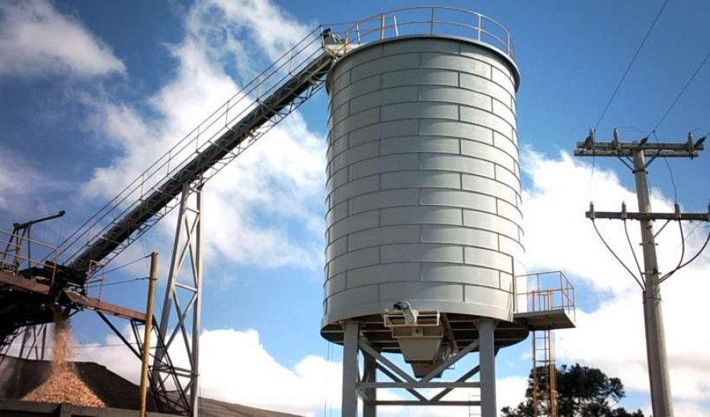
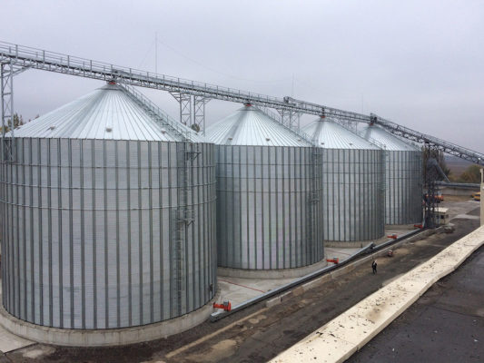
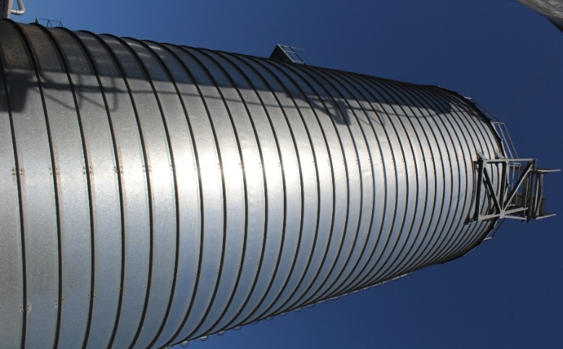

a)

b)

c)

Figure 1 - Types of metal silos:
a – welded silo; b – panel silo;
c – spiral-fold silo
Review of the research sources and publications
A number of domestic and foreign scientists were involved in the analysis of structures, calculation methods and experimental studies of cylindrical shells of metal silos for strength and stability [1-7]. The behavior and physical characteristics of bulk material in silos were studied and described in detail by Kachurenko V. [3]. Bannikov D. presented his theoretical concept of the interaction of particulate solids with elements of capacitive building structures in his monograph [4]. Selamovic I. and Balevicius R. analyzed in detail the influence of rolling friction on the distribution of wall pressure and speed inside the flowing material [5]. Schultz D. discusses the general characteristics of particulate solids, starting from the flow properties of solid particles to the flow behavior of powders and particulate materials in bins and silos [6]. Coelho L. and Calil С. in their work [7] presented software for calculating the pressure in cylindrical silos, taking into account all the requirements of the European standard EN 1991-4 2006 [8]. Bibik M. and Moroz P. compared Ukrainian and European standards in their work [9] and made calculations according to both standards, depending on the flexibility of silos.

Definition of unresolved aspects of the problem
The main normative document in Ukraine that regulates the design of steel silos, classification of their structures, determination of loads and forces in the elements is DBN B2.2-8-98 Enterprises, buildings and structures for storage and processing of grain [8], which was issued to replace SNiP 2.10.05-85 Enterprises, buildings and structures for storage and processing of grain [9]. Another normative document in Ukraine is DSTU-N B EN 1991-4:2012 Eurocode 1: Actions on structures – Part 4: Silos and tanks. [10], which defines the effects on silo structures. Since these two documents are valid on the territory of Ukraine and are in slightly different positions, the question of their comparison arises.

Problem statement
The purpose of this article is to review the normative documents which regulate the determination of loads and forces in silos and compare them.

Basic material and results
Normative documents of Ukraine. The main normative document in Ukraine that regulates the design of metal structures, including thin-walled shells, is DBN B.2.6-198:2014 Steel Structures [11]. This document contains general recommendations for assessing the strength and stability of torsional shells. Other normative documents in Ukraine are DBN B2.2-8-98 [8], which regulates the design of silos, classification of their structures, determination of loads and forces in elements, and DSTU-N B EN 1991-4:2012 [10], which defines only the effects on structures. These two documents regulate the principles for the calculation of loads from particulate solids that occur inside the silos.
DBN B2.2-8-98. According to these norms, the main loads and influences on the silo are: horizontal and vertical (due to friction) loads from the pressure of particulate solids, taking into account the central unloading of the silo; own weight of the structure; load from snow on the surface; influence of temperature; load from thermal suspensions; load from wind pressure (for an unfilled silo).
Normative horizontal pressure , vertical pressure from frictional forces and vertical pressure on the bottom of the silo from the action of particulate solids are determined by the formulas:
, (1)
, (2)
, (3)
where ρ is the hydraulic radius of the cross-section of the silo, m, which is determined by the formula ρ = A/U;
A, U are area and perimeter of the silo cross-section, respectively, m² and m;
λ is the lateral pressure ratio of particulate solids, λ is characterized by the ratio of the average values of horizontal and vertical pressure according to p. 4.6 [8] and is determined by the formula: ;
e is the base of the natural logarithm;
γ is bulk unit weight, kgf/m³, taken according to tab. A.1 [8];
φ is the angle of internal friction, degrees, taken according to tab. A.1 [17];
f is coefficient of wall friction, taken according to tab. A.1 [8].
Also, for the walls of steel round sheet silos not reinforced with ribs, the annular horizontal pressure is taken into account , which is determined by the formula: = a₁,
where a₁ is the coefficient of local pressure increase, which is taken in accordance with the requirements of 4.11. [8] depending on the h/d ratio;
h is height of silo from the hopper apex to the equivalent surface, m.
The sum of the limit calculated values of uniformly distributed horizontal pressures with the limit calculated values of annular horizontal pressures is determined by the formula:
, (4)
where γ_{fm} is load reliability factor.
DSTU-N B EN 1991-4:2012. This normative document assumes that the value of loads during the movement of particulate solids in a silo structure depends on the flexibility of the structure, the class of impacts, the category of the wall surface, and the amount of eccentricity after loading and during discharge. In this regard, various procedures are given for determining the horizontal pressure p_{hf}, wall frictional traction p_{wf} and vertical pressure p_{vf} which are applied to the silo body after loading and symmetrical pressures during discharge p_{he} and p_{we}. Symmetrical loads after filling and during storage for slender silos are determined by the formulas given in Table 1.

Table 1 – Formulas for determining the loads on the vertical walls of slender silos

Loads on the vertical walls of slender silos | Loads after loading | Loads during discharge
Horizontal pressure
Wall frictional traction
Substitute uniform pressure increase for patch loads
Notes: , ,

Definitions in Table 1:
γ is the characteristic value of the unit weight;
μ is the characteristic value of the wall friction coefficient for solid sliding on the vertical wall;
K is the characteristic value of the lateral pressure ratio;
z is the depth below the equivalent surface of the solid;
A is the plan cross-sectional area of the silo;
U is the internal perimeter of the plan cross-section of the silo;
C_{h} horizontal pressure discharge factor (load magnifying factor);
C_{w} wall frictional traction discharge factor (load magnifying factor);
C_{pf} filling patch load factor (load magnifying factor);
C_{pe} discharge patch load factor (load magnifying factor)
The characteristic values of the particulate solids are taken in accordance with E.1 [10].
It should be noted that when determining the maximum load p_{hf}, p_{wf}, p_{vf} for a cylinder, different extreme values of the properties of particulate solids are used (Table 2).
Table 3 shows the values of particulate solids
γ, ϕ_{r}, ϕ_{i}, К which are taken into account in the calculations of horizontal and vertical loads, depending on the design standards.
As it can be seen from Tab. 3, the differences in the values of the weight γ are insignificant. At the same time, the angle of repose ϕ_{r}, аngle of internal friction φ₁ and the lateral pressure ratio K have significant deviations. In Table 4 values of the wall friction coefficient are given.

Table 2 – Values of properties to be used for different wall loading assessments

For the vertical wall or cylinder | Characteristic value to be adopted
For the vertical wall or cylinder | Wall friction  coefficient μ | Lateral pressure ratio K | Weight γ
Maximum normal pressure on vertical wall | Lower | Upper | Upper
Maximum frictional traction on vertical wall | Upper | Upper | Upper
Maximum vertical load on hopper or silo bottom | Lower | Lower | Upper

Table 3 – Value of weight γ, angle of repose ϕ_{r}, аngle of internal friction φ₁
and lateral pressure ratio K of agricultural crops

Normative document | The type of particulate solids | Weight γ, kN/m³ | Angle of repose ϕ_{r} | Angle of internal friction φ₁ | Lateral pressure ratio K
DBN | All grains and legumes | 8 | 25 | 25 | 0.406
DSTU | Wheat | 7.5* – 9** | 34 | 27* – 34** | 0.49* – 0.6**
DSTU | Corn | 7* – 8** | 35 | 27* – 35** | 0.46* – 0.6**
DSTU | Barley | 7* – 8** | 31 | 24* – 32** | 0.53* – 0.65**
DSTU | Soy | 7* – 8** | 29 | 22* – 29** | 0.57* – 0.7**
Notes: * lower characteristic value; ** upper characteristic value of weight γ taken according to tab. E.1 DSTU;
* lower characteristic value; ** the upper characteristic value of the аngle of internal friction φ₁and lateral pressure ratio K, calculated by formulas (4.1) and (4.2), (4.5) and (4.6) DSTU
Table 4 - The value of the wall friction coefficient μ

Normative document | The type of particulate solids | Wall surface definitions | Wall friction coefficient μ
DBN | All grains and legumes | metal walls | 0.4
DBN | All grains and legumes | concrete walls | 0.4
DSTU | Wheat | Wall category D1 | 0.21* – 0.28**
DSTU | Wheat | Wall category D2 | 0.33*– 0.44**
DSTU | Corn | Wall category D1 | 0.18* – 0.27**
DSTU | Corn | Wall category D2 | 0.29*– 0.45**
DSTU | Barley | Wall category D1 | 0.21* – 0.28**
DSTU | Barley | Wall category D2 | 0.28*– 0.38**
DSTU | Soy | Wall category D1 | 0.21* – 0.28**
DSTU | Soy | Wall category D2 | 0.33*– 0.44**
Notes: * lower characteristic value; ** upper characteristic value, calculated according to formulas (4.3) and (4.4)DSTU
The wall surface categories are given in tab. 4.1 DSTU:
wall type D1 - classified as "Slippery" - polished stainless steel;
wall type D2 - classified as "Smooth" - smooth mild carbon steel (welded, bolted construction);

The wall friction coefficient μ shows a large discrepancy in the values depending on the regulatory documents.
It is worth noting that the calculation of horizontal and vertical pressures on silo walls according to DBN has the following differences from DSTU: flow forms during discharge are not taken into account, silo structures are not divided by flexibility, and therefore the calculation of horizontal and vertical pressures for all types of structures is performed by one formula The statistical variation of particulate solids properties is also not taken into account, namely the characteristic value of weight γ = 8 kN/m³ is assumed for all grain crops, the angle of repose ϕ_{r} and аngle of internal friction φ₁ are assumed to be the same ϕ = 25^{о}. It is also worth noting that in the DBN, the wall friction coefficient for both metal and concrete silos corresponds to the value of μ =0.4.
In order to compare these building codes, the horizontal pressure p_{hf} and wall frictional traction p_{wf} that act on the walls of the silo were determined according to both standards. The following data were used for the calculation. Geometric parameters of the silo: diameter 6 m, height 15 m. A silo of this size is classified as slender according to DSTU, and therefore the calculation of horizontal pressure and wall frictional traction according to both standards is performed by using the same formula. To assess the effect of the particulate solids properties on the loads that it causes in the silo structure, were made the calculations for different types of particulate solids, namely wheat, barley, corn, and soybeans. The results of comparing horizontal pressure and wall frictional traction are shown in Fig. 2.

a)  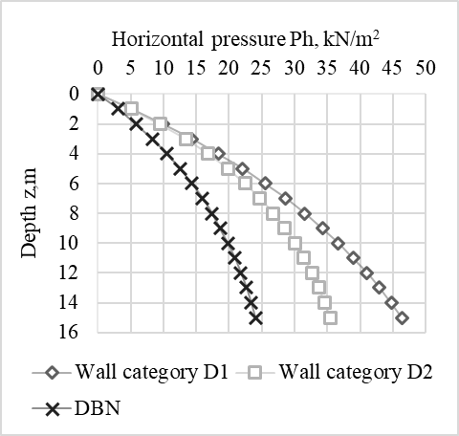 | 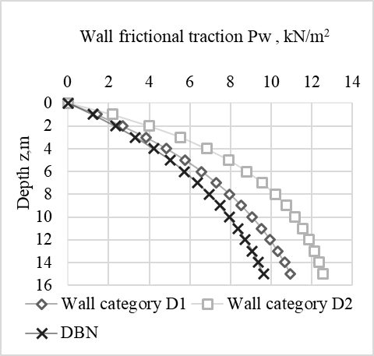
Figure 2 –The value of horizontal pressure and wall frictional traction
of the particulate solids on the walls of a slender silo:
a) wheat (Note: the type of wall is given in Table 4)

b)  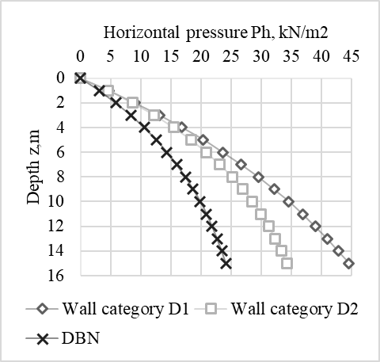 | 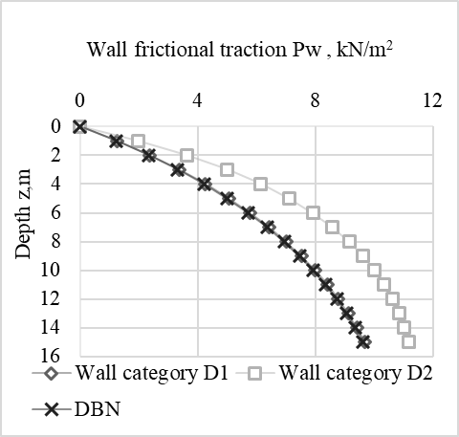
c)  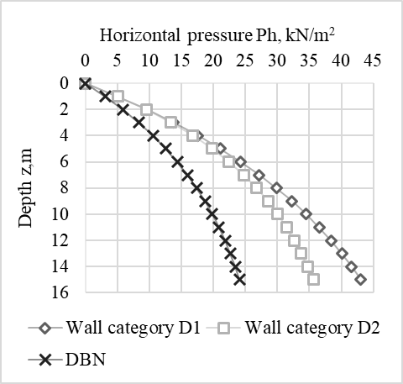 | 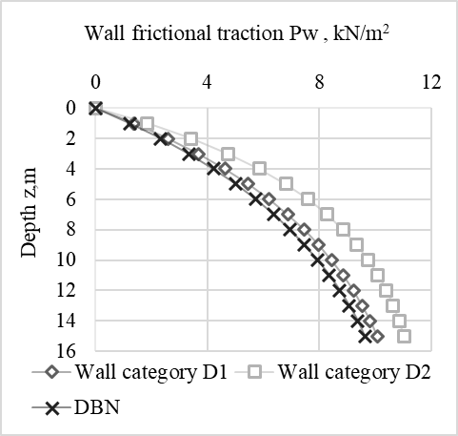
d)  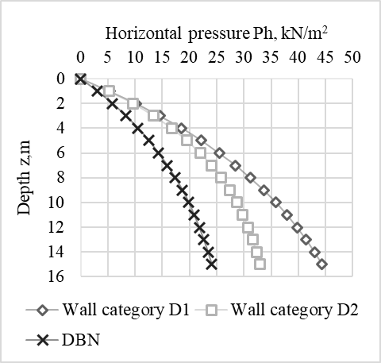 | 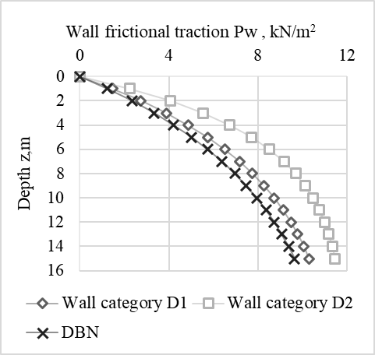
Figure 2* –The value of horizontal pressure and wall frictional traction
of the particulate solids on the walls of a slender silo:
b) corn; c) barley; d) soybeans (Note: the type of wall is given in Table 4)

Figure 2 shows an increase in pressure with increasing of silo depth. The values of the horizontal pressures on the silo wall according to DSTU, which took into account the spread of particulate solids, are 27-48% higher than the calculations according to DBN; the wall frictional traction are 1-23% higher. It is worth noting that the maximum difference in horizontal pressure values between the two standards reaches a maximum deviation of 48% for a D1 wall category, which is characterized as very smooth according to DSTU. While the difference in wall frictional traction between the two standards reaches a maximum deviation of 23% for a D2 wall category, which is characterized as smooth according to DSTU. Consequently, the value of the wall friction coefficient has a significant impact on the horizontal pressure calculation. Having analyzed the obtained graphs, it can be concluded that the spreads of statistical properties of particulate solids has a significant impact on the magnitude of loads on the vertical walls of silos.
Conclusions
The article reviews the normative documents that are in force on the territory of Ukraine, which regulate the determination of loads and forces in silos. During the comparison, it was noted that horizontal and vertical pressures on silo walls according to DBN has the following differences from DSTU: flow forms during discharge are not taken into account, silo structures are not divided by flexibility, and therefore the calculation of horizontal and vertical pressures for all types of structures is performed by one formula The statistical variation of particulate solids properties is also not taken into account. When comparing the pressures that act on the walls of a slender silo according to both standards, it was noted that the value of the wall friction coefficient has a significant impact on the calculation of horizontal pressure.

References
1. Pichugin S., Oksenenko K. (2019). Comparative analysis of design solutions of metal silos. Academic journal. Industrial Machine Building, Civil Engineering, 2(53), 54-60  https://doi.org/10.26906/znp.2019.53.1890 |  | 1. Pichugin S., Oksenenko K. (2019). Comparative analysis of design solutions of metal silos. Academic journal. Industrial Machine Building, Civil Engineering, 2(53), 54-60  https://doi.org/10.26906/znp.2019.53.1890
2. Haver Lipp. Взято з https://xaver-lipp.com/ |  | 2. Haver Lipp. Retrieved from https://xaver-lipp.com/
3. Качуренко В.В., Банников Д.О. (2016). Конструктивные решения стальных емкостей для сыпучих материалов. Днепропетровск: Новая идеология |  | 3. Kachurenko V.V., Bannikov D.O. (2016). Constructive solutions of steel tanks for bulk materials. Dnepropetrovsk: New ideology
4. Банніков Д.О. (2009). Сипучий матеріал в ємнісній конструкції. Дніп-ропетровськ: Нова ідеологія |  | 4. Bannikov D.O. (2009). Bulk material in capacitive construction. Dnepropetrovsk: Nova Ideology
5. Sielamowicz I., Balevicius R. (2013). Experimental and computational analysis of granular material flow in model. Warsaw: Institute of Fundamental Technological Research Polish Academy of Experimental Sciences |  | 5. Sielamowicz I., Balevicius R. (2013). Experimental and computational analysis of granular material flow in model. Warsaw: Institute of Fundamental Technological Research Polish Academy of Experimental Sciences
6. Schulze D. (2009). Powders and Bulk Solids. Behavior, Characterization, Storage and Flow. Springer |  | 6. Schulze D. (2009). Powders and Bulk Solids. Behavior, Characterization, Storage and Flow. Springer
7. Coelho L.C., Calil C.(Jr) (2017). Software to Calculate Pressures in Cylindrical Metal Silos. Journal of Advances in Information Technology, 8(1), 47-51 |  | 7. Coelho L.C., Calil C.(Jr) (2017). Software to Calculate Pressures in Cylindrical Metal Silos. Journal of Advances in Information Technology, 8(1), 47-51
8. EN 1991-4:2011 (2011). Eurocode 1 - Actions on structures - Part 4: Silos and tanks |  | 8. EN 1991-4:2011 (2011). Eurocode 1 - Actions on structures - Part 4: Silos and tanks
9. Бібік М.В., Мороз П.С. (2014). Визначення горизонтального навантаження на вертикальні стіни ємнісних конструкцій за різними нормами. Збірник наукових праць: Галузеве машинобудування, будівництво, 1(40), 166-174 |  | 9. Bibyk M.V., Moroz P.S. (2014). Determination of the horizontal load on the vertical walls of capacity structures according to various standards. Academic journal. Industrial Machine Building, Civil Engineering, 1(40), 166-174
10. ДБН В.2.2-8-98 (1998). Підприємства, будівлі та споруди по зберіганню та переробці зерна. Київ: Держбуд України |  | 10. DBN B.2.2-8-98 (1998). Enterprises, buildings and structures for storage and processing of grain. Kyiv: State Construction Committee of Ukraine
11. СНиП 2.10.05-85 (1985). Предприятия, здания и сооружения по хранению и переработке зерна. М.: ЦИТП Госстроя |  | 11. SNiP 2.10.05-85 (1985). Enterprises, buildings and structures for storage and processing of grain. M.: CITP Gosstroy
12. ДСТУ-Н Б EN 1991-4:2012. Єврокод 1. (2012). Дії на конструкції. Ч. 4. Бункери і резервуари. Київ: Мінбуд України |  | 12. DSTU-NB EN 1991-4:2012. Eurocode 1. (2012). Actions on structures. Part 4. Bunkers and tanks. Kyiv: Ministry of Construction of Ukraine
13. ДБН В.2.6-198:2014 (2014). Сталеві конструкції. Норми проектування. Київ, Мінрегіон України |  | 13. DBN B.2.6-198: 2014 (2014). Steel structures. Design standards. Kyiv, Ministry of Regional Development of Ukraine

