Yalanska S. The problem of university students tolerance manifestation / Svitlana Yalanska, Valentyn Marchenko, Alexander Moskalenko // Modern Sciens – Moderni veda. – Praha. – Ceska republica, Nemoros. – 2019. – № 5. – С. 134-142.

УДК 159.923.2-057.875:316.647.5
THE PROBLEM OF UNIVERSITY STUDENTS TOLERANCE MANIFESTATION

ПРОБЛЕМА ПРОЯВУ ТОЛЕРАНТНОСТІ СТУДЕНТСЬКОЇ МОЛОДІ

Svitlana Yalanska
Doctor of Pedagogical Sciences, professor,
Head of the Department of General, Age and Practical Psychology,
Poltava V. G. Korolenko National Pedagogical University
Valentyn Marchenko
PhD in Physics and Mathematics, associate professor,
Associate Professor of General Physics and Mathematics,
Poltava V. G. Korolenko National Pedagogical University
Alexander Moskalenko
Teacher of mathematics and informatics,
Poltava gymnasium № 17.

Resume. The article focuses on the problem of university students tolerance psychology as one of the most urgent. The university students, however, must be aware of the necessity of social relations development, based on such qualities as justice, refusal of making violence and causing harm to other people. Only these approaches may lead to the global public space consolidation and incorporation. Therefore, the tolerance development is to be accomplished not only in the secondary schools, but in the higher education institutions as well. The given article aims at all-embracing analysis of the problem of tolerance manifestation in the student environment, and thorough investigation of the main psychological-pedagogical and training means of its development. Essentially, the most important objectives of the article are: 1) to reveal the problem of tolerance amongst the contemporary youth; 2) to represent the results of the tolerance manifestation amongst students of Physics and Mathematics department of the pedagogical university; 3) to substantiate the system of psychological-pedagogical and training means of university students tolerance development. It is the fact the effective solution of all the above-mentioned goals grounds in the complex of investigation methods. Firstly, the theoretical ones are theoretical analysis, generalization, and classification. Secondly, the most efficient empirical methods are testing (survey “Can you be considered a tolerant person?” by Ye. Kailiuk), technique of diagnosing the empathy level (by V. Boiko), and survey (the questionnaire “Personal responsibility” by S. Yalanska). Statistic methods also tend to be effectual. The results of the disquisition of tolerance development among the students of Physics and Mathematics department of pedagogical university have been revealed in succession. It has been proved that the implementation of the program of the person’s tolerance development in educational space is of high necessity now. It provides special teaching-educative environment forming, embodying such parameters as a) tolerance cognitive constituent ascertainment (personal responsibility); b) emotional constituent ascertainment (empathy); c) behavioral constituent sets and development based on constructive interaction with entourage and surroundings. The program is supposed to be effectively inculcated integrating psychological-pedagogical and training means in the teaching-educative process in secondary schools as well as in higher education institutions.
Key words: tolerance, empathy, personal responsibility, students, psychological-pedagogical means, training means.
Preface. Defining the problem, its topicality for theory and practice.
Nowadays lots of people face such phenomena as criminality, terrorism, military conflicts, careless attitude towards the environment, etc. It is vitally important for education institutions, municipal authorities, NGOs, and charity funds to promote the information about psychological culture, eco-psychological interaction with entourage, and the ways to avoid aggression and violence. The urgency to power up this sphere of activity, particularly in higher education institutions, is of the first priority at the moment. The university students in particular have to realize the comprehensive requirement of social relations development on the basis of such virtues as tolerance, solidarity, refusal to make violence and cause harm to surroundings as well as to learn how to solve all the conflicts by means of constructive dialogues and negotiations. Only these approaches might consolidate and integrate global public space.
The reference to the civilized world countries’ vector of development opens up the further urgent necessity to bring up personalities, oriented on personal responsibility, empathy, independence, freedom, own ideas and judgments, perceiving the diverse view points and life principles of other people likewise the deep internationalization of different culture values. This reference is the key rule of prospective teachers, which will be working at the New Ukrainian School. To be more specific, they will possess the whole spectrum of competences, among those are ability to learn, to master their own knowledge, and to produce an effective communication strategy; skills to work in team, revolve, follow ethical standards, appreciate the diversity and multiculturalism, make critical thinking on fundamental world-view theories and principles of education and professional activity. The teachers must also manage the innovative technologies in their work to prevent aggression among junior schoolchildren and teenagers.
Analysis of the latest research papers and publications. The problem of the university students tolerance manifestations has been thoroughly described in many disquisitions in recent years. V. Pavlenko and M. Melnychuk, in particular, present the system-leveled approach, interpreting the tolerance as acceptance (tolerance on the social psychological level), lenience (tolerance on the individual psychological level), and persistence (tolerance on the psycho-physiological level) (Pavlenko, Melnychuk, 2014).
V. Bondar claims that tolerance provides the possibility of human personality acceptance, comprehension, and honest communication. The researcher states that tolerance is based on respect to personality, patient attitude towards different manifestations, points of view, even mistakes and faults, i.e. the attitude to other people, excepting blame, but containing compassion, empathy, understanding the value of human personality, and willingness to help (Bondar, 2015).
M. Dzhanobilova defines tolerance as an active moral position and psychological readiness to patience in the name of positive interaction between ethnos, social groups, people of other cultures, nationalities, religious and social backgrounds (Dzhanobilova, 2017).
O. Shayuk determines tolerance as the distinct ontophenomenological substance, the form of human existence, special psycho-spiritual state of a person, world-view universal and powerful theoretical construct of the modern philosophical-scientific discourse, also to be fixed means of constructive co-living of people, groups, ethnos, nations (Shayuk, 2017).
Introducing the problem. Regardless to many philosophical, psychological-pedagogical researches on the problem of tolerance, the peculiarities of tolerant environment forming in the higher education institutions still remain unsettled.
Aim and targets. The aim of the article is to present all-round study of the problem of tolerance manifestation in the student environment and to ascertain the most important psychological-pedagogical and training means of its development. Properly speaking, the main goals to achieve are: 1) to disclose the problem of tolerance of present-day youth; 2) to show up the results of the disquisition of tolerance manifestation indices amid students of physical and mathematical faculty of the pedagogical university; 3) to justify psychological-pedagogical training means of university students tolerance development.
Methods of research. Above all, the effective solution of the latest targets is founded upon the complex of investigation methods. Theoretical ones integrate theoretical analysis, generalization, and classification. Empirical methods embody testing, diagnostics methods, and questioning. Statistic methods were also used in succession. It should be noted the methodical toolkit of the given research is based on key indices of the tolerance – personal experience, empathy, and constructive interaction with entourage and surroundings. Undergraduate students of Physics and Mathematics department of Poltava V. G. Korolenko National Pedagogical University (307 of them took part in the disquisition) answered, in particular, the questionnaire “Personal responsibility” (by S. Yalanska) to set up principal features of the responsible personality. It was logically qualified that the problem of students’ empathy manifestation level requires the technique of diagnosing the empathy level (by V. Boiko). Finally, the most efficient means to ascertain peculiarities of the future teachers’ interaction with entourage and surroundings as well as to describe personal responsibility manifestations based on the survey “Can you be considered a tolerant person” (by Ye. Kailiuk).
Corollaries of the given research obviously need further systematization via simple classifying by a certain characteristic feature. It has an x identification, while each separate value of the feature shows up x1, x2, x3, …, xk marking; the number of values is revealed as k-marker. It is logically determined absolute numbers, which signify how many times every x feature value may be come across, make f1, f2, f3, …, fk parameters. Finally, fraction of the feature value ω1, ω2, ω3, ..., ωk in the total number of testing turned to be the relative frequency, calculated by ω=f/n (n is a number of testing) formula and represented in percentages.
As a matter of fact, mathematical calculations make a foundation on frequency grouping (m) correlatively to the number of values of a certain group. Therefore, an average arithmetic mean (x) comes out a fraction of feature values sum divided by the number of testing in the calculation formula x=(x1+x2+x3+...+xn)/n=(1/n)*Σxi, integrating xn – the feature value and n – the number of testing (measures).
Results. The exposition of the research main material.
Due to its contents, the tolerance of the person provides for benevolent and bearable attitude to the entourage and surrounding events, which neither violate human rights nor make any harm to the environment. In addition, the structure of personal tolerance embraces such core structural constituents: cognitive (knowledge of objects and life situations, based on personal experience acquisition); emotional (emotional states, which precede the behavioral constituent formation, thus, promote systematization of knowledge and appearance of certain behavior); behavioral (leading to basic fixed sets, value orientations, and ethnic values actualization. Such orientation, as to tolerance, can be explored in different deeds and actions of a person, whereas deed is the only one structure to correspond real entire self-fulfillment manifestations of man as a person, individual, citizen).
It is necessary to emphasize that personal responsibility, empathy, constructive interaction with entourage and environment are among the fundamental indices of tolerance. Moreover, the study has examined recognition of viewpoints diversity, life principles and values of other people as well as latitude towards entourage and surroundings combined with non-violence of human rights and environment harm refusal, eagerness to help other people considered to be the criteria of the tolerance.
Students of Physics and Mathematics department of Poltava V. G. Korolenko National Pedagogical University (307 in number) were active participants of stating investigation, aimed to study some data. The survey “Personal responsibility” (author is S. Yalanska), in particular, made possible the further understanding of the personal responsibility problem. The data are presented in such a consecution (see Figure 1).
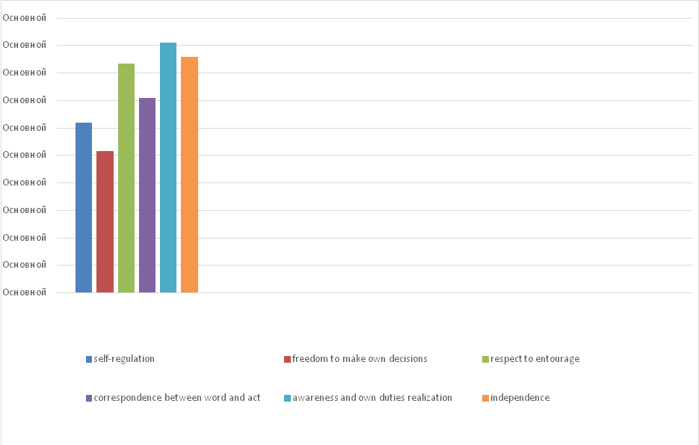
Figure 1. Results of the survey “Personal responsibility” (systematized by S. P. Yalanska) of Physics and Mathematics department students of Poltava V. G. Korolenko National Pedagogical University.
It is clear about Figure 1 that respondents pointed out various aspects (ω1-ω6, %), k=6, amid them are self-regulation (62,0 %), freedom of decision-making (51,6 %), respect to entourage (83,3 %), correspondence between word and deed (71,0%), awareness and fulfillment of own responsibilities (91,0%), and independence (85,8%).
The latest was confirmed on the basis of the survey “Can you be considered a tolerant person” by Ye. Kailiuk (see Figure 2).
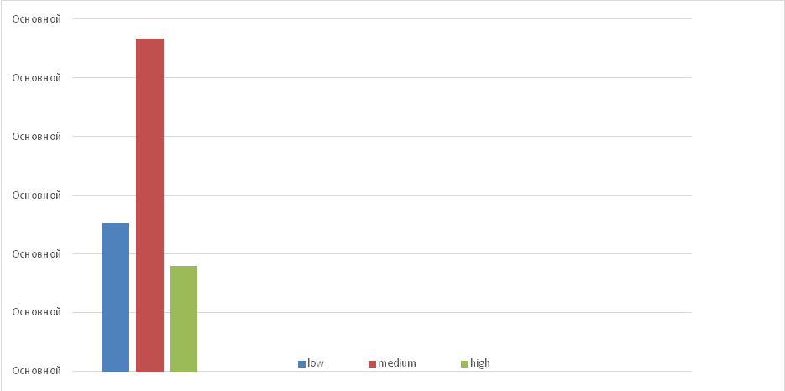
Figure 2. Results of the investigation, based on the methods “Are you considered to be tolerant person?” (systematized by Ye. Kailiuk).
Part of respondents (x) got from 0 to 4 points (m), representing their pertinacity, obstinacy. Such people constantly try to impose his opinion on others in any way. Often he raises his voice. Thus, it is quite complicated to maintain durable relations with such people. 56,7 % of students (х) have got from 6 to 12 points (m). They are able to firmly stand for their ideas, lead a constructive dialogue, change their opinion if objective reasons are present. They may be able to express excessive harshness, disrespect towards the collocutor. 18% of students (x) of Physics and Mathematics department have got from 14 to 18 points (m). Such personalities can accept any idea, treat a seemingly paradoxical act with understanding even if they disapprove it. They are reasonably critical of their own thought and are able to renounce their views that proved to be erroneous while preserving respect and tactfulness towards the collocutor.
According to the used technique of diagnosing the level of empathic abilities (by V. Boiko) the following data have been obtained (see Figure 3).
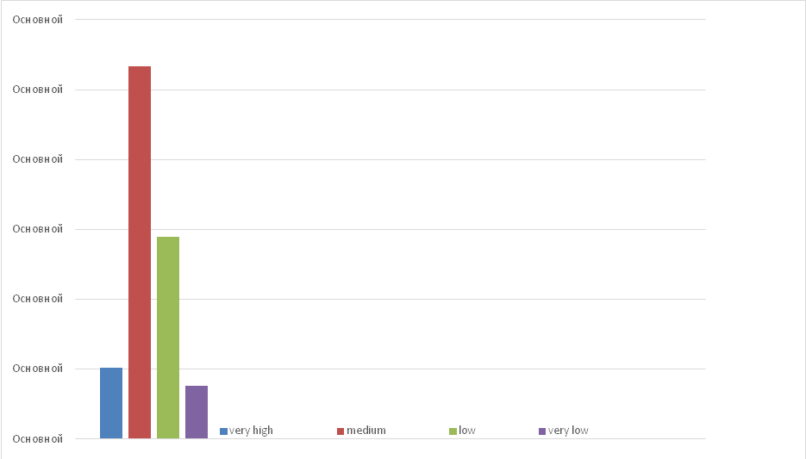
Figure 3. Results of the survey based on diagnosing the level of empathic abilities (systematized by by V. Boiko).
Indices of separate scales and the general total evaluation of the empathy level have been analyzed. According to the technique, there were six tendencies (scales) distinguished in the structure of empathy: rational, emotional, intuitive channels of empathy, sets contributing to empathy, penetrative ability, and identification. The scale evaluations played additional role in interpreting the empathy level. The total index may theoretically vary between 0 and 36 points.
10,2% of respondents have got 30 points and more – a very high level of empathy (m); 53,3% of students have 29-22 points showing a medium level of empathy (m); 28,9% of students have got from 21 to 15 points – a reduced level of empathy (m); 7,6% have less than 14 points – a very low level of empathic abilities (m).
Within the framework of the International scientific project supported by US Peace Corps in Ukraine “Leadership. Tolerance. Volunteerism” (2015–2016) a program of the university students tolerance development has been initiated. The aim of the program is to develop the determined indicators of maturity and growth of tolerance of the student (high school) youth. The goals of the program are to foster tolerance, personal responsibility, empathy, constructive interaction with other people and the environment. The program involves creating a special educational environment with the following characteristics: а) the cognitive set of tolerance (personal responsibility); b) the emotional set (empathy); c) formation and development of the behavioral component on the basis of the constructive interaction with other people and the environment. An important element of the effective program implementation is the integration of psychological, pedagogical, and training means in the educational process of the comprehensive secondary and higher education institutions.
Module 1. “Formation and development of positive, eco-psychological thinking, internalizing of universal values and understanding other cultures”. It contributes to the development of indicators of the cognitive component of tolerance, forms desire for self-improvement, motivates to creative self-realization, ensures the development of positive thinking, organization of the educational process allowing deep perception and understanding of universal values”. Module 2. “Formation and development of psychological resilience, self-regulation” is aimed at the development of indicators of the emotional component of the personal tolerance. Its content includes motivation for benevolent and tolerant attitudes towards other people, encourages avoiding aggression and jealousy. It is essential to use all the elements of the module incorporating psychological and educational means”. Module 3. “Acquiring the experience of the constructive dialogue, friendly and tolerant attitude to the events in order not to violate human rights” is aimed at the development of indicators of the behavioral component of the personal tolerance. Its content encourages making positive actions, creating mutual understanding, ensuring permanent constructive feedback” (Kapustian, Yalanska, Nikolashina, 2016).
It is advisable to include the program modules to lessons with students (pupils), meetings of psychology clubs, the courses “Basics of Inclusive Education”, “Psychology”, “Psychology of Higher Education”, “Developmental and Educational Psychology”, “Developmental Psychology” та ін.
Discussion. The comparative analysis of the received data and the results obtained by the other scholars shows that according to V. Pavlenko and M. Melnichuk (Ukraine) the social psychological level (value orientations) plays the leading role in the tolerance determination. The individual psychological levels (divergent thinking, empathy) are of less importance. The psycho-physiological level has the least importance (Pavlenko, Melnichuk, 2014). The conclusions made by N. Levus (Ukraine). The comparative analysis of personalities with different tolerance levels enabled us to locate differences in their personal dimension structure. Ethnically tolerant tested subjects are confident, emotionally stable, tolerant to ambiguity; they have wide and various interests, they show interest in moral, ethic, and worldview issues. Ethnically intolerant personalities are aggressive, egotistical, and domination-minded. The author considers it to be of utmost importance to prevent manifestations of intolerance during the student period and to form the tolerance culture (Levus, 2013). Having based her opinion on the theoretical studies of changes in the state legal system (Uzbekistan), M. Dzhanobilova stresses the high level of the tolerance culture of her state, the young generation’s expression of tolerance having a leading role in this phenomenon (Dzhanobilova, 2016).
Conclusions
According to the results of the theoretical analysis of the problem, the summative study done, in particular, among undergraduate students of the Physics and Mathematics department of Poltava V. G. Korolenko National Pedagogical University (307 students took part in the study) the following conclusions can be made: 1) the study has highlighted issues of tolerance among modern youth; 2) the results of the study of tolerance indicators among the students of the Physics and Mathematics department of the pedagogical university are as follows: according to the Personal Responsibility survey (by S. Yalanska) the respondents have determined the following aspects: self-regulation (62,0%); freedom of decision-making (51,6%); respect to others (83,3%); matching words with actions (71,0%); comprehension and fulfillment of obligations (91,0%); independence (85,8%). The results of the study based on the method “Can you be considered a tolerant person?” (the author is Y. Kailiuk) show that 25,3 % of respondents scored between 0 and 4 points showing non-compliance, obstinacy of the personality. The person constantly tries to impose their will on others by any means available. Such people often raise their voice. Consequently, it is hard to keep lasting relationship with people possessing different opinions. 56,7 % of students got from 6 to 12 points. Such personalities are able to defend their point of view firmly, lead a constructive dialogue, change their opinion if objective reasons are available. They may show excessive harshness, disrespect for the collocutor. 18% of students of the Physics and Mathematics department have got from 14 to 18 points. Such personalities can accept any idea, comprehend a seemingly paradoxical act even if they do not approve of it. The results of the method of diagnostics of empathic abilities (by V. Boiko): 10,2% respondents got 30 points or more – a very high level of empathy; 53,3% of students have 29-22 points showing medium level empathy; 28,9% of students got from 21 to 15 points – the reduced level; 7,6% have less than 14 points showing a very low level of empathy; 3) it has been proved that psychological and pedagogical, art-therapeutic, training means of the developed program can contribute to the effective formation of tolerance of the participants of the educational process, the dissemination of ideas of personal responsibility, empathy, independence, freedom, personal opinions, and recognition of the diversity of opinions and life principles; readiness for consolidation of the Ukrainians in the European area and the world.
References
- Boiko, V. Metodyka diahnostyky rivnia empatiinykh zdibnostei [Methods of Diagnosing Empathic Abilities]. Retrieved from https://psycabi.net/testy/229-metodika-diagnostiki-urovnya-empaticheskikh-sposobnostej-v-v-bojko-test-na-empatiyu-bojko.
- Bondar, V. (2015). Osoblyvosti formuvannia tolerantnosti maibutnikh psykholohiv u vyshchykh navchalnykh zakladakh [Specific Features of Formation of Tolerance of Trainee Psychologists in Higher Educational Establishments]. Zbirnyk naukovykh prats Khmelnytskoho instytutu sotsialnykh tekhnolohii Universytetu “Ukraina” [Collection of Scientific Works of Khmelnytsk Institute of Social Techology of Ukraine University], 11, 32–34.
- Dzhanobilova, M. (2016). Tolerantnost kak tip pravovoho soznanyja [Tolerance as a Type of the Correct Consciousness]. Nauka. Mysl [Science. Thought], 4, 27–30.
- Dzhanobilova, M. (2017). Tolerantnost v vospitanii podrastajushhego pokolenija [Tolerance in the Education of the Coming Generation]. Osobystist, suspilstvo, zakon: psykholohichni problemy ta shliakhy yikh rozviazannia: zb. tez dop. mizhnar. nauk.-prakt. konf., prysviach. Pamiati prof. S.P. Bocharovoi (30 bereznia 2017 r., m. Kharkiv, Ukraina) [Personality, Society, Law: A Collection of Reports of the International Scientifc Conference Dedicated to Memory of Prof. S. Bocharova (March 30, 2017, Kharkiv, Ukraine)]. (pp. 93-96). Kharkiv: HNUVS. -
- Kailiuk, Y. Metodyka “Chy mozhna vvazhaty Vas tolerantnoju ljudynoju?” [Technique “Can you be considered a tolerant person?”]. Praktykum: testova psykhodiaghnostyka [Practicum: Test Psychodiagnostics]. Retrieved from eprints.kname.edu.ua/3121/8/Тести.doc
- Levus, N. (2013). Osobystist etnichno tolerantnoi liudyny: yaka vona? [Personality of an Ethnically Tolerant Person: What Is It Like?]. Zbirnyk naukovykh prats KPNU imeni Ivana Ohiienka, Instytutu psykholohii imeni H.S. Kostiuka NAPN Ukrainy [Collection of Scientific Works of Ivan Ohiienko KPNU, H. Kostiuk Psychology Institute of the National Academy of Pedagogical Sciences of Ukraine], 313–322.
- Pavlenko, V., Melnychuk, M. (2014). Psykhologhija tolerantnosti osobystosti (na materiali doslidzhennja studentiv): monoghrafija [Psychology of Tolerance of a Personality (Based on Student Research): A Monograph]. Poltava: Sole Proprietor Myron I. A.
- Shayuk, О. Y. (2017). Vitacultural horizons of tolerance conceptual cognition. Psykholohiia i suspilstvo [Psychology and Society], 1 (67), 73-78.
- Yalanska, S., Kapustian, I., Nikolashina, T. (2016). Tolerance, Volunteerism and Leadership : textbook. Poltava : Publishing House “Simon”.

