INFORMATION TECHNOLOGY FOR BUILDING A MODEL OF FINANCIAL FORECASTING

E V Skakalina
PhD, Department of Computer and Information Technologies and Systems,
Poltava National Technical Yuri Kondratyuk University, Pershotravnevyi avenue, 24, 36011, Poltava, Ukraine
e-mail: elenaskakalina2501@gmail.com

Abstract
The solution of the problem of formation of the financial forecasting model (FFM) is realized using information technology using the methods of genetic algorithms, fuzzy neural network model (FNNM). As a software implementation, the Genetic Algorithm Input Selection of ST Neural Networks, MATLAB Fuzzy Logic Toolbox is used. The model adequately reflects the core of the main economic indicators and makes it possible to predict their changes.

Keywords: economic indicators, genetic algorithm, selection of input data, fuzzy sets.

The most important feature of the American socio-economic model is its orientation toward accelerating the pace of scientific and technological progress, the formation of an innovative model of the economy. The US economy is the world's largest economy in terms of nominal gross domestic product (GDP), accounting for at least a quarter of world GDP since the end of World War II. It is one of the most diversified national economies in the world and has been leading the world economy for the past 100 years. These factors determined the choice of the US economy as a subject area for verification of information technology for forecasting economic indicators [1]. The use of standard deterministic methods of forecasting faces a number of problems - the definition of necessary and sufficient parameters (arguments) for assessing the state of the studied subject area, the so-called "curse of dimension", when the number of indicators and evaluation criteria taken into account is limited by the speed and size of computing resources, the phenomenon of "super-system" . The use of intelligent methods, which include genetic algorithms [2], the apparatus of fuzzy sets [3], the theory of self-organizing systems [4] allows to increase the depth of the forecast by revealing hidden patterns and relationships among poorly formalized global financiall indicators.
Information technology of FFM construction has the following structure:
Step 1 - the initial set of economic indicators is formed (the dimension of the set is 45).
Step 2 - using the genetic algorithm, the dimension of the initial set is reduced from 45 indicators to 12, selected by GA as the most significant. Selection errors were minimal (0.000909).
Step 3 - with the help of the apparatus of fuzzy sets, the FNNM of each indicator is constructed. After the generation of the Sugeno type fuzzy output system, a hybrid network is trained with a specified error level of 0 and a number of cycles of 400. In the FNNM, 81 rules are obtained.
Step 4-Test the FNNM on the training set of data. The test result showed the deviation of the actual US GDP from the model (FNNM) in the range (0,099376% - 0,18479%), which confirms the correctness of the proposed information technology (Fig. 1).

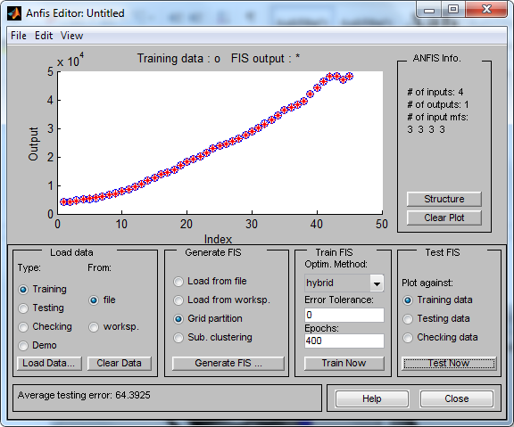

Figure 1 - Graph of coincidence of the testing of the FNNM with the incoming sample

Step 5 - with the help of FNNM we compute the forecast values of the 12 macroeconomic indicators of the US economy selected by step 2 up to 2020. The results of the computational experiment showed that the range of deviations of the model values of the parameter from the real ones lies in the range from 0.064326% to 9.2%.
Lowering the dimension of the initial set of macroeconomic indicators was carried out using the Genetic Algorithm Input Selection software package of ST Neural Networks. The formation of the FNNM was carried out using the software of the MATLAB Fuzzy Logic Toolbox, using the adaptive neural-fuzzy inference (ANFIS) system of the Sugeno type [5].
The quality of FNNM depends to a large extent on the choice of parameters that determine the "core for analysis" and forecasting. The aggregate of 12 parameters of the US macroeconomics that can be used as input variables of the FNNM is considered. The generalizing properties of FNNM largely depend on the composition of the training sample. Verification of the FNNM showed the adequacy of the information content of the initial data to the level of informativeness of all the available statistical data. The obtained model allows to predict the further development of macroeconomic indicators.

References

[1] The official website of the U.S. Bureau of Labor Statistics Major Economic Indicators.

Retrieved from : www.bls.gov.

[2] O. Ciftcioglu and M.S. Bittermann, Adaptive formation of Pareto front in evolutionary multi-objective optimization, Evolutionary Computation, W. P. d. Santos, Ed. Vienna: In-Tech, pp. 417-444, 2009.

[3] Jantzen J. Tutorial On Fuzzy Logic. – TU of Denmark, 2004.
[4] Skakalina O.V. Applied aspects of using the method of group consideration of arguments in the short-term forecasting / O.V.Skakalina // Scientific Bulletin of the National Mining University. Issue No. 6 (150). - P. 80-88, 2015.
[5] Jang J. S. R. ANFIS: Adaptive-Network-Based Fuzzy Inference System. - IEEE Trans. Systems & Cybernetics, Vol. 23, 1993.

