The work of silo capacities under the influence of the wind load

Sergei Pichugin¹, Anton Makhinko², Natalia Makhinko³,

¹ Poltava National Technical Yuri Kondratyuk University, Ukraine,
e-mail: pichugin.sf@gmail.com
² ETUAL LLC, Ukraine,
e-mail: pasargada1981@gmail.com
³National Aviation University, Ukraine,
e-mail: pasargada1985@gmail.com

Abstract: This paper deals with the detailed studying of work of cylindrical silo capacity with vertical stiffeners under the influence of asymmetric wind load, which is represented by the completed trigonometric cosines-series. Figures of changing of the internal forces for steel silos with different geometric characteristics (the height, the diameter, the thickness of ribs and the wall of the body) are shown and the detailed analysis of factors, which influence the deflected mode of the framework, is done. The assessment of borders of the use of the capacities’ calculation method is given in a table. It is offered convenient representation of the capacities’ reactions in the non-dimensional polar frame of axes.

Keywords: cylindrical silos, internal forces, polar coordinates, thin-walled shell, wind loads. ____________________________________________________________________________________________
- Introduction.

Cylindrical silo capacity is a shell of rotation, which is reinforced by vertical stiffeners. The main loads of the framework are the pressure of the bulk material, which cause axially symmetric load of the capacity, and the pressure of the wind flow, which belong to the asymmetric loads. The research of the deflected mode of the steel shells under the load, which is defined by the exponential law, was thoroughly examined in this paper [4]. The wind load on the vertical silos affects stiffeners and the body. Uneven distribution of the wind load along the perimeter of cylindrical capacities is described by the function of the aerodynamic coefficient . The factorization of the function and the wind load, correspondingly, into the completed trigonometric series allow simplifying the determination of internal forces in the framework’s elements. Meanwhile, the problem solving could be separate to the each element. A series of premises are taken in order to avoid complications, which is caused by the secondary factors and considering of which is of no practical value and engineering benefit. In particular, hypothesis about the absence of shifts in the middle of the capacity surface, the absence of extension of the capacity in the annular direction and assumptions about the unknown tensions, efforts of deformation and displacements, are the functions of the one coordinate x, which is plot along the height of the capacity.

- The main material.
In the general case elements of the wind load could be introduced as and the equation of equilibrium according to the momentless theory [3] will be

(1)

where N_{h,k} are linear longitudinal efforts in radial direction; A_{k} is an amplitude k value of the element; D_{w} is the diameter of the shell.
On the fig. 1 there is more detailed information about the work of the cylindrical capacity’s body under the influence of asymmetric load according to the harmonic law of cosine. From the given analysis and series of analogous figures (for silos of different height H_{w} , diameter D_{w} , thickness of rib t_{p} , the wall of the body t_{w} and different number of ribs n_{p} ) we can make a generalizing conclusion. For capacities from the flat sheet of the small elongation Δ_{w} ≤ 1,5 the increase of the thickness of the body sheets results in decrease of linear efforts in vertical ribs, whereas the increase of ribs’ thickness, on the contrary, results in the small growth of efforts. Meanwhile, the harmonica’s parameter of the load k (to k = 6) practically does not affect monotonous character of the given dependence. Monotony began to disappear when moving to the higher capacities Δ_{w} > 1,5 or to the corrugated plates of the body. In this case, already when k = 5, curves of linear longitudinal efforts in meridional (longitudinal) direction N_{p,k}(x) are gradually shifted to the left in the area of the little value of efforts, changing to the negative area. It means that there are zones that appear on a certain height, within which efforts of extension is functioning in vertical stiffeners. The higher capacity is, the longer the given zone.

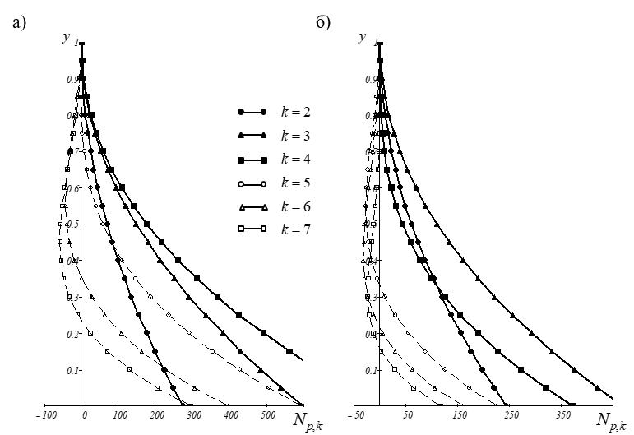
Figure 1. Linear efforts in vertical ribs of the capacity under the load cos(kϕ) when D_{w} = 10m, H_{w} = 30m, n_{p} = 30: (а) t_{w} = 6mm, t_{p} = 6mm; (б) t_{w} = 6mm, t_{p} = 12mm
The use of corrugated plates does not eliminate the given zone, but compared to the flat sheets it “presses down” the curve of efforts stronger to the axis of ordinates. This is because the profiling reduces efforts in ribs. With regard to radial displacements, they decrease with the growth of the sheets’ thickness or with the use of corrugated plates, and also decrease less with the growth of transverse section of vertical ribs. It means that from the point of view of rigidity it is more effectively to increase the thickness of body than of its ribs.
The analysis shows that one of the main factors, which influence the deflected mode of capacity, is the value of k harmonica of the external load. That is why there is a question about the existence of the boundary value k, higher of which the offered method will result in a significant mistake. The numeral value of the given mistake could be defined on the basis of the A.L. Goldenveyzer’s research [1].

, (2)

where ΔJ_{w} is the ratio of inertia moments of corrugated and flat sheets; α_{wp} is the coefficient that shows the ratio of the area of transverse section of stiffeners and sheets of the body; δ_{Dt} is the coefficient of the geometric scale.
Calculations, using the formula (2) for capacity D_{w} = 10 m, are given in the tab. 1, the data of which shows obvious suitability of the described method.

Table 2. The assessment of borders of using the method of capacities’ calculation on the asymmetric load, which is represented by the trigonometric cosine-series.
, mm | Flat sheet |  |  | Corrugated plate
 | k_{lim} when n_{p} = 30 і t_{p} , |  |  | k_{lim} when n_{p} = 30 і t_{p}
 | 2mm | 6mm | 12mm | 2mm | 6mm | 12mm
2 | 9958 | 12590 | 15740 | 1174 | 1485 | 1856
6 | 2969 | 3319 | 3784 | 1051 | 1174 | 1340
12 | 1438 | 1530 | 1660 | 1017 | 1083 | 1174

Total deflected mode of the capacity under the influence of the wind load will be consisted of the separate deflected modes of the k influence
, (3)

where R is a generalized parameter of the reaction; y is a non-dimensional height y = x/H_{w}; a_{k} are coefficients of the factorization, the numerical values of which could be calculated by method of the least quadrates using [2].
The zero term of series (3) corresponds to the axially symmetric load, that’s why it does not cause efforts in ribs. Displacements of the body are also very small, that is why in the next calculations we could ignore them. The second element a₁R₁ is the one unbalanced part of the wind load in each annular section, which causes a usual bend of the capacity. Other terms of series (3), when k ≥ 2, could be rewritten in the form of a sum of products of some value r_{D,k} (y) , which corresponds to the reaction of the capacity in the point (y; 𝜑 = 0), on the cosine (sinus) of function of the reaction changing according to ϕ - ∨.

We could not say for sure that this conditional separation significantly simplifies calculation, but undoubtedly gives them obviousness. As an example there was made calculation of coefficients r_{D,k}(y) of the linear efforts in vertical ribs and radial displacements of the body points in the table 2. It was selected a capacity with a flat wall for the calculations when D_{w} = 10 m, H_{w} = 20 m, n_{p} = 30: (а) t_{w} = t_{p} = 6 mm. The calculated value of the wind load was w_{p} = 1 kPa, and conditions of fixing near the basis corresponded to the hard closing. The similar tables uniquely determine the deflected mode of capacities and are the basis for acceptance further design solutions.

Table 3. The example of amplitude calculation of trigonometric series of reactions.
y | 1ϕ | 2ϕ | 3ϕ | 4ϕ | … | 10ϕ
Amplitude values for linear efforts in vertical stiffeners
0,0 | 0 | 0 | 0 | 0 |  | 0
0,1 | 0,1 | 0,8 | 1,2 | 0,2 |  | 0
0,2 | 0,4 | 3 | 4,7 | 0,7 |  | 0
1,0 | 9,2 | 75,3 | 118,9 | 18,2 | - | 0,9
Amplitude values for radial displacements of body points
0,0 | 0,5 | 5 | 17,8 | 4,8 |  | 0,1
0,1 | 0,4 | 4,3 | 15,4 | 4,2 |  | 0,1
0,2 | 0,4 | 3,7 | 13,1 | 3,5 |  | 0,1
1,0 | 0 | 0 | 0 | 0 |  | 0

As a convenient method of analysis of the obtained results, it is recommended to use the only non-dimensional polar frame of axes, in which dependence of the radius-vector ρ_{D} on angular coordinate ϕ is expressed as . With the such content, the area of changing of any capacity’s reaction has a diapason [-1;1], and reactions could be plotted on the one plane of references. On the fig. 2 it is shown the given frame of axes as an example of the tab. 3 and are shown figures of reactions for analogous capacity when H_{w} = 10 m (to the right)

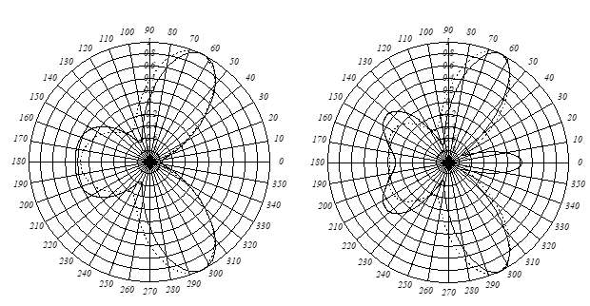
Figure 2. The representation of the capacities’ reactions in the non-dimensional polar coordinates.

- Conclusion.

1. One of the main factors, which affect the deflected mode of the silo capacity under the influence of the asymmetric load according to the harmonious law of cosine, is the value of k harmonica of the external load.
2. The analysis of quantitative evaluation of the mistake of the border value k shows the obvious suitability of the described material.
3. Total deflected mode of the capacity under the influence of the wind load will be consisted of the separate deflected modes of the k influence, for representation of which it is convenient to use non-dimensional polar frame of references.

- References

1. Goldenveyzer A. Teoriya uprugih tonkih obolochek. Moscow: Nauka, 1976. – 512 p.
2. DBN V.1.2-2:2006: Systema zabezpechenniana diinostita bezpeky budivelnykh obiektiv. Navantazhennia i vplyvy. Normy proektuvannia. – Kyiv: Minbud Ukraine, 2006. – 60 p.
3. Lessig E. Listovyie metallicheskie konstruktsii / E. Lessig; A. Lileev; A. Sokolov. – Moscow: Stroizdat, 1970. – 512 p.
4. Makhinko A. Analysis of the deflective mode of thin-walled barrell shell / A. Makhinko, N. Makhinko // Academic journal. Industrial Machine Building, Civil Engineering, 1(50) (2018). – Poltava: PoltNTU. 2018. – pp. 69-78.

