**Reliability of Steel Frameworks of Industrial Buildings**

**Pichugin S.F., DSc, Professor**

[pichugin.sf@gmail.](mailto:pichugin.sf@gmail.)com

**Patenko Iu.E., PhD**

maslova_yuliya@i.ua

Poltava National Technical Yuri Kondratyuk University, Ukraine

**Abstract.** The work is dedicated to the reliability assessment of one-storey industrial buildings with overhead travelling cranes. Problems of reliability assessment of such buildings are compared with the complex character of external loads. The nature of this loads is complicated and depends on many spatial and space-temporal factors.

Among all of the loads which influences on industrial buildings crane loads have the largest values. Often these loads define the architecture and spatial design of workshops, materials and weight supporting structures. Notwithstanding, the problem of obtaining a probabilistic model of crane loads which will describe actual nature of the crane loads on structures of industrial buildings is not solved. Therefore, the problem of development the probabilistic models is relevant and justified as well as the calculation the values of numerical characteristics of vertical and horizontal crane loads.

**Analysis of last research sources and publications.** The results of extensive experimental investigations of nature of crane loads are presented in the works [9, 16]. Experimental data were processed in the technique of random variables and random processes and were confirmed the probabilistic nature of crane loads. The problems of standardization and development of analytical models of crane loads are considered in works [6, 10, 14]. Comparative analysis of the values of crane loads which were defined according to national and international codes [1, 11, 20] is presented in [19]. The refined values of crane loads allow to get more accurate reliability assessment of industrial buildings [6, 10]. The question of structures reliability is considered in [7, 8, 13, 17]. The approaches to the reliability assessment were developed using probabilistic methods which describe the behavior of structures under external loads. Reliability assessment of steel frames of one-storey industrial buildings with overhead cranes is described in [12, 15, 18], where the spatial nature of the frameworks was refined. Furthermore, the detailed analysis of loads and review of Codes [2] which classify parameters of overhead traveling cranes were done.

**NUMERICAL CHARACTERISTICS OF CRANE LOADS**

**Numerical characteristics of vertical crane loads*.*** Vertical load (Fig. 1) on the structures of different rows (columns, crane girders) was defined as:

 (1)

where ,  − weight of the bridge and the crab of crane;  − hoisting load;  − crane span;  − approach of the crane hook;  − sum of influence line ordinates;  − the number of wheels on one side of crane.

To the non-linear function (1) with three random arguments the procedure of statistical linearization was applied. In this case the mathematical expectations  and  were determined by substitution instead of random arguments the mathematical expectations of . So we got accurate result because all second derivatives that define the mathematical expectation are zeros.

To calculate the dispersion of maximum crane load the next coefficients were determined:

; ;

. (2)

Using the obtained coefficients, we defined the dispersion of vertical crane load as follows:

 (3)

For the estimation the precision of dispersion we calculated the mixed derivatives:

; ; . (4)

The dispersion precision of maximum crane load was determined using the linearization procedure:

. (5)



а)

b)

**Figure 1 – Schemes of crane loads:**

**a) impose of vertical loads to the transverse frames; b) impose of horizontal loads to the crane wheels**

The precision of dispersion of minimum crane loads can be defined similarly.

For the numerical evaluation the crane with lifting capacity *t* was taken. The weight distribution was taken as normal with variation coefficient , distribution  − uniform. The obtained precision of dispersion was very low (*2,2%* ). The obtained numerical characteristics were used to construct a graph of normal distribution of the load on the column. This graph well corresponds to experimental polygons of loads.

Obtained formulas allow to use simple random arguments ,  і  instead of complicated experimental study of vertical crane loads. Furthermore, the available experimental data and a priori reasons followed by analytical determination of the characteristics of crane loads can be used.

**Numerical characteristics of horizontal crane loads.**To calculate the dispersion of minimum crane load we determined next coefficients:

; ;

. (6)

Then the dispersion of minimum crane load can be defined as:

 (7)

The mathematical expectation of lateral forces on the wheels of four-wheel crane (Fig. 2) can be fined using formula (8). These forces are limiting skewing of the bridge:

. (8)

To determine the dispersion of lateral forces we can also apply linearization process and define the necessary coefficients. Then the dispersion of maximum lateral forces will be:

. (9)

On the other side of crane will appear lateral forces with the following numerical characteristics:

 or ; or . (10)

The obtained formulas allow to use the numerical characteristics of horizontal crane loads in calculations and to use these characteristics for estimation reliability of structures of industrial buildings.

**Calculation of numerical characteristics of crane loads.** For the definition the numerical characteristics ofcrane loads the industrial building (with a span of 24 *m* and a columns step 6 *m*) with a four-wheels traveling cranes was chosen. The cranes with medium operating mode and the separate drive base were considered. Crane span is *m* and a crane base is 4,4 *m*. The mathematical expectations of maximum and minimum loads on crane wheels  *kN*,  *kN* were calculated by substituting in (1) the numerical characteristics of all parameters. The mathematical expectations of lateral forces on the wheels of the crane were calculated using formulas (8) and (10): *kN*;  *kN*.

The mathematical expectations of horizontal load on a column from lateral forces:  *kN*. We expressed the expectation and the standard for lateral forces with , then: , ,

where – load on the column of the crane without weight.

The obtained numerical characteristics of horizontal crane load correspond to the experimental values. For the further calculations of the reliability of columns of industrial buildings the numerical characteristics of vertical and horizontal crane loads were worked out.

**DESIGN MODELS OF FRAMEWORKS**

The calculation of spatial models of frameworks (Fig. 12) for all loads, including crane loads were done using computing complex for strength analysis of structures by the finite element method. Spatial design schemes of frames were formed from spatial blocks of buildings, which included all transverse frames or medium blocks with the number of transverse frames from 7 to 10. As the distributive disks, the main constructions which provide the spatial work of the frames were introduced in design models. Such constructions are the bracing system in the top and bottom chords of roof truss, crane girders with brake constructions, longitudinal working platforms and bracing elements on the columns.

б)

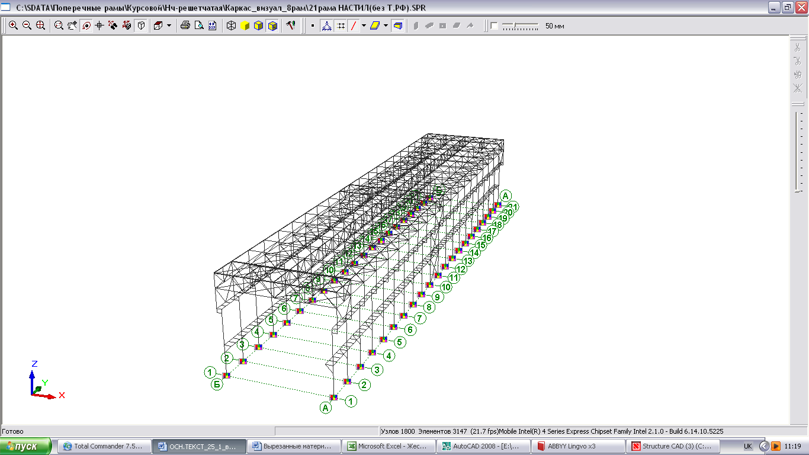

б)

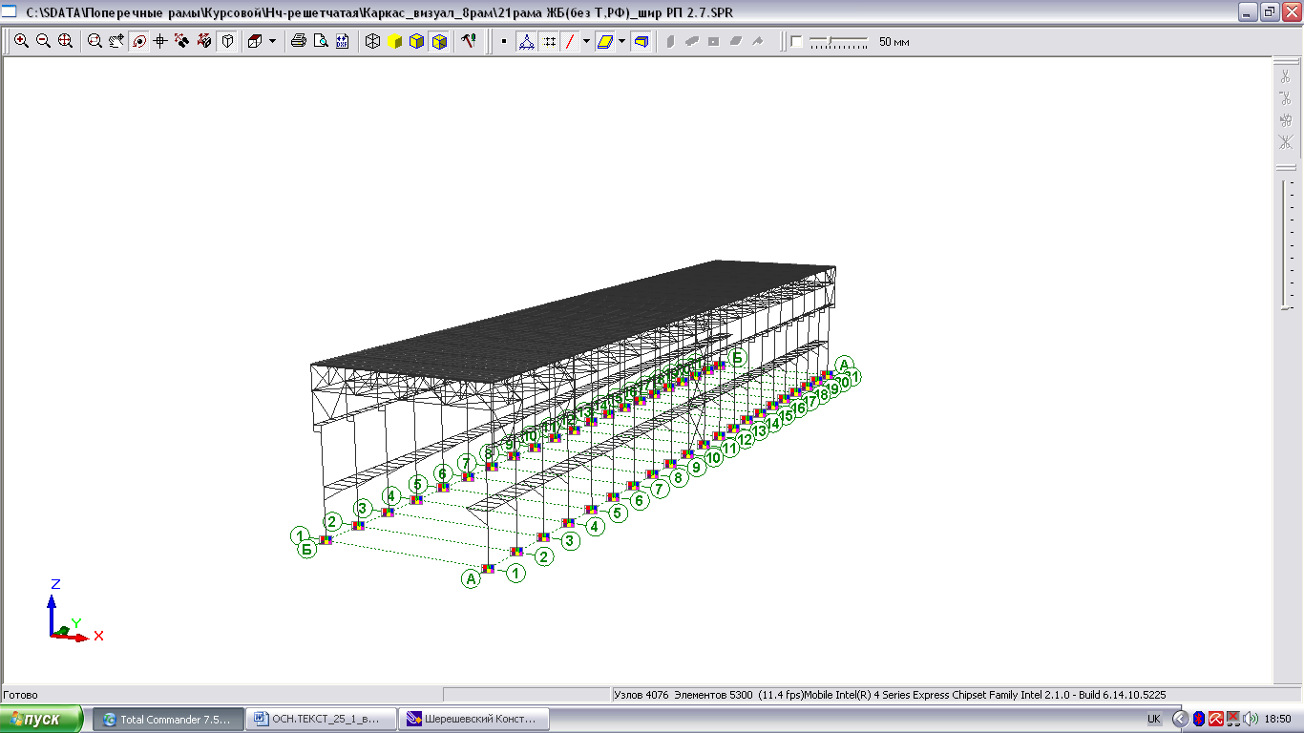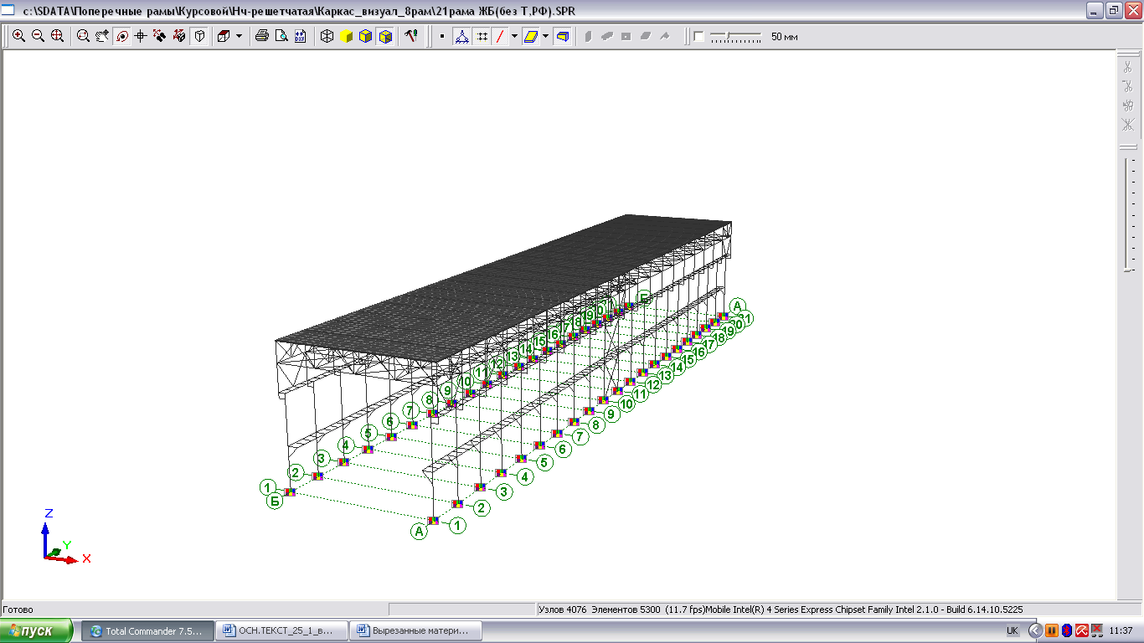

Fig. 2. Spatial design models of industrial building: a) with a «heavy» coverage (prefabricated concrete panels); b) «light» coverage (profiled steel on purlins)

A comparison of internal efforts (bending moments and longitudinal forces) (Fig. 3, 4) of frames at different design models of frames has been made. Various cases of calculation are considered when the model contains elements which simulate the work of all possible bracing disks and individual bracings and combinations of bracings.

Constructions, which mainly provide spatial work and which should be taken into account in the formation of design models, are the coverage of the building, the bracings on bottom chords of roof truss, crane girders with a braking structures and longitudinal working platforms. It was found that consideration of other longitudinal structures of frames did not give a significant effect.

**THE NUMERICAL RELIABILITY EVALUATION OF COLUMNS OF INDUSTRIAL BUILDINGS**

The analytical model of crane loads was used in the calculation of reliability of columns on the example of multispan industrial building. The spans of building are 24 *m*, the top elevation mark of the column is +14,000.

The columns of the building were designed on the resistance of structures in the plane and out of the plane of action of compatible effect of dead and variable loads calculated according to Codes DBN V.1.2-2: 2006 [7]. The structures were uploaded by random vertical loads: dead and snow loads applied with eccentricity, the vertical crane loads and horizontal loads, distributed wind loads. The results of probabilistic reliability calculation are shown in Fig. 3, 4 as the probability of no-failure of structures during 50 years, expressed in bels .

The main objective of the reliability estimation was identifying the various parameters which effect on no-failure probability of structures. In particular, two types of coverings for buildings were taken into account: «heavy» – prefabricated concrete panels and «light» – profiled steel.



Figure 3 - The dependence of the probability of no-failure of columns on the type of coverage



Figure 4 – Dependence of the probability of columns no-failure on the duty of overhead cranes

For each variant of coverage, the various ranges of columns of building (Fig. 3) and types of connection of column and girder (Fig. 4) were considered. In addition, the varied climatic loads were calculated (by considering the building, located in the II, III, V, and VI snow area of Ukraine and II, III and V wind area). Since the extreme wind load effect on the outer columns, the parameters of middle and outer columns were analyzed separately (for such columns different loading surface were considered). In total 56 variants of columns were worked out.



Figure 5 – Dependence of the probability of no-failure of columns on the type of connection the girder and column

**Conclusions.** The analytical probabilistic model of crane loads was established in the work. This model allows to obtain actual reliability parameters of buildings with overhead cranes.

Travelling cranes with the capacity from 5 up to 50 tons with different types of drive modes and regimes of work were chosen for the calculations. The location of travelling cranes was considered in buildings with different columns spacing, different types of coverage and bracing structures that provide space work of frames.

Consideration of the spatial nature of frameworks in calculations has permitted to detect the reserves of frameworks of industrial buildings and identify the influence of bracing elements on the reliability assessments.

The calculation of spatial models of industrial buildings were done on the combinations of all influencing loads, including crane loads. Spatial design models of frames were formed out spatial blocks of buildings, which included all transverse frames or middle blocks with 7-10 frames.

It was determined, that the structures, which mainly provide space behavior and which should be considered while forming design models are the coverage of buildings, bracing elements on the bottom of the roof truss, crane girders with braking force transferring girders and longitudinal working platforms.

To identify the quantitative impact of bracing systems on the reliability of frameworks the bracing blocks were removed alternately until the transverse frame of the building was obtained. The parameters of the plane frame were compared with the parameters of the frames in the space blocks. Probabilistic calculations of the columns as the parts of frameworks models with bracing systems (crane girders with braking force transferring girders, the bracings on bottom chords of roof truss) showed high reliability of structures of typical industrial buildings, for which the probability of failure during 50 years is . The attaching other elements, such as bracing elements on the top chords of roof truss, purlins of coverage, horizontal beams of wall trelliswork in design models showed a minor influence on the reliability of frameworks. The probability of failure reduces steeply if the bracing elements of the roof truss and braking force transferring girders were not taken into account in spatial models of the frameworks.

**References**

1. CEN, EN 1991-1-3. Eurocode 1 – Actions on structures. Part 3: Actions induced by cranes and machinery. – Brussels, 2003. – 43 р.

2. FEM 9.511 (06.1986). Rules for the design of series lifting equipment; Classification of mechanisms. −1986. – 10 р.

3. ISO 2394:2015. General principles on reliability for structures. – Geneve, Switzerland: International organization for standardization, 2015. 111 p.

4. [ISO 13822:2010](https://www.iso.org/obp/ui/#iso:std:iso:13822:ed-2:en), Bases for design of structures – Assessment of existing structures. – Geneve, Switzerland: International organization for standardization, 2010. – 44 p.

5. [ISO 13824:2009](https://www.iso.org/obp/ui/#iso:std:iso:13824:ed-1:en), Bases for design of structures – General principles on risk assessment of systems involving structures. – Geneve, Switzerland: International organization for standardization, 2009. 43 p.

6. Patenko Iu. Determination of Accidental Crane Loads Parameters // International Scientific-Practical Conference of Young Scientists. Build Master Class. – Kyiv: KNUCA, 2016. – С. 75.

7. Pichugin S.F. Reliability Analysis of Steel Structures / S.F. Pichugin // Proceedings of METNET Seminar 2014 in Moscow. – Hamk University of Applied Sciences: Hömeenlinna, Finland, 2014. – P. 115 – 122.

8. Pichugin S.F. Reliability of Building Structures / S.F. Pichugin, N.A. Demchenko. – Poltava : PNTU, 2005. – 91 p.

9. Pichugin S. Analysis of Bridge Crane Loads on Industrial Buildings / S. Pichugin // XLIV Konferencja Naukowa KILiW PAN i KN PZITB. Tom 7. – Poznan-Krynica, 1998. – Р. 171 – 178.

10. Pichugin S. Probabilistic Description of Crane Load on Building Structures // XLIII Konferencja Naukowa KILiW PAN i KN PZITB. Tom III. – Poznan-Krynica, 1997. – Р. 171 – 178.

11. ДБН В.1.2-2:2006. Навантаження і впливи: [Чинний від 2007-01-01] / Мінбуд України. – К. : Вид-во «Сталь», 2006. – 60 с.

DBN V.1.2-2:2006. Navantazhennya i vplyvy: [Chynnyy vid 2007-01-01] / Minbud Ukrayiny. – K. : Vyd-vo «Stalʹ», 2006. – 60 s.

12. Патенко Ю.Е. Надійність сталевих каркасів одноповерхових виробничих будівель: автореф. дис. на здобуття наук. ступеня канд. техн. наук: спец. 05.23.01 «Будівельні конструкції, будівлі та споруди» / Ю.Е. Патенко. – Полтава : ПолтНТУ, 2012. – 25 С.

Patenko Iu.E. Nadiynistʹ stalevykh karkasiv odnopoverkhovykh vyrobnychykh budivelʹ: avtoref. dys. na zdobuttya nauk. stupenya kand. tekhn. nauk: spets. 05.23.01 «Budivelʹni konstruktsiyi, budivli ta sporudy» / Iu.E. Patenko. – Poltava : PoltNTU, 2012. – 25 S.

13. Пичугин С. Ф. Розрахунок надійності будівельних конструкцій Reliability Calculation of Building Structures [Текст]: монографія / С.Ф. Пічугін. – Полтава: ТОВ «Асмі», 2016. – 520 с.

Pichugin S. F. Rozrakhunok nadiynosti budivelʹnykh konstruktsiy Reliability Calculation of Building Structures [Tekst]: monohrafiya / S.F. Pichuhin. – Poltava: TOV «Asmi», 2016. – 520 s.

14. Пічугін С.Ф. Ймовірнісна модель кранових навантажень на каркаси виробничих будівель / С.Ф. Пічугін, Ю.Е. Патенко // Cтальзалізобетонні конструкції: дослідження, проектування, будівництво, експлуатація: Зб. наук. статей. Вип. 12. – Полтава: ПолтНТУ, 2016. – С. 189 – 195.

Pichugin S.F. Ymovirnisna modelʹ kranovykh navantazhenʹ na karkasy vyrobnychykh budivelʹ / S.F. Pichuhin, YU.E. Patenko // Ctalʹzalizobetonni konstruktsiyi: doslidzhennya, proektuvannya, budivnytstvo, ekspluatatsiya: Zb. nauk. statey. Vyp. 12. – Poltava: PoltNTU, 2016. – S. 189 – 195.

15. Пічугін С.Ф. Визначення внеску в’язевих елементів у надійність каркасів виробничих будівель / С.Ф. Пічугін, Ю.Е. Патенко // Галузеве машинобудування, будівництво: зб. наук. пр. – Полтава: ПолтНТУ, 2015. – Вип. 1(43) – С. 29–34.

Pichugin S.F. Vyznachennya vnesku vʺyazevykh elementiv u nadiynistʹ karkasiv vyrobnychykh budivelʹ / S.F. Pichuhin, Yu.E. Patenko // Haluzeve mashynobuduvannya, budivnytstvo: zb. nauk. pr. – Poltava: PoltNTU, 2015. – Vyp. 1(43) – S. 29–34.

16. Пичугин С.Ф. Крановые нагрузки на строительные конструкции: монография / С.Ф. Пичугин. – Полтава: ООО «АСМИ», 2014.

Pichugin S.F. Kranovyye nagruzki na stroitel'nyye konstruktsii: monografiya / S.F. Pichugin. – Poltava: OOO «ASMI», 2014.

17. Пичугин С. Ф. Надежность стальных конструкций производственных зданий : Монография / С.Ф. Пичугин. – [2-е изд.]. – М. : Изд-во «АСВ», 2011. – 455 с.

Pichugin S. F. Nadezhnost' stal'nykh konstruktsiy proizvodstvennykh zdaniy : Monografiya / S.F. Pichugin. – [2-ye izd.]. – M. : Izd-vo «ASV», 2011. – 455 s.

18. Пічугін С.Ф. Оцінка надійності сталевих колон постійного перерізу виробничих будівель / С.Ф. Пічугін, Ю.Е. Патенко // Современные строительные конструкции из металла и древисины: сб. науч. тр. – Одесса: ОГАСА, 2011. – № 15, часть 2. – С. 191–197.

Pichugin S.F. Otsinka nadiynosti stalevykh kolon postiynoho pererizu vyrobnychykh budivelʹ / S.F. Pichuhin, Iu.E. Patenko // Sovremennye stroytelʹnye konstruktsyy yz metalla y drevysyny: sb. nauch. tr. – Odessa: OHASA, 2011. – № 15, chastʹ 2. – S. 191–197.

19. Пічугін С.Ф. Вплив кранових навантажень на каркаси виробничих будівель / С.Ф. Пічугін, Ю.Е. Патенко // Будівельні конструкції спортивних та просторових споруд: сьогодення та перспективи розвитку: зб. наук. пр. – Київ: УКРНДІПСК, 2010. – Вип. 5 – С. 106–116.

Pichuhin S.F. Vplyv kranovykh navantazhenʹ na karkasy vyrobnychykh budivelʹ / S.F. Pichugin, Iu.E. Patenko // Budivelʹni konstruktsiyi sportyvnykh ta prostorovykh sporud: sʹohodennya ta perspektyvy rozvytku: zb. nauk. pr. – Kyyiv: UKRNDIPSK, 2010. – Vyp. 5 – S. 106–116.

20. СНиП 2.01.07-85. Нагрузки и воздействия / Госстрой СССР. – М. : ЦИТП Госстрой СССР, 1987. – 36 с.

SNiP 2.01.07-85. Nagruzki i vozdeystviya / Gosstroy SSSR. – M. : TSITP Gosstroy SSSR, 1987. – 36 s.