UDC 624.014

DESIGN OF PASSIVE HOUSES: EXPERIENCE OF GERMANY

Chichulina Kseniya, Ph.D., Associate professor, Enterprise Economics and Human Resources Department, Poltava National Technical Yuri Kondratyuk University

The passive house technology was invented by doctor of science Mr. Feist in the German city of Darmstadt. It was calculated the energy balance of buildings. He was able to calculate the performance of such a building, which, if properly executed, no longer required a special heating system - a passive house. The energy concept of a passive house allows to reduce energy consumption in new buildings by 8-10 times. Thus, while an ordinary building in Germany consumes from 150 to 250 kW.h / m² per year, passive house is enough only 10-15 kW.h / m2 per year [1].
The basic criterion for a passive house is the creation of a continuous building envelope with increased thermal insulation and thermal conductivity <0.15 W/(m²∙K). The following criteria are taken into account:
– prevention of "cold bridges" – places of heat leakage;
– the compactness of the construction;
– passive use of solar energy due to the building's South orientation and lack of shading;
– special high-quality windows and window profiles with thermal conductivity <0.8 W / (m²∙K);
– energoproiect about 50%; air exchange rate according to the pressure difference test: n50<0.6 / h;
– heat recovery from exhaust air, heat retention rate >75%;
– highly efficient installation saving electricity for use in commercial purposes;
– water heating by solar collectors or heat pump;
– passive air heating using, for example, an earth heat exchanger.

Construction of residential buildings by passive house is already quite common in Germany and has a great success. There are also numerous innovative projects in the field of school construction. Elementary school "ZUD-OST" (Fig. 1): passive house has become a demonstration project for the whole Swabian region of Bavaria. The school, built according to the passive house standard, has enough heat produced by 25 students and one teacher (which corresponds to 1.5 kW) to heat the classroom during the educational process all year round.
Due to the large number of people in the room, the cost of insulation of the school - passive house is less than the cost of insulation of residential passive houses. In addition, one of the advantages of the passive house school is that even if the heat pumps are switched off (see the section "Additional heating and cooling" below), the indoor temperature will not drop to critical levels for a few days. Special windows for the passive house guarantee comfort in the winter time equally for all educational places, including those that are located near the windows.
a) b)

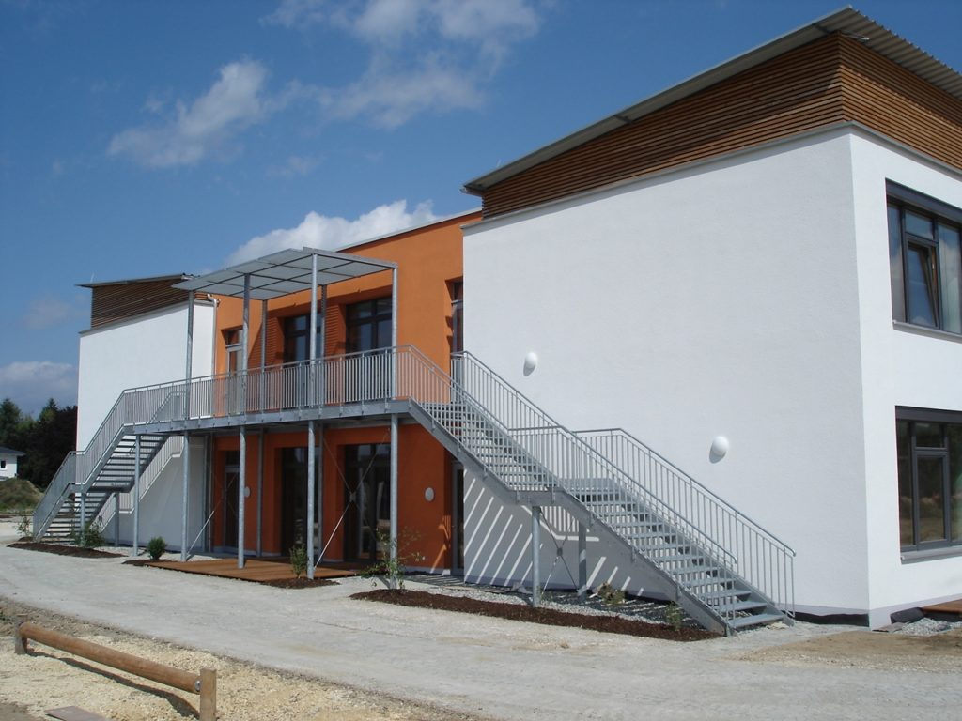
c) d) e)
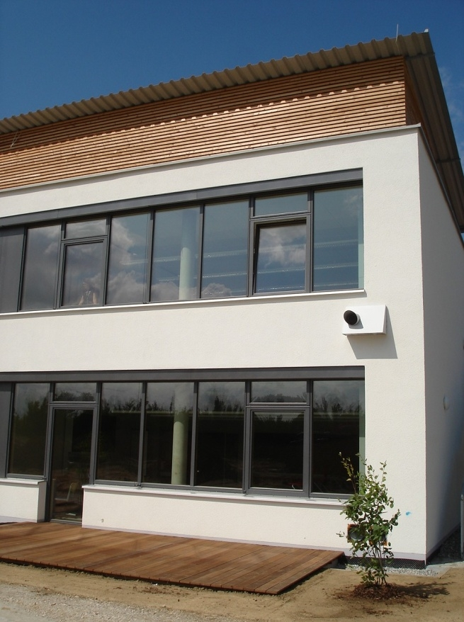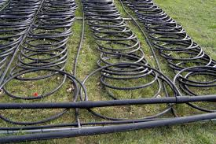
Fig. 1 – Example of a passive house (Elementary school "ZUD-OST"):
a) view from the southeast; b) shed roof of assembly hall; с) an angle of the facade; d) heat pump; e) collectors

The air quality in a passive house also compares favorably with other buildings. Studies have shown that the requirement of complete replacement of air in a building twice a day (DIN 1946, part 2: limiting the concentration of CO2 in the premises to a level not exceeding 1500 ppm) cannot be achieved only through ventilation through open Windows. And the results of measurements of CO2 level in classrooms show that its volume in rooms with traditional ventilation ranges from 2500 to 4000 ppm. Controlled mechanical ventilation provides an inflow of 15-20 m³ of fresh air per person, which corresponds to the complete air exchange in the room twice a day. In addition, guarantees the absence of noise and draughts in the class room and prevent dry air. Thus, the building of the passive house not only significantly reduces operating costs, but, above all, creates more favorable conditions for the training of students and teachers.
Due to the compactness of the construction and the location of the premises inside the building, the project was best suited to the requirements of a passive house. Roof construction was investigated alternative solutions from the point of view of reducing costs. Identified the following objectives for the project:
– multifunctional use of the central areas of the building, with the possibility of further expansion of the side wings of the building;
– central location of sanitary, auxiliary and technical premises;
– placement of the main premises in the Eastern and Western wings of the building;
– massive prefabricated structures for load-bearing structures, ceilings and interior walls;
– thermowell-wooden or capital construction;
– power consumption <15 kW.h / (m2 per year);
– the rate of air exchange according to the test for a pressure difference - n50 <0.6/h;
–providing additional heat demand by means of a heat pump with soil collectors based on salt concentrate and using the same system for cooling in summer;
– provide additional energy needs by using solar power systems;
– maximum comfort for students and teachers with minimal operating costs.

Construction of residential buildings by passive house is already quite common in Germany and has a great success. There are also numerous innovative projects in the field of school construction (Fig.2) [2].
a) b)
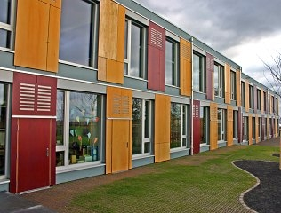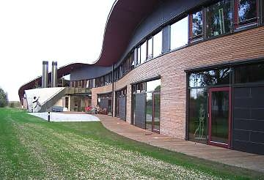
Fig. 2 – Innovative projects of passive houses:
a) School Riedberg, Frankfurt; b) School Waldorf, Munich

References
1. Эндхардт М. Проект пассивный дом / М. Эндхардт // Гюнцбург, Германия. URL: www.pro-passivhaus.com

2. ЕКО-БАУ. Начальная школа по стандарту пассивного строительства. URL: // http://alyans-km.odessa.ua/passivnyj-dom/nachalnaya-shkola-po-standartu-passivnogo-stroitelstva/

