МОДЕЛЮВАННЯ ЦІЛЬОВИХ ОПЕРАЦІЙ У ТЕХНІЧНИХ

І БІОЛОГІЧНИХ СИСТЕМАХ ТА ОБ’ЄКТАХ

The angle δ was used to account for hyperpronation and hypersupination in the calcaneus model. (Fig. 2).
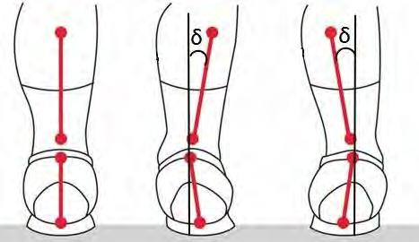
The angle δ directly reflects the degree of deviation of the pronation from the norm. The angle of rotation of the ₁ plane is determined by the sum or difference of the α and δ angles, depending on the type of pronation. The angle δ can be obtained experimentally by different methods, for example, with a gait test.

CONCLUSIONS. The proposed computer model will help to opti-mize the process of modeling the calcaneus during reconstruction, which in turn will facilitate the process of surgical intervention, as well as re-duce the time of patient's adaptation to the new implant.

REFERENCES
1. Heimann T, Meinzer HP. Statistical shape models for 3D medical
image segmentation: A review. Med
Image Analysis. 2009;
- Melinska AU, Romaszkiewicz P, Wagel J, Sasiadek M. Statistical, Morphometric, Anatomical Shape Model (Atlas) of Calcaneus. 2015;

CLOUD COMPUTING FOR THE NANOSTRUCTURES МODELING

Kuznetsova T., Bazavluk V., Ivanchenko A.

Poltava National Technical Yuriy Kondratyuka University
prosp. Pershotravnevyi , 24, Poltava, 36011, Ukraine. Е-mail: k23@pntu.edu.ua
The paper proposes a method of using cloud computing for modeling nanosystems and nanostructures such as atoms and molecules. Standard methods sometimes cannot have good results because of lack of computer power. Moreover, it takes a long time to complete your modeling. Cloud computing can solve this problem using powerful remote servers.
Key words: cloud computing, modeling, nanostructures.

Theoretical modeling and simulation play an important role in understanding the subtle and complex behavior of nanostructures. Atomic simulations can capture the microscale mechanism of nanostructures, but they are limited to very small systems due to their computational cost.

Nanostructure modeling is the computation of the positions and orbitals of atoms in arbitrary nanostructures [1]. Accurate atomic-scale quantum theory of nanostructures and nanosystems fabricated from nanostructures enables

precision metrology of these nanosystems and provides the predictive, precision modeling tools needed for engineering these systems for applications including advanced semiconductor lasers and detectors, single photon detectors, etc [2].

The progress of computer modeling of nanostructures depends very much on the power of existing computers and the efficiency of computational algorithms. To calculate complex nanosystems, such as nanorobots, consisting of bil-lions of atoms, a computer needs to calculate a huge number of equations of quantum mechanics. This process can take from a few minutes to tens or even hundreds of years.

Therefore, it is expedient to use cloud computing for precise nanosystem modeling, which allows reducing the time of computing by using powerful remote servers. This allows researchers and engineers to save money on the powerful data centers, and use existing ones, paying only for the used computing time.

Cloud computing (CC) involves sending outgoing parameters of the nanosystem to the remote servers which can process data much faster than PCs and getting only the result of modeling. Scientist do not have to care about the mod-eling process.

Figure 1 shows some of uses of CC which can help simulate a nanostructure.
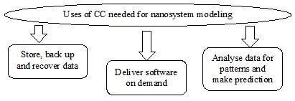
Top benefits of cloud computing include [3]:

1. Cost. Cloud computing elimi-nates the capital expense of buying hardware and software and setting up and running on-site datacenters - the racks of servers, the round-the-clock electricity for power and cooling.

2. Speed. Most cloud computing
Figure 1 – Uses of cloud computing services are provided self service and on demand, so even vast amounts of

computing resources can be provi-
sioned in minutes, typically with just a few mouse clicks, giving a lot of flexibility and taking the pressure off capacity

ХVII Міжнародна науково-технічна конференція «Фізичні процеси та поля технічних і біологічних об’єктів» 152

МОДЕЛЮВАННЯ ЦІЛЬОВИХ ОПЕРАЦІЙ У ТЕХНІЧНИХ

І БІОЛОГІЧНИХ СИСТЕМАХ ТА ОБ’ЄКТАХ

planning.
- Global scale. The benefits of cloud computing services include the ability to scale elastically. In cloud speak, that means delivering the right amount of IT resources - for example, more or less computing power, storage, bandwidth - right when its needed and from the right geographic location.

- Productivity. On-site datacenters typically require a lot of “racking and stacking” - hardware set up, software patching and other time-consuming IT management chores. Cloud computing removes the need for many of these tasks.
  - Performance. The biggest cloud com-puting services run on a worldwide network of secure datacenters, which are regularly upgraded to the latest generation of fast and efficient computing hardware. This offers several benefits over a single corporate data-center, including reduced network latency for applications and greater economies of scale.

  - Reliability. Cloud computing makes da-ta backup, disaster recovery and business continuity easier and less expensive, because data can be mirrored at multiple redundant sites on the cloud provider’s network.
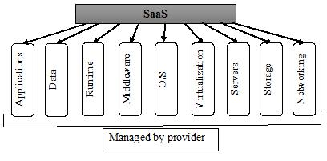
Figure 2 – Management model of SaaS | Most cloud computing services fall into
 | three broad categories: infrastructure as a ser-
vice (IaaS), platform as a service (PaaS) and software as a service (SaaS). These are sometimes called the cloud compu-ting stack, because they build on top of one another.

The most appropriate type for goals of nanostructure modeling and simulations is SaaS because it is cheap but, at the same time, provides all needed functions.

Software -as-a-service (figure 2) is a method for delivering software applications over the Internet, on demand and typically on a subscription basis. With SaaS, cloud providers host and manage the software application and underlying infrastructure and handle any maintenance, like software upgrades and security patching.

Not all clouds are the same. There are three different ways to deploy cloud computing resources (fig.3): public cloud, private cloud and hybrid cloud [3].

Public clouds are owned and operated by a third-party cloud service provider, which deliver their computing resources like servers and storage over the Inter-net. With a public cloud, all hardware, software and other supporting infrastruc-ture is owned and managed by the cloud provider. You access these services and manage your account using a web brows-er.
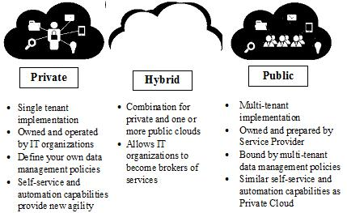
Private clouds refer to cloud compu-ting resources used exclusively by a single business or organisations. A private cloud can be physically located on the compa-ny’s on-site datacenter. Some companies also pay third-party service providers to
Figure 3 – Deployment models of cloud computing host their private cloud. A private cloud is one in which the services and infrastruc-
ture are maintained on a private network.

Hybrid clouds combine public and private clouds, bound together by technology that allows data and applications to be shared between them. By allowing data and applications to move between private and public clouds, hybrid cloud gives businesses greater flexibility and more deployment options.

All of deployment models have a lot of advantages and can be used for modeling of nanostructures and nanosystem. To sum up, cloud computing is a perfect idea for those who wants to create complex precise nanostructures and
nonosystems but aren’t ready to spend a huge amount of money for datacenters and computer power.

REFERENCES
- Bulavin L.A. Computer modeling physical systems / L.A. Bulavin, N.I. Lebovka. – Dolgoprudn, 2011. – 352.
- Wescott, Bob. The Every Computer Performance Book, Chapter 7: Modeling Computer Performance. // Cre-ateSpace. – 2013.
- Thomas Erl. Cloud Computing: Concepts, Technology & Architecture / Thomas Erl, Zaigham Mahmood, Ricar-do Puttini // Prentice Hall. – Boston, USA, 2013. - 1st Edition – 491 p.

ХVII Міжнародна науково-технічна конференція «Фізичні процеси та поля технічних і біологічних об’єктів» 153

