Modern engineering and innovative technologies Issue 3 / Vol.1

http://www.moderntechno.de/index.php/meit/article/view/ge3-010 DOI: 10.30890/2567-5273.2018-03-01-010

UDC 004.94

NANOSYSTEM COMPUTER MODELING USING CLOUD COMPUTING

КОМПЮТЕРЕНЕ МОДЕЛЮВАННЯ НАНОСИСТЕМ З ВИКОРИСТАННЯМ ХМАРНИХ ОБЧИСЛЕНЬ
Kurys Yu.O./ Курись Ю. О.

lecturer/ викладач
ORCID: 0000-0003-1367-4875
Kuznetsova T. Yu./Кузнецова Т.Ю.
c.c.s./к.хім.н.
_{ORCID:} 0000-0002-1918-9435
Parashchiienko I.N./Парашієнко І.М.
c.t.s./к.т.н.
ORCID:0000-0002-4454-980х
Rogova N.Yu./Рогова Н.Ю.
lecturer/ викладач

Poltava National Technical Yu. Kondratyuk University, Poltava, avenue Pershotravnevyi, 24, 36601
Полтавський національний технічний університет імені Ю. Кондратюка, м.Полтава,пр.Першотравневий,24,36011

Abstract. The paper proposes a method of using cloud computing for modeling nanosystems and nanostructures such as atoms and molecules. Standard methods sometimes cannot have good results because of lack of computer power. Moreover, it takes a long time to complete your modeling. Cloud computing can solve this problem using powerful remote servers.

Keywords: cloud computing, modeling, nanosystem, nanostructures.

Theoretical modeling and simulation play an important role in understanding the subtle and complex behavior of nanostructures. Atomic simulations can capture the microscale mechanism of nanostructures, but they are limited to very small systems due to their computational cost.

Nanostructure modeling is the computation of the positions and orbitals of atoms in arbitrary nanostructures [1].

Accurate atomic-scale quantum theory of nanostructures and nanosystems fabricated from nanostructures enables precision metrology of these nanosystems and provides the predictive, precision modeling tools needed for engineering these systems for applications including advanced semiconductor lasers and detectors, single photon detectors, etc [2].
The progress of computer modeling of nanostructures depends very much on the power of existing computers and the efficiency of computational algorithms. To calculate complex nanosystems, such as nanorobots, consisting of billions of atoms, a computer needs to calculate a huge number of equations of quantum mechanics. This process can take from a few minutes to tens or even hundreds of years.
Therefore, it is expedient to use cloud computing for precise nanosystem modeling, which allows reducing the time of computing by using powerful remote servers. This allows researchers and engineers to save money on the powerful data centers, and use existing ones, paying only for the used computing time.

Cloud computing (CC) involves sending outgoing parameters of the nanosystem to the remote servers which can process data much faster than PCs and getting only

ISSN 2567-5273 ₆₈ Technical sciences

Modern engineering and innovative technologies Issue 3 / Vol.1

the result of modeling. Scientist do not have to care about the modeling process.
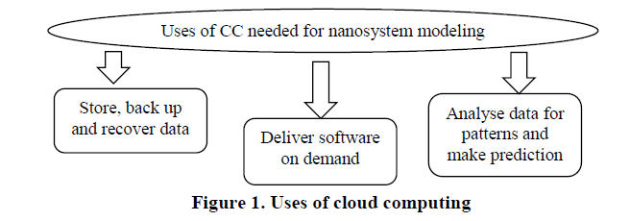
Figure 1 shows some of uses of CC which can help simulate a nanostructure.

Top benefits of cloud computing include [3]:
- Cost. Cloud computing eliminates the capital expense of buying hardware and software and setting up and running on-site datacenters - the racks of servers, the round-the-clock electricity for power and cooling.

- Speed. Most cloud computing services are provided self service and on demand, so even vast amounts of computing resources can be provisioned in minutes, typically with just a few mouse clicks, giving a lot of flexibility and taking the pressure off capacity planning.

- Global scale. The benefits of cloud computing services include the ability to scale elastically. In cloud speak, that means delivering the right amount of IT resources - for example, more or less computing power, storage, bandwidth - right when its needed and from the right geographic location.
- Productivity. On-site datacenters typically require a lot of “racking and stacking” - hardware set up, software patching and other time-consuming IT management chores. Cloud computing removes the need for many of these tasks.

- Performance. The biggest cloud computing services run on a worldwide network of secure datacenters, which are regularly upgraded to the latest generation of fast and efficient computing hardware. This offers several benefits over a single corporate datacenter, including reduced network latency for applications and greater economies of scale.
- Reliability. Cloud computing makes data backup, disaster recovery and business continuity easier and less expensive, because data can be mirrored at multiple redundant sites on the cloud provider’s network.

Most cloud computing services fall into three broad categories: infrastructure as a service (IaaS), platform as a service (PaaS) and software as a service (SaaS). These are sometimes called the cloud computing stack, because they build on top of one another.

The most appropriate type for goals of nanostructure modeling and simulations is SaaS because it is cheap but, at the same time, provides all needed functions.

Software-as-a-service (figure 2) is a method for delivering software applications over the Internet, on demand and typically on a subscription basis. With SaaS, cloud providers host and manage the software application and underlying infrastructure and

ISSN 2567-5273 ₆₉ Technical sciences

Modern engineering and innovative technologies Issue 3 / Vol.1

handle any maintenance, like software upgrades and security patching.

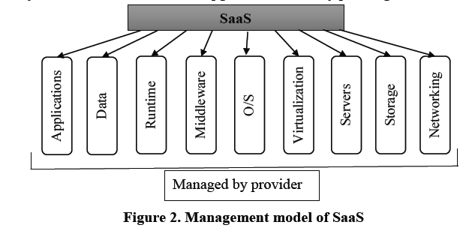

Not all clouds are the same. There are three different ways to deploy cloud computing resources (fig.3): public cloud, private cloud and hybrid cloud [3].

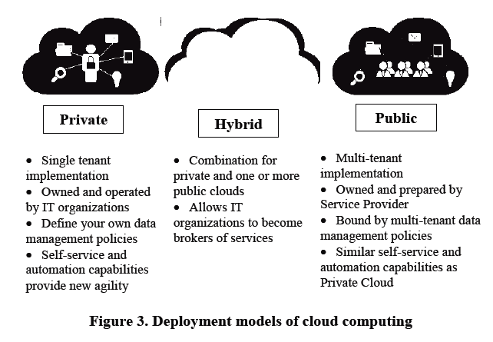

Public clouds are owned and operated by a third-party cloud service provider, which deliver their computing resources like servers and storage over the Internet. With a public cloud, all hardware, software and other supporting infrastructure is owned and managed by the cloud provider. You access these services and manage your account using a web browser.

Private clouds refer to cloud computing resources used exclusively by a single business or organisations. A private cloud can be physically located on the company’s on-site datacenter. Some companies also pay third-party service providers

ISSN 2567-5273 ₇₀ Technical sciences

Modern engineering and innovative technologies Issue 3 / Vol.1

to host their private cloud. A private cloud is one in which the services and infrastructure are maintained on a private network.

Hybrid clouds combine public and private clouds, bound together by technology that allows data and applications to be shared between them. By allowing data and applications to move between private and public clouds, hybrid cloud gives businesses greater flexibility and more deployment options.

All of deployment models have a lot of advantages and can be used for modeling of nanostructures and nanosystem.

To sum up, cloud computing is a perfect idea for those who wants to create complex precise nanostructures and nonosystems but aren’t ready to spend a huge amount of money for datacenters and computer power.

References

- Bulavin L.A. Computer modeling physical systems / L.A. Bulavin, N.I. Lebovka. – Dolgoprudn, 2011. – 352.

- Wescott, Bob. The Every Computer Performance Book, Chapter 7: Modeling Computer Performance. // CreateSpace. – 2013.

- Thomas Erl. Cloud Computing: Concepts, Technology & Architecture / Thomas Erl, Zaigham Mahmood, Ricardo Puttini // Prentice Hall. – Boston, USA, 2013. - 1st Edition – 491 p.

Анотація. В роботі запропоновано метод використання хмарних обчислень для моделювання таких наносистем та наноструктур як атоми та молекули. Даний метод дозволяє позбутися деяких недоліків стандартних методів моделювання, наприклад недостатня обчислювальна потужність персональних комп’ютерів і невеликих серверів та тривалий час обробки інформації і моделювання.

Ключові слова: хмарні обчислення, моделювання, наносистеми, наноструктури.

ISSN 2567-5273 ₇₁ Technical sciences

