**Збірник наукових праць. Галузеве машинобудування, будівництво**

**Academic journal. Industrial Machine Building, Civil Engineering**

[**http://journals.nupp.edu.ua/znp**](http://journals.nupp.edu.ua/znp)

[**https://doi.org/10.26906/znp.2022.58.ХХХХ**](https://doi.org/10.26906/znp.2022.58.ХХХХ)

**UDC 624.13**

**Dependence of the plastic rocks properties   
on the pressure change in the well**

**Mykhailovska Olena1*, Solovyov Veniamin2**

1 Poltava National Technical Yuri Kondratyuk University <https://orcid.org/0000-0001-7451-3210>

2 Poltava National Technical Yuri Kondratyuk University https://orcid.org/0000-0002-0805-9661

*Corresponding author: [ab.Mykhailovska_OV@nupp.edu.ua](mailto:ab.Mykhailovska_OV@nupp.edu.ua)

Experimental studies of changes in rock properties depending on the pressure in the well and in the massif of the plastic layer at different distances from the well over time were carried out. The function demonstrates the power dependence of the pressure ratio at the moment of time on the geostatic pressure. After sealing the well, the pressure in the massif of the plastic formation increases in the near-well zone and decreases in the peripheral zone. Over time, the pressure in the massif of the plastic layer is equalized over the entire area of the layer. Pressure changes in a plastic rock have an impulse character. Thermal (residual) stresses affect the destruction of rocks during drilling with an increase in the depth of the well

**Keywords:** plastic rock, rheology, stress-strain state, trunk, well

**Залежність властивостей пластичних гірських порід   
від зміни тиску в свердловині**

**Михайловська О.В.1*, Соловйов В.В.2**

1,2  Полтавський національний технічний університет імені Юрія Кондратюка

*Адреса для листування: [ab.Mykhailovska_OV@nupp.edu.ua](mailto:ab.Mykhailovska_OV@nupp.edu.ua)

В розрізах родовищ Дніпрово-Донецькій западині виявлені потужні товщі солі у пермських та девонських відкладах За даними спостережень, такі деформації мають нестійкий характер і можуть проявлятись в будь-який момент експлуатації вертикального ствола. В статті досліджено поведінку гірського масиву з вмістом високопластичних порід на моделі. В якості моделі масиву високопластичної породи був використаний парафін, що обмежувався по горизонталі трубою великого діаметра, а по вертикалі – жорсткими плитами. В якості моделі свердловини була використана гумова трубка, заповнена рідиною. Тиск на модель текучого пласта створювався гідравлічним пресом, який автома­тично підтримував заданий тиск протягом всього експерименту. Для вимірювання тиску в моделі свердловини і гірського масиву були використані напівпровідникові датчики об'ємного тиску, що були установлені на різній відстані від осі свердловини. До початку експерименту модель гірського масиву із умовною свердловиною ви­держувалась до вирівнювання тиску у всіх точках об'єму. Потім тиск в моделі свердлови­ни зменшували до атмосферного і свердловину герметизували. Показники датчиків тиску реєструвались протягом всього експерименту. В результаті експерименту встановлено, що інтенсивність падіння тиску зменшується від свердловини. При розкритті свердловиною пластичного пласта спостерігається інверсія тиску подалі від свердловини. Встановлено, що у першому наближенні для визначення тиску соляних та глинистих відкладень на кріплення в будь-який момент часу можна використати апроксимуючу функцію. Яка демонструє степеневу залежність відношення тиску на момент часу до геостатичного тиску. Після герметизації свердловини тиск в масиві пластичного пласта зростає в при-свердловинній зоні і зменшується в периферійній і з часом вирівнюється по всій площі. Зміни тиску в пластичній породі мають імпульсний характер. Термічні напруження, які мають назву залишко­вих, впливають на руйнування гірських порід під час буріння зі збільшенням гли­бини свердловини

**Ключові слова:** напружено-деформований стан, реологічні властивості, свердловина, стовбур, пластична порода.

Creative Commons License

**Introduction**

Oil and gas filds located in the Dnipro-Donetsk Basin are characterized by significant depths of occurrence, high thermobaric gradients, differences in formation pressures along the section, multicomponent formation fluids, etc.

Thick strata of salt in Permian and Devonian sediments were found in sections of deposits in the Dnipro-Donetsk Basin. In tectonic terms, the deposits have salt-dome structures. In the cross-section of the sedimentary stratum, sub-saline and supra-saline complexes, separated by a saline complex, are found in the deposits of the Poltava region [1]. Terrigenous sediments occur in practically all sedimentary rocks of the Dnipro-Donetsk Basin.

he main problem of drilling is related to ensuring the stability of well walls in clay and salt rocks. It is necessary to pay attention to the prevention of spalling and collapse of the walls of the well. So it is necessary to pay sufficient attention to research and prediction of stresses acting on the wellbore. Ensuring the integrity of well walls during their drilling is one of the primary tasks of improving the quality and increasing the technical and economic indicators of their construction. From the practice of drilling directional wells, the costs of combating complications are on average 20-25% of the calendar time of drilling. The loss of stability of clay or salt rocks is understood as falling out, crumbling, collapsing, narrowing of the trunk, cavernous and gutter formations. These phenomena lead to the seizure of the drill string and a significant increase in the material costs of materials and production time for their elimination [2].

Most of the complications that exist in wells are the result of a certain stressed state of the massif. Therefore, it is necessary to analyze the causes of complications, collapses, deformations of well walls.

In real conditions of occurrence, rocks are in a state of comprehensive compression. After opening the formation by drilling, a local force field is formed on the perimeter of the wellbore. This leads to various deformations on the well walls: from plastic flow to brittle failure. The nature of these deformations is determined by the properties of the rock and the magnitude of the rock pressure. The conditions of formation, composition and degree of lithification of rocks cause a wide range of changes in their properties.

For example, plastic and water-sensitive rocks behave as highly plastic bodies. Thus, the presence of such rocks in the wellbore can cause narrowing of the wellbore. However, under the influence of temperature and pressure, new rigid chemical bonds between its structural elements arise in such rocks. The nature of destruction of such rocks is already brittle or plastic-brittle. They are capable of cracking and crumbling in deep conditions when opened by drilling.

**Review of the research sources and publications**

At the stage of drilling and operation of wells, it is important to determine the change in the volumetric stress state of the rock massif containing plastic rocks. Because it is quite difficult to directly measure the pressure in the massif of rocks. The authors analyzed individual cases of assessing the stability of wellbore shafts.

For example, in the works of A.I. Riznychuk, I.I. Chudyk. the factors affecting the stability of the well walls in conditions prone to landslides and rockfalls were analyzed [2,3].

R. V. Rachkevych also analyzed a special case of the stress-deformed state of the drill string in the curved part of the well. The analysis was carried out when a trough or cavern formed on the wall of the well. Additionally, the force of interaction of the drill string with the bottom of the chute or cavern was determined [6].

Often the destruction of rocks occurs outside the zone of elastic deformations - in the zone of the plastic state. This is characterized by the appearance of significant residual deformations in the rocks. Evaluation of their stability in the wellbore is reflected by the dependence of K.F. Puks. In the initial data, the diameter of the wellbore and the rock-crushing tool, the volumes of the wells are known [2].

Plastic deformations occur as a result of displacement of dislocations. They start from places of structural disruption and spread along the sliding plane gradually, without disturbing the crystalline structure and integrity of the substance.

Along with this, mutual movement of rather large volumes, compression, crumpling, etc. (quasi-plasticity) is observed in the rocks. The behavior of a mountain massif under the action of forces can be described by various models: mechanical model - elastic (Hooke's body); mechanical model, which is a heavy body lying on a horizontal plane and connected to a spring (Saint-Venant body).

The work of E.M. Baranovsky [4,5] is devoted to solving the problem of wellbore stability. The stress-strain state of wellbores was quite difficult to describe by analytical equations.

An analytical model for the characterization of salt massifs was also proposed by M. Todores (2020) based on octahedral geomechanical parameters. It was verified both by laboratory studies using modeling tools and by on-site measurements [7].

Hadiseh Mansouri, Rassoul Ajalloeian (2018) determined from the results of experiments that the axial peak stress, strain and modulus of elasticity gradually increase with the increase of strain rate. It was established that the model of viscoelastic creep of Burgers agrees quite well with the experimental data on creep. [8].

**Definition of unsolved aspects of the problem**

A new deformation criterion of the compressive strength of samples of salt rocks was also proposed. The limiting principal deformation is a function of the stress parameter in the form of the ratio of hydrostatic pressure to stress intensity [9]. That is, it was established that the deformation will depend on the hydrostatic pressure. This needs to be verified in natural or laboratory conditions.

Most rocks belong to strengthening bodies. In order to maintain plastic deformations in them, it is necessary to increase the tension. At the same time, the growth of stresses occurs at a decreasing rate. This behavior of the rock is modeled by a combination of an ideally elastic Hooke body and an ideally viscous Newtonian body (a piston with holes moving in a cylinder filled with a viscous liquid). When these bodies are connected in parallel, the model of the Kelvin - Voigt body is obtained, when it is connected in series - the Maxwell body. However, these models describe the stress-strain state of rocks without taking into account the rheological properties of the rock and the corresponding thermobaric conditions of the massif.

**Problem statement**

The purpose of the research is to conduct experimental studies of changes in rock properties depending on the pressure in the well and in the massif of the plastic reservoir at different distances from the well over time.

**Basic material and results**

The plasticity of rocks increases with increasing temperature and lateral pressure. However, the number of dislocations in rocks does not change. At the same time, their mobility increases significantly, which contributes to plastic deformation. Rocks that behave as brittle under normal conditions acquire pronounced plastic properties at elevated pressures and temperatures.

This is important when developing deposits at great depths. For example, the ability to plastic deformation in limestones and siltstones appears already at all-round pressures of about 50 MPa, in anhydrites - about 100 MPa. The construction of vertical shafts in salt rocks coincides with the spread of deformations of the rock contour over a long period of time. As the data of natural observations show, such deformations have an unstable character [5, 6] and can appear at any moment of operation of a vertical shaft. At shallow depths (up to 200 m), the well bore, drilled through salt rocks, was not secured. However, with an increase in the depth of salt deposits (more than 300 m), the "creeping effect" of rock salt begins to manifest itself actively.

This phenomenon occurs at tangential stresses on the trunk contour of 10-15 MPa according to research data. At great depths (1000 m and more), the development of rheological processes is accompanied by significant deformations of the rock contour of vertical shafts. Also, the load on hard fasteners in the long term increases to 20 MPa or more.

Therefore, it is necessary to investigate the behavior of the mountain massif with the content of highly plastic rocks on the model. As a model of the massif of highly plastic rock, paraffin was used, which was limited horizontally by a large-diameter pipe, and vertically by hard plates.

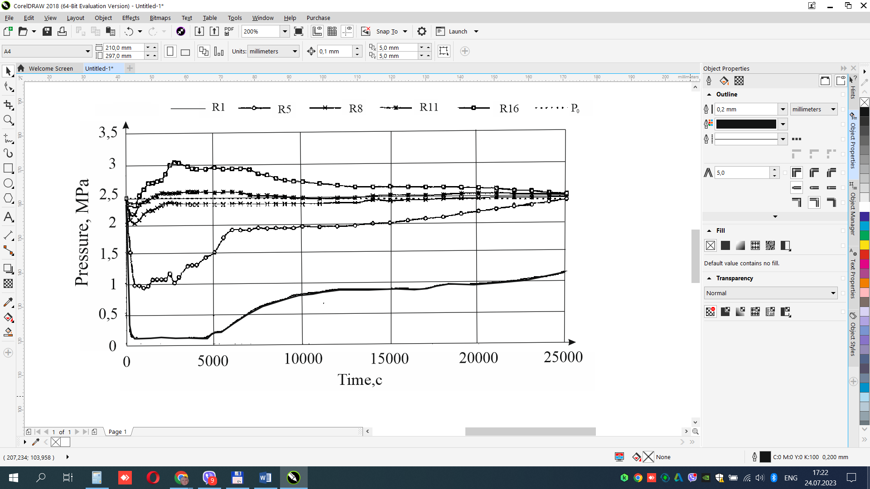

**Figure 1 –** **Graphs of pressure changes in the well model and at different distances from the axis (R1-R16) of the well in the model: P0 is the initial pressure in the model, MPa; R - the radius of the wells**

A rubber tube filled with liquid was used as a well model. The pressure on the model of the fluidized bed was created by a hydraulic press, which automatically maintained the set pressure throughout the experiment. Semiconductor volumetric pressure sensors were used to measure the pressure in the model of the well and the rock massif. They were installed at different distances from the axis of the well.

Before the start of the experiment, the model of the mountain massif with a conventional well was maintained until the pressure equalized at all points of the volume. Then the pressure in the well model was reduced to atmospheric and the well was sealed.

The readings of the pressure sensors were recorded throughout the experiment. In fig. 1 shows graphs of pressure changes in the well and in the massif of the plastic layer in the "pressure-time" coordinates at different distances from the axis of the well.

The readings of the pressure sensors were recorded throughout the experiment. In fig. 1 shows graphs of pressure changes in the well and in the massif of the plastic reservoir in the pressure-time coordinates at different distances from the axis of the well.

From fig. 1 shows that when the pressure in the well model decreases (corresponding to the moment when the well opens the mass of plastic rocks), the pressure decreases over the entire area of the mass. At the same time, when the point is far from the axis of the well, the magnitude of the pressure drop in the massif decreases [10-14].

After closing the well, the nature of the pressure change in the massif at different distances from the axis of the well is significantly different. In the well and at a distance of two radii of the well, the pressure remains unchanged. At a distance of five radii, stabilization and a slight decrease in pressure are observed first, and then an increase. At a distance of more than 8R from the axis of the well, the pressure increases and at a distance of more than 11R it exceeds the set pressure. Over time, the dynamics change: the pressure on the peripheral sensors begins to fall, and in the well and near-well zone - to increase. Fig. 2 shows graphs of pressure changes in the well and in the massif of the plastic layer in the "pressure-distance" coordinates from the axis of the well after sealing the well, which corresponds to the state of the massif after fixing the well.

It can be seen from Fig. 2 that in this experiment the maximum pressure changes in the massif of the plastic layer occur at a distance from the axis of the well to eight values of its radii. In the zone of distance along the formation, which is equal to the distance of eight to eleven well radii, pressure changes are insignificant.

The analysis of the graphs shows that the pressure changes in the massif of the plastic reservoir model have a pulse character. It is obvious that this character is due to the periodic accumulation of energy in a certain zone of the massif and the shift towards the well [11].

When assessing the stress-strain state of plastic rocks around the well, it is necessary to take into account the thermal conditions of the rocks. The difficulty of evaluating the resistance of rocks to thermal effects around the borehole lies primarily in the fact that it depends on the coefficient of linear temperature expansion of the material, its modulus of elasticity, thermal conductivity. And also from the regularity of the distribution of the temperature field, the state of the surface, the properties of the surrounding deposit, etc.

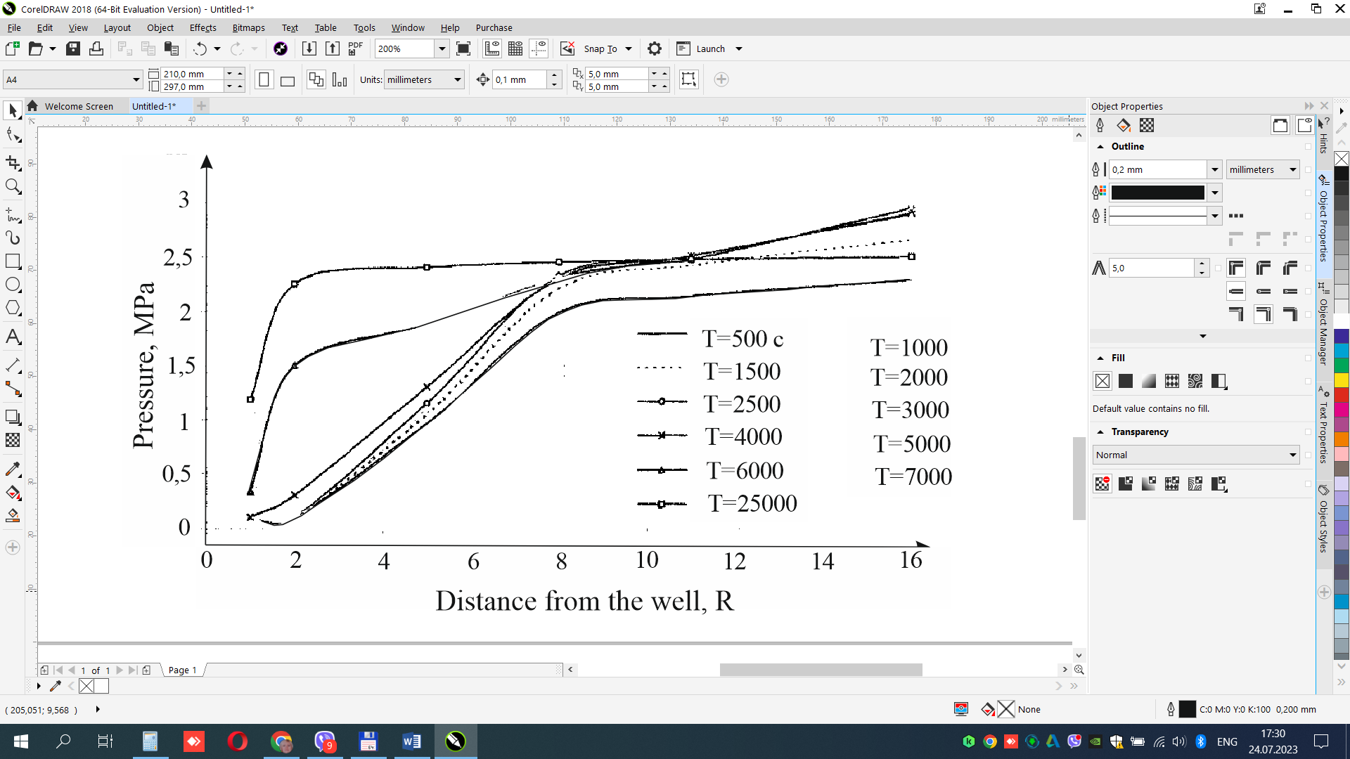

**Figure 2 – Graphs of pressure changes in the well model at sharp time intervals   
after sealing the well, depending on the distance of the sensor from the axis of the well [8].**

For example, if a body is heated unevenly in volume, then the temperature deformations of individual elements corresponding to such heating become limited due to the fact that neighboring elements interfere with free deformations. At the same time, stresses will arise, the distribution of which will depend on the regularity of the temperature distribution.

If the material is homogeneous and the temperature is the same throughout the volume of the body, then temperature deformations inside the body are not limited by anything and do not cause temperature stresses. Temperature stresses can occur only when the material is heterogeneous in temperature coefficients of volume expansion or due to uneven distribution of the temperature field by volume. Also, temperature stresses can occur under the condition of external limitation of temperature deformations on the surface of the body.

Temperature stresses are always given by temperature deformation. Therefore, uneven temperature fields, unlike uniform ones, can be accompanied by a change in temperature stresses.

Most often, rocks consist of mineral particles cemented together with different physical and thermal characteristics. It is obvious that even with uniform temperature fields, there are always volumetric temperature stresses inside rock layers. Temperature stresses are caused not only by temperature, but also by heterogeneity of structural components and anisotropy of their thermal expansion and other properties at the joints of grains or blocks of grains that make up the micro- and macrovolumes of the body. In particular, temperature stresses can affect the stress-strain state of the massif when drilling ductile rocks, which must be taken into account [13].

With a certain heterogeneity of plastic rocks under the action of a uniform temperature field, temperature stresses will arise due to the difference in physical and thermal characteristics of non-homogeneous materials. Such local thermal stresses affect the destruction of rocks during drilling with an increase in the depth of the well [12].



**Figure 3 – The model of the development   
of pressure on a column of casing pipes in   
an inelastically deformed loosened compacted near-stem rock massif [14]**

The model of the development of pressure on a column of inelastically deformed rock mass (salt, clay) loosened around the well is shown in Fig. 3. In fig. 3. t0 − t1 − time period from the end of the column descent to the level of solidification of the plugging material in the annular space in the interval of fluid rocks; t1 − t2 − the time during which the loosened volume of the rock is compressed to the volume with the initial density before the formation is opened; t2 is the moment of time when the pressure on the column reaches σc of the temporary resistance to uniaxial compression of the rock; t2 − t3 − time of change of mountain pressure from σс to geostatic pressure Рg.

The task of predicting column pressures is to determine the rock pressure at any point in time. Pressure, time and its changes remain unknown. But the experimental dependences of the temporary resistance to uniaxial compression on the strain rate σv = f(v) on the density are known σ = f(ρ) and density from the rate of deformation ρ = f(v) for salt rocks. The physical mechanism of the processes and variable power capabilities of the rock in the zone of reduced stresses is important. Stresses arise due to the pressure behind the zone of reduced pressures.

In the absence of direct instrumental measurements of column pressure in salt rocks, dynamometric measurements of column pressure in creeping clays were used to predict the pressure-time relationship. The pressure was determined as the average of 11 pressure sensors.

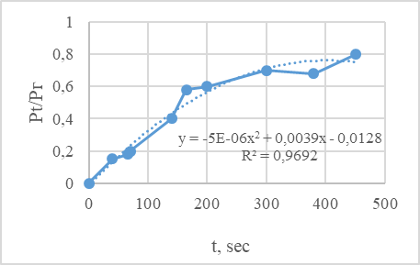**Figure 4 – Geostatic pressure - 2.633 MPa,   
depth - 142.6 m, average density of overlying   
rocks - 1847 kg/m3, test time - 658 days**

As a first approximation, the approximating function can be used to determine the pressure of salt and clay deposits on fasteners at any moment in time:

*Рt/Pг=-5·10-6t2+0,0039t+0,0128*, (1)

where Pt is the pressure at this moment in time, MPa; Rg - geostatic pressure, MPa;

t - time, days [Fig. 4].

**Conclusions**

During the conducted research, it was found that the opening of the plastic layer of the well is accompanied by a decrease in pressure in the layer. At the same time, the intensity of the pressure drop decreases from the well. When a plastic layer is opened by a well, a pressure inversion is observed at a distance from the well. After sealing the well, the pressure in the massif of the plastic layer increases in the near-well zone and decreases in the peripheral zone and eventually equalizes over the entire area. Pressure changes in a plastic rock have an impulse character. Thermal stresses, which are called residual, affect the destruction of rocks during drilling with an increase in the depth of the well.

When developing the methodology, the results of own experimental research, geophysical research in wells, instrumental measurements of pressure development over time on fasteners in mine construction and literary sources were used.

The methodology needs clarification, which consists in the need for direct instrumental measurements of the pressure of salt rocks on the column. It is also necessary to specify the measurements of the density of salts in the well, for example, using "gamma-gamma" logging. It is also necessary to carry out laboratory experiments on finding compression curves at low pressures. This will make it possible to specify the time t3.

**References**

|  |  |  |
| --- | --- | --- |
| 1. Бейзик О., Різничук А., Гордійчук М., Ковердій Б. (2022). [Підвищення якості розкриття соленосних відкладів в умовах високих температур](https://scholar.google.com.ua/scholar?oi=bibs&cluster=15840979092061669411&btnI=1&hl=uk). *Grail of Science,* 17, 213-217  <https://doi.org/10.36074/grail-of-science.22.07.2022> |  | 1. Beyzyk O, Riznychuk A, Gordiychuk M, Koverdiy B (2022). Improving the quality of the opening of salt-bearing sediments under conditions of high temperatures. *Grail of Science*, 17, 213-217  <https://doi.org/10.36074/grail-of-science.22.07.2022> |
| 2. Різничук А.І. (2020) *Удосконалення технології запобігання руйнуванню стінок скерованих свердловин: дис. ... канд. техн. наук*: спец. 05.15.10 "Буріння свердловин"Івано-Франківськ |  | 2. Riznychuk A.I. (2020) *Improvement of the technology of preventing the destruction of the walls of directional wells*: thesis ... candidate technical Sciences: special. 05.15.10 «Drilling of wells» Ivano-Frankivsk |
| 3. Чудик І.І., Фем’як Я.М., Різничук А.І., Васько І С., Юрич Л.Р. (2019). Експериментальні дослідження механічних властивостей гірських порід в термобаричних умовах. *Розвідка та розробка нафтових і газових родовищ,* 3(72), 32-41 |  | 3. Chudyk I.I., Femyak Y.M., Riznychuk A.I., Vasko І.S., Yurich L.R. (2019). Experimental studies of the mechanical properties of rocks in thermobaric conditions. *Exploration and development of oil and gas fields*, 3(72), 32-41 |
| 4. Барановський Е.М., Мойсішин В.М. (2006). Головне завдання геомеханіки у вирішенні проблем глибокого буріння. *Розвідка та розробка нафтових і газових родовищ,* 4, 5-9 |  | 4. Baranovskyi E.M., Moysyshyn V.М. (2006). The main task of geomechanics in solving problems of deep drilling *Oil exploration and development and gas deposits*, 4, 5-9 |
| 5.Барановський Е.М. (2006). Комбіноване руйнування гірських порід при бурінні глибоких свердловин. *Науковий вісник Івано-Франківського національного технічного університету нафти і газу*, 1, 26-30 |  | 5.Baranovsky E.M. (2006) Combined destruction of rocks during drilling of deep wells. *Scientific Bulletin of Ivano-Frankivsk National Technical University of Oil and Gas,* 1, 26-30 |
| 6. Рачкевич Р.В., Величкович А.С., Гриців В.В., Козлов А.А. (2012). Напружено-деформований стан бурильної колони у криволінійному стовбурі свердловини із виробками стінок. *Національний гірничий університет. Збірник наукових праць*, 37, 124-134 |  | 6. Rachkevich R.V., Velichkovich A.S., Hrytsiv V.V., Kozlov A.A. (2012). The stress-strain state of the drill string in the curved wellbore with wall formations *National Mining University. Collection of scientific works*, 37, 124-134 |
| 7. Toderas M. (2020). The octahedral concept and cubic triaxiality in assessment of secondary stress state. *Mining of Mineral Deposits*, 14 (1), 81-90  <https://doi.org/10.33271/mining14.01.081> |  | 7. Toderas M. (2020). The octahedral concept and cubic triaxiality in assessment of secondary stress state. *Mining of Mineral Deposits*, 14 (1), 81-90  <https://doi.org/10.33271/mining14.01.081> |
| 8. Mansouri H., Ajalloeian R. (2018). Mechanical behavior of salt rock under uniaxial compression and creep tests. [*International Journal of Rock Mechanics and Mining Sciences*](https://www.sciencedirect.com/journal/international-journal-of-rock-mechanics-and-mining-sciences)[, 110](https://www.sciencedirect.com/journal/international-journal-of-rock-mechanics-and-mining-sciences/vol/110/suppl/C), 19-27  <https://doi.org/10.1016/j.ijrmms.2018.07.006> |  | 8. Mansouri H., Ajalloeian R. (2018). Mechanical behavior of salt rock under uniaxial compression and creep tests. [*International Journal of Rock Mechanics and Mining Sciences*](https://www.sciencedirect.com/journal/international-journal-of-rock-mechanics-and-mining-sciences)[, 110](https://www.sciencedirect.com/journal/international-journal-of-rock-mechanics-and-mining-sciences/vol/110/suppl/C), 19-27  <https://doi.org/10.1016/j.ijrmms.2018.07.006> |
| 9. Aptukov V.N. (2016). Deformation criterion of salt rock failure. [Journal of Mining Science](https://www.researchgate.net/journal/Journal-of-Mining-Science-1573-8736), 52(3), 448-453  <https://doi.org/10.1134/S1062739116030645> |  | 9. Aptukov V.N. (2016). Deformation criterion of salt rock failure. [Journal of Mining Science](https://www.researchgate.net/journal/Journal-of-Mining-Science-1573-8736), 52(3), 448-453  <https://doi.org/10.1134/S1062739116030645> |
| 10. Світалка П.І., Соловйов В.В., Бандуріна О.В. (2013). Методика та результати визначення міцності соляних порід залежно від швидкості непружної деформації. [*Збірник наукових праць. Галузеве машинобудування, будівництво*](http://irbis-nbuv.gov.ua/cgi-bin/irbis_nbuv/cgiirbis_64.exe?Z21ID=&I21DBN=UJRN&P21DBN=UJRN&S21STN=1&S21REF=10&S21FMT=JUU_all&C21COM=S&S21CNR=20&S21P01=0&S21P02=0&S21P03=IJ=&S21COLORTERMS=1&S21STR=%D0%9669612)*,* 4(2), 175-181 |  | 10. Svitalka P.I., Solovyov V.V., Bandurina O.V. (2013). Methods and results of determining the strength of salt rocks depending on the rate of inelastic deformation. *Academic journal. Industrial Machine Building, Civil Engineering*, 4(2), 175-181 |
| 11.Дуда З.М., Світалка П.І. (2000). Результати дослідження об'ємно-напруженого стану навколосвердловинного масиву з вмістом пластичних порід. *Нафта і газ України: зб. наук. праць. VI Міжнар. наук.-практ. конф. «Нафта і газ України − 2000»,* 2, 44-46 |  | 11. Duda Z.M., Svitalka P.I. (2000. The results of the study of the volume-stress state of the wellbore massif with the content of plastic rocks. *Oil and gas of Ukraine: coll. of science works VI Intern. Scientific and Practical conf. "Oil and gas of Ukraine - 2000",* 2, 44-46 |
| 12.Мочернюк Д.Ю., Чернов В.Б. (2000). Оцінка впливу температури на зміну стану гірських порід навколо стовбура свердловини. *Нафта і газ України: зб. наук. праць. VI Міжнар. наук.-практ. конф. «Нафта і газ України − 2000»,* 2. 43-44 |  | 12.Mocherniuk D.Yu., Chernov V.B. (2000). Assessment of the influence of temperature on the change in the state of rocks around the wellbore. *Oil and gas of Ukraine: coll. of science works VI Intern. Scientific and Practical conf. "Oil and gas of Ukraine - 2000",* 2, 43-44 |
| 13.Світалка П.І., Соловйов В.В. (2000). Вибір шляху встановлення залежності тиск – час при невідомому об’ємонапруженому стані, непружнодеформованому навколо свердловинного масиву, із змінними в часі міцнісними властивостями порід. *Нафта і газ України: зб. наук. праць. VI Міжнар. наук.-практ. конф. «Нафта і газ України − 2000»,* 2, 91-92 |  | 13.Svitalka P.I., Solovyov V.V. (2000). The choice of the way to establish the pressure-time dependence at an unknown volumetric stress state, inelastically deformed around the well massif, with time-varying rock strength. *Oil and gas of Ukraine: coll. of science works VI Intern. Scientific and Practical conf. "Oil and gas of Ukraine - 2000",* 2, 91-92 |
| 14.Світалка П.І., Соловйов В.В. Прогнозування величини тиску на обсадну колону при розкритті солей і глин *Нафта і газ України: зб. наук. праць. VI Міжнар. наук.-практ. конф. «Нафта і газ України − 2000»,* 2, 67-70 |  | 14.Svitalka, P.I. Solovyov V.V. (2000) Prediction of the value of the pressure on the casing during the opening of salts and clays. *Oil and gas of Ukraine: coll. of science works VI Intern. Scientific and Practical conf. "Oil and gas of Ukraine - 2000",* 2, 67-70 |