Збірник наукових праць. Галузеве машинобудування, будівництво
Academic journal. Industrial Machine Building, Civil Engineering
http://journals.nupp.edu.ua/znp
https://doi.org/10.26906/znp.2022.58.ХХХХ

UDC 624.154:624.138.2

The practice of strengthening the base of a slab foundation
of a multi-story building with soil-cement elements

Krysan Vladimir¹, Krysan Vitali², Hasenko Anton³*

¹ «Geoprotect» LLC, Dnipro https://orcid.org/0000-0001-7497-4615
² «Geobud» LLC, Dnipro https://orcid.org/0000-0002-9683-7838
³ National University «Yuri Kondratyuk Poltava polytechnic» https://orcid.org/0000-0003-1045-8077
*Corresponding author E-mail: gasentk@gmail.com

The characteristic geotechnical conditions of modern high-rise construction are considered. The engineering and geological conditions of the site were analyzed. In particular, it was noted that loose soils lie up to a depth of 2.2 m, and below 13.0…13.5 – eolian-deluvial deposits (sandy and silty loams with a deformation modulus of 5…7 MPa). The territory is flooded. An effective constructive-technological solution was tested using the drilling-mixing method of placing soil-cement elements to strengthen the base made of highly compressible clay soils under the slab foundation of a multi-story residential building with a parking lot under the conditions of the existing building. The results of tests of soil cement samples, which were selected during the execution of works, for uniaxial compression are presented.

Keywords: engineering and geological element, eolian-deluvial deposits, ground base, vertical soil-cement element, slab foundation, testing of cement soil for uniaxial compression, soil deformation modulus, settlement

Практика підсилення ґрунтоцементними елементами
основи плитного фундаменту багатоповерхового будинку

Крисан В.І.¹, Крисан В.В.², Гасенко А.В.³*

¹ ТОВ «Геопротект», м. Дніпро
² ТОВ «Геобуд», м. Дніпро
³ Національний університет «Полтавська політехніка імені Юрія Кондратюка»
*Адреса для листування E-mail: gasentk@gmail.com

Розглянуто характерні геотехнічні умови сучасного багатоповерхового будівництва, як-то: наявність у межах масиву ґрунтів з особливими властивостями (слабкі, просадочні, техногенні й ін.); вплив негативних інженерно-геологічних процесів, наприклад підтоплення; суттєва неоднорідність масиву як за його площею, так і глибиною; щільна забудова; значний тиск на основу, що викликає необхідність застосування плитних фундаментів; необхідність улаштування паркінгів у підвальних приміщеннях. Відзначено, що армовані ґрунтоцементними елементами основи розраховують шляхом приведення деформаційних характеристик до необхідних середньозважених величин, а подальші розрахунки виконують вже з урахуванням визначених параметрів як для природних основ. Проаназізовано інженерно-геологічні умови ділянки. Зокрема, відзначено, що до глибини 2,2 м залягають насипні ґрунти, а нижче до 13,0-13,5 – еолово-делювіальні відклади (супіски та суглинки пилуваті з модулем деформації 5-7 МПа). Територію підтоплено. Апробовано ефективне конструктивно-технологічне рішення з використанням бурозмішувального способу влаштування ґрунтоцементних елементів діаметром 600 мм і з шагом 1,35-1,45 м для підсилення основи, складеної сильностисливими глинистими ґрунтами, під плитний фундамент товщиною 600 мм багатоповерхового житлового будинку з паркінгом за умов існуючої забудови. Подано результати випробувань зразків ґрунтоцементу, що були відібрані при виконанні робіт, на одновісьовий стиск. Модуль деформації матеріалу ґрунтоцементних елементів визначали за нормативною методикою. Встановлено, що отримані характеристики армованого ґрунтоцементного масиву забезпечують достатній ріаень надійності функціонування будинку. Зафіксовано, що фактичні абсолютні осідання основи плитного фундаменту багатоповерхового житлового будинку та його крен не перевищили їх граничні значення для відповідного типу будівель і споруд.

Ключові слова: інженерно-геологічний елемент, еолово-делювіальні відклади, ґрунтова основа, вертикальний ґрунтоцементний елемент, плитний фундамент, випробування ґрунтоцементу на одноосьвий стиск, модуль деформації ґрунту, осідання

Introduction
From the global experience of modern multi-story urban construction, it is possible to distinguish the following hard but at the same time sufficiently characteristic geotechnical conditions [1-5]:
– the presence within the massif of soils with special properties, for example, weak, subsidence, able to swell, man-made deposits, etc.;
– the influence of negative engineering and geological processes, such as flooding of the territory, suffusion, karst, landslides, etc.;
– significant heterogeneity of the soil massif both in terms of its area and depth;
– significant pressure on the ground base, which often necessitates the use of slab foundations;
– dense construction, including old, surrounding areas, the presence of underground communications and various engineering structures;
– the need to arrange parking lots in the basements of buildings, etc.
Under such conditions during designing, the problem of substantiation of structural and technological solutions of foundations and foundations of buildings is always relevant.

Review of the research sources and publications
A large number of scientific works are dedicated to solving this problem, but discussions about the most practical and rational way to solve it continue [3-5].
In particular, under the geotechnical conditions listed above, jet grouting and drilling mixing technologies for the installation of soil-cement piles and soil-cement elements (SCE) have proven to be sufficiently effective (especially for reducing the settlements of the foundations of buildings and structures) and at the same time reliable for the creation of pile or reinforced foundations of foundation slabs [6-13].
The materials for creating such piles and elements are the soil of a specific construction site, cement, water, etc. If necessary, a steel reinforcing frame is immersed in a mobile soil-cement mixture, and the same mixture ensures the stability of the walls of the well even in floating. After hardening of the soil-cement mixture, a soil-cement element or pile of the design embedment depth and diameter is formed.
It is also appropriate to note that according to the results of laboratory and field studies of many geotechnicians [6-12], it was established, in particular, that:
– when the cement content increases from 5% to 50%, the mechanical parameters of the soil cement increase linearly, so the strength of the soil cement can be adjusted by the cement content;
– soils with a lower content of clay particles have higher mechanical properties, sands with a small content of clay particles are more suitable for stronger soil cement;
– reinforcement with a steel frame increases the bearing capacity of soil-cement elements and piles by material to a value that exceeds their bearing capacity by the soil.
According to the building standards of design [1], artificial soil bases reinforced with SCE are calculated by reducing the deformation characteristics to the required weighted average values, and further calculations are performed already considering the specified parameters as for natural bases.
However, the methods of calculating soil bases reinforced with SCE using the spatial version of the finite element method (FEM) using an elastic-plastic model and simulation modeling of the influence of soil heterogeneity parameters and reinforcement elements on the stress-strain state (SSS) of the system "reinforced SCE base – slab" have also been well tested. foundation" [9, 11, 13].

Definition of unsolved aspects of the problem
So, today geotechnicians have created a number of technologies for arranging soil-cement piles and foundations. All of them have both positive and negative sides, and therefore the important question for practice regarding the areas of rational use of each group of structural and technological solutions with the use of soil-cement methods of arranging piles and artificial foundations in relation to certain complex geotechnical conditions has not yet been resolved.

Problem statement
Therefore, the goal of this work is to test the structural and technological solution using the drilling-mixing method of arranging soil-cement elements to strengthen the soil base made of highly compressible clay soils under the slab foundation of a multi-story residential building with parking under the conditions of existing surrounding buildings.

Basic material and results
In one of the micro-districts of the city of Dnipro, the construction of a multi-storey residential building with parking in its basement was planned.
In terms of geostructure, the built-up area is located within the Middle Dnieper Block of the Ukrainian Crystalline Shield. The surface of the crystalline foundation is wavy, uneven, and the depth of occurrence is uneven on a relatively short length of the profile.
The new building is located in the area of old buildings, where there are abandoned underground communications, basements, etc. From the planning surface, the construction site is complicated by the presence of a layer of construction debris with a thickness of up to 2.2 m.
The engineering and geological section of this construction site is shown in Fig. 1.
The physical and mechanical characteristics of the soils of this plot are summarized in Table 1.
Therefore, according to the set of factors specified in regulatory documents, the site belongs to the middle category of the complexity of engineering and geological conditions.

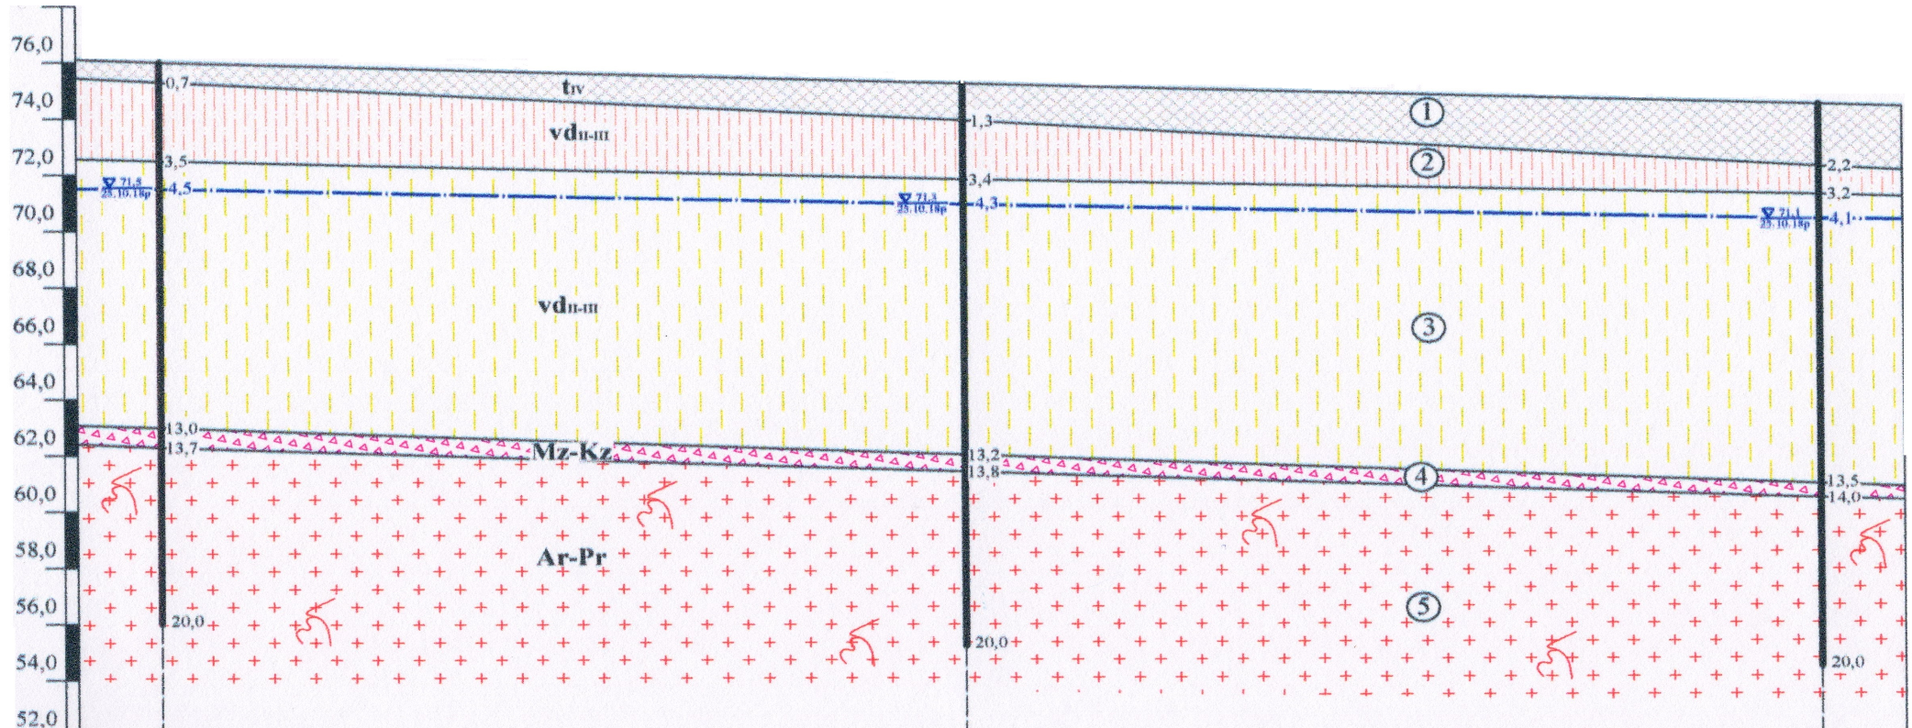
Figure 1 – Engineering and geological section at the construction site:
layer 1 – modern man-made deposits (bulky soils, which include
a soil-vegetable layer, sand, construction debris, household waste products);
layer 2 – loess, dusty, hard sand; layer 3 – loam, light dusty, soft plastic;
layer 4 – eluvial deposits, represented by the fragmental zone
of the weathering crust of crystalline rocks with sand-clay materials;
layer 5 - slightly weathered granites

Table 1 – Normative and calculated values of indicators of physical and mechanical properties of the soils of the site

Names and conventional designations of indicators of soil properties |  | Units of measurement | Layer number
 |  |  | 2 | 3 | 4
Water content, W |  | % | 16,7 | 26,6 | 12,2
Liquid limit, W_{L} |  | % | 26 | 29 | -
Plastic limit, W_{р} |  | % | 19 | 20 | -
Plasticity index, I_{р} |  | % | 7 | 9 | -
Total unit weight, ρ |  | T/m³ | 1,61 | 1,82 | 2,13
Soil elements unit weight, ρ_{ѕ} |  | T/m³ | 2,67 | 2,68 | 2,66
Dry unit weight, ρ_{d} |  | T/m³ | 1,38 | 1,44 | 1,90
Wet unit weight, ρ_{w} |  | T/m³ | 1,83 | - | -
Porosity, п |  | % | 48,3 | 46,3 | 28,6
Void ratio, е |  | - | 0,934 | 0,862 | 0,400
Liquidity index, I_{L} |  | - | < 0 | 0,73 | -
Degree of saturation, S_{r} |  | - | 0,48 | 0,83 | 0,81
Granulometric composition | > 10,0 mm | % | - | - | 17,7
 | 10,0-5,0 mm | % | - | - | 14,8
 | 5,0-2,0 mm | % | - | - | 15,6
 | 2,0-1,0 mm | % | - | - | 14,1
 | 1, 0-0,5 mm | % | - | - | 10,4
 | 0,5-0,25 mm | % | - | - | 10,3
 | 0,25-0.1 mm | % | - | - | 8,4
 | 0,1-0,05 mm | % | 23,1 | 21,6 | 5,6
 | 0.05-0,01 mm | % | 35,9 | 35,1 | 2,3
 | 0,01-0,005 mm | % | 34,2 | 35,2 | 0,8
 | < 0,005 m | % | 6.8 | 8,1 | -
Angle of internal friction, φ (in a natural state / in a locked state) |  | degree | 21 / 16 | 18 | 34
Specific cohesion, с (in a natural state / in a locked state) |  | kPa | 10 / 6 | 13 | 45
Deformation modulus, Е (in a natural state / in a locked state) |  | MPa | 8 / 5 | 7 | 45
Specific gravity of soil, γ_{І} (in a natural state / in a locked state) |  | kN/m³ | 14,6 / 16,6 | 16,5 | 19,3
Angle of internal friction, φ_{І} (in a natural state / in a locked state) |  | degree | 19 / 14 | 16 | 32
Specific cohesion, с_{І} (in a natural state / in a locked state) |  | kPa | 7 / 3 | 10 | 42
Specific gravity of soil, γ_{ІІ} (in a natural state / in a locked state) |  | kN/m³ | 15,5 / 17,6 | 17,5 | 20,5
Angle of internal friction, φ_{ІІ} (in a natural state / in a locked state) |  | degree | 20 / 15 | 17 | 33
Specific cohesion, с_{ІІ} (in a natural state / in a locked state) |  | kPa | 8 / 4 | 11 | 43

The geological and lithological section from the surface of this site of construction works is represented by the following engineering and geological layers:
– modern man-made deposits – bulk soils, which include a soil-vegetable layer, sand, construction debris, household waste products, etc., with a layer thickness from 0.7 to 2.2 m (layer 1).
From a depth of 0.7–2.2 m, modern man-made sediments are underlain by Middle-Upper Quaternary eolian deluvial sediments, represented by:
– sandy loess, gray, dusty, hard, layer thickness 1.0…2.8 m (layer 2);
– dark brown loam, slightly dusty, soft-plastic, layer thickness 9.5…10.3 m (layer 3);
– from a depth of 13.0 to 13.5 m, there are Mesozoic-Cenozoic eluvial deposits, represented by a fragmental zone of the weathering crust of crystalline rocks with sand-clay materials, with a layer thickness of 0.5…0.7 m (layer 4);
– below the depth of 13.7…14.0 m there are Archean-Proterozoic sediments, represented by slightly weathered granites (layer 5).
In terms of hydrogeology, the site is located within the Ukrainian basin of fractured crystalline waters. The roundwater level was recorded at a depth of 4.1…4.5 m from the site surface. Their replenishment is due to rain and melt water and inflow of water mains. The discharge of the water horizon takes place in the channel of the Dnipro River. Thus, in fact, the territory of this site has already been flooded.
The diagram of the basement of the building in which parking is planned is presented in Fig. 2.
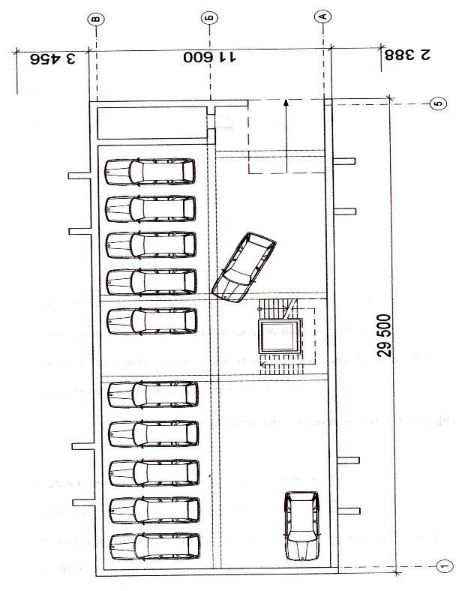

Figure 2 – Scheme of the basement of the building

According to the density of buildings, the physical and mechanical characteristics of the soils of the site and the experience of construction in the surrounding area, it was decided to strengthen the weak soils of the massif with vertical rigid SCE with a diameter of 600 mm and a step of 1.35-1.45 m (Fig. 3 and Fig. 4). According to the conditions of the relief, the deepening of the pit, where the parking lot will be located, is carried out by 3 m at the deepest point, as well as by securing the sides of the pit. The slab foundation is adopted with a plan size of 30500 mm x 12600 mm and a thickness of 600 mm.

Figure 3 – Scheme of placement of soil-cement elements in the plan

Figure 4 – Section of placement of soil-cement elements

Already directly in the process of performing work on the construction site, samples were taken from the manufactured SCE by cutting a part of these elements. From them, cubic samples with a side size of 100 mm were made for uniaxial compression testing.
In the laboratory, a vertical load was applied to the soil cement sample until its destruction. Due to the fact that vertical deformations were recorded during the tests, the compressibility coefficient was also obtained, which is the ratio of the relative vertical deformation to the pressure that caused this deformation.
According to the standards [14], the modulus of soil-cement deformation E is the coefficient of proportionality of the linear relationship between the increase in pressure on the sample and its deformation:
(1)
where µ is Poisson's ratio, which [15] takes as 0.30 for sands and sandy loams; 0.35 – for loams; 0.42 – for clays;
Δр – an increase in pressure equal to р_{n} – р_{о}, 10⁵ Pa.
Δs – increase in subsidence (compression), cm.
Normative characteristics of soil cement, as well as soils, are calculated using the formula [15]:
(2)
where П is the number of characteristic definitions;
Х_{і} – individual values of characteristics obtained from the results of individual i-th tests.
Soil cement was made at the rate of 75 kg of M400 cement per 1 linear meter of drilling. Series of 6 samples were selected for the uniaxial compression test. Examples of the results of some of these tests are presented in the graphs shown in Fig. 5 and Fig. 6.
As a result of such control, it was established that the characteristics of the reinforced soil-cement massif provide a sufficient level of reliability of construction and operation of the building.
The general appearance of a multi-story residential building with parking in the basement, a slab foundation on a base reinforced with vertical soil-cement elements, after its commissioning is shown in Fig. 7.
At all stages of its design and construction, scientific and technical monitoring was carried out [15], the stages (preparatory, working, post-construction), the volumes and features of which depended on the complexity of the object and were determined by the corresponding work program.
It was established, in particular, that the actual absolute settlement of the soil base of the slab foundation of a multi-story residential building and its slope did not exceed their limit values for the corresponding type of buildings and structures [1]. The chosen option turned out to be expedient in terms of both technical and economic indicators.

Figure 5 – Graph of the dependence of the compression of the soil cement sample on the load

Figure 6 – Graphs of the dependence of the amount of compression of the soil cement sample on the load:
row 1 – sample 4, row 2 – sample 6

Figure 7 – General view of a multi-storey residential building with a slab foundation on a soil-cement base
after commissioning

Conclusions
So, the effectiveness of the constructive-technological solution using the drilling-mixing method of arranging soil-cement elements for strengthening the foundation composed of highly compressible clay soils under the slab foundation of a multi-story residential building with parking was proven on the real site under the conditions of existing surrounding buildings. The characteristics of the reinforced soil-cement massif provide a sufficient level of reliability of the building's functioning.

References
1. ДБН В.2.1-10: 2018. (2018). Основи і фундаменти будівель та споруд. Основні положення. Київ: Міністерство регіонального розвитку, будівництва та житлово-комунального господарства України. |  | 1. DBN V.2.1-10: 2018. (2018). Bases and foundations of buildings and structures. Main principles. Kyiv: Ministry of Regional Development, Construction, and Housing of Ukraine.
2. ДБН В.1.1-45:2017. (2017). Будівлі і споруди в складних інженерно-геологічних умовах. Загальні положення. Київ: Міністерство регіонального розвитку, будівництва та житлово-комунального господарства України. |  | 2. DBN V.1.1-45:2017. (2017). Buildings and structures in difficult engineering and geological conditions. Main principles. Kyiv: Ministry of Regional Development, Construction, and Housing of Ukraine.
3. Cheng Y.M., Law C.W., Liu L. (2021). Analysis, Design and Construction of Foundations. London: CRC Press.  https://doi.org/10.1201/9780429293450. |  | 3. Cheng Y.M., Law C.W. & Liu L. (2021). Analysis, Design and Construction of Foundations. London: CRC Press.  https://doi.org/10.1201/9780429293450.
4. Briaud J.-L (2013). Geotechnical Engineering: Unsaturated and Saturated Soils. Hoboken: John Wiley & Sons.  https://doi.org/10.1002/9781118686195 |  | 4. Briaud J.-L (2013). Geotechnical Engineering: Unsaturated and Saturated Soils. Hoboken: John Wiley & Sons.  https://doi.org/10.1002/9781118686195
5. Katzenbach R., Leppla S., Seip M., Kurze S. (2015). Value Engineering as a basis for safe, optimized and sustainable design of geotechnical structures. Proc. of the XVI ECSMGE Geotechnical Engineering for Infrastructure and Development. Edinburg, pp. 601–606.  https://doi.org/10.1680/ecsmge.60678.vol2.073. |  | 5. Katzenbach R., Leppla S., Seip M. & Kurze S. (2015). Value Engineering as a basis for safe, optimized and sustainable design of geotechnical structures. Proc. of the XVI ECSMGE Geotechnical Engineering for Infrastructure and Development. Edinburg, pp. 601–606.  https://doi.org/10.1680/ecsmge.60678.vol2.073.
6. Bruce D. (2000). An introduction to the deep soil mixing methods as used in geotechnical applications. Report FHWA-RD-99-138. U.S. Dept. of Transportation, Federal Highway Administration. |  | 6. Bruce D. (2000). An introduction to the deep soil mixing methods as used in geotechnical applications. Report FHWA-RD-99-138. U.S. Dept. of Transportation, Federal Highway Administration.
7. Van Impe W., Verástegui Flores R., Van Impe P. (2005). Deep mixing research results in under water conditions. Proc. of the 16th Intern. Conf. on Soil Mechanics and Geotechnical Engineering. Rotterdam: Millpress Science Publishers, V. 3, pp. 1275-1278. |  | 7. Van Impe W., Verástegui Flores R. & Van Impe P. (2005). Deep mixing research results in under water conditions. Proc. of the 16th Intern. Conf. on Soil Mechanics and Geotechnical Engineering. Rotterdam: Millpress Science Publishers, V. 3, pp. 1275-1278.
8. Denies N., Lysebetten G.V. (2012). Summary of the short courses of the IS-GI 2012 latest advances in deep mixing Proc. of the Intern. Symposium on Ground Improvement IS-GI, pp. 73–123. Brussels. |  | 8. Denies N. & Lysebetten G.V. (2012). Summary of the short courses of the IS-GI 2012 latest advances in deep mixing Proc. of the Intern. Symposium on Ground Improvement IS-GI, pp. 73–123. Brussels.
9. Zotsenko N, Vynnykov Yu., Zotsenko V. (2015). Soil-cement piles by boring-mixing technology. Energy, energy saving and rational nature use, pp. 192–253, Oradea University Press. |  | 9. Zotsenko N, Vynnykov Yu. & Zotsenko V. (2015). Soil-cement piles by boring-mixing technology. Energy, energy saving and rational nature use, pp. 192–253, Oradea University Press.
10. Denies N., Huybrechts N., De Cock F., Lameire B., Maertens J., Vervoort A., Guimond-Barret A. (2015). Thoughts on the durability of the soil mix material. Proc. of the XVI ECSMGE Geotechnical Engineering for Infrastructure and Development. Edinburg.  https://doi:10.1680/ecsmge.60678 |  | 10. Denies N., Huybrechts N., De Cock F., Lameire B., Maertens J., Vervoort A. & Guimond-Barret A. (2015). Thoughts on the durability of the soil mix material. Proc. of the XVI ECSMGE Geotechnical Engineering for Infrastructure and Development. Edinburg.  https://doi:10.1680/ecsmge.60678
11. Kryvosheiev P., Farenyuk G., Tytarenko V., Boyko I., Kornienko M., Zotsenko M., Vynnykov Yu., Siedin V., Shokarev V., Krysan V. (2017). Innovative projects in difficult soil conditions using artificial foundation and base, arranged without soil excavation. Proc. of 19th Intern. Conf. on Soil Mechanics and Geotechnical Engineering, pp. 3007–3010. Seoul. ICE Publishing, Seoul.  https://doi.org/10.1680/geot.1997.47.3.693. |  | 11. Kryvosheiev P., Farenyuk G., Tytarenko V., Boyko I., Kornienko M., Zotsenko M., Vynnykov Yu., Siedin V., Shokarev V. & Krysan V. (2017). Innovative projects in difficult soil conditions using artificial foundation and base, arranged without soil excavation. Proc. of 19th Intern. Conf. on Soil Mechanics and Geotechnical Engineering, pp. 3007–3010. Seoul. ICE Publishing, Seoul.  https://doi.org/10.1680/geot.1997.47.3.693.
12. Krysan V., Krysan V. (2018). Jet and jet-mixing grouting. Academic Journal. Series: Industrial Machine Building, Civil Engineering. Is. 2(51)′. pp. 68–72. Poltava National Technical Yuri Kondratyuk University.  https://doi.org/10.26906/znp.2018.51.1294 |  | 12. Krysan V. & Krysan V. (2018). Jet and jet-mixing grouting. Academic Journal. Series: Industrial Machine Building, Civil Engineering. Is. 2(51)′. pp. 68–72. Poltava National Technical Yuri Kondratyuk University.  https://doi.org/10.26906/znp.2018.51.1294
13. Vynnykov Yu., Voskobiinyk O., Kharchenko M., Marchenko V. (2017). Probabilistic analysis of deformed mode of engineering constructions’ soil-cement grounds. Proc. of the 6th Intern. Scientific Conf. “Reliability and Durability of Railway Transport Engineering Structures and Buildings”, 116.  https://doi.org/10.1051/matecconf/201711602038 |  | 13. Vynnykov Yu., Voskobiinyk O., Kharchenko M. & Marchenko V. (2017). Probabilistic analysis of deformed mode of engineering constructions’ soil-cement grounds. Proc. of the 6th Intern. Scientific Conf. “Reliability and Durability of Railway Transport Engineering Structures and Buildings”, 116.  https://doi.org/10.1051/matecconf/201711602038
14. ДСТУ Б В.2.1-4-96. (1997). Ґрунти. Методи лабораторного визначення характеристик міцності і деформованості. Київ: Державний комітет України у справах містобудування та архітектури. |  | 14. DSTU B V.2.1-4-96. (1997). Soils. Methods of laboratory determination of strength and deformability characteristics. Kyiv: State Committee of Ukraine for Urban Planning and Architecture.
15. ДСТУ-Н Б В.1.2-17:2016. (2017). Настанова щодо науково-технічного моніторингу будівель та споруд. Київ: Державний комітет України у справах містобудування та архітектури. |  | 15. DSTU B V.1.2-17:2016. (2017). Instruction on scientific and technical monitoring of buildings and structures. Kyiv: State Committee of Ukraine for Urban Planning and Architecture.

