Збірник наукових праць. Галузеве машинобудування, будівництво
Academic journal. Industrial Machine Building, Civil Engineering
http://journals.nupp.edu.ua/znp
https://doi.org/10.26906/znp.2022.59.ХХХХ

УДК 621.01:69]-868

Determination of the vibrating table kinetic energy

Korobko Bogdan¹*, Zhyhylii Serhii², Korotych Yuriy³

¹ Poltava National Technical Yuri Kondratyuk University https://orcid.org/0000-0002-9086-3904
² Poltava National Technical Yuri Kondratyuk University https://orcid.org/0000-0001-5829-9226
³ Poltava National Technical Yuri Kondratyuk University https://orcid.org/0000-0002-1961-5318
*Corresponding author E-mail: korobko@pntu.edu.ua

The article determines the total kinetic energy of the vibrating table, in which the vibrator is fixed on a lever vertically in the center under the vibrating plate. To find the total kinetic energy, a kinematic diagram of the vibrating table under study was drawn up, and the functional dependence of the vibrating table total kinetic energy on the factors acting on it obtained. A graph of the change in the vibrating table kinetic energy under study was drawn depending on the lever length, on which the vibrator was fixed. The analysis of the resulting dependence indicates an increase in the kinematic energy of the vibrating table with an increase in the lever length. The obtained kinetic energy is necessary for the development of an above-mentioned equipment mathematical model, which will be compiled later using Lagrange equations of the second kind

Keywords: vibrating table, lever, vibrator, imbalance, degree of freedom, kinetic energy

Визначення кінетичної енергії вібраційного столу

Коробко Б. О.¹*, Жигилій С. М.², Коротич Ю. Ю.³

¹ Національний університет «Полтавська політехніка імені Юрія Кондратюка»
² Національний університет «Полтавська політехніка імені Юрія Кондратюка»
³ Національний університет «Полтавська політехніка імені Юрія Кондратюка»
*Адреса для листування E-mail: korobko@pntu.edu.ua

В статті проводиться визначення загальної кінетичної енергії технологічного комплекту обладнання для виробництва бетонних виробів (вібростолу), у якого віброзбуджувач закріплюється на важелі вертикально по центру під віброплитою. Дане обладнання використовується для виготовлення малогабаритних бетонних виробів. При виконанні досліджень були використанні методи математичної фізики та фізико-математичне моделювання методами прикладної механіки. Для визначення положення і опису вільних рухів матеріальних тіл, з яких складається розглядувана механічна система, була застосована ортогональна вібраційна система відліку з трьох систем координат. Для знаходження загальної кінетичної енергії, що є сумою кінетичних енергій декількох матеріальних тіл - плити, корпусу віброзбуджувача, дебаланса і ємності з бетонною сумішшю, була складена кінематична схема досліджуваного вібростолу і отримана функціональна залежність загальної кінетичної енергії вібростолу від діючих на нього факторів. Був побудований графік зміни кінетичної енергії досліджуваного вібраційного столу залежно від довжини важеля, на якому закріплювався віброзбуджувач, із врахуванням номінальних чисельних значень величін параметрів вібростолу. Аналіз одержаної залежності вказує на збільшення кінематичної енергії вібростолу при збільшенні довжини важеля, що підтверджує ефективність важільного закріплення віброзбуджувача. Це в свою чергу призводить до зменшення енерговитрат під час віброущільнення бетонних виробів за рахунок зменшення потужності використовуваного для ущільнення віброзбуджувача. Отримана функціональна залежність кінетичної енергії також необхідна для складання в подальшому математичної моделі вищезгаданого обладнання за допомогою рівнянь Лагранжа другого роду

Ключові слова: вібростіл, важіль, вібратор, дебаланс, ступінь вільності, кінетична енергія

Introduction
Vibration is the most common method of compacting concrete composites [1,2]. More than 90% of all construction products made of concrete and reinforced concrete are made using this method of concrete mix compaction [3]. This is explained by the fact that in the process of vibrational action on concrete mixtures, favorable conditions for thixotropic rarefaction and the most compact placement of aggregate particles are created [4,5].
The modern development of construction requires the introduction of the latest technologies and the installation of engineering equipment for various purposes according to the criteria of energy minimization and high efficiency of the technological process. There are a huge variety of vibration machines used in construction, which differ in design and purpose. And, above all, great attention should be paid to the development and implementation of energy-saving technologies and equipment.
A review of various vibration equipment designs shows, that in the manufacture of a wide concrete products range equipment with the required operating parameters used, with the help of which high-quality vibration compaction of the concrete mix is achieved. In order to find out the influence of individual parameters of the developed by us technological set of equipment for the manufacture of concrete products [6] on the movement of its working body and energy consumption, it is necessary to determine the kinetic energy and make a mathematical model of this mechanical system.

Review of the research sources and publications
Extensive use of vibration technology, numerous theoretical and experimental studies of the dynamics of vibrating machines made it possible to identify the features of their work, to explain and put into practice the peculiar effects that occur during the action of vibration on mechanical systems [7,8,9]. Therefore, a lot of research and development is devoted to this issue [10,11], which reveals such advantages of vibration equipment as high sealing efficiency, simplicity of design, high reliability and relatively low metal consumption and energy intensity. One of the priority directions of construction vibration equipment development is to reduce energy costs in production. Energy saving technologies along with increasing productivity and improving product quality occupy a priority place in modern construction.
In our case, we need to create a vibrating table, which by placing a vibration exciter on the vertical lever under the vibrating plate would save energy in the manufacture of concrete products by reducing the power of the vibrator while maintaining the required parameters of vibration compaction.

Definition of unsolved aspects of the problem
It is necessary to make a mathematical model of the developed and constructed vibration table according to the kinematic scheme, that has not been used before, having previously determined its kinetic energy.
Problem statement
The purpose of this work is to obtain the functional dependence of mechanical system total kinetic energy, that simulates a vibrating table with a vibrating exciter placed on a vertical lever under the vibrating plate. This functional dependence of kinetic energy is necessary for the analysis of technological factors, in particular the length of the lever, having an impact on the energy intensity of this mechanical system, as well as for further compilation of a technological equipment set mathematical model for the manufacture of concrete products (vibrating table) using the Lagrange equations of the second order.
To achieve a certain goal, it is necessary to solve the following tasks:

1. Create a kinematic diagram of the vibrating table with a vibration exciter placed on a vertical lever under the vibrating plate.

2. To determine the kinetic energy of individual material bodies composing the vibro-table.
3. Formulate the functional dependence of the total kinetic energy of the vibro-table on the factors affecting it.
4. Build a graphical dependence of the change in the kinetic energy of the vibrating table under study depending on the length of the lever on which the vibration exciter is fixed.

Basic material and results
To clarify the general trend of vibration table for the manufacture of small-sized concrete products individual parameters influence on the movement of his working body, as well as the mutual influence of the vibrating table individual nodes movement let us consider it as a mechanical system, get this mechanical system a mathematical model, and solve it.
The general view of the technological set of equipment for the concrete products manufacture (vibrating table) is shown in Fig. 1.

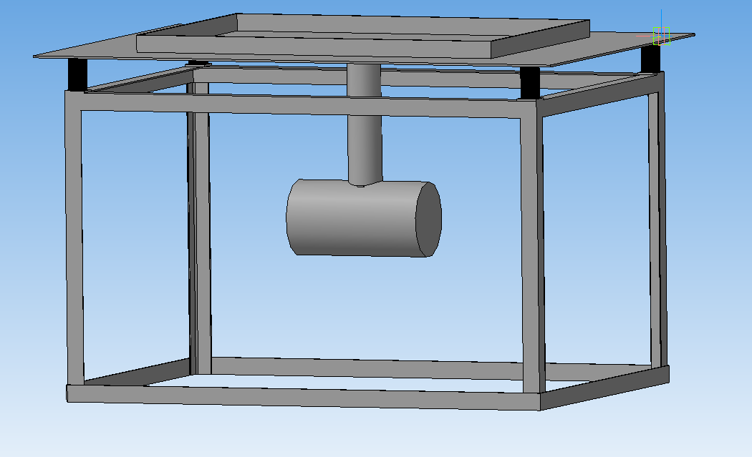

Figure 1 – General view of the technological set
of equipment for the manufacture
of concrete products

Technological set of equipment (subsequently vibrating table) consists (see Fig. 2) from the plate 1 with dimensions 2a₁×2b₁ in projections and thickness 2δ₁, which rests on a fixed supporting surface with the help of four elastic elements with rigidity C each. To the plate 1 lever 2 is rigidly attached with length l_{lever}, to the lower end of which is also rigidly attached mechanical centrifugal imbalanced oscillator exciter (vibrator), debalancing shaft axis of rotation 4 which, at rest, the vibrating table is parallel to the longer axis of symmetry of the plate 1. On shaft 4 imbalance 5 rigidly fixed, the rotation of which generates, provides and determines the working technological movement of the vibrating table under consideration. On plate 1 symmetrically placed and rigidly fixed technological tank for concrete products molding.
Undoubtedly, the primary source of operation for the vibrating table used in the production of small-sized concrete products is the rotation of the unbalanced shaft 4 with imbalance 5 of exciter, parameters and characteristics of which completely determine the structure, magnitude and effectiveness of the dynamic action on the processed medium [12].
To obtain a mathematical model, let us use the
Lagrange equations of the second order [13]
, | (1)
where T – kinetic energy of a mechanical system.
To find kinetic energy T let us consider in Figure 3 the kinematic scheme of the vibration table, as a mechanical system consisting of a plate 1, which is the working body of the vibrating table and which we will consider as an absolutely solid body in the form of a homogeneous rectangular parallelepiped with mass m₁. The external restraints that limit the movement of the slab are elastic elements (springs), with distances between vertical longitudinal axes equal to 2a and 2b (see. Fig. 2). Lever weight 2 ignored. The exciter consists of its body 3, which we take for an absolutely solid homogeneous hollow circular cylinder with a mass m₃, inside which the debalanced shaft 4 has the ability to rotate (the mass of which is also neglected) with an imbalance5 located on it, with mass m and eccentricitye. Central longitudinal axis of the body 3 of exciter determines the rotation axis position of its debalancing shaft 4.
In a first approximation, the container fixed on the slab, together with the concrete mix to be molded, will be considered as a homogeneous solid with mass m₆ in the form of a rectangular parallelepiped dimensions 2a₆×2b₆×2h₆, which is rigidly attached to the plate 1 (see Fig. 2).
Thus, the considered vibration device is modeled by a mechanical system consisting of four material bodies.
During the direct vibration action, which determines the process of manufacturing (molding) concrete products, material bodies 1,3 and 6 carry out complex spatial movements that can be considered as free. The movement of a free solid can be decomposed in many ways [14] for two movements: а) translational motion together with an arbitrarily selected fixed point of the body, which is called the pole; b) spherical motion around this pole.
To determine the position and description of the free motions of material bodies of the mechanical system under consideration, we apply an orthogonal vibration reference frame [15], which consists of three coordinate systems: fixed Oxyz and movable Cx′y′z′ and Cx₁y₁z₁. Start of count O of system Oxyz let us associate with the center of plate 1 inertia C in the position of mechanical system static equilibrium, which is shown in the Figure 2, by aligning the corresponding coordinate axes with the main central axes of plate inertia.

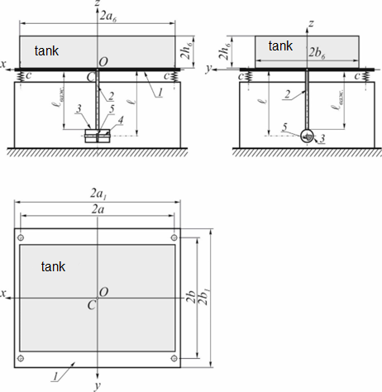
Figure 2 – Vibrating table for the manufacture of concrete products
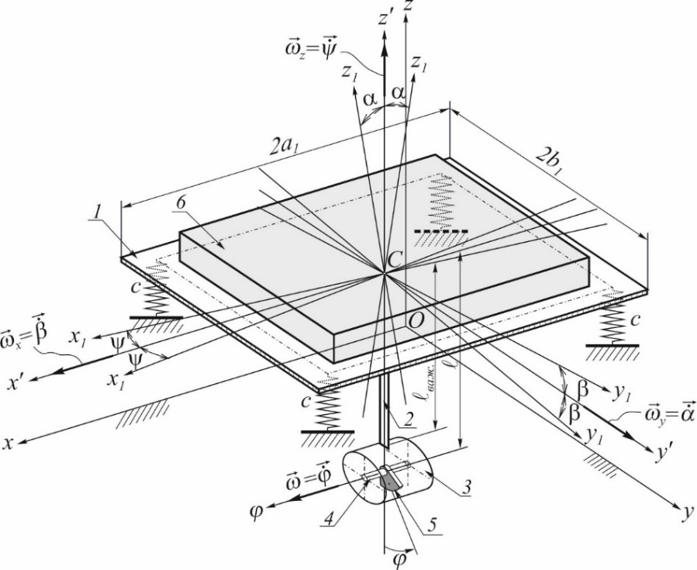

Figure 3 – Kinematic scheme of the vibrating table

The origin of both moving coordinate systems moves with the point C; In this case, the system Cx′y′z′ moves progressively, so that its axes remain parallel to the axes of the fixed coordinate system, and the system Cx₁y₁z₁ rigidly bound to the plate 1. In the static equilibrium position of a mechanical system, all three coordinate systems coincide, and when a mechanical system moves, a point C uniquely characterizes the motion of the center of inertia of a plate relative to a fixed coordinate system Cxyz.
Euler's angles of rotation of the moving system relative to the fixed one will be replaced by vibrational angles of rotation α, β and ψ (Fig. 4), where:
- α specifies the plate rotation angle 1 (or movable system Cx₁y₁z₁) in the frontal coordinate plane Cx′z′ around the axis Cy′ or (which is the same) around a fixed axis Оy with angular velocity$\dot{α}$;
- β – plate 1 rotation angle in the profile plane Cy′z′ around the axis Оx with angular velocity $\dot{β}$;
- ψ – plate 1 rotation angle in the horizontal plane Cx′y′ around the axis Оz with angular velocity $\dot{ψ}$.

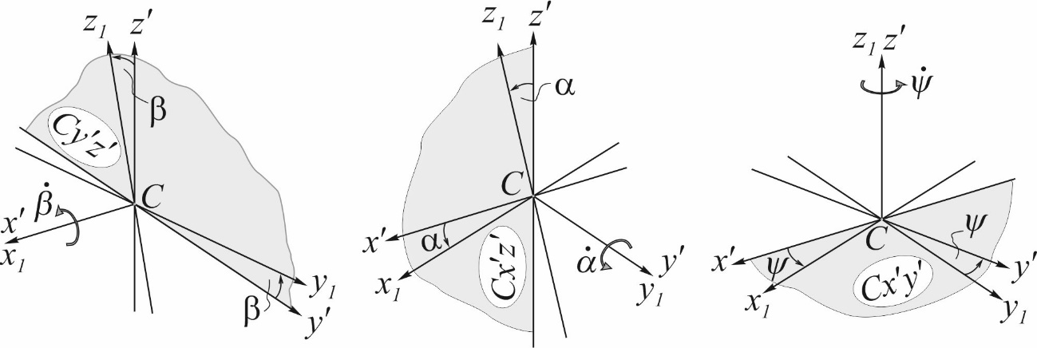

Figure 4 – Vibration count system

When moving a mechanical system, vibration angles α, β and ψ acquire only small values, which distinguishes them favorably from Eulerian angles, in which only the nutation angle is small, and the angles of precession and self-rotation may not be small. Vibration angles are of the same order and are given by periodic trigonometric functions; corresponding angular velocities $\dot{α}$, $\dot{β}$ and $\dot{ψ}$ are same order with angular velocity $ω=\dot{ϕ}$.
Such assumptions make it possible to significantly simplify the process of determining kinetic energy and obtain a simpler mathematical model, which describes with a high degree of accuracy the position and movement of any point and individual material body of the table under study.
Since the mechanical system that simulates the vibrating table consists of four material bodies, its kinetic energy
T = T₁ + T₃ + T₅ + T₆ , | (2)
where T₁, T₃, T₅, T₆ – accordingly, the kinetic energies of each of the bodies.
To find T₁ let's choose the center of inertia beyond the pole C of plate 1; then by Koenig's theorem [16]
, | (2)
Where v_{c} – point speed module C;
ω₁Ω₁ – plate 1 instantaneous angular velocity module around the axis Ω₁ of instant rotation, which in the considered position of the mechanical system passes through a point C;
I₁Ω₁ – axial moment of plate inertia 1 relative to the instantaneous axis Ω₁.
Due to the fact that the origin of the moving reference frame is chosen in the plate 1 inertia center, then [17]
,
where $I_{1x_{1}}$, $I_{1y_{1}}$, $I_{1z_{1}}$– accordingly, the plate 1 inertia moments relative to coordinate axes Cx₁, Cy₁ and Cz₁;$ω_{1x}$, $ω_{1y}$ і $ω_{1z}$ – projections of instantaneous angular velocity ${\vec{ω}}_{1Ω_{1}}$ on the corresponding axes of the fixed system Oxyz.
Next, we note that $ω_{1x}=\dot{β}$, $ω_{1y}=\dot{α}$ and $ω_{1z}=\dot{ψ}$, and with the coordinate method of determining the point motion [18] module $v_{C}=\sqrt{v_{Cx}^{2}+v_{Cy}^{2}+v_{Cz}^{2}}$, where $v_{Cx}={\dot{x}}_{C}$, $v_{Cy}={\dot{y}}_{C}$ and $v_{Cz}={\dot{z}}_{C}$ – vector projections ${\vec{v}}_{C}$ to the axis Oxyz. Then
$v_{С}^{2}={\dot{x}}_{С}^{2}+{\dot{y}}_{С}^{2}+{\dot{z}}_{С}^{2}$.
Substituting all the above values, we finally get that
, | (3)
To find T₃ we choose the center of inertia for the pole C₃ of the exciter body 3. Similar to the definition T₁ we get that
.
Since the plate 1, lever 2 and body connected rigidly, then according to the concepts of theoretical mechanics these three different physical bodies are one material body, because of which
,
,
.
Absolute speed [19] vector ${\vec{v}}_{3}$ of body mass center 3
${\vec{v}}_{C_{3}}={\vec{v}}_{C_{3}e}+{\vec{v}}_{C_{3}r}$,
where ${\vec{v}}_{C_{3}e}$ and ${\vec{v}}_{C_{3}r}$ – respectively, the vectors of portable and relative velocities of the point C₃.
Since portable movement is free, then
${\vec{v}}_{С_{3}е}={\vec{v}}_{С_{3}е1}+{\vec{v}}_{С_{3}е2}$,
where ${\vec{v}}_{С_{3}е1}$ – pole velocity; ${\vec{v}}_{С_{3}е2}$– point velocity C₃ in its spherical motion around the pole.
Since a point is chosen as the pole C, then
${\vec{v}}_{С_{3}е1}={\vec{v}}_{C}=\vec{i}⋅{\dot{x}}_{C}+\vec{j}⋅{\dot{y}}_{C}+\vec{k}⋅{\dot{z}}_{C}$.
To find ${\vec{v}}_{С_{3}е2}$ let's apply vibration angles and depict body 3 inertia center C₃ (see Fig. 5) in three orthogonal projections, where$l=CC_{3}=l_{важ.}+\left(δ_{1}+R_{3}\right)$; R₃ – outer body radius 3.
Let's write ${\vec{v}}_{С_{3}е2}$ as the sum of three addends
${\vec{v}}_{С_{3}е2}={\vec{v}}_{3xy}+{\vec{v}}_{3xz}+{\vec{v}}_{3yz}$,
where ${\vec{v}}_{3xy}$, ${\vec{v}}_{3xz}$ and ${\vec{v}}_{3yz}$ – vector projections ${\vec{v}}_{С_{3}е2}$ to planes xy, yz and zx

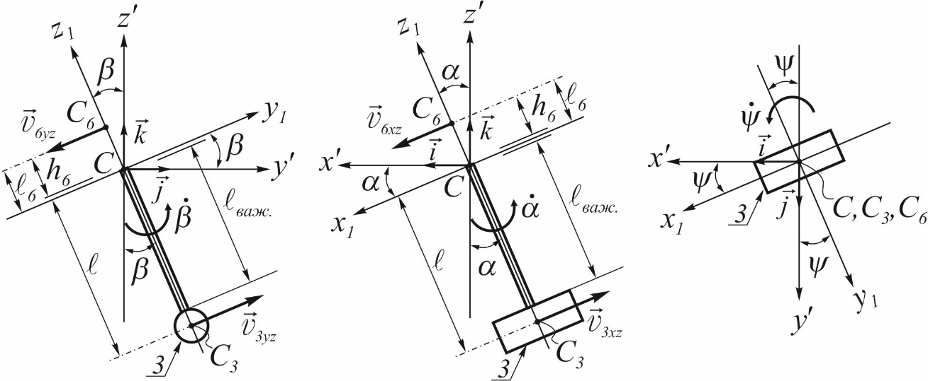

Figure 5 – To determining a portable speed ${\vec{v}}_{С_{3}е2}$ and ${\vec{v}}_{С_{6}е2}$

From Figure 5 it is obvious that the velocity modules $v_{3yz}=\dot{β}⋅l$, $v_{3xz}=\dot{α}⋅l$ and $v_{3xy}=\dot{ψ}⋅0=0$, and the corresponding projections on the specified planes:
,
.
Adding, we get that
,
.
Since the plate 1, lever 2 and body 3 connected rigidly, then any movement of the point C₃ relative to the point C absent, which is why ${\vec{v}}_{C_{3}r}=0$, and
.
Squaring the resulting expression and substituting the value $v_{C_{3}}^{2}$ into the formula of kinetic energy T₃ for body 3, we get
(4)
Choosing center of Inertia C₆ as pole of material body 6, similar to the definition T₃ we consistently establish that
(5)
To determine T₅ let's decompose the complex movement of imbalance 5 on portable with the body 3 and relative movement with respect to the specified body. Portable movement is free. The relative motion of the imbalance is rotation with angular velocity $ω=\dot{ϕ}$. By Koenig's theorem
where I′₅– moment of imbalance inertia 5 relative to the axis passing through its center of mass parallel to the axis of rotation of the debalancing shaft 4.
Vector ${\vec{v}}_{C_{5}}$ of absolute velocity of the imbalance center of mass 5
${\vec{v}}_{C_{5}}={\vec{v}}_{C_{5}e}+{\vec{v}}_{C_{5}r}$, | (6)
Since portable movement is free, then
${\vec{v}}_{С_{5}е}={\vec{v}}_{С_{5}е1}+{\vec{v}}_{С_{5}е2}$, | (7)
where ${\vec{v}}_{С_{5}е1}$ – pole velocity;
${\vec{v}}_{С_{5}е2}$– center of mass imbalance velocity 5 in its spherical motion around the pole.
To simplify rather complex and cumbersome calculations, we apply a coordinate method for determining motion and its kinematic characteristics.
Since a point is chosen as the pole C₃, then
,
To find ${\vec{v}}_{С_{5}е2}$ we will use vibration angles and for clarity we will depict schematically in the figure 6 the imbalance 5 center of inertia C₅ in three orthogonal projections, where $e=C_{3}C_{5}$ – its eccentricity.

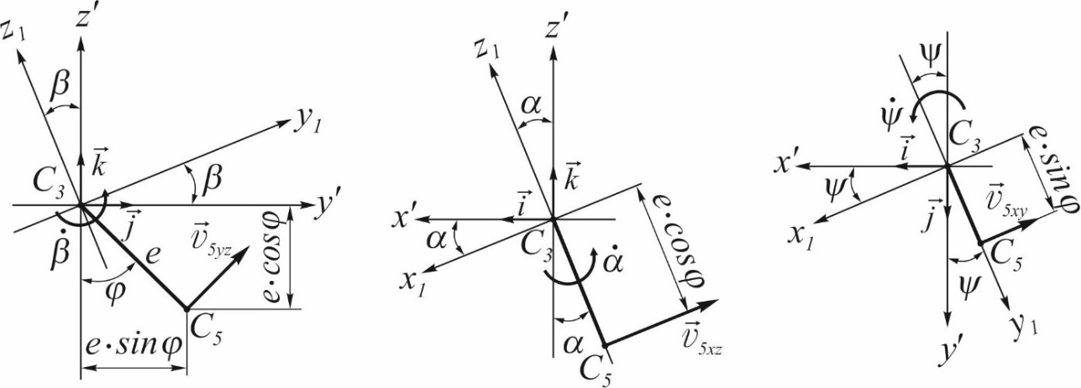

Figure 6 – Decomposition ${\vec{v}}_{С_{5}е2}$ into three components

Let's write now ${\vec{v}}_{С_{5}е2}$ as the sum of three terms:
${\vec{v}}_{С_{5}е2}={\vec{v}}_{5xy}+{\vec{v}}_{5xz}+{\vec{v}}_{5yz}$, (8)
where${\vec{v}}_{5xy}$, ${\vec{v}}_{5xz}$ and ${\vec{v}}_{5yz}$ – velocity vector ${\vec{v}}_{С_{5}е2}$ projections to coordinate planes xy, yz and zx.
From Figure 6 it is obvious that the velocity modules
$v_{5yz}=\dot{β}⋅e$, $v_{5xz}=\dot{α}⋅e⋅cosϕ$ and $v_{5xy}=\dot{ψ}⋅e⋅sinϕ$,
and the corresponding projections on the specified planes
${\vec{v}}_{5yz}=\vec{j}⋅v_{5yz}⋅cosϕ+\vec{k}⋅v_{5yz}⋅sinϕ=\vec{j}⋅\dot{β}⋅e⋅cosϕ+\vec{k}⋅\dot{β}⋅e⋅sinϕ$,
${\vec{v}}_{5xz}=-\vec{i}⋅v_{5xz}cosα+\vec{k}⋅v_{5xz}sinα=-\vec{i}⋅\dot{α}⋅ecosϕcosα+\vec{k}⋅\dot{α}⋅ecosϕsinα$,
${\vec{v}}_{5xy}=-\vec{i}⋅v_{5xy}cosψ-\vec{j}⋅v_{5xy}sinψ=-\vec{i}⋅\dot{ψ}⋅esinϕcosψ-\vec{j}⋅\dot{ψ}⋅esinϕsinψ$.
Substituting these values in formula (8), and the values of ${\vec{v}}_{С_{5}е1}$ and ${\vec{v}}_{С_{5}е2}$ in formula (7), we have
$$\begin{aligned}{\vec{v}}_{С_{5}е}=\vec{i}⋅\left({\dot{x}}_{C}-\dot{α}⋅l⋅cosα-\dot{α}⋅e⋅cosϕ⋅cosα-\dot{ψ}⋅e⋅sinϕ⋅cosψ\right)+ \\ +\vec{j}⋅\left[{\dot{y}}_{C}+\dot{β}⋅l⋅cosβ+\dot{β}⋅e⋅cosϕ-\dot{ψ}⋅e⋅sinϕ⋅sinψ\right]+ \\ +\vec{k}⋅\left[{\dot{z}}_{C}+\dot{α}⋅l⋅sinα+\dot{α}⋅e⋅cosϕ⋅sinα+\dot{β}⋅l⋅sinβ+\dot{β}⋅e⋅sinϕ\right] .\end{aligned}$$
Since the relative motion of the imbalance is rotational, then (see Fig. 7) the module $v_{C_{5}r}=C_{3}C_{5}⋅ω=e⋅\dot{ϕ}$, and a vector
${\vec{v}}_{C_{5}r}=\vec{j}⋅v_{C_{5}r}⋅cosϕ+\vec{k}⋅v_{C_{5}r}⋅sinϕ=\vec{j}⋅\dot{ϕ}⋅e⋅cosϕ+\vec{k}⋅\dot{ϕ}⋅e⋅sinϕ$.

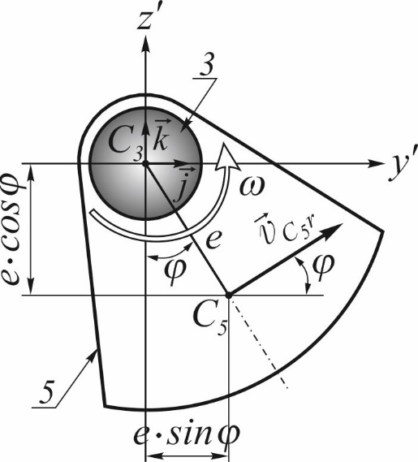

Fig. 7. To determine the relative speed ${\vec{v}}_{C_{5}r}$ of an imbalance

After substitution ${\vec{v}}_{С_{5}е}$ and ${\vec{v}}_{C_{5}r}$ into formula (6), squaring and substituting the value $v_{C_{5}}^{2}$ into the formula of kinetic energy T₅, we get
$$T_{5}=\frac{m}{2}⋅\left({\dot{x}}_{C}^{2}+{\dot{y}}_{C}^{2}+{\dot{z}}_{C}^{2}\right)-$$
$$-m⋅l⋅{\dot{x}}_{C}⋅\dot{α}⋅cosα-m⋅e⋅{\dot{x}}_{C}⋅\dot{α}⋅cosα⋅cosϕ-m⋅e⋅{\dot{x}}_{C}⋅\dot{ψ}⋅cosψ⋅sinϕ+$$
$$+m⋅l⋅{\dot{y}}_{C}⋅\dot{β}⋅cosβ+m⋅e⋅{\dot{y}}_{C}⋅\dot{β}⋅cosϕ-$$
$$-m⋅e⋅{\dot{y}}_{C}⋅\dot{ψ}⋅sinψ⋅sinϕ+m⋅e⋅{\dot{y}}_{C}⋅\dot{ϕ}⋅cosϕ+$$
$$+m⋅l⋅{\dot{z}}_{C}⋅\dot{α}⋅sinα+m⋅l⋅{\dot{z}}_{C}⋅\dot{β}⋅sinβ+$$
$$+m⋅e⋅{\dot{z}}_{C}⋅\dot{α}⋅sinα⋅cosϕ+m⋅e⋅{\dot{z}}_{C}⋅\dot{β}⋅sinϕ+m⋅e⋅{\dot{z}}_{C}⋅\dot{ϕ}⋅sinϕ-$$
$$-\frac{m}{2}⋅l^{2}⋅{\dot{α}}^{2}⋅cos2α+m⋅l⋅e⋅{\dot{α}}^{2}⋅cosϕ-\frac{m}{2}⋅e^{2}⋅{\dot{α}}^{2}⋅\cos^{2}ϕ⋅cos2α+$$
$$+\frac{m}{2}⋅l^{2}⋅{\dot{β}}^{2}+m⋅l⋅e⋅{\dot{β}}^{2}⋅cos\left(β-ϕ\right)+\frac{m}{2}⋅e^{2}⋅{\dot{β}}^{2}-\frac{m}{2}⋅e^{2}⋅{\dot{ψ}}^{2}⋅\sin^{2}ϕ+$$
$$+m⋅l^{2}⋅\dot{α}⋅\dot{β}⋅sinα⋅sinβ+m⋅l⋅e⋅\dot{α}⋅\dot{β}⋅sinα⋅sinβ⋅cosϕ+$$
$$+m⋅l⋅e⋅\dot{α}⋅\dot{β}⋅sinα⋅sinϕ+m⋅l⋅e⋅\dot{α}⋅\dot{ψ}⋅cosα⋅cosψ⋅sinϕ+$$
$$+m⋅l⋅e⋅\dot{α}⋅\dot{ϕ}⋅sinα⋅sinϕ+\frac{m}{2}⋅e^{2}⋅\dot{α}⋅\dot{β}⋅sinα⋅sin2ϕ+$$
$$+\frac{m}{2}⋅e^{2}⋅\dot{α}⋅\dot{ψ}⋅cosα⋅cosψ⋅sin2ϕ+\frac{m}{2}⋅e^{2}⋅\dot{α}⋅\dot{ϕ}⋅sinα⋅sin2ϕ-$$
$$-m⋅l⋅e⋅\dot{β}⋅\dot{ψ}⋅cosβ⋅sinψ⋅sinϕ+m⋅l⋅e⋅\dot{β}⋅\dot{ϕ}⋅cos\left(β-ϕ\right)-$$
$$-\frac{m}{2}⋅e^{2}⋅\dot{β}⋅\dot{ψ}⋅sinψ⋅sin2ϕ+m⋅e^{2}⋅\dot{β}⋅\dot{ϕ}-$$
$-\frac{m}{2}⋅e^{2}⋅\dot{ψ}⋅\dot{ϕ}⋅sinψ⋅sin2ϕ+\frac{I_{5}⋅{\dot{ϕ}}^{2}}{2}$. (9)
Substituting values (3), (4), (5) and (9) to the formula (2), and having performed legitimate transformations, we get that the kinetic energy of the vibrating table
$$T=\frac{M}{2}⋅{\dot{x}}_{С}^{2}+\frac{M}{2}⋅{\dot{y}}_{С}^{2}+\frac{M}{2}⋅{\dot{z}}_{С}^{2}-$$
$$-\left[\left(m_{3}+m\right)⋅l+m_{6}⋅l_{6}\right]⋅{\dot{x}}_{C}⋅\dot{α}⋅cosα-m⋅e⋅{\dot{x}}_{C}⋅\dot{α}⋅cosα⋅cosϕ-$$
$$-m⋅e⋅{\dot{x}}_{C}⋅\dot{ψ}⋅cosψ⋅sinϕ+\left[\left(m_{3}+m\right)⋅l-m_{6}⋅l_{6}\right]⋅{\dot{y}}_{C}⋅\dot{β}⋅cosβ+$$
$$+m⋅e⋅{\dot{y}}_{C}⋅\dot{ϕ}⋅cosϕ+\left[\left(m_{3}+m\right)⋅l+m_{6}⋅l_{6}\right]⋅{\dot{z}}_{C}⋅\dot{α}⋅sinα+$$
$$+m⋅e⋅{\dot{z}}_{C}⋅\dot{α}⋅sinα⋅cosϕ+\left[\left(m_{3}+m\right)⋅l-m_{6}⋅l_{6}\right]⋅{\dot{z}}_{C}⋅\dot{β}⋅sinβ+$$
$$+m⋅e⋅{\dot{z}}_{C}⋅\dot{β}⋅sinϕ+m⋅e⋅{\dot{z}}_{C}⋅\dot{ϕ}⋅sinϕ+\frac{m_{3}⋅l^{2}+m_{6}⋅l_{6}^{2}}{2}⋅{\dot{α}}^{2}-$$
$$-\frac{m⋅l^{2}}{2}⋅{\dot{α}}^{2}⋅cos2α+m⋅l⋅e⋅{\dot{α}}^{2}⋅cosϕ-\frac{m⋅e^{2}}{2}⋅{\dot{α}}^{2}⋅\cos^{2}ϕ⋅cos2α+$$
$$+\frac{\left(m_{3}+m\right)⋅l^{2}+m_{6}⋅l_{6}^{2}+m⋅e^{2}}{2}⋅{\dot{β}}^{2}+m⋅l⋅e⋅{\dot{β}}^{2}⋅cos\left(β-ϕ\right)-$$
$$-\frac{m⋅e^{2}}{2}⋅{\dot{ψ}}^{2}⋅\sin^{2}ϕ+\left[\left(m_{3}+m\right)⋅l^{2}-m_{6}⋅l_{6}^{2}\right]⋅\dot{α}⋅\dot{β}⋅sinα⋅sinβ+$$
$$+m⋅l⋅e⋅\dot{α}⋅\dot{β}⋅sinα⋅sinβ⋅cosϕ+$$
$$+m⋅l⋅e⋅\dot{α}⋅\dot{β}⋅sinα⋅sinϕ+m⋅l⋅e⋅\dot{α}⋅\dot{ψ}⋅cosα⋅cosψ⋅sinϕ+$$
$$+m⋅l⋅e⋅\dot{α}⋅\dot{ϕ}⋅sinα⋅sinϕ+\frac{m⋅e^{2}}{2}⋅\dot{α}⋅\dot{β}⋅sinα⋅sin2ϕ+$$
$$+\frac{m⋅e^{2}}{2}⋅\dot{α}⋅\dot{ψ}⋅cosα⋅cosψ⋅sin2ϕ+\frac{m⋅e^{2}}{2}⋅\dot{α}⋅\dot{ϕ}⋅sinα⋅sin2ϕ-$$
$$-m⋅l⋅e⋅\dot{β}⋅\dot{ψ}⋅cosβ⋅sinψ⋅sinϕ+m⋅l⋅e⋅\dot{β}⋅\dot{ϕ}⋅cos\left(β-ϕ\right)-$$
$-\frac{m⋅e^{2}}{2}⋅\dot{β}⋅\dot{ψ}⋅sinψ⋅sin2ϕ+m⋅e^{2}⋅\dot{β}⋅\dot{ϕ}-$ . (10)
where $M=m_{1}+m_{3}+m_{6}+m$ – the total weight of the vibrating table;$I_{x}=I_{1x_{1}}+I_{3x_{3}}+I_{6x_{6}}$, $I_{y}=I_{1y_{1}}+I_{3y_{3}}+I_{6y_{6}}$ and $I_{z}=I_{1z_{1}}+I_{3z_{3}}+I_{6z_{6}}$ – reduced moving part inertia moments of the table relative to the corresponding axes.
As an example of the application of equation (10), we construct a graph of the change in kinetic energy T of vibrating table under study, which it is able to reproduce depending on the length of the lever${ l}_{важ.}$, to which the vibration alarm is fixed in the center under the vibrating plate. For construction, the mathematical program "Mathcad Prime" was used and taking into account the nominal numerical values of the greatness of the parameters of the vibrating table, which are included in the equation (10) (See. Table. 1).
Table 1 – Nominal parameters of the vibrating table.
№ | Parameter name | Denomination | Unit of measure | Size
1. | Mass of vibrating plate | m ₁ | kg | 170
2. | Mass of the excitor | m ₃ | kg | 10
3. | Mass of imbalance | m | kg | 2
4. | Mass of load with form | m₆ | kg | 50
5. | Imbalance eccentricity | e | m | 0,03

A vibration excitor ИВ-99БУ2 was used (power N=0,5 Kw, frequency 50 Hz, rotational speed n = 3000 rpm, acting force P =2,5 KN), which was fixed to the vibrating plate in size 2a $×$2b = 1,6 m$×$1,3 m, thru the lever. Lever length${ l}_{важ.}$ was accepted equal accordingly 0; 100; 200; 300 mm based on constructive images.
The plot is shown in Fig. 8. The dependence curve increases, which confirms the effectiveness of the lever fastening of the vibrating device to the vibrating table.

Fig 8. Graph of the change in the kinetic energy of the vibrating table T, which it is able to introduce when compacting concrete products, depending on the length of the lever ${ l}_{важ.}$

Conclusions
To obtain a mathematical model of the developed design of the vibrating table, we proposed to use the Lagrange equation of the second kind. This method is the most common method used in solving problems regarding the motion of mechanical systems.
The considered vibrating table was modeled by a mechanical system, which consists of several material bodies - plate, vibration exciter body, imbalance and tank with concrete mix. To determine the position and description of the mechanical system above-mentioned material bodies free motions under consideration, an orthogonal vibration reference system from three coordinate systems was used.
The total kinetic energy of the vibrating table was determined, which is the sum of the kinetic energy of the four material bodies that make up it.
This functional dependence of the total kinetic energy will later be used to compile a mathematical model of the vibration table in the Lagrange equations of the second kind, with the help of which it will be possible to analyze the influence of its constituent parameters – geometric and kinematic – on the process of compacting the concrete mix to reduce energy consumption during vibration compaction of products.
As an example of the application of functional dependence, a graph of changes in the kinetic energy of the investigated vibration table depending on the length of the lever was constructed, on which the vibration excitor was fixed. Analysis of the obtained dependence indicates an increase in the kinematic energy of the vibrating table with increasing lever length. The lever made it possible to create conditions for successful power transfer from the vibration excitor to the table without unforeseen losses.

References
1. Назаренко І.І. Вібраційні машини і процеси будівельної індустрії: навчальний посібник / І.І. Назаренко. – К.: КНУБА, 2007. – 230 с |  | 1. Nazarenko I.I. Vibrational Machines and Processes in the Construction Industry: A textbook / I.I. Nazarenko. – Kyiv: KNUBA, 2007. – 230 p.
2. Дудар І. Н. Теоретичні основи технології виробів із пресованих бетонів : моногр. / І. Н. Дудар. – Вінниця : УНІВЕРСУМ-Вінниця, 2006. – 89 с. – ISBN 966-641-163-6. |  | 2. Dudar I.N. Theoretical Foundations of Technology for Products Made of Pressed Concretes: Monograph / I.N. Dudar. – Vinnytsia: UNIVERSUM-Vinnytsia, 2006. – 89 p. – ISBN 966-641-163-6.
3. Гусев Б. В. Вібраційна технологія бетону / Б. В. Гусев, В. Г. Зазимко. – К.: Будівельник, 1991. – 230 с |  | 3. Gusev B.V., Zazymko V.G. Vibrational Technology of Concrete / B.V. Gusev, V.G. Zazymko. – Kyiv: Budivelnyk, 1991. – 230 p.
4. Ручинський, М.М. Огляд і аналіз існуючих режимів ущільнення бетонних сумішей/ М.М. Ручинський, А.Г. Свідерський, О.С. Дꞌяченко// МНТК «Прогресивна техніка, технологія та інженерна освіта». – Київ, 2019. |  | 4. Ruchynskyi, M.M., Sviderskyi, A.G., D'yachenko, O.S. Review and Analysis of Existing Compaction Modes for Concrete Mixtures. MNTK 'Progressive Technics, Technology, and Engineering Education'. – Kyiv, 2019.
5. Назаренко І. І. Фізичні основи механіки будівельних матеріалів / І. І.Назаренко, М. М. Ручинський. – Львів: Афіша, 2002. – 128 с. |  | 5. Nazarenko I.I., Ruchynskyi M.M. Physical Principles of Mechanics of Building Materials. – Lviv: Afisha, 2002. – 128 p..
6. Пат. 146691 Україна. МПК B28B 1/08 (2006.01). Вібростіл з важільним закріпленням віброзбуджувача / Коробко Б.О., Коротич Ю.Ю., Васильєв Є.А.; власник Національний університет "Полтавська політехніка імені Юрія Кондратюка". – № u 2020 06563; заявл. 12.10.2020; опубл. 10.03.2021, Бюл. № 10. |  | 6. Pat. 146691 Ukraine. IPC B28B 1/08 (2006.01). Vibro-table with lever-mounted vibrator / Korobko B.O., Korotych Yu.Yu., Vasilyev Ye.A.; owner National University 'Poltava Polytechnic named after Yuri Kondratyuk'. – No. u 2020 06563; filed 12.10.2020; published 10.03.2021, Bull. No. 10.
7. Дворкін Л. Й. Проектування складів бетону із заданими власти- востями / Дворкін Л. Й. Дворкін О. Л., Гарніцький Ю. В. – Рівне : Вид-во РДТУ, 2000. – 215 с. |  | 7. Dvorkin L.Y. Designing Concrete Mixtures with Specified Properties / Dvorkin L.Y., Dvorkin O.L., Harnitskyi Yu.V. – Rivne: Publishing House of RSTU, 2000. – 215 p.
8. Nesterenko M.P. Study of vibrations of plate of oscillation cassette setting as active working organ / M.P. Nesterenko, P.O. Molchanov // Conference reports materials «Problems of energ and nature use 2013» (Poltava National Technical Yuri Kondratyuk University, University of Tuzla, China Universitety of Petroleum). – Budapest, 2014. – Р. 146 – 151. |  | 8. Nesterenko M.P. Study of vibrations of plate of oscillation cassette setting as active working organ / M.P. Nesterenko, P.O. Molchanov // Conference reports materials «Problems of energ and nature use 2013» (Poltava National Technical Yuri Kondratyuk University, University of Tuzla, China Universitety of Petroleum). – Budapest, 2014. – Р. 146 – 151.
9. Конструкційні матеріали нового покоління та технології їх впровадження у будівництво / [Р. Ф. Рунова, В. І. Братчун, В. І. Гоц та ін.] – К. : УВПК ЕксОб, 2008. – 360 с. |  | 9. Advanced Construction Materials and Technologies for Implementation in Construction / [R. F. Runova, V. I. Bratchun, V. I. Hots, et al.] – Kyiv: UVPK ExOb, 2008. – 360 p.
10. Нестеренко М.П. Класифікація та оцінка споживчих якостей сучасних вібраційних машин для формування залізобетонних виробів / М.П. Нестеренко // Збірник наукових праць (галузеве машинобудування, будівництво). – Полтава: ПолтНТУ, 2007. – Вип. 20. – С. 20 – 25. |  | 10. Nesterenko M.P. Classification and Assessment of Consumer Qualities of Modern Vibrating Machines for Forming Reinforced Concrete Products / M.P. Nesterenko // Collection of Scientific Papers (Branch Mechanical Engineering, Construction). – Poltava: PoltNTU, 2007. – Issue 20. – Pp. 20 – 25.
11. Загреба, В. П. Технологія роздільного віброімпульсного формування каменебетонних виробів : монографія / В. П. Загреба, І. Н. Дудар, А. О. Коваленко. — Вінниця : ВНТУ, 2012. — 92 с. ISBN 978-966-641-493-2 |  | 11. Zagreba, V.P. Technology of Separate Vibro-impulse Formation of Stone Concrete Products: Monograph / V.P. Zagreba, I.N. Dudar, A.O. Kovalenko. — Vinnytsia: VNTU, 2012. — 92 p. ISBN 978-966-641-493-2.
12. Zhyhylii S.M. Mathematical model of the dynamic action of the controlled vibration exciter on the processed medium of mixer with toroidal working container / S.M. Zhyhylii, M.O. Kharchenko, J.O. Katella // International Journal of Engineering & Technology Vol. 7, No. 3.2, 2018. – Pp. 478 – 485  DOI: 10.14419/ijet.v7i3.2.14576 |  | 12. Zhyhylii S.M. Mathematical model of the dynamic action of the controlled vibration exciter on the processed medium of mixer with toroidal working container / S.M. Zhyhylii, M.O. Kharchenko, J.O. Katella // International Journal of Engineering & Technology Vol. 7, No. 3.2, 2018. – Pp. 478 – 485  DOI: 10.14419/ijet.v7i3.2.14576
13. Morin D. Introduction to Classical Mechanics: With Problems and Solutions / David Morin. – Cambridge University Press; 1st edition, 2008. – 734 p. ISBN-10: ‎ 0521876222 |  | 13. Morin D. Introduction to Classical Mechanics: With Problems and Solutions / David Morin. – Cambridge University Press; 1st edition, 2008. – 734 p. ISBN-10: ‎ 0521876222
14. Павловський М.А. Теоретична механіка: підручник / М.А. Павловський. – К.: Техніка, 2002. – 512 с. |  | 14. Pavlovskyi M.A. Theoretical Mechanics: Textbook / M.A. Pavlovskyi. – Kyiv: Tekhnika, 2002. – 512 p.
15. Сердюк Л.И. Основы теории, расчет и конструирование управляемых вибрационных машин с дебалансными вибровозбудителями: Дис. … д-ра техн. наук: 05.02.02 и 01.02.06. Харьков. политехн. ин-т.– Харьков, 1991.– 301 с. |  | 15. Serdjuk L.I. Fundamentals of Theory, Calculation, and Design of Controlled Vibrating Machines with Unbalanced Vibration Exciters: Dissertation for the Degree of Doctor of Technical Sciences: Specializations 05.02.02 and 01.02.06. Kharkiv Polytechnic Institute – Kharkiv, 1991. – 301 p.
16. Seely F. Analytical mechanics for engineers / Fred B. Seely, Newton E. Ensign. – Chapman & Hall, Limited, New York, London; 3d ed., rewritten View all formats and editions, 1941. – 488 p. |  | 16. Seely F. Analytical mechanics for engineers / Fred B. Seely, Newton E. Ensign. – Chapman & Hall, Limited, New York, London; 3d ed., rewritten View all formats and editions, 1941. – 488 p.
17. Beer F. Vector mechanics for engineers: statics and dynamics, tenth edition / Ferdinand P. Beer, E. Russell Johnston, Jr., David F. Mazurek, Phillip J. Cornwell – New York: McGraw-Hill Companies, Inc., 2013. – 1360 p. |  | 17. Beer F. Vector mechanics for engineers: statics and dynamics, tenth edition / Ferdinand P. Beer, E. Russell Johnston, Jr., David F. Mazurek, Phillip J. Cornwell – New York: McGraw-Hill Companies, Inc., 2013. – 1360 p.
18. Жигилій С.М. Кінематика точки: курс лекцій з дисципліни «Теоретична механіка» для студентів технічних спеціальностей усіх форм навчання / C.М. Жигилій. – Полтава : ПолтНТУ, 2017. – 194 с. |  | 18. Zhyhiliy S.M. Point Kinematics: Lecture Course on Theoretical Mechanics for Students of Technical Specialties of All Forms of Education / S.M. Zhyhiliy. – Poltava: PoltNTU, 2017. – 194 p.
19. Ruina A. Introduction to Statics and Dynamics / Andy Ruina, Rudra Pratap. – Oxford University Press (Preprint), 2011. – 1029 p. |  | 19. Ruina A. Introduction to Statics and Dynamics / Andy Ruina, Rudra Pratap. – Oxford University Press (Preprint), 2011. – 1029 p.

