Збірник наукових праць. Галузеве машинобудування, будівництво
Academic journal. Industrial Machine Building, Civil Engineering
http://journals.nupp.edu.ua/znp
https://doi.org/10.26906/znp.2023.59.0000

UDC 66.001.5:693.546

Mobile complex of equipment for 3D printing

Nesterenko Mykola¹, Orysenko Olexandr², Zhyla Ihor³, Sidan Denis⁴

¹ National University «Yuri Kondratyuk Poltava Polytechnic» https://orcid.org/0000-0002-4073-1233
² National University «Yuri Kondratyuk Poltava Polytechnic» https://orcid.org/0000-0002-8961-2147
³ National University «Yuri Kondratyuk Poltava Polytechnic» https://orcid.org/0000-0002-8750-7650
⁴ National University «Yuri Kondratyuk Poltava Polytechnic» https://orcid.org/0009-0006-7945-5615
*Corresponding author E-mail: nesterenkonikola@gmail.com

The research explores the possibility of using mobile 3D printing technologies in construction and manufacturing. It is noted that many equipment manufacturers are already utilizing 3D printing for constructing various objects, but one of the limitations has been the lack of mobility. However, new concepts and prototypes of mobile 3D printers are emerging, which allow for construction and manufacturing in different locations without the need for additional transportation equipment. The proposed design of a mobile 3D construction printer-complex, housed on a cargo semi-trailer, is suggested as a mobile and autonomous system for construction purposes

Keywords: additive manufacturing, 3D printing, robotic printers, concrete printing, concrete mixture, vibrator

Мобільний комплекс обладнання для 3D-друку

Нестеренко М.М.¹*, Орисенко О.В.², Жила І.В.³, Сідан Д.О.⁴

¹ Національний університет «Полтавська політехніка імені Юрія Кондратюка»
² Національний університет «Полтавська політехніка імені Юрія Кондратюка»
³ Національний університет «Полтавська політехніка імені Юрія Кондратюка»
⁴ Національний університет «Полтавська політехніка імені Юрія Кондратюка»
*Адреса для листування E-mail: nesterenkonikola@gmail.com

В роботі досліджується можливість використання мобільних технологій 3D-друку в будівництві і виробництві. Зазначається, що багато виробників обладнання вже використовують 3D-друк для будівництва різних об'єктів, але одним з обмежень була відсутність мобільності. Проте, з'являються нові концепції та прототипи мобільних 3D-принтерів, які дозволяють виконувати будівництво та виробництво в різних місцях без необхідності використання додаткового обладнання для переміщення. Зосереджено увагу на двох основних напрямках розвитку. Перший - рухомі робочі комплекси з вбудованим 3D-принтером, що можуть переміщатися по будівельному майданчику та автоматично налаштовувати своє положення для друку. Другий - портативні 3D-принтери, які можна легко переносити та використовувати в різних місцях. Зазначається, що ці технології розширюють можливості будівельної індустрії, знижують залежність від фіксованих станцій та дозволяють виконувати роботи на віддалених або важкодоступних місцях. Запропонована конструкція 3D будівельного принтера-комплексу, розміщеного на базі вантажного напівпричепу, пропонується як рухома та автономна система для будівництва. У цій конструкції використовується здвоєний екструдер з можливістю відключення одного сопла подачі, що дозволяє ефективно управляти процесом роздрукування. За рахунок того, що комплекс обладнаний механізмами, які забезпечують його автономну роботу та можливість пересування по дорогам різних категорій, його можна використовувати на місці будівництва, одразу після переміщення на будівельний майданчик

Ключові слова: адитивне виробництво; 3D друк; роботизовані принтери, друк бетонним розчином, бетонна суміш, віброзбуджувач

Introduction
Many equipment manufacturers for construction purposes have started utilizing 3D printing technologies. One of the drawbacks of most of these printer designs is the lack of mobility. The printer constructs the building or object within its working area, and subsequently, after completing the printing of the construction or product, lifting and transportation machinery is required to move the equipment to a new work location. However, modern research and development efforts are actively working on solving this problem. New concepts and prototypes of mobile 3D printers are emerging, which allow for construction and manufacturing in different locations without the need for additional transportation equipment.
One of the directions of development is the creation of mobile working complexes with an integrated 3D printer. These complexes can be equipped with wheeled or tracked chassis, allowing them to freely move around construction sites or other areas. Such equipment working complexes can autonomously find optimal routes for construction and automatically adjust their positions for printing objects [1].
Another solution is the development of portable 3D printers that can be easily carried and used in various locations. These printers can have compact dimensions and be collapsible, allowing them to be transported to hard-to-reach places or over long distances. Such printers should be equipped with an automated navigation system that assists the user in spatial orientation and adjusting printing parameters.
In addition, attention is being given to the development of construction robots that can build and dismantle structures. These robots have the ability to perform complex construction tasks, including 3D printing, and provide maximum mobility as they can be transported and configured in different sections of a construction site. These construction robots are capable of autonomous movement across the terrain using mechanisms such as wheels or tracks. They are equipped with powerful sensors that enable them to analyze the surrounding environment and perform precise movements without colliding with obstacles [2, 3].
Such mobile 3D printers and construction robots significantly expand the possibilities of using 3D printing technology in construction. They reduce dependence on fixed stations and enable work to be carried out in remote or hard-to-reach locations. Additionally, they contribute to the more efficient use of resources and reduce the time spent on equipment relocation.
The application of mobile 3D printing technologies in construction holds significant potential for the fast and efficient execution of various types of projects. They can be utilized for prototyping, small-scale construction, architectural elements, and other structures. These technologies enable quick responsiveness to changing requirements and client needs, while also reducing costs and improving the overall quality of construction.
Indeed, in the future, we can expect even greater innovations in the field of mobile 3D printing technologies, which will open up new possibilities for the construction industry and accelerate construction and manufacturing processes. The continuous advancements in this field are likely to lead to improved efficiency, expanded capabilities, and enhanced integration with other construction technologies. This can revolutionize the way buildings are designed, constructed, and customized, ultimately shaping the future of the industry.

Definition of unsolved aspects of the problem
Despite the progress in the development of mobile 3D printing technologies for construction, there are still several unresolved issues associated with this problem [4, 5].
The size and weight of the equipment are important considerations. Mobile 3D printers and construction robots require a compact and lightweight design to ensure mobility. However, this can limit their capabilities and power. Addressing this issue requires a balanced approach to the size and functionality of the equipment.
Power supply is another important aspect. Mobile devices require a stable and efficient source of energy. Ensuring a reliable power supply that allows for extended operation without the need for frequent recharging or battery replacement is essential.
Stability and precision are crucial factors when it comes to the movement of mobile equipment on uneven surfaces. Addressing this issue involves developing mechanisms to compensate for vibrations, implementing sensors for accurate positioning, and designing control algorithms to maintain printer stability during operation.

Problem statement
The objective of this work is to review the designs of volumetric construction 3D printers and analyze the technologies that are most suitable for their use in mobile conditions.
To achieve this objective, the following tasks need to be accomplished:
Conduct a review of the most common designs of construction 3D printers that provide mobility and the ability to operate on moving platforms.
Analyze the advantages and disadvantages of different construction 3D printer designs in the context of their mobile application.
Evaluate their maneuverability, stability, and printing accuracy, as well as their energy efficiency and reliability.
Assess the capabilities of different construction 3D printer designs for quick reconfiguration when changing the production program.
Investigate the technical solutions and functional capabilities that enable rapid parameter changes and transitioning from one project to another.
Propose a concept for combining a 3D printer with automotive chassis and suggest possible areas of application.
This research approach will help identify the most suitable designs of mobile construction 3D printers and recognize potential directions for further development of 3D printing technologies in the construction industry.
Basic material and results
A construction 3D printer consists of the same structural elements as its counterparts in other industries. It has important components such as a gantry, used for the printer's movement in both vertical and horizontal directions; an extruder, which deposits material layer by layer, and electric drives that control the platform's motion in the desired direction. The size of a construction 3D printer is typically determined by the dimensions of the object being built and can vary significantly [6]..
However, specialized construction 3D printers can be used in the construction industry, which may have additional components or modifications to ensure high precision, speed, and efficiency during construction projects. This indicates that construction 3D printers have a general structural concept but can be customized and modified to suit the needs of the construction industry and be placed on mobile platforms.
Researchers from the Massachusetts Institute of Technology (MIT) have developed a design for a 3D construction printer that combines the printer structure with a tracked crawler, making the machine more mobile and reducing the need for specialized equipment during construction (Figure 1) [5]..
A distinctive feature of this printer is that instead of traditional concrete walls, it proposes printing a foam insulation framework that will later be filled with a concrete mixture.
In the photo, you can see the already printed framework of the building structure (Figure 2). There is also a known printer design from Cazza Construction, the X1 3D Printing model (Figure 3). The mobile X1 3D Printing system is capable of independently moving to the construction site [7].

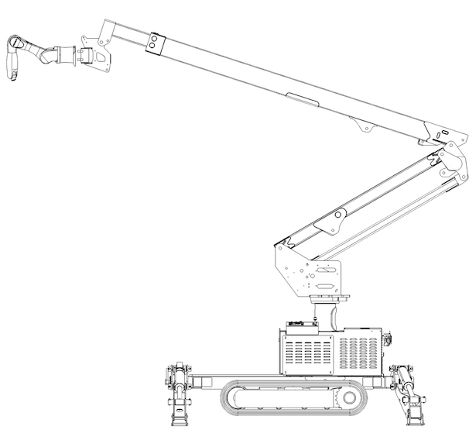
Figure 1 – Mobile printer on a tracked chassis.

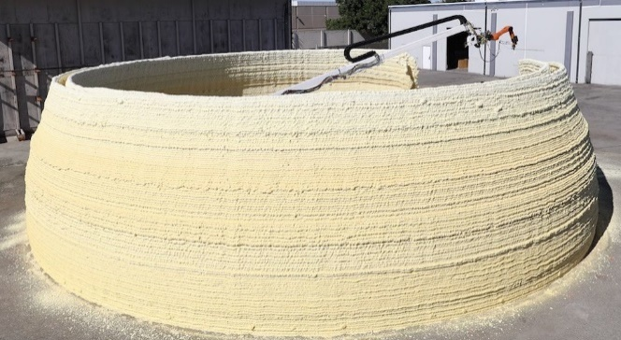

Figure 2 - Polyurethane insulation frame of a building
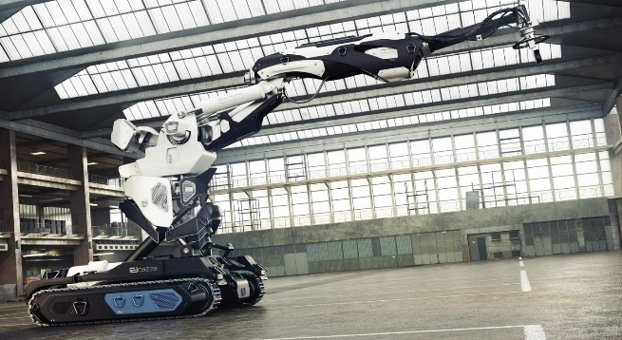

Figure 3 - Mobile X1 3D Printing Complex

A drawback of printers on a tracked chassis is their limited mobility between construction sites and the need to involve specialized equipment for transportation (Figure 4) [7].
Mobile 3D printer designs mounted on a wheeled trailer base, incorporating a robotic arm for performing various operations, have started to emerge (Figure 5) [4].

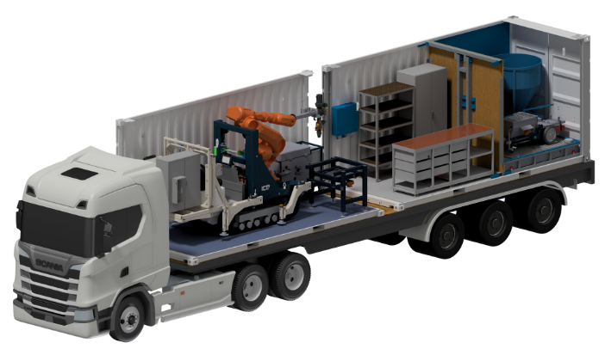

Figure 4 – Transportation of the mobile
3D Printing system

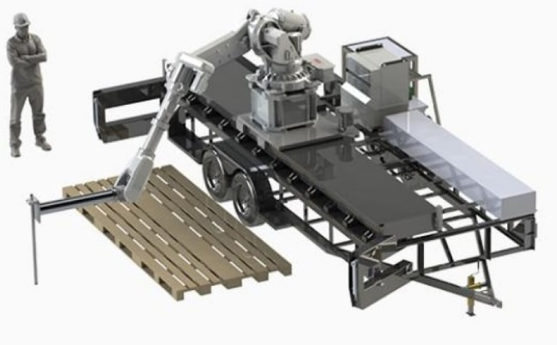

Figure 5 – A trailer with a versatile
robotic arm manipulator

The main component that ensures reliable operation of the printer is the extruder. Considering the possible options for using different extruder designs, namely, single (Figure 6) [8].and dual (Figure 7) [9].

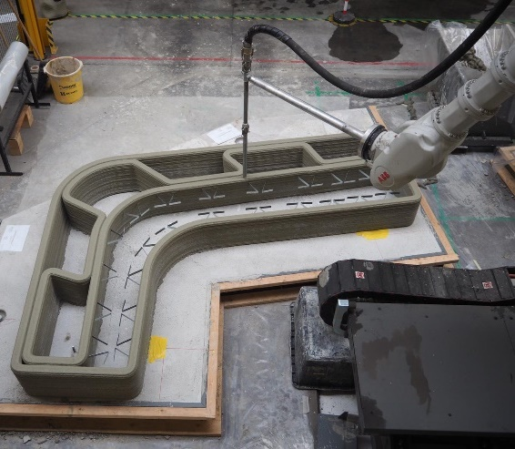

Figure 6 – Single extruder

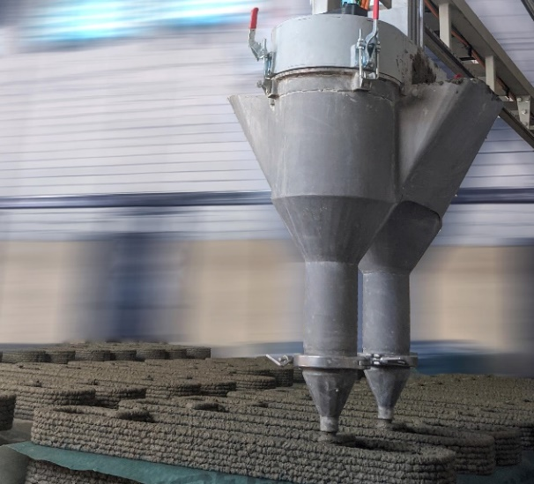

Figure 7 – Dual extruder

The use of a dual extruder nearly doubles the productivity of the machine, but it has a drawback - it complicates the work with different (curved) motion trajectories while simultaneously feeding the mixture.
We propose a design for a 3D construction printer complex, which is mounted on a cargo semi-trailer (Figure 8) equipped with a dual extruder that allows for disconnecting one feeding nozzle.
The mobile complex can be used as a self-contained unit equipped with a mixer (7) and a concrete pump (6) that supplies the ready mix to the extruder (5). The extruder is placed on the metal framework of the portal (4), which is supported by telescopic outriggers (3). The capacity of the semi-trailer allows for the placement of the mixture for preparing the solution and other components.

The operation of the complex begins with the deployment of the portal with the extruder upon arrival at the construction site, which is supported by telescopic outriggers. Then, the preparation of the working mixture takes place, where the components are mixed using the built-in mixer. The delivery of the prepared mixture occurs through pressure pipelines to the extruder with the assistance of a concrete pump.
The electrical part of the complex can be powered either by connecting to an external power supply or by utilizing the built-in diesel generator.
The schematic structure of the printer consists of two structural blocks (Figure 9). The first block comprises the preparation and pump-ing unit for the construction mixture (Figure 10), which is con-veyed through delivery hoses to the second block. To enhance the design of the first unit, a vibration exciter has been installed on the bunker (Figure 11).
.

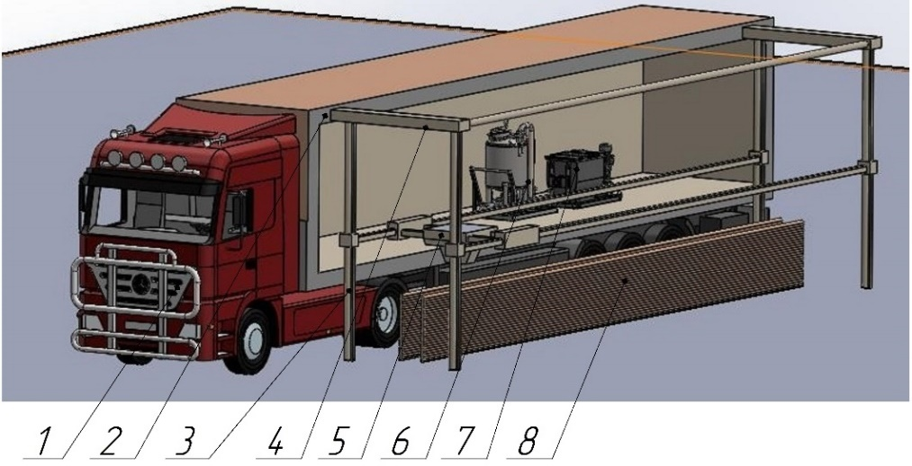

Figure 8 - 3D construction printer complex mounted on a cargo semi-trailer
1 – Truck tractor, 2 – Semi-trailer, 3 – Telescopic outriggers, 4 – Portal,
5 – Extruder, 6 – Concrete pump, 7 – Mixer 8 – Printed element

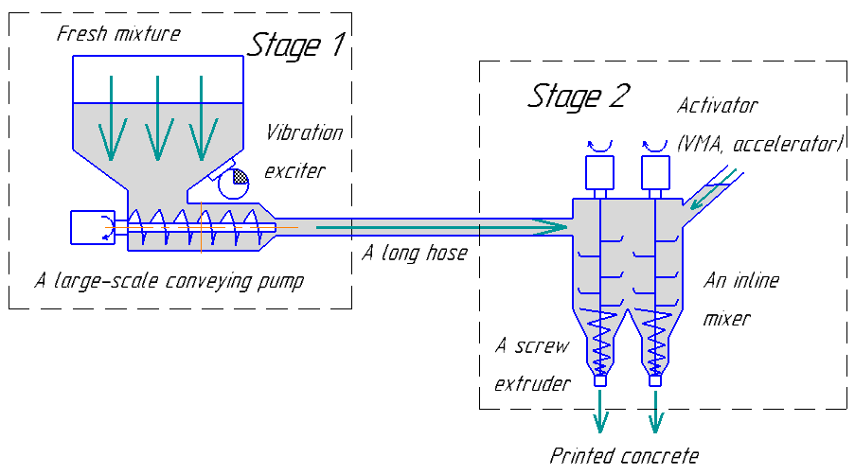
Figure 9 – The scheme of feeding the concrete mixture into the printing area

This will optimize the process of mixing and homogenizing the mixture, ensuring its uniformity and preventing the presence of hardened particles on the walls. The second block consists of a housing that houses two shafts with mixture-agitating blades and screws. Printing of building structures can occur simultane-ously using two streams or one stream by utilizing separate drive motors.
This structural proposal allows for nearly doubling the printing speed. To expedite the curing process of the mixture deposited into the second block, a curing accelerator is introduced.
The obtained structural elements can be further utilized, if needed, as permanent formwork and filled with insulation material or concrete mix.

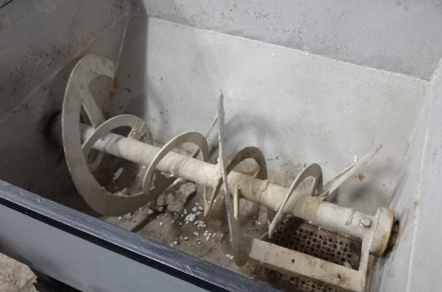

Figure 10 – Mixer for preparing construction mix

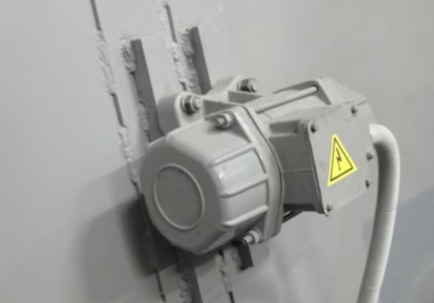

Figure 11 – Vibrator is installed on the hopper

Conclusions
The proposed concept of using a printer installed on a semi-trailer offers significant prospects in construction. It can be utilized for various purposes such as residential and industrial building construction, protective structures, retaining walls, and fences. The complex's autonomous operation and its ability to move on roads of different categories enable its immediate use at the construction site after transportation. Furthermore, the printing block's design can be enhanced by incorporating mechanisms for the placement of reinforcing elements.
Overall, mobile 3D printing technologies open up new possibilities for the construction industry, where speed, maneuverability, and quality are critical factors for success. Thanks to these innovations, we can expect faster, more efficient, and durable construction processes, promoting the development of modern construction practices and enhancing the quality of our lives.

References
1. Nazarenko I., Diachenko O., Pryhotskyi V., Nesterenko M. (2021). Structural analysis of vibration platform for panel units forming and consideration of its utilizing options. Academic Journal. Industrial Machine Building, Civil Engineering, 1(56). 37-42  https://doi.org/10.26906/znp.2021.56.2505 |  | 1. Nazarenko I., Diachenko O., Pryhotskyi V., Nesterenko M. (2021). Structural analysis of vibration platform for panel units forming and consideration of its utilizing options. Academic Journal. Industrial Machine Building, Civil Engineering, 1(56). 37-42  https://doi.org/10.26906/znp.2021.56.2505
2. Шатов С.В., Савицкий Н.В., Карпушин С.А. (2017). Обобщение инновационных технологий 3D-печати строительных объектов для разработки стартапов. Строительство. Материаловедение. Машиностроение. Серия: Создание высокотехнологических экокомплексов в Украине на основе концепции сбалансированного (устойчивого) развития, 99, 194-200 |  | 2. Shatov S., Savitsky N., Karpushin S. (2017). Generalization of innovative technologies for 3D printing of building objects for the development of start-ups. Construction.  Materials Science. Engineering. Series: Creation of high-tech eco-complexes in Ukraine based on the concept of balanced (sustainable) development, 99, 194-200
3. Alwi A., Karayiannis S., Starkey B., Gardner M.,  Reodique K., Varley Th. (2013). «Contrucktion». MegaScale 3D Printing, Group 1: Final Report. Faculty of Engineering and Physical Sciences University of Surrey. [Electronic resource]. - Access mode:  http://personal.ee.surrey.ac.uk/Personal/R.Webb/MDDP/2012/Report/3D%20Building%20Printer%20-%20Group%201.pdf |  | 3. Alwi A., Karayiannis S., Starkey B., Gardner M.,  Reodique K., Varley Th. (2013). «Contrucktion». MegaScale 3D Printing, Group 1: Final Report. Faculty of Engineering and Physical Sciences University of Surrey. [Electronic resource]. - Access mode:  http://personal.ee.surrey.ac.uk/Personal/R.Webb/MDDP/2012/Report/3D%20Building%20Printer%20-%20Group%201.pdf
4. Lipson Н., Kurman M. (2013). Fabricated: The New World of 3D Printing. Indiana: Wiley |  | 4. Lipson Н., Kurman M. (2013). Fabricated: The New World of 3D Printing. Indiana: Wiley.
5. Khoshnevis. B. (2004). Automated construction by contour crafting-related robotics and information technologies. Automation in construction, 13(1), 5-19  https://doi.org/10.1016/j.autcon.2003.08.012 |  | 5. Khoshnevis. B. (2004). Automated construction by contour crafting-related robotics and information technologies. Automation in construction. 13(1), 5-19  https://doi.org/10.1016/j.autcon.2003.08.012
6. Shatov S., Savytskyi M. & Marchenko I. (2019).  Improvement of 3D printing object equipment. Bulletin of Prydniprovs’ka State Academy of Civil Engineering and Architecture, 1, 90-101  https://doi.org/10.30838/J.BPSACEA.2312.261119.91.593 |  | 6. Shatov S., Savytskyi M. & Marchenko I. (2019).  Improvement of 3D printing object equipment. Bulletin of Prydniprovs’ka State Academy of Civil Engineering and Architecture, 1, 90-101  https://doi.org/10.30838/J.BPSACEA.2312.261119.91.593
7. Savytskyi N.V., Shatov S.V., Ozhyshchenko O.A. (2016). 3D-printing of build objects. Вісник Придніпровської державної академії будівництва та архітектури. 3, 18-26 |  | 7. Savytskyi N.V., Shatov S.V., Ozhyshchenko O.A. (2016). 3D-printing of build objects. Вісник Придніпровської державної академії будівництва та архітектури. 3, 18-26
8. Kuhudzai R.J. (2022). Apis Cor Is Ready to Scale Up The 3D-Printed Home & Building Sector With Its Advanced Compact Mobile Robot Tech. [Electronic resource]. - Access mode:  https://cleantechnica.com/2022/02/09/apis-cor-is-ready-to-scale-up-the-3d-printed-home-building-sector-with-its-advanced-compact-mobile-robot-tech/ |  | 8. Kuhudzai R.J. (2022). Apis Cor Is Ready to Scale Up The 3D-Printed Home & Building Sector With Its Advanced Compact Mobile Robot Tech. [Electronic resource]. - Access mode:  https://cleantechnica.com/2022/02/09/apis-cor-is-ready-to-scale-up-the-3d-printed-home-building-sector-with-its-advanced-compact-mobile-robot-tech/
9. Mok K. (2018). Huge Modular 3D Printer Creates $1,000 Tiny House Out of Mud. [Electronic resource]. - Access mode:  https://www.treehugger.com/gaia-house-d-printed-out-mud-wasp-4857768 |  | 9. Mok K. (2018). Huge Modular 3D Printer Creates $1,000 Tiny House Out of Mud. [Electronic resource]. - Access mode:  https://www.treehugger.com/gaia-house-d-printed-out-mud-wasp-4857768

