ATAMANCHUK, N.; YALANSKA, S.; SAIKO, N.; ZHAMARDIY, V.; ZHDANOVA-NEDILKO, O. Memória e seu papel na língua educacional. Revista Entre Linguas, Araraquara, v. 7, n. esp.8, 2021. DOI: 10.29051/el.v7iesp.8.16386.
Disponível em: https://periodicos.fclar.unesp.br/entrelinguas/article/view/16386.
Acesso em: 5 jun. 2022.
https://periodicos.fclar.unesp.br/entrelinguas/article/view/16386 (Web of Science)

MEMORY AND ITS ROLE IN EDUCATIONAL LANGUAGEMEMÓRIA E SEU PAPEL NA LÍNGUA EDUCACIONALLA MEMORIA Y SU PAPEL EN EL LENGUAJE EDUCATIVO
Nina ATAMANCHUK ¹
Svitlana YALANSKA²
Nataliia SAIKO³
Valeriy ZHAMARDIY⁴
Olena ZHDANOVA-NEDILKO⁵

АBSTRACT: Learning a language is one of the most critical issues that everyone hasconsidered for a long time. Language is one of the most important or, better to say, the mostimportant thing to pay attention to. Because through language, human beings communicatewith each other and meet their needs. One of the factors that have a significant impact onlanguage learning is memory. Now the role of memory in language learning is a topic that wewill address in this article. The research method of this article is of the library type, which wewill deal with by reviewing reliable sources and related books during a month. Eventually, werealized that a bit of knowledge of psychology is essential for all teachers. It can be concludedthat the place of memory, especially initially in learning the language and recognizing themechanisms by which memory operates, is essential.
KEYWORDS: Language. Communication. Memory. Language learning.
RESUMO: Aprender um idioma é uma das questões mais críticas que todos considerarampor muito tempo. A linguagem é uma das coisas mais importantes ou, melhor dizendo, a maisimportante a se prestar atenção. Porque por meio da linguagem os seres humanos secomunicam e atendem às suas necessidades. Um dos fatores que têm um impacto significativo
__________________________________________________________________
¹ PhD in Psychology, Associate Professor of the Department of Psychology and Pedagogy, National University «Yuri Kondratyuk Poltava Polytechnic», Poltava, Ukraine. https://orcid.org/0000-0023-8332-0756
e-mail: nina.atamanchuk@gmail.com
² Doctor of Psychological Sciences, Professor, Head of the Department of Psychology and Pedagogy, National University «Yuri Kondratyuk Poltava Polytechnic», Poltava, Ukraine. https://orcid.org/0000-0003-3289-5331
e-mail: yalanskasvetlana@gmail.com
³ Doctor of Pedagogical Sciences, Associate Professor of the Department of Psychology and Pedagogy, NationalUniversity «Yuri Kondratyuk Poltava Polytechnic», Poltava, Ukraine. https://orcid.org/0000-0002-8459-6301 e-mail: natsayko@gmail.com
⁴ Doctor of Pedagogical Sciences, Associate Professor of the Department of Physical Education and Health, Physical Therapy, Ergotherapy with Sports Medicine and Physical Rehabilitation,Poltava State Medical University, Poltava, Ukraine. https://orcid.org/0000-0002-3579-6112
e-mail: Shamardi@ukr.net
⁵ Doctor of Pedagogical Sciences, Associate Professor, Head of the Department of Pedagogical Skills and Management named after I. Ziaziun, Poltava V. G. Korolenko National Pedagogical University, Poltava, Ukraine. https://orcid.org/0000-0002-1414-2355
e-mail: neonylla2015@ukr.net

na aprendizagem de línguas é a memória. Agora, o papel da memória na aprendizagem delínguas é um tópico que abordaremos neste artigo. O método de pesquisa deste artigo é dotipo biblioteca, do qual lidaremos revisando fontes confiáveis e livros relacionados duranteum mês. Eventualmente, percebemos que um pouco de conhecimento de psicologia éessencial para todos os professores. Pode-se concluir que o lugar da memória,principalmente inicialmente no aprendizado da língua e no reconhecimento dos mecanismospelos quais a memória opera, é essencial.
PALABRAS CLAVE: Lenguaje. Comunicación. Memoria. Aprendizaje de idiomas.
RESUMEN: Aprender un idioma es una de las cuestiones más críticas que todo el mundo haconsiderado durante mucho tiempo. El idioma es uno de los aspectos más importantes o,mejor dicho, lo más importante a lo que hay que prestar atención. Porque a través dellenguaje, los seres humanos se comunican entre sí y satisfacen sus necesidades. Uno de losfactores que tiene un impacto significativo en el aprendizaje de idiomas es la memoria. Ahorabien, el papel de la memoria en el aprendizaje de idiomas es un tema que abordaremos eneste artículo. El método de investigación de este artículo es del tipo biblioteca, del que nosocuparemos revisando fuentes confiables y libros relacionados durante un mes. Finalmente,nos dimos cuenta de que un poco de conocimiento de psicología es esencial para todos losprofesores. Se puede concluir que el lugar de la memoria, especialmente inicialmente en elaprendizaje del idioma y en el reconocimiento de los mecanismos por los que opera lamemoria, es fundamental.
PALABRAS CLAVE: Lenguaje. Comunicación. Memoria. Aprendizaje de idiomas.

Introduction
For students majoring in 017 «Physical Culture and Sports» stress is not an unusualphenomenon, but rather a reaction to a combination of problems, to the endless process ofdealing with everyday difficulties. Qualified athletes, in order to improve their results insports, constantly adapt to high physiological and psychological stress. To achieve the goalsof sports and in a high level of competitiveness, athletes are forced to overcome a wide rangeof stress-factors, both internal and external.
Student life is full of stressful situations, which are a source of constant change, whichoften causes stress. These changes sometimes lead to difficulties in the interaction of studentyouth with both the inner and outer world. Stress affects a young person's ability to work, hishealth, relationships with others and close relatives.
It has long been known that art has a positive effect on the development of the nervoussystem, emotional sphere and aesthetic feelings. The use of art techniques in working withstudents promotes the development of self-realization and self-improvement, increasemotivation to study in higher educational establishments, leads to successful professionaldevelopment (Atamanchuk, 2015).
The urgency of using a creative approach in the fight against depression, chronicfatigue, youth stress is obvious. Fatigue, lack of slee, these are just a few reasons that causethese conditions. Art techniques for students majoring in 017 «Physical Culture and Sports» isan immersion in creative activity (from a non-standard solution to the creation of a newproduct), creative self-expression, ingenuity, creativity, initiative, the ability to relax, get ridof negative emotions, express yourself from the other side, create your own product, learnsomething new, do your favorite thing (hobby) or learn a previously unknown skill.
In this regard, the problem of studying the manifestation of stress in students majoringin 017 «Physical Culture and Sports» and the impact of creativity on overcoming it becomesimportant.
The problem of stress in student youth has been studied by such scientists as:E. Alekseeva, I. Ivanova, S. Karyakina, O. Kokun, K. Kraeva, T. Kruzheva, O. Lozgacheva,I. Menshykova, A. Pyetunova, O. Serhyeyeva, A. Faustova, M. Khutorna, L. Shantanova,Yu. Shcherbatykh, D. Bright, J. Greenberg, F. Jones, S. Gerrold et al.
Researchers like V. Voronova, T. Petrovska, G. Gorska and P. Kvashuk, pay greatattention to the study of the influence of personal factors on the achievements of the athlete.
The analysis of the classifications of stresses developed by scientists gives grounds toclaim that stresses are the result of influence of stress-factors which cause different reaction atdifferent people and differ in the content, force and duration.
We agree with the opinion that only such a reaction of an individual that reaches thethreshold levels of his psychological and physiological capabilities can be stressful (Kulish,2015).
In general, stress is a non-specific component of adaptation, which plays a mobilizingrole and determines the involvement of energy and plastic resources for the adaptiverestructuring of the body.
We understand stress as an emotional state of a person that occurs under stress, mainlyin extreme situations.
Stressful events usually cause a person extremely strong emotions, to survive underthe pressure of trauma, protective mechanisms begin to activate. Mechanisms ofpsychological protection are both automatic (unconscious person) and such as copingstrategies (formed and conscious human ability), which are human actions aimed atcombining cognitive, emotional and behavioral strategies that are used to cope with thedemands of everyday life (Lazarus & Folkman, 1984; Plutchik, 1962).
Playing professional sports carries a significant number of stressful situations, andtherefore requires an adequate response to them. The reaction of a young person to thesurrounding reality is associated with individual psychological characteristics, acquiredexperience, established values, beliefs, etc. Significant in overcoming stressful situations arethe features of a young person’s ideas about himself, attitude to himself.
Manifestation of behavioral reactions is largely due to the stress-resistance of theindividual. The problem of stress-resistance of the individual has been studied by suchscientists as: M. Bilova, N. Brezhneva, S. Gaponova, G. Dubchak, V. Korolchuk,V. Krainyuk, R. Kupriyanov, Y. Kuzmina, T. Sereda, O. Lozgacheva, Y. Shcherbatykh et al.
Our observations suggest that the student age is an important stage in the developmentof stress-resistance of the future highly qualified athlete. The basis of student stress-resistanceis self-control, which as a system-forming component of self-regulation of personality affectsall mental phenomena and goal setting, information analysis, decision making andimplementation of the plan.
Exploring the problem of human self-control, G. Nikiforov stressed the importance ofthe processes of mental self-regulation, self-control in identifying the emotional stability ofthe individual (Abolin, 2011; Lazarus & Folkman, 1984; Momot et al., 2020; Plutchik, 1962;Petrovskaya, 2014).
According to L. Abolin, a person’s emotional stability is the ability to resist emotionalfactors under the action of various stressors, ensuring the successful performance ofactivities (Abolin, 2011).
V. Gorska believes that in the process of sports athletes face such a kind of stress as«organizational stress», by which the researcher understands «the athlete’s reaction to theorganizational factors of training in training and during performances atcompetitions» (Gorskaya, 2012).
O. Karpova notes that the athlete’s stress-resistance is characterized by «the ability tocontrol their emotions, maintain high performance, perform extreme activities without tensionand as a result of adaptation development, due to which the body acquires a new quality,namely adaptation in the form of fortitude or resistance to stress» (Petrovskaya, 2014).
We agree with the opinion of T. Petrovska, who states that emotional intelligence is:«It is a personal resource to increase adaptability to psychological stress and performance insports. The development of emotional intelligence in athletes and the ability to recognizeother people’s emotions have a positive effect on reducing stress duringcompetitions» (Petrovskaya, 2014).
Summarizing the above, stress resistance (individual sensitivity to stress) isunderstood as a combination of personal personality traits, which allow to transfer stressfulsituations without unpleasant consequences for human activity and its environment.
Student youth is in a state of lack of time, constant contact with people, which requiressignificant emotional expense. Art techniques are an important means of working with studentyouth, as they are based on art as an activity that conveys reality in concrete-sensory images.
The use of art techniques promotes the expression of emotions, feelings, experiences, thedisclosure of creative potential, the development of teamwork skills. Thus, professionals canactively apply art techniques in the educational space (Yalanska & Atamanchuk, 2017).
Following scientists have paid considerable attention to the study of the influence ofcreativity on the emotional development of the individual: A. I. Arzhanova, I. P. Voropaeva,V. G. Nechaeva, R. V. Ovcharova et al.
Let us define the advantages of using creativity as a means of increasing the stressresistance of a student of a higher education institution (HEI): promotes the attraction ofinternal resources; helps to understand their own hidden states, forms of behavior that arelittle manifested in life (Atamanchuk, 2015); art creates conditions for the approchement ofstudent youth, understanding each other through the perception of created images,empathy (Kopytin, 1999); allows you to look at problems differently and find a way to solvethem.
Thus, creativity has a positive effect on the cognitive (awareness of themselves, theiractions, the realization of creative opportunities) and emotional (allows you to relax, focus,express negative and positive emotions, reduce anxiety, overcome fears, improveinterpersonal relationships) sphere.
Thus, in connection with the constant action of stressors on students HEI, there is aneed to develop stress-resistance of young people as one of the most important professionalcharacteristics of the future specialist. At the same time, the positive influence of creativity onstudent youth has been scientifically proved, which led to the choice of the purpose of ourresearch.
The aim of our study is a theoretical substantiation and empirical research of factors ofdevelopment of stress and a resource of increase of stress resistance at students of a specialty017 «Physical culture and sports».
Materials and methods
The aim of the study is a theoretical substantiation and empirical research of factors ofdevelopment of stress, means of its overcoming in students of a specialty 017 «Physicalculture and sports».
We conducted a study in 2020-2021 on the basis of the National University «PoltavaPolytechnic named after Yuri Kondratyuk». It was attended by 70 second-year students (whohad time to adapt to study in HEI) of the Faculty of Physical Culture and Sports.We conducted the empirical study in four stages.
We used the following methods:theoretical: deductive – description of the researched problem; inductive – establishingpatterns, systematization based on the results of empirical research; empirical: determiningthe causes of learning stress – test for learning stress by Yu. V. Shcherbatykh; assessment ofthe level of stress resistance of student youth (stress-resistance self-assessment test byS. Cowhen and G. Willianson); interpretive – explanation of the researched problem on thebasis of theory and empirical results.
Results and Discussion
The first stage of the study was aimed at identifying the causes of stress in studentsmajoring in 017 «Physical Culture and Sports». Students were asked to draw a circle ofsectors. Each sector had a specific statement to evaluate on a 10-point scale.
The results of theanswers of the subjects are presented in Figure 1.Thus, the main causes of stress in students are high workload, fear of the future, whichis probably due to low orientation in ways of acquiring knowledge (methods of independentacquisition of knowledge, ways of self-regulation of educational work, rational organizationof the educational work).
Lack of cognitive motives leads to difficulties in overcoming difficulties ineducational work, suppression of cognitive activity and is a stress-causing factor. Quitepowerful causes of student youth stress are unwillingness to study or frustration in theprofession and incomprehensible, boring textbooks. Obviously, this is due to the fact thatstudents do not have a clear idea of the content of future professional activities. Theemergence of stress causes the severity of teachers, which can be explained by the imbalancebetween the demands of teachers and the ability of students to predict the implementation ofthe requirements in conditions where it is impossible to fulfill. Problems in personal life havea great influence on the formation of stress in young people, irregular diet, inability toorganize their daily routine, meaning subjective assessment of the threat or adverse effectsand assessment of opportunities to overcome stress are created by students themselves. In some students, stressors are inconvenience, shyness, too serious attitude to learning, which isan individual reaction of young people to the new environment and causes increased anxiety,constant nervous tension and mental fatigue. The stressor for some students is living awayfrom their parents. The least stressful for students are the problem of cohabitation with otherstudents and group conflict, ie interpersonal problems.
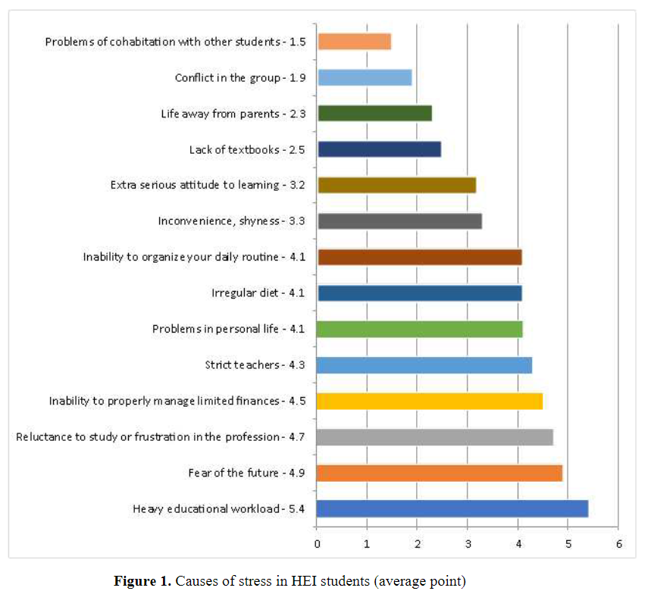
Figure 1. Causes of stress in HEI students (average point)

It is extremely important to know which events and in which cases are stressful forstudent youth. This will come in handy, because it will help mitigate the negative consequences, and possibly get rid of the unwanted condition. In the course of the survey wefound signs of stress in students (Fig. 2).
The highest sign of stress for students majoring in 017 «Physical Culture and Sports»is haste, a feeling of constant lack of time – 4.9. This is due to the fact that the pace of life ofstudent youth is extremely fast. In addition to classes, students attend sports sections. Tobecome a competitive professional, a student must always be focused, efficient and effective.Significant signs of stress are: increased distraction, poor concentration – 4.7; bad mood,depression – 4.7.
Due to the accelerated pace of life, students increase the level of anxiety, there is astate of stress. Lack and inability to properly manage their own time are the reasons for: badsleep – 4.4; impossibility of getting rid of extraneous opinions – 4.2; low efficiency, increasedfatigue – 4.2; irritability, resentment – 4.1; fear, anxiety – 4.1; feelings of helplessness,inability to cope with problems – 3.9; headache – 3.9; loss of confidence, decreased self-esteem – 3.4; violation of social contacts, problems in communication – 2.5. Physiologicalindicators are less stressful for students, since following was noted by us: rapid heartbeat,heart pain – 2.3; problems with the gastrointestinal tract – 1.6; difficulty breathing – 1.5;muscle tension or tremor – 1.2. Thus, the stress of students is caused by constant overloadsassociated with the peculiarities of learning in HEI.
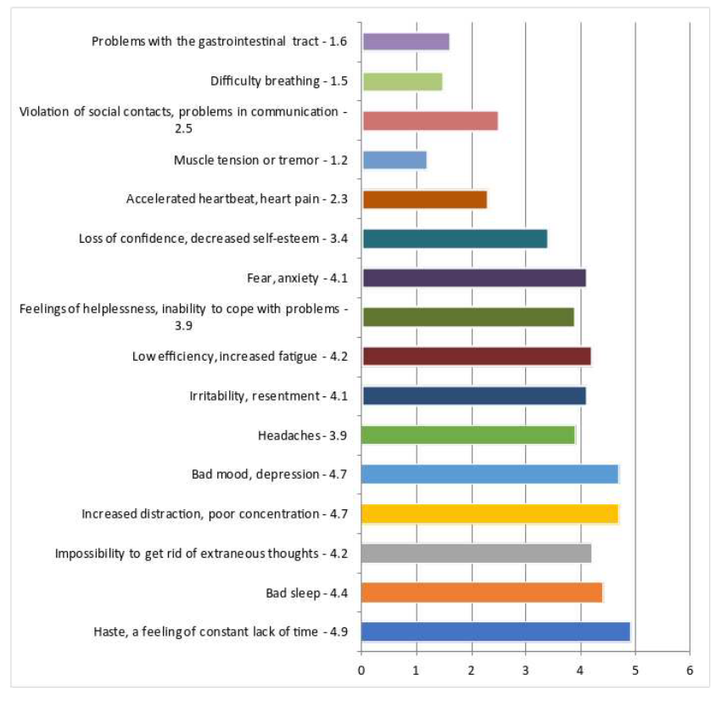
Figure 2. Signs of HEI student stress (average points)
Thus, the stress of students majoring in 017 «Physical Culture and Sports» ismanifested mainly at the psychological level, which affects reduced efficiency, increaseddistraction, poor concentration, bad mood, depression. Biological signs of stress in mostsubjects are present in small numbers.
During the second stage of the study, self-assessment of students’ stress-resistance wasdetermined. The stress self-assessment test allowed students to assess their level of stressresistance (the level can be assessed as excellent, good, satisfactory, bad, very bad). Theresults of the answers of the subjects are presented in Table 1.
Students majoring in 017 «Physical Culture and Sports» assess the level of their stress-resistance as follows: «satisfactory» – 56 %; «good» – 30 %; «bad» – 10 %; «excellent» –4 %; «very bad» – 0 %. The results indicate that the subjects have an underdeveloped level ofself-confidence, self-esteem, which significantly affects the manifestation of personal stress-resistance.
Stress-nonresistant students are those who find it difficult to tolerate even smallstresses, adapt poorly to educational and sports activities, are immediately irritated or nervousbecause of problems. As a rule, these are not psychologically flexible people who easilypanic. Thus, the connection of stress resistance of student youth with their individualpsychological characteristics as subjects of educational and sports activities can be traced.

Table 1. Indicators of self-esteem of students majoring in 017 «Physical Culture andSports»on stress-resistance (in % of the total number of subjects)
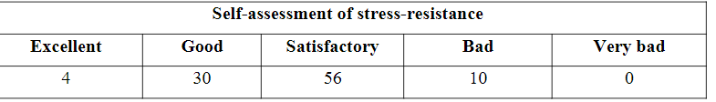

Thus, the results of a study of the level of assessment in stress-resistance of studentsmajoring in 017 «Physical Culture and Sports» indicate that most of them are prone tostressful situations. Students do not always know how to find a way out of an unpredictablesituation and feel anxious. Therefore, they need to increase the level of stress resistance. Toincrease the level of stress resistance requires self-improvement of the individual and self-organization of their own time.
We believe that creativity provides an opportunity to reflect and reduce emotionalstress, see the prospects of their own activities, get rid of feelings of insecurity and fear,which will significantly increase the stress resistance of future professionals in physicalculture and sports. Art increases the stress resistance of students, which is one of theconditions for effective educational and sports activities.
The third stage of the study. In order to increase stress resistance, a number of arttechniques were conducted with students (at the beginning and at the end of the second year).The creative process was aimed at reducing emotional stress and psychological fatigue.Before conducting art techniques, we tried to create a favorable psychological atmosphere, inparticular: acquainted students with the purpose of activity (disclosure of creative potential,creativity, the opportunity to express themselves on the other side, to create their own unique work of art, to immerse themselves in a favorite thing (hobby) or learn a new one); acquaintedwith the tasks of activity (emotional reset, reduction of psychological fatigue, stress throughcreative expression in activity); emphasized students’ attention to the fact that the activity canbe carried out both individually and in groups (search for the necessary materials, methods ofmaking a creative product); answered students’ questions to avoid misunderstandings duringthe activity.
Students majoring in 017 «Physical Culture and Sports» were offered art techniques,namely: «Bridge: «I’m a student» – «I’m a professional» (by Svetlana Yalanska); «Creatingan art diary My emotional states» (by Victoria Nazarevich and modified by NinaAtamanchuk); «Creative contribution» (by Svetlana Yalanska); «Word of occupation» (byNina Atamanchuk); «Black square» (by Victoria Nazarevich); «Soap bubble of stress» (byVictoria Nazarevich) etc.
In working with students used the components of the «Program for the development oftolerance of student youth», in particular art-therapeutic techniques: «Path to Success» and«Collage» (Yalanska & Atamanchuk, 2017).
Conducting art techniques with students did not solve all their internal and externalproblems, but their emotional tension decreased significantly. Importantly, some studentsopened up from another, unknown side.
The fourth stage of the study was conducted by analogy with the second determinedthe self-esteem of students’ stress-resistance after conducting art techniques. The results wereanalyzed and interpreted, their quantitative and qualitative analysis was performed (Tab. 2).
Positive dynamics was observed in students’ assessment of the level of their stress-resistance as «excellent» (from 4 % to 12 %). Almost half of students (from 33 % to 62 %) after psychocorrection rated the level of their stress-resistance as «good». The level ofstudents’ assessment of their stress-resistance as «satisfactory» had also changed significantly(from 56 % to 25 %). Students’ self-esteem of stress-resistance as «bad» decreasedsignificantly (from 7 % to 1 %). Students who rate their stress resistance as «satisfactory» and«bad» lack of self-confidence have inadequate self-esteem. Yes, students with low self-esteemshow a higher level of fear or anxiety in a threatening situation, they often perceivethemselves as having low ability to cope with the situation, so they are less energetic, tend toobey the situation, try to avoid difficulties.

Table 2. Indicators of self-esteem of students majoring in 017 «Physical Culture andSports»on stress-resistance (in % of the total number of subjects)
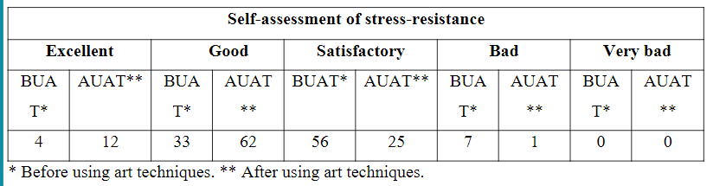

Artistic creativity helps to better identify and evaluate their feelings, memories,images of the future, to understand themselves (Atamanchuk, 2015). Creativity as one of theresources to increase stress resistance helps students to plan time effectively; be optimisticabout solving problems; be able to relax; understand your emotions; increases self-esteem andpositive mood. Thus, the purposeful creative development of student youth helps to increaseresilience in stressful situations, which will significantly change the way and quality of theirlives.
Conclusions
Stress in students majoring in 017 «Physical Culture and Sports» is manifested mainlyat the psychological level, which affects reduced efficiency, increased distraction, poorconcentration, bad mood and depression. A significant number of students are prone tostressful situations. Students do not always know how to find a way out of unpredictablesituations and feel anxious. Therefore, they need to increase the level of stress-resistance.
Under stress, which is the result of living conditions, the student needs to changebehavior, thoughts, feelings to more positive. To maintain your mental health, you need tohave a high level of stress-resistance, one of the ways to overcome stress is creativity. The useof art in the educational process allows you to switch the attention and type of studentactivity, which helps to reduce their internal tension and stress. Art plays an extremelyimportant role in relieving stress in students, namely: gives the opportunity to expressthemselves creatively; get rid of negative emotions and thoughts; to harmonize the psycho-emotional state; distract from internal tension; to increase the success of educational andsports activities; find ways out of difficult situations faster and more efficiently; reduceaggression; increase self-esteem, the level of claims; to perceive one’s own efficiencypositively, to activate one’s potential, etc.
In the future it is necessary to study the role of art techniques in the formation of apositive resource of the image of «I», which will help in the fight against chronic fatigue,stress in sports.
References
Abolin L. M. Psychological mechanisms of human emotional stability : monograph. Kazan :Kazan University Publishing House, 2011. 262 p. [in Russian].
Atamanchur N., Yalanska S., OnipkoV., Ishchenko V. Motivation of freshmen of higheducational establishments : psychological resource of art practice. SUSTAINABLEdevelopment under the conditions of European integration : collective monograph [editorialboard Darko Bele, Lidija Weis, Nevenka Maher]. Part I. Ljubljana : Ljubljana School ofBusiness, 2019. Р. 89−102.
Atamanchuk N. M. Art therapy as a means of studying and overcoming barriers in adolescent communication. Science and education. South Ukrainian National Pedagogical Universitynamed after K. D. Ushinsky, 2015. No 3/СХХХІІ. P. 12−17. [in Ukrainian].
Donchenko V. I., Zhamardiy V. O., Shkola O. М., Kabatska O. V., Fomenko V. H. Health-saving Competencies in Physical Education of Students // Wiadomości Lekarskie. 2020. ТomLXXIII, nr 1. P. 145–150.Voznesenskaya O. L., Sidorkina M. Yu. Art therapy in overcoming mental trauma : Apractical guide. Kyiv : Golden Gate, 2015. 148 p. [in Ukrainian].
Gorskaya G. B. Organizational stress in sports : sources, specificity of manifestations,research directions. Physical culture, sports : theory and practice. 2012. No 4. P. 74−76. [inRussian].
Griban G., Prontenko K., Zhamardiy V., Tkachenko P., Kruk M., Kostyuk Y., Zhukovskyi Y.Professional Stages of a Physical Education Teacher as Determined Using FitnessTechnologies // Journal of Physical Education and Sport. 2018. 18 (2), Р. 565–569.
Kiprych S., Donets O., Kornosenko O., Khomenko P., Zhamardiy V., Shkola O.,Binetskyi D., Kasich N., Serhiіenko V. аnd Bloshchynskyi I.Evaluation of Interconnection ofSpecial Working Capacity and Response of Single Combat Sportsmen’s CardiorespiratorySystem at the Stage of Direct Training for Competition // International Journal of AppliedExercise Physiology. 2020. 9 (7). Р. 115–123.
Kononets N., Grynova M., Zhamardiy V., Mamon O. and Liulka H.Problems ofImplementation of The System of Resource-Based Learning of Future Teachers of PhysicalCulture // International Journal of Applied Exercise Physiology. 2020. 9 (12). Р. 50–60.
Kornosenko O., Denysovets T., Danysko O., Synytsya S., Voloshko L., Zhamardiy V.,Donchenko V., Shkola O., Prystynskyi V. and Otravenko O.System of Preparation of FutureFitness Coaches’ for Health-Improving Activity in the Conditions of RehabilitationEstablishments // International Journal of Applied Exercise Physiology. 2020. 9 (8). Р. 33–41.
Kopytin A. I. Art therapy basics. St. Petersburg : Publishing House «Lan», 1999. 256 p. [inRussian].
Kulish O. V. Features of stress-resistance formation in students-psychologists. Bulletin ofChernihiv National Pedagogical University named after T. G. Shevchenko. Series :Psychological Sciences. No 126. 2015. P. 87−91. [in Ukrainian].
Lazarus R. & Folkman S. Stress, appraisal and coping. New York : Springer. 1984.Momot O., Zhamardiy V., Hrynova V., Gorlova L. and Sharlay N. Experimental Verificationof the Effectiveness of Organizational and Pedagogical Conditions for the Education of theFuture Teacher in the Health-Preserving Environment of the Institution of Higher Education //International Journal of Applied Exercise Physiology. 2020. 9 (10). Р. 253–261.
Plutchik R. The emotions : Facts, Theories and a New Model. New York : Random House.1962.Petrovskaya T. V. Emotional intelligence and competitive anxiety in athletes. Science inOlympic sports. 2014. No 4. P. 60–63. [in Russian].
Yalanska S., Atamanchuk N. Art-ecopsychopractice in the educational space. Proceedings ofthe 1st International Scientific Conference Eastern European Conference of Management andEconomics, May 24, 2019. Ljubljana : Ljubljana School of Business, 2019. Р. 266−269.
Yalanska S. P., Atamanchuk N. M. Psychology of forming a tolerant environment in theconditions of the new Ukrainian school. Science and education. South Ukrainian NationalPedagogical University named after K. D. Ushinsky. No 1. 2017. P. 71−75. [in Ukrainian].
Shkola O., Zhamardiy V., Saienko V., Tolchieva H. and Poluliashchenko I. The StructureModel of Methodical System Usage Fitness-Technology in Student Physical Education //International Journal of Applied Exercise Physiology. 2020. 9 (10). Р. 89–96.
Zhamardiy V. O., Donchenko V. I., Yemets A. V., Skrinnik Y. O. Physical Development byMeans of Fitness Technologies as One of General Aspects of Student’s Health // WiadomościLekarskie. 2019. Тom LXXII, nr 5 cz II. P. 1074–1078.
Zhamardiy V., Griban G., Shkola O., Fomenko O., Khrystenko D., Dikhtiarenko Z.,Yeromenko E., Lytvynenko A., Terentieva N., Otravenko O., Samokish I., Husarevych O. аnd Bloshchynskyi I. Methodical System of Using Fitness Technologies in PhysicalEducation of Students // International Journal of Applied Exercise Physiology. 2020. 9 (5).Р. 27–34.
Zhamardiy V., Shkola O., Tolchieva H., Saienko V. Fitness Technologies in the System ofPhysical Qualities Development by Young Students // Journal of Physical Education andSport. 2020. Vol 20 (1), Art 19. pp. 142–149.
Zhamardiy V. O., Shkola O. М., Okhrimenko I. M., Strelchenko O. G., Aloshyna A. I.,Opanasiuk F. H., Griban G. P., Yahodzinskyi V. P., Mozolev O. M., Prontenko K. V.Checking of the Methodical System Efficiency of Fitness Technologies Application inStudents’ Physical Education // Wiadomości Lekarskie. 2020. Тom LXXIII, nr 2. P. 332–341.
Zhamardiy V., Shkola O., Ulianova V., Bilostotska O., Okhrimenko I., Okhrimenko S.,Griban G., Prontenko K., Bloshchynskyi I. Influence of Fitness Technologies on the StudentYouth’s Physical Qualities Development // Revista Dilemas Contemporáneos : Educación,Política y Valores. Año : VII, Número : Edición Especial, Artículo no. : 49. Período :Octubre, 2019.Zhamardiy V., Shkola O., Bezpaliy S., Kalynovskyi B., Vasylenko O., Ivanochko I.,Dovgan N., Malynskyi I., Danylenko O., Griban G., Prontenko K. Modern FitnessTechnologies in the Physical Education of Students // Revista Dilemas Contemporáneos :Educación, Política y Valores. Año : VII, Número : Edición Especial, Artículo no. : 81.Período : Noviembre, 2019.
Zhamardiy V., Shkola O., Boichenko A., Prystynskyi V., Kornosenko O., Dmytrenko K.,Kabatska O., Staroselska Y., Hordiienko O. and Postova S.Dynamics of Physical Fitness ofStudents during Powerlifting Classes // International Journal of Applied Exercise Physiology.2020. 9 (9). Р. 49–60.
Zhamardiy V., Shkola O., Otravenko O., Momot O., Andreieva M., Andrieieva O.,Mudryk V., Slusarev V., Broslavska H. and Putiatina G. Dynamics of the Functional State ofStudents in the Process of Powerlifting in Higher Education // International Journal ofApplied Exercise Physiology. 2020. 9 (10). Р. 24–35.
Zhamardiy V., Shkola O., Saienko V. and Tolchieva H.Model of Pedagogical System forTeaching Students Motor Actions in Powerlifting // International Journal of Applied ExercisePhysiology. 2020. 9 (12). Р. 76–85.

