UDC 657
JEL: М411

The automated accounting system as an organizational and technical component of the accounting policy of PJSC "Firm "Poltavpivo"

Dmytrenko А.V.*, D.Sc. (Economics), associate professor, Associate Professor of Finance, Banking and Taxation
National University "Yuri Kondratyuk Poltava Polytechnic"
Solod V. S., student
National University "Yuri Kondratyuk Poltava Polytechnic"

*ORCID 0000-0003-3304-8652
_____________________
© Dmytrenko А., 29.11.2021.
© Solod V., 29.11.2021.

Стаття отримана редакцією 29.11.2021 р.
The article was received by editorial board on 29.11.2021

Introduction. Today's rules of business are constantly changing, and the struggle of enterprises for the consumer is constantly intensifying. However, this struggle must be conducted by controlling the profitability of their economy. In these conditions, the issues of reducing the cost of production, increasing profitability, minimizing inventories, fulfilling orders on time, etc. become especially relevant. After all, a market economy displaces the weaker and leaves only those companies that have correctly and competently understood the requirements of the market, properly organized accounting and skillfully motivated employees to work.
Because the accounting department is the main provider of information for the head (in making management decisions) and for the administration (for the effective implementation of responsibilities related to the synchronicity of resource flows, monitoring compliance with applicable laws, cash discipline, etc.). Therefore, the level of business management efficiency increases significantly due to the increasing effectiveness of the accounting process in terms of timeliness of information, its reliability and detail, which creates the need to use computer software to automate accounting information.
The usefulness of accounting information today is determined by the completeness, reliability, efficiency and flexibility of submitting the necessary data to the specified users, which is no longer possible under conditions of manual data processing.
In recent years, there has been a tendency of general computerization – "digitalization" of all types of activity, in particular, the rapid introduction of modern technological achievements of scientific progress, and in the economic relations of business entities, therefore the number of users of such technology is constantly growing. That is why accounting software is beginning to gain more and more importance, the number of which has increased significantly over the past three to four years. As a result, in modern economic conditions, enterprises carrying out activities face the task of choosing the appropriate software for automation of accounting and management that most satisfies their needs.
Analysis of recent research and publications. Consideration of certain aspects of accounting automation is devoted to the works of domestic scientists. In particular, Bukalo N. A. studied the development of accounting automation systems; considered the functions of meeting the needs of users in automated accounting systems; studied methods of conducting automated accounting according to International Accounting Standards (IFRS); examined in detail the procedures of the process of automation of reporting under IFRS [2].
Lobov S. T. subjected to careful scientific consideration the theoretical aspects of determining the economic efficiency of implementation and application of information technology in the enterprise, conditions and consequences of technology implementation, the main trends in IT development in enterprises, key benefits and opportunities for their use [5]. Petina L. V. in her scientific works developed the topic of application of automated workplace in accounting and management accounting, taking into account the features of each of the areas in which the economic activity of the enterprise [6].
Polyanska O. A. focused in her research on the need for management accounting in an automated environment, market monitoring of modern information technology, especially application packages, which allow management accounting in a computer environment; studied the requirements to be met by computer programs aimed at automating management accounting [7].
Ponomareva T. V. published the results of its own research on the accounting of certain calculation processes, including in particular value added tax for enterprises that have switched to filing electronic tax reporting [8]. An important place in her research is to determine the features of accounting for taxable transactions in various software products and the formation of the main documents used in accounting for taxable transactions.
The research of such scientists as P.V. Ivanyuta, S.V. Ivakhnenkov, О.S. Kryvokon, S.F. Lazaryeva, R.L. are characterized by fragmentation and reveal in general the general theoretical aspects of automated information processing in accounting processes.
The purpose and objectives of the research. The purpose of the work is to study the features of automation of accounting at PJSC "Firm "Poltavpivo" as an organizational and technical component of accounting policy for the formation of effective activities of the enterprise.
The following tasks have been identified to achieve this goal:
1) determine from the accounting policy of PJSC "Firm "Poltavpivo" which information processing technology (type of software) is used by the company's accounting department;
2) describe the approach of choosing a software product to automate accounting in the enterprise;
3) to analyze the software product ISpro as a means to automate the processes of accounting for personnel, labor and wages in the enterprise.
Presentation of the main material. Because one of the ways of proper organization of accounting in enterprises of various forms of ownership is the accounting policy, which specifically establishes the methodological and organizational and technical aspects of accounting, including information processing technology in accounting, the level of automation of accounting procedures, document management. Thus, the organization of accounting allows in conditions of uncertainty to decide on the choice of an adequate way to reflect the facts of economic life in accounting.
Accounting policy – is the specific principles and procedures used by the management of the enterprise for the preparation of financial statements and accounting, providing for the streamlining of accounting procedures in the enterprise and the provision of accounting planning and rationality [1]. This includes any accounting methods, measurement systems and accounting disclosure procedures. The accounting policy must comply with generally accepted accounting principles (GAAP) and/or International Financial Reporting Standards (IFRS).
Today, every company needs to see a real picture of its financial condition for decision-making, and the main factor influencing the objectivity and efficiency of information is a professionally developed accounting policy for the automation of accounting processes.
In the decree "On the accounting policy" of PJSC "Firm "Poltavpivo" in the first section the following is defined: "Accounting is carried out in a machine-oriented form using ISpro software."
When choosing the software for the organization of the accounting system in the automated environment of PJSC "Firm "Poltavpivo" was guided by the following principles:
1. Since the implementation and organization of an automated accounting system is a complex and multi-stage process that requires significant investment, therefore, the most effective and correct approach to automating accounting operations is the "western" approach, where this approach is based on the following statement: "Automation of enterprise accounting processes must be effective and proceed from the company's prosperity strategy", that is, it is necessary to automate those tasks that will help achieve the goals of the enterprise, where all automation tasks will be assessed from the" Efficiency/Price "position. This approach is indeed called correct, even almost ideal. The essence of this approach is as follows:
- in accordance with the existing strategy and goals of the enterprise, allocate accounting areas for which a qualitative improvement is required;
- in the corresponding accounting area, a corresponding automation task is built, which ensures the process of increasing efficiency;
- the likely effect of the task of automating accounting is determined the day before and is mainly compared with expenditure items for modernization and adjustment;
- implementation of automation and reorganization of the company's accounting [10, p. 43].
2. The organization of accounting and analytical procedures for obtaining information should be the basis for the formation of information support of the management of the enterprise, which would allow management to competently and quickly form management decisions [11, p. 24].
3. Availability of extensive functionality to optimize all processes. In addition, the software can be easily customized according to the characteristics of accounting work in enterprises of a particular industry.
4. Easy transition from other systems. This should take into account the possibility of simultaneous accounting and tax accounting, which in modern conditions is quite relevant and practical. Simultaneous input of data required for both tax and accounting allows users to track all business transactions and changes in the composition of assets and liabilities that occur in different parts of the accounting work.
5. Compliance with the law, timely update, because the program must be built taking into account the peculiarities of accounting in Ukraine on the basis of National Accounting Regulations (Standards) and/or International Accounting Standards, as well as current tax legislation.
6. Arbitrary modular configuration.
The main feature of the presented typological characteristics of software for automation of enterprise accounting (Table 1), are the subjects of accounting, because you need to understand in detail that different software products of different classes are designed for enterprises of different sizes.
Table 1
Classification feature of software for automating the accounting system of companies
Sign of software typology | The main types of software
1. By means of creation | Development of program code by a full-time programmer.  Formation on request by the corresponding firm-developer.  Writing a panoramic accounting automation program.
2. On the subject of accounting | Private accounting.  Small businesses.  Medium companies.  Large enterprises.  Polyprofile companies.
3. By means of implementation of accounting functions in the software product | A software product where priority is given to entering accounting transactions manually.  A software product where priority is given to entering accounting transactions according to templates.
4. By the complexity of the functions performed | Integrated consolidated accounting software product.  Secluded automated workstations (AWS).  Complexes of connected workstations.
5. By appointment | Accounting software product.  Financial analytical systems.  A software product for automation of management activities, including an accounting module.  Legal databases.
(developed on the basis of the source [9, p. 62])

Accounting automation programs have a complete set of variable parts, where because of an error-free software configuration procedure can be implemented in the following order:
1. Adjusting the chart of accounts in accordance with the characteristics of the company, the optimization of accounting and task setting.
2. Setting up standard postings in accordance with the characteristics of the company, carried out by optimizing accounting and setting the task.
3. Adjusting the forms of primary documents in accordance with the characteristics of the company, the optimization of accounting and task setting.
4. Adjustment of forms of the accounting reporting and calculations on taxes according to characteristic features of the company, the carried-out optimization of accounting and statement of a task.
Let us consider the capabilities of the ISpro system, which are used in labor accounting, calculation and payment of wages at PJSC "Firm "Poltavpivo". Keeping records of labor, accrual and payment of wages is an important element of the accounting and management system, since, on the one hand, it helps to determine the amount of labor costs and accordingly determine the actual cost of manufactured products, works and services performed, on the other hand, it allows the maximum efficiently use the available labor resources.
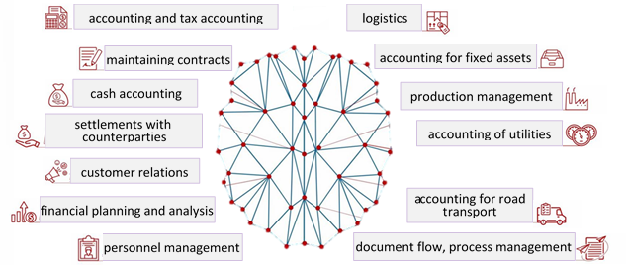
Fig. 1. Areas of application of the ISpro software package [3]
Despite the significant importance of automation of labor accounting and its payment for the accounting system, this area of ​​accounting is the most difficult area of ​​automation, due to the following problems: the complexity of calculation and diversity of wage structures of employees of different enterprises; constant change of normative documents that determine the procedure for accrual of wages, accruals and deductions from it; ambiguity in the interpretation of current legislation; variety of algorithms for performing auxiliary calculations for different types of payments and payment terms; availability of conditions and benefits for withholding personal income tax; there are differences in the period of accrual and payment of wages depending on the characteristics of the enterprises; formation of regulated reports, which are constantly updated and changed.
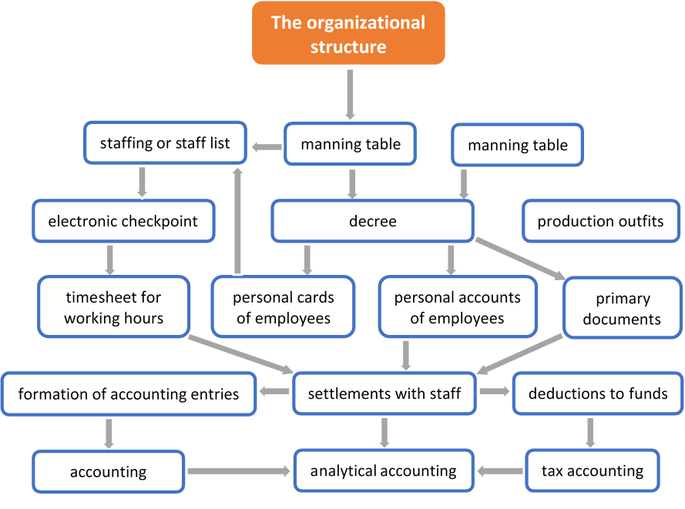
Fig. 2. Organizational structure of personnel, labor and wages

The Personnel Accounting system consists of the subsystems Personnel Accounting and Labor and Wage Accounting. The links between documents and system modules simplify and speed up the personnel accounting process (Figure 2). The operations for which the subsystem Accounting for labor and wages in ISpro is responsible are shown in Figure 3.
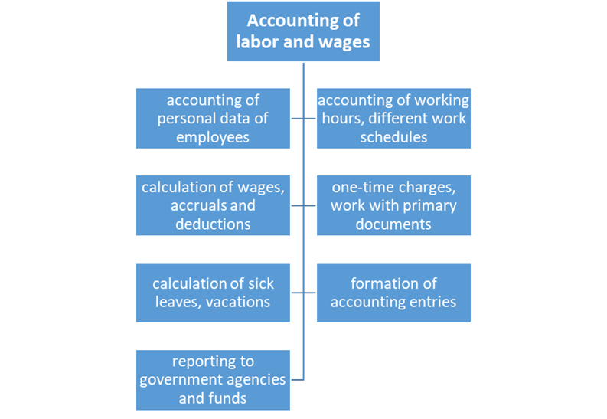
Fig. 3. Operations for which the subsystem Accounting for labor and wages in ISpro is responsible

Working with the subsystem begins with the settings. All information in the module Settings of the subsystem Accounting for labor and wages is presented in the form of a hierarchical list with the following items: types of payments, funds, transfers, directories (for information that does not change very often: Accounting, Staff categories, Groups of staff categories, , Grounds for dismissal, Ranks, Ranks, Titles, Insurance Fees, Types of employment, Qualification categories, etc.).
The Calculation Methods item contains a list of available methods for calculating accruals and deductions. By default, the Complex offers basic calculation methods, the use of which is possible in all organizations, regardless of the field of activity [4].
PJSC "Firm "Poltavpivo" uses methods of calculating labor and wages for the sphere of activity of industrial enterprises.
Therefore, the accounting of personnel and salaries in ISpro is carried out through the maintenance of the file of employees; preparation of personnel orders; staffing; support for a wide range of payroll deductions and deductions (including individual and team outfits); calculation of various surcharges, allowances, bonuses, financial assistance, dividends, etc.; support of daily and summary accounting of working time; calculation of vacation and sick leave payments; formation of payment information and transfer lists (connection with the cash accounting subsystem); formation and calculation of documents of any type; calculation of taxes and preparation of reports for the SFSU and the Pension Fund; formation of form 1DF; recalculation of income tax; personification [3].
Conclusions. According to the results of the study of the state of the automation process at PJSC "Firm" Poltavpivo ", it was found that: the accounting service of the enterprise for the automation of accounting uses the ISpro software – this is approved in the accounting policy of the enterprise; the key principles for choosing ISpro as an automated accounting system are compliance with the law and the "Western" approach, which consists in an optimal combination of "Efficiency/Price" principles; the ISpro personnel accounting system consists of personnel accounting and labor and wages accounting subsystems, and the links between documents and system modules make it possible to simplify and speed up the personnel accounting process; since PJSC "Firm "Poltavpivo" is a large enterprise, it uses the methods of calculating labor and wages accounting in ISpro for the sphere of activity of industrial enterprises.
However, one should not forget that automation is a complex and time-consuming process and for its successful implementation it is necessary to think in advance about the solution of at least the main problems associated with it.
So, these problems stimulate the following studies, the key direction of which is the development of an optimal methodology that will allow, in a short time and with minimal cost, to introduce elements of accounting automation in an enterprise.

REFERENCES:
1. Accounting Policies [Electronic resource] // Investopedia – Resource access mode. URL : https://www.investopedia.com/terms/a/accounting-policies.asp (accessed: 25.11.2021).
2. Bukalo, N.A. (2013), "Accounting automation in modern conditions" / N.A. Bukalo // Zbirnyk naukovykh prats ChDTU. Seriia "Ekonomika", vol. 33, no. II, pg. 56–59.
3. ISpro Complex [Electronic resource] // ISpro – Resource access mode. URL : https://ispro.ua/page/is-pro-system (accessed: 25.11.2021).
4. ISpro user guide (2020). Personnel accounting: labor and wage accounting. 270 p. (Version 8).
5. Lobov, S.P. (2013), "Methods for assessing the economic effect of using automated information systems in procurement planning" / S.P. Lobov // Naukovyi visnyk Uzhhorodskoho universytetu Seriia "Ekonomika", vol. 4 (41), pg. 176–181.
6. Petina, L.V. (2010), "Features of automation of management and accounting in agricultural enterprises" / L.V. Petina // Zbirnyk naukovykh prats ChDTU. Seriia "Ekonomika", vol. 25, no. I, pg. 26–29.
7. Polyanska, O.A. (2011), "Problematic aspects of management accounting automation" / O.A. Polyanska // Visnyk Lvivskoi komertsiinoi akademii, vol. 35, pg. 286–290.
8. Ponomareva, T.V. (2013), "Automation of accounting for VAT calculations: approaches and practical solutions" / T.V. Ponomareva // Visnyk NTU "KhPI" Seriia "Tekhnichnyi prohres i efektyvnist vyrobnytstva", vol. 61 (1040), pg. 22–29.
9. Shypunova, O.V. (2011), "Automation of enterprise management: basic principles, functions and approaches" / O.V. Shypunova // Aktual'ni problemy ekonomiky, vol. 6, pg. 25–38.
10. Skrypnyk, S. (2020), "Features of automation of enterprise accounting in modern conditions" / S. Skrypnyk, І. Franchuk, І. Shepel // Ekonomika ta derzhava, vol. 10, pg. 39–45. DOI: 10.32702/2306-6806.2020.10.39
11. Slavkova, O.P. (2013), "Automation of accounting and analytical procedures for obtaining information" / O.P. Slavkova, S.A. Garkusha // Naukovi pratsi Poltavskoi derzhavnoi ahrarnoi akademii, vol. 2 (7). no. 1, pg. 19–25.
12. Zavgorodniy, V.P. (1998), Avtomatyzatsiia bukhhalterskoho obliku, kontroliu, analizu ta audytu [Automation of accounting, control, analysis and audit] / V.P. Zavgorodniy. A.S.K., Kyiv, Ukraine.

УДК 657
JEL: М411

Дмитренко А.В., доктор економічних наук, доцент, доцент кафедри фінансів, банківського бізнесу та оподаткування Національного університету "Полтавська політехніка імені Юрія Кондратюка", Солод В.С., студентка Національного університету "Полтавська політехніка імені Юрія Кондратюка". Автоматизована система бухгалтерського обліку як організаційно-технічна складова облікової політики ПрАТ "Фірма "Полтавпиво". Стаття є досить актуальною, оскільки в умовах безперервних змін у бізнес-середовищі, коли підприємствам доводиться постійно боротися за споживача, при цьому контролюючи питання рентабельності свого бізнесу, адже ринкова економіка витісняє слабших, а виживають лише ті підприємства, які найбільш правильно і компетентно зрозуміли вимоги ринку, тому правильно організували облік, уміло здійснили мотивацію працівників до роботи. Рівень ефективності управління бізнесом значно зростає завдяки зростанню результативності процесу обліку за умов своєчасності інформації, її вірогідності та деталізації, що спричиняє потребу використання комп'ютерного програмного забезпечення для автоматизації облікової інформації.
В останні роки спостерігається тенденція загальної комп’ютеризації "діджиталізації" – за останні три-чотири роки кількість програмного забезпечення облікової роботи значно збільшилася. Урезультаті чого, перед підприємствами, які проводять господарську діяльність, виникає завдання вибору відповідного програмного забезпечення для автоматизації обліку та управління, яке найбільш задовольнятиме їхні потреби.
Новизною досліджуваної теми є дослідження особливостей автоматизації бухгалтерського обліку на ПрАТ "Фірма "Полтавпиво" на противагу укоріненому тренду дослідження загальнотеоретичних аспектів автоматизованої системи бухгалтерського обліку.
Завдання дослідження: визначити із облікової політики ПрАТ "Фірма "Полтавпиво", яку технологію обробки інформації (вид програмного забезпечення) використовує бухгалтерська служба підприємства; описати підхід обрання програмного продукту задля автоматизації обліку на підприємстві; проаналізувати програмний продукт як засіб для автоматизації процесів обліку персоналу, праці й заробітної плати на підприємстві.
В статті розглянуто один із способів належної організації бухгалтерського обліку на підприємствах різних форм власності – це облікова політика. Із Наказі "Про облікову політику" ПрАТ "Фірма "Полтавпиво" встановлено, який програмний продукт використовує бухгалтерська служба підприємства для автоматизації. Досліджено принципи вибору програмного засобу для організації системи обліку в автоматизованому середовищі, якими керувалося керівництво ПрАТ "Фірма "Полтавпиво". Представлено класифікаційну характеристику існуючого програмного забезпечення для автоматизації системи обліку підприємств. Розглянуто сфери застосування програмного комплексу ISpro. Описано можливості програмного комплексу ISpro щодо ведення обліку праці, нарахування та виплати заробітної плати. Продемонстровано графічно організаційну структуру обліку кадрів, праці й заробітної плати та операції, за які відповідає підсистема облік праці й заробітної плати у ISpro. Розкрито ряд головних функціональних можливостей обліку кадрів і заробітної плати в ISpro. Доведено, що автоматизація бухгалтерського обліку є важливим елементом організаційно-технічного компоненту облікової політики підприємства, а її реалізація є складним і трудомістким процесом, для її успішності необхідно заздалегідь продумати вирішення хоча б основних проблем, що пов'язані з нею.
Ключові слова: автоматизована система бухгалтерського обліку, бухгалтерська інформація, програмний продукт, облікова політика, бухгалтерський облік.

UDC 657
JEL: М41

Dmytrenko A.V., D.Sc. (Economics), Associate Professor, Associate Professor of Finance, Banking and Taxation of the National University "Yuriy Kondratyuk Poltava Polytechnic", Solod V. S., student of the National University "Yuri Kondratyuk Poltava Polytechnic". The automated accounting system as an organizational and technical component of the accounting policy of PJSC "Firm "Poltavpivo". The article is quite relevant, because in the conditions of continuous changes in the business environment, when companies have to constantly fight for the consumer, while controlling the profitability of their business, because the market economy displaces the weaker, and survive only those companies that most correctly and competently understand the requirements market, so properly organized accounting, skillfully motivated employees to work. The level of business management efficiency increases significantly due to the increasing effectiveness of the accounting process in terms of timeliness of information, its reliability and detail, which necessitates the use of computer software to automate accounting information.
In recent years, there has been a trend of general computerization of "digitalization" – over the past three or four years, the number of accounting software has increased significantly. As a result, businesses that carry out economic activities are faced with the task of choosing the appropriate software to automate accounting and management, which will best meet their needs.
The novelty of the researched topic is the study of the peculiarities of accounting automation at PJSC "Firm "Poltavpivo" in contrast to the ingrained trend of research of general theoretical aspects of the automated accounting system.
Objectives of the study: to determine from the accounting policy of PJSC "Firm "Poltavpivo" which information processing technology (type of software) is used by the company's accounting department; describe the approach of choosing a software product to automate accounting in the enterprise; to analyze the software product as a means to automate the processes of accounting for personnel, labor and wages in the enterprise.
The article considers one of the ways of proper organization of accounting in enterprises of various forms of ownership – is the accounting policy. The Decree "On the Accounting Policy" of PJSC "Firm "Poltavpivo" establishes which software product is used by the company's accounting service for automation. The classification characteristic of the existing software for automation of the enterprise accounting system is presented. Areas of application of the ISpro software package are considered. The possibilities of the ISpro software package for labor accounting, accrual and payment of wages are described. The organizational structure of personnel, labor and wage accounting and operations for which the labor and wage accounting subsystem in ISpro is responsible is graphically demonstrated. A number of the main functionalities of personnel and salary accounting in ISpro are revealed. It is proved that accounting automation is an important element of the organizational and technical component of the accounting policy of the enterprise, and its implementation is a complex and time-consuming process, for its success it is necessary to think in advance to solve at least the main problems associated with it.
Key words: automated accounting system, accounting information, software product, accounting policy, accounting.

